*# Tableau-challenge*

Click the link below to access the public tableau https://public.tableau.com/app/profile/neha.sharma5782/viz/Newyorkbikeanalysis/Story1?publish=yes

*The findings of the New York City bike analysis for the month of November 2022.*

1) Geographic location of Popular start and end stations.

2) Popularity of rideable types.

3) Popularity of rideable types based on the members or casual users.

4) Weekly analysis of the number of rides during November 2022.

5) Peak hours to end or start the ride.

6) Casual vs member users’ analysis.

*Tableau Pages Details -*

1) The map represents the start and end stations. every station has a distinct colour, and the start stations have a bigger marker than the end stations.

As per visualization, all the stations are in New Jersey.

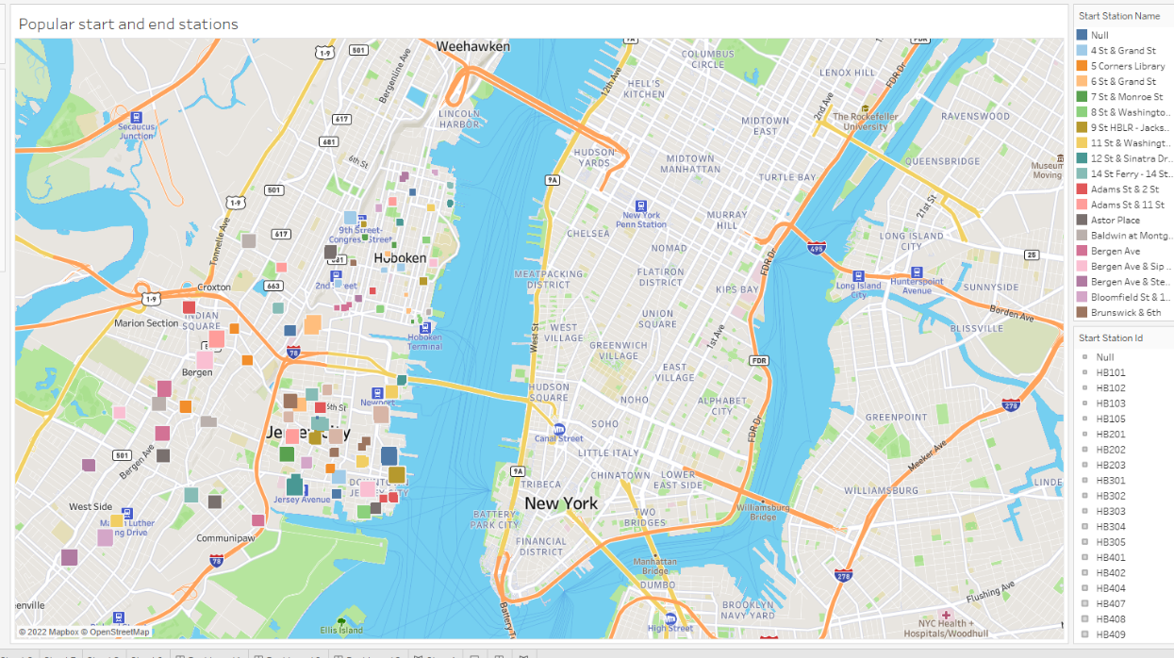

*Dashboards*

Dashboard-01

Dashboard -01 is the previous map of the start and the end stations and their locations.

Dashboard-02

* Represents the comparison of member VS casual users. Member users are more in number than casual users.
* popularity of the rideable type. Classic bikes are the most popular while docked bikes are the least popular.
* popularity of rideable type depending on the member types. The bike popularity trend continues to show up regardless of whether the user is a casual user or a member.

Dashboard -03

Dashboard 03 represents the peak hours of starting and ending the rides. Also the weekly analysis of the ride numbers during November 2022.

06 November to 12 November was the busiest week while 20 November to 26 November would be considered the slowest as the last weeks do not have complete data.

The peak hour to start the ride is 17 & 18 which means 5 PM and 6 PM. The peak hours to end the ride are also the same even though the number of rides starting, and ends do not match.

