Itgalpura, Rajanukunte, Bengaluru - 560064

**School of Engineering**

A Project Report on

# “An IOT-Based Intelligent System for Real-Time Parking Monitoring and Automatic Billing”

Submitted in partial fulfillment of the requirement for the course

Innovative Project – Raspberry-pi using Python (**CSE 1003**)

Submitted by   
 Group: IPR 101

|  |  |
| --- | --- |
| Student Name | Roll No |
| SHREYA RAVI KUMAR | 20211CSE0229 |
| VAIBHAV BHARADWAJ | 20211CCS0052 |
| NEHA R | 20211CSE0224 |
| SAHANA R PRASAD | 20211CIT0066 |
| KISHOR B | 20211ECE0207 |

Under the supervision of

**Guide name: Dr. Rajkumar N**

**Designation: Assistant Professor**

**Department: Computer Science and Engineering**

Dec- 28th 2022

**Abstract (100-150 words):**

Modernization is something that everyone wants. With the increase in modernization, people are expecting to live a sustainable and hassle-free life. In this modern society, Parking is a major issue. Due to the growing number of vehicles in these cities, parking becomes a challenging task. We have tried to boost this particular system with the help of modern technologies (IOT).

IOT based parking management system allows for efficient parking space utilization using IOT technology. To demonstrate the concept, IR sensors are used to monitor the parking slot. This system reads the number of vacant parking slots and updates status in the server to allow for checking parking slot availability online. This allows users to check for available parking spaces online from anywhere and avail hassle free parking.

The parking industry is in the midst of a transformation. Rapid technological advances are enabling a new breed of parking solutions that are more efficient, convenient, and sustainable. As the number of cars on the road continues to grow and the available land space for infrastructure and development remains constant, there is a greater need for solutions that can initiate faster and optimized parking – minimizing the hassle and unnecessary congestion on the roads. IoT is the ideal option for sustaining quick urbanization.

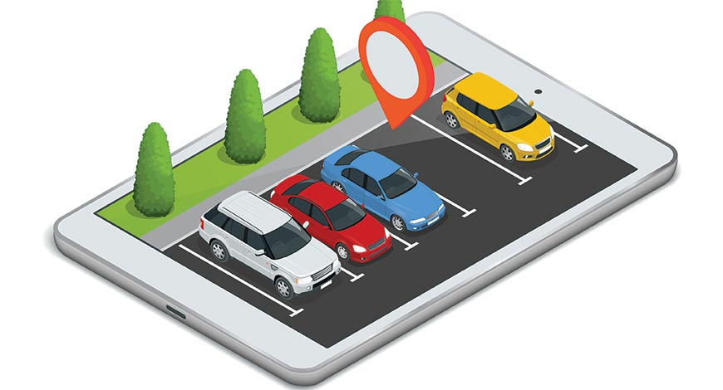

**Hardware, Software and tools used:**

**Hardware:**

* Raspberry-Pi zero
* Ultrasonic sensors
* IR sensors
* Buzzer
* RF Reader
* RF Cards
* LCD display
* UTP cable
* SD Card
* LEDs
* Resistors

**Software:**

* PuTTY
* Win32 Disk Imager
* Raspbian OS with libraries installed
* SD card formatter

**Block diagram & Description:**

The IR detect sensor is used to sense the vehicle near the parking sensor; it is interfaced with Raspberry Pi to know the status of the Slot.  RF reader is connected to the Tx, Rx pin of the Raspberry Pi. An LCD is an electronic display module which uses liquid crystal to produce a visible image. An infrared (IR) sensor is an electronic device that measures and detects infrared radiation in its surrounding environment.

**Results (Model’s image):**

The projection on the screen corresponds to the system model parking slots. This is a real time display regarding the status of the parking lot. As this is a web-based representation, anyone will be able to get the status of the parking lot by visiting the website on the URL through their cell phones, laptops, desktops and other internet supporting devices. The model of the parking lot has two parking slots. Thus, we can park a maximum number of two cars through the system.

When we turn on our project the number of vacant and filled spots is indicated on a display LCD and similarly on the Blynk app. The project also shows the status of the parking zone when a single vehicle is parked in the parking zone. Once when the user enters the parking detection sensor, he would receive a parking slot number on his mobile application where he is supposed to park his vehicle. Upon parking the vehicle in the respective slot and the IR sensor successfully detecting the vehicle it would show a notification on the app; the start time of the vehicle and the slot number in which the vehicle is parked and it would be similarly updated on the LCD.

**Challenges faced:**

* Selecting the title of the project was a tedious and challenging task as we had to research possible industry-related projects and build on them.
* Researching hardware and software libraries pertaining to our project was also a demanding task.
* Since the start of the 3rd semester and our packed schedules, meeting offline has become a herculean task, and hence most of our discussions are held through the online platform.
* A key challenge is ensuring correct information is displayed to the users on the application at all times.

**Conclusion:**

The development of the Internet of Things and Cloud Technology up new opportunities for smart cities. Smart parking has always been the backbone of building smart cities. IoT-based smart parking system offers real-time slots, parking procedures, information and improves users’ ability to save time on proper parking. It helps to solve growing traffic congestion concerns. As for future work, users can book parking in a remote location. GPS, reservations, and license plate scanners can be included in the future.

The built system also gives the requested user online information about the occupancy or vacancy of the parking lot. The future of these kinds of techs is highly growing and these techniques can be utilized in various other fields like hospitals, protected areas, etc.

Smart parking IoT project will help in:

* **The seamless flowing of traffic**

Public transport routes can be adjusted in real-time according to need, and smart traffic lights systems can improve congestion.

* **Energy efficiency can  be improved**

One can easily track down the power consumption & energy consumption by monitoring in real-time.

* **Cities can be made safer**

Cities can use technology to improve residents’ safety and improve response times with the widespread use of Wi-Fi communications and IoT technology.

* **Encouragement of greater citizen engagement**

Citizens can respond to daily problems enabling neighbors to connect and share resources to improve communities and neighborhoods.