- Marketing Channel Performance Analysis

1.Total rows in ad_spend data
select count(*) as Ads_Total_Rows from dbo.ad;
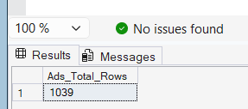
Key finding: The spend table has 1,039 rows of daily ad results, from 1 January to 30 June 2025.

2.Total rows in signups data
select count(*) as signups_total_rows from dbo.signups;
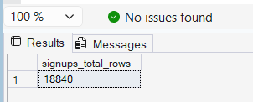
Key finding: The signups table has 18,840 rows. Each row is one new user.

3.Are any rows repeated in the spend table?
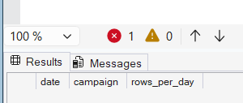
Key finding: The result is empty, so no ad has more than one row on the same day. The spend data has no repeated rows.

4. How much money did each ad spend, and how many views and clicks did it get?
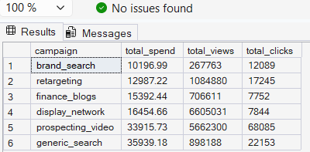
Key finding:
- generic_search spent the most ($35,939), and prospecting_video was next ($33,916).
- brand_search spent the least ($10,197). display_network got the most views (6.6 million) but only 7,844 clicks.

5. Which ads get clicked the most, and which clicks are the cheapest?

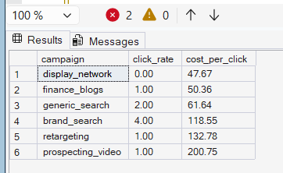
Key finding:
- brand_search has the best click rate: about 4.5 clicks for every 100 views.
- prospecting_video has the cheapest click at about $0.50.
- display_network is the worst: about 0.1 clicks for every 100 views, and the most expensive click at about $2.10.

6. How many signups and paying customers did each ad bring?
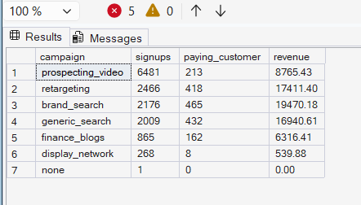
Key finding:
- prospecting_video brought the most signups (6,481), but only 213 of them paid.
- brand_search brought 2,176 signups and 465 paying customers, the most of any ad. display_network brought 268 signups, and only 8 paid.

7. What did one signup and one paying customer cost for each ad, and how much money came back per ₹1 spent?

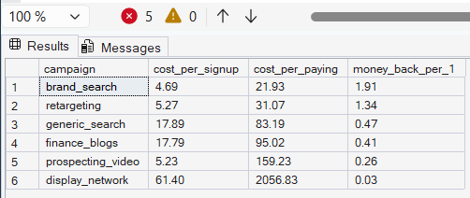

Key finding:
- brand_search is the cheapest way to get a paying customer ($21.93), and it earns back $1.91 for every $1 spent.
- retargeting is second ($31.07, and $1.34 back for every $1).
- These are the only two ads that earned back more than they cost.
- display_network is the worst: $2,056.83 for one paying customer, and only $0.03 back for every $1 spent. (All amounts are in US dollars.)

8. Is the ad with the cheapest signups also the cheapest for paying customers? Rank the ads

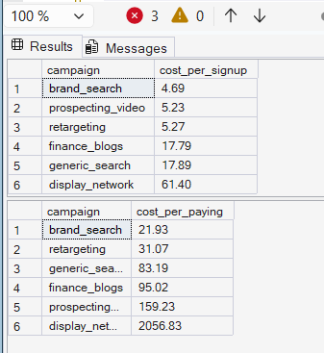
Key finding:
- The two lists are in a different order.
- prospecting_video is 2nd cheapest for signups ($5.23) but 5th for paying customers ($159.23).
- generic_search moves up from 5th to 3rd, and retargeting moves up from 3rd to 2nd. Cheap signups are not the same as cheap paying customers

9. Out of every 100 signups, how many start paying, for each channel (ads, organic, referral)?
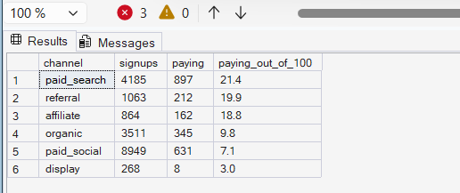

Key finding:
- Out of every 100 signups, 21 from paid_search start paying.
- It is about 20 for referral and 19 for affiliate. organic is 10, paid_social is 7, and display is only 3.
- Search ads and finance blogs bring users who pay as often as free referral users.
- Social and banner ads bring users who pay less often than organic users.

10. Do paying customers pick the monthly or the yearly plan, and which ad brings more yearly customers?

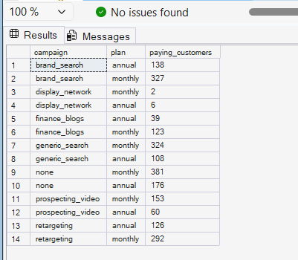
Key finding:
- Most paying customers choose the monthly plan for every ad.
- The share choosing the yearly plan is about 30% for brand_search and retargeting, 28% for prospecting_video, 25% for generic_search and 24% for finance_blogs.
- (The 'none' rows are organic and referral signups. display_network has only 8 paying customers, which is too few to judge.)

12.How did spend change month by month, and did any ad stop?
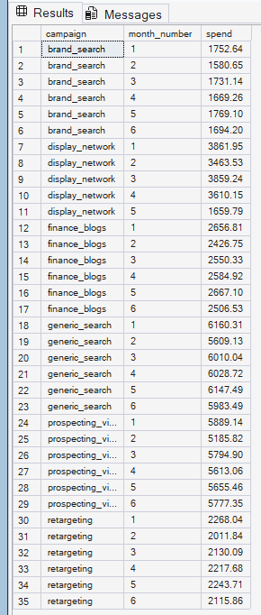
Key finding:
- brand_search, finance_blogs, generic_search, prospecting_video and retargeting spent about the same every month.
- display_network spent about $3,500 to $3,900 a month from January to April, dropped to $1,660 in May, and has no row for June.
- So it stopped after May.

11. How many days do people take to start paying, for each ad?
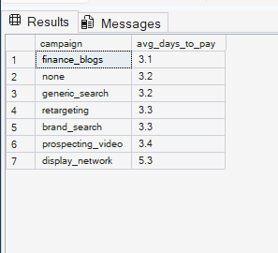
Key finding:
- People take about 3 days to start paying, for every ad (3.1 to 3.4 days).
- display_network is slower at 5.3 days, but it has only 8 paying customers.

13.Did the cost of a paying customer go up or down over the months?
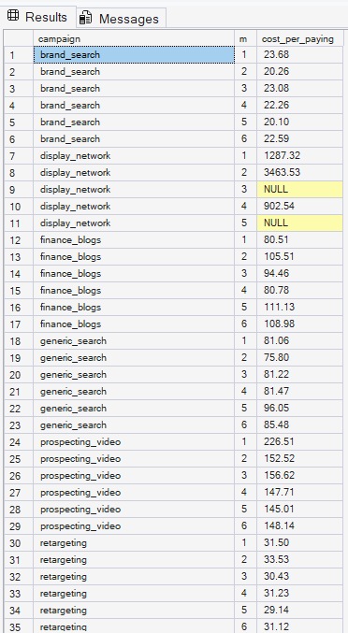
Key finding:
- brand_search stayed cheap and steady ($20 to $24 a month).
- retargeting also stayed steady ($29 to $34). generic_search ranged from $76 to $96 and finance_blogs from $81 to $111, with no clear trend.
- prospecting_video was $227 in January, then about $145 to $157 a month. display_network had no paying customers at all in March and May (NULL).

Recommendation
- Spend more on brand_search and retargeting, and keep generic_search.
- Spend less on prospecting_video, and do not restart display_network.
- Watch the cost when you increase the budget of brand_search and retargeting, because they reach a limited group of people.

