**LAB SESSION 28/07**

* Creating the employee table

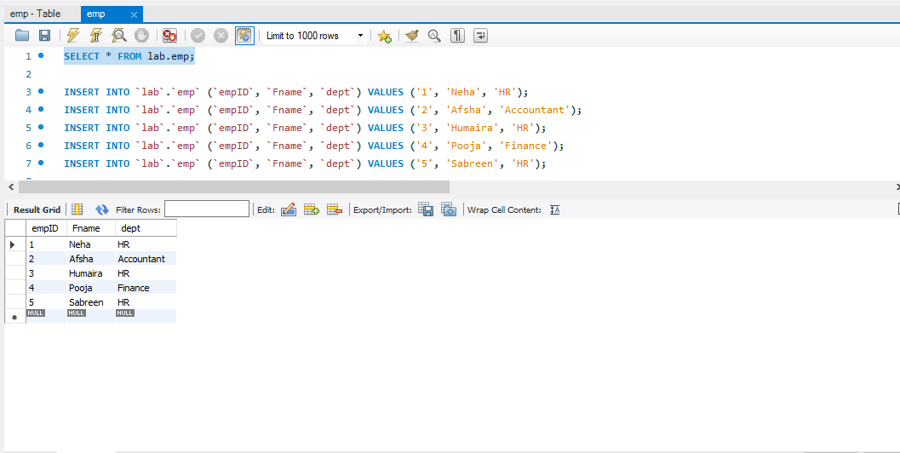

1. **Assume there is an Employee table having multiple data and one the column name is department.**

**Write a query to fetch the number of employees working in the**

**department ‘HR’.**

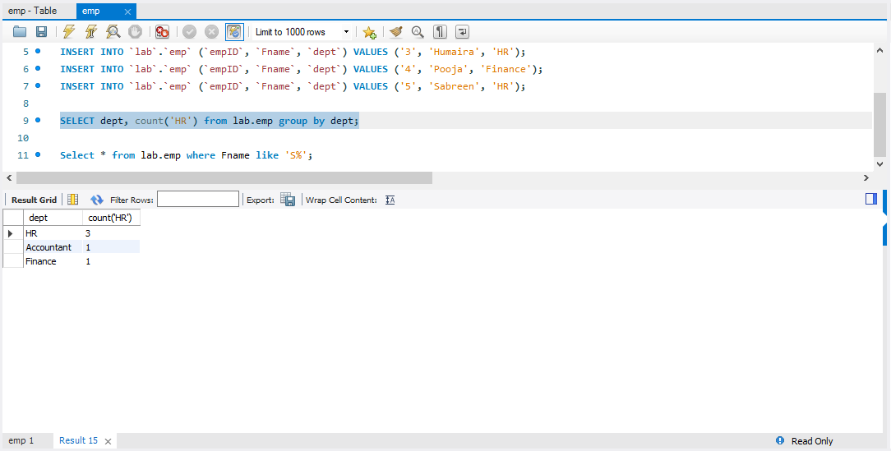

1. **Assume there is an Employee table having multiple data and one the column name is fname.**

**Write a query to find the firstnames of employees that begin with ‘S’.**

