|  |
| --- |
| Name of the Student: Neha Gupta |
| Class and Div and Roll No :TE1/49 |
| Experiment No.2 |
| Aim:Use basic networking commands in Linux (ping, tracert, nslookup, netstat, ARP, RARP, ip, ifconfig, dig, route) |
| Date of Performance: 18-07-2025 |
| Date of Submission: 22-07-2025 |

# Experiment No 2

**Aim: Use basic networking commands in Linux (ping, tracert, nslookup, netstat, ARP, RARP, ip, ifconfig, dig, route)**

**Theory and Output:**

**Ipconfig for windows And ifconfig for linux:**

Displays all current TCP/IP network configuration values and refreshes Dynamic Host Configuration Protocol (DHCP) and Domain Name System (DNS) settings. Used without parameters, ipconfig displays Internet Protocol version 4 (IPv4) and IPv6 addresses, subnet mask, and default gateway for all adapters.

**Output:**

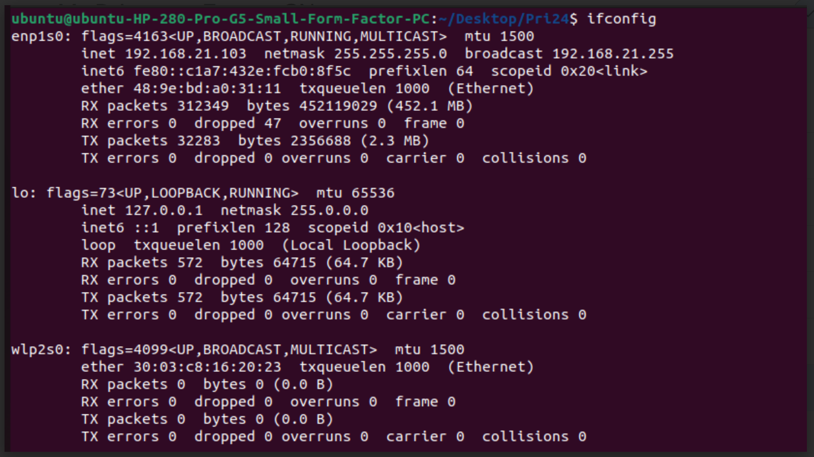

**Ipconfig /all for windows & ip r for linux:**

Displays all configuration information for each adapter bound to TCP/IP.

**Output:**

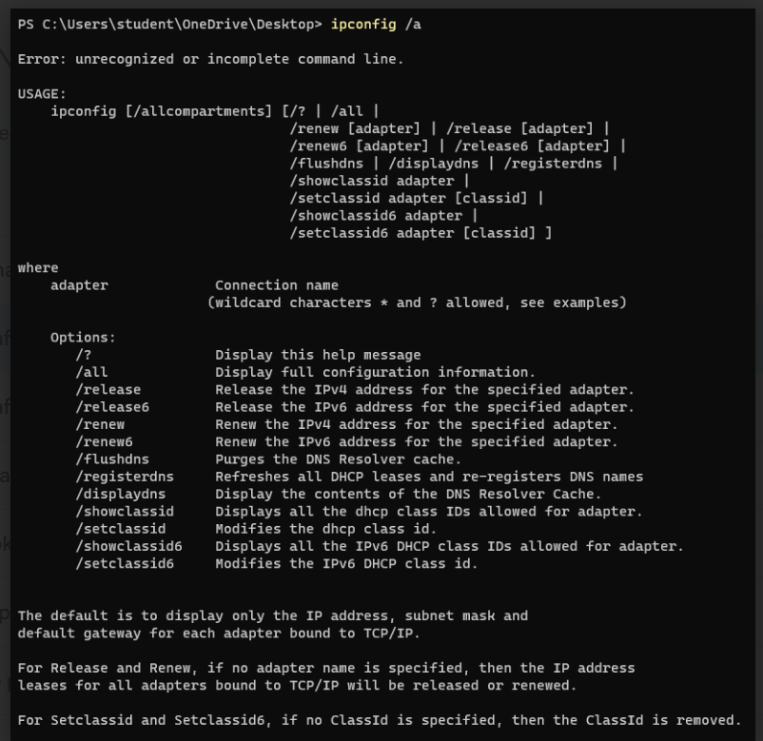

**Ping:**

The ping command is a command-prompt command, used to test the ability of the source computer to reach a specified destination computer.It’s usually used as a simple way to verify that a computer can communicate over the network with another computer or network device.

**Output:**

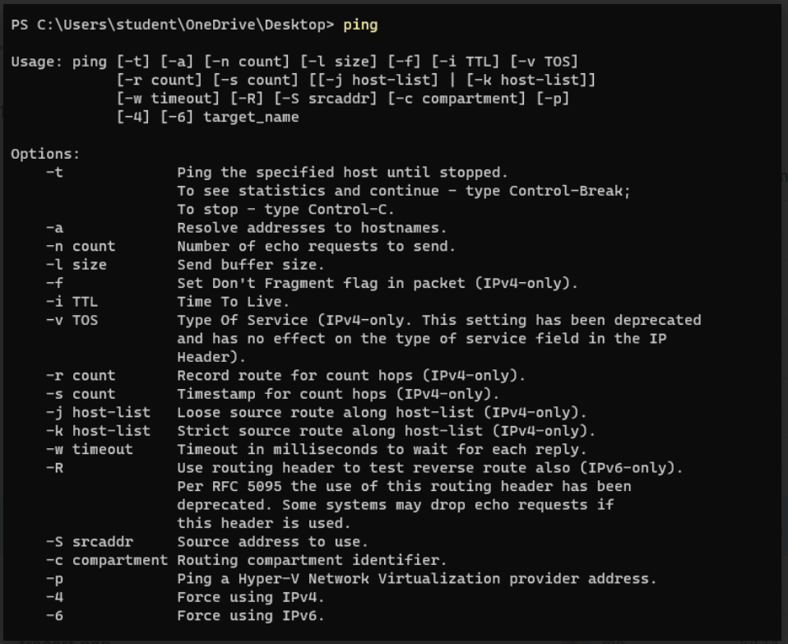

**Tracert for windows & traceroute for linux:**

The tracert command (spelled traceroute in Unix/linux implementations) is one of the key diagnostic tools for TCP/IP. It displays a list of all routers that a packet must go through to get from the computer where tracert is run to any other computer on the internet.

**Output:**

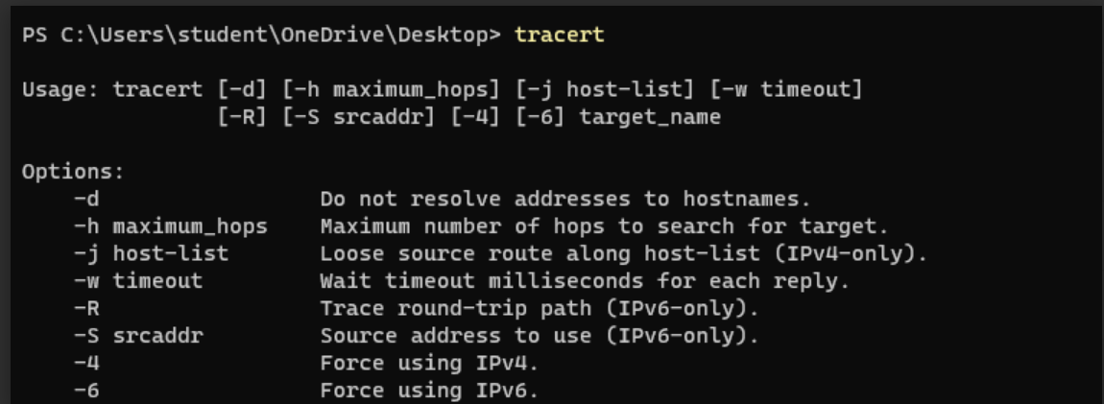

**Nslookup:**

Nslookup(from name server lookup) is a network administration command line tool for querying the domain name system (DNS) to obtain the mapping between domain name and IP address ,or other DNS records.

**Output:**

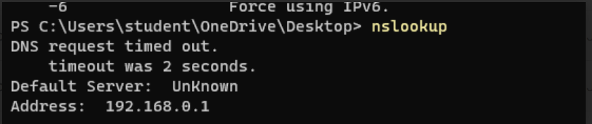

**Hostname:**

A hostname is a label that is assigned to a device connected to a computer network and that is used to identify the device in various forms of electronic communication ,such as the World Wide Web .Hostnames may be simple names consisting of a single word or phrase ,or they may be structured .Each hostname usually has at least one numeric network address associated with it for routing packets for performance and other reasons.

**Output:**

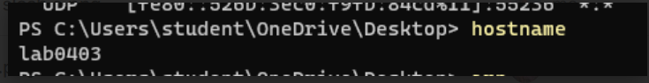

**Arp:**

## Arp command manipulates the System’s ARP cache . It allows a complete dump of the ARP cache

.ARP stands for Address Resolution Protocol.The primary function of this protocol is to resolve the IP address of a system to its mac address, and hence it works between level 2(Data link layer ) and level 3 ( Network layer).

**Output:**

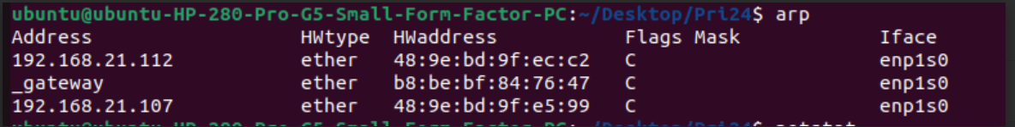

**CONCLUSION:**

We have understood and implemented the functions of all the basic networking commands.

**Questions:**

**1. What does the ping command do?  
Ans:** The ping command is used to test the connectivity between a computer and a remote host by sending ICMP echo requests and measuring the response.

**2. What is the Linux equivalent of tracert in Windows?  
Ans:** The Linux equivalent of the Windows tracert command is traceroute, which traces the path taken by packets to reach a destination.

**3. How is nslookup used in Linux?  
Ans:** The nslookup command in Linux is used to query DNS records and retrieve information such as the IP address of a domain.

**4. What does the netstat command display?  
Ans:** The netstat command displays active network connections, open ports, routing tables, and protocol statistics on a system.

**5. What is the function of the arp command?  
Ans:** The arp command is used to display or modify the Address Resolution Protocol (ARP) table, which stores the mapping between IP addresses and MAC addresses.