|  |
| --- |
| Name of the Student: Neha Gupta |
| Class and Div and Roll No :TE1/49 |
| Experiment No.3 |
| Aim: Build a simple network topology and configure it for static routing protocol using packet tracer. Setup a network and configure IP addressing, subnetting, masking |
| Date of Performance: 22-07-2025 |
| Date of Submission: 29-07-2025 |

Experiment No 3

**Aim: Build a simple network topology and configure it for static routing protocol using packet tracer. Setup a network and configure IP addressing, subnetting, masking Theory:**

**Static routing** is a form of routing that occurs when a router uses a manually-configured routing entry, rather than information from a dynamic routing protocol to forward traffic. In many cases, static routes are usually manually configured by a network administrator by adding in entries into a routing table, though this may not always be the case. Unlike dynamic routing, static routes are fixed and do not change if the network is changed or reconfigured. Static routing and dynamic routing are not mutually exclusive. Both dynamic routing and static routing are usually used on a router to maximize routing efficiency and to provide backups in the event that dynamic routing information fails to be exchanged. Static routing can also be used in stub networks, or to provide a gateway Static routing. **Network topologies** describe the methods in which all the elements of a network are mapped. The topology term refers to both the physical and logical layout of a network. Two main types of network topologies in computer networks are

1. **Physical topology :** This type of network is an actual layout of the computer cables and other network devices.
2. **Logical topology :** Logical topology gives insight's about a network's physical design.

**Different types of Physical Topologies are:** P2P Topology, Bus Topology, Ring Topology, Star Topology, Tree Topology, Mesh Topology, Hybrid Topology.

* **Ping** - Ping is a command-line utility, available on virtually any operating system with network connectivity, that acts as a test to see if a networked device is reachable.The ping command sends a request over the network to a specific device. A successful ping results in a response from the computer that was pinged back to the originating computer.

**Syntax:** ping (ip address of other device)

* **Ifconfig (logical connection)-** command is used to configure the kernel-resident network nterfaces. It is used at the boot time to set up the interfaces as necessary. After that, it is usually used when needed during debugging or when you need system tuning. Also, this command is used to assign the IP address and netmask to an interface or to enable or disable a given interface.

**Syntax:** ifconfig

* **ipconfig /all (physical connection):** Displays all current TCP/IP network configuration values and refreshes Dynamic Host Configuration Protocol (DHCP) and Domain Name System (DNS) settings. Used without parameters, ipconfig displays Internet Protocol version 4 (IPv4) and IPv6 addresses, subnet mask, and default gateway for all adapters.

**Syntax:** ipconfig /all

**Procedure:**

1. Create a simple network topology in Cisco Packet Tracer using two or more routers, PCs, and switches.
2. Assign appropriate IP addresses and subnet masks to all devices.
3. Configure static routes on each router by manually entering the routing table entries.
4. Verify IP addressing using the ifconfig or ipconfig command on end devices.
5. Test connectivity by using the ping command between end devices in different networks.
6. Observe successful replies to confirm that static routing is working.

**Output:**

* **Star topology:**

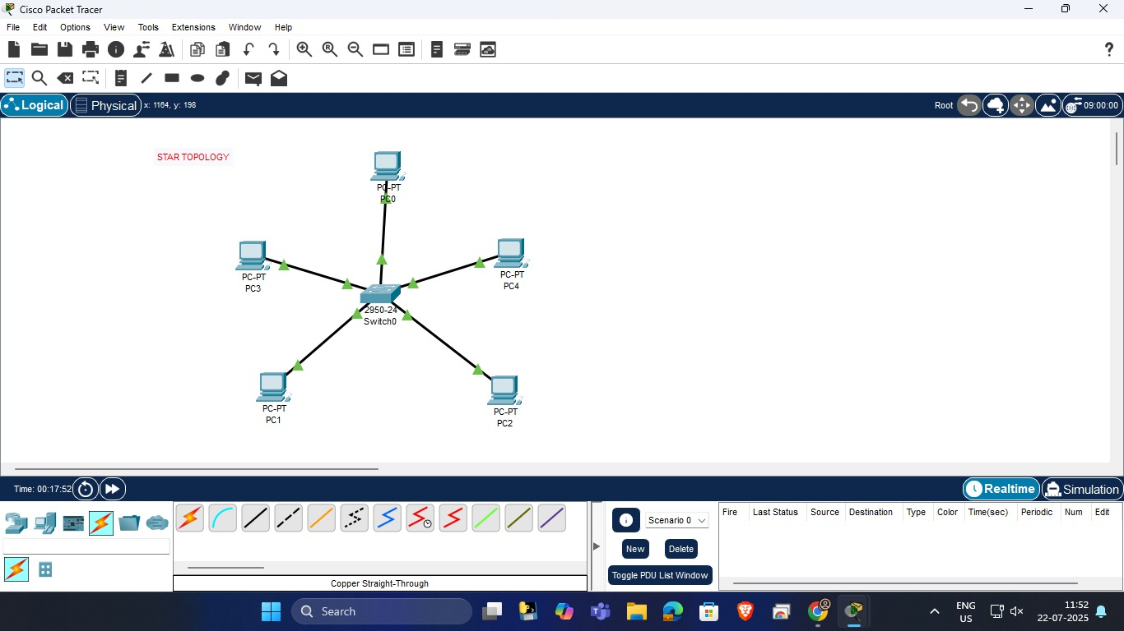

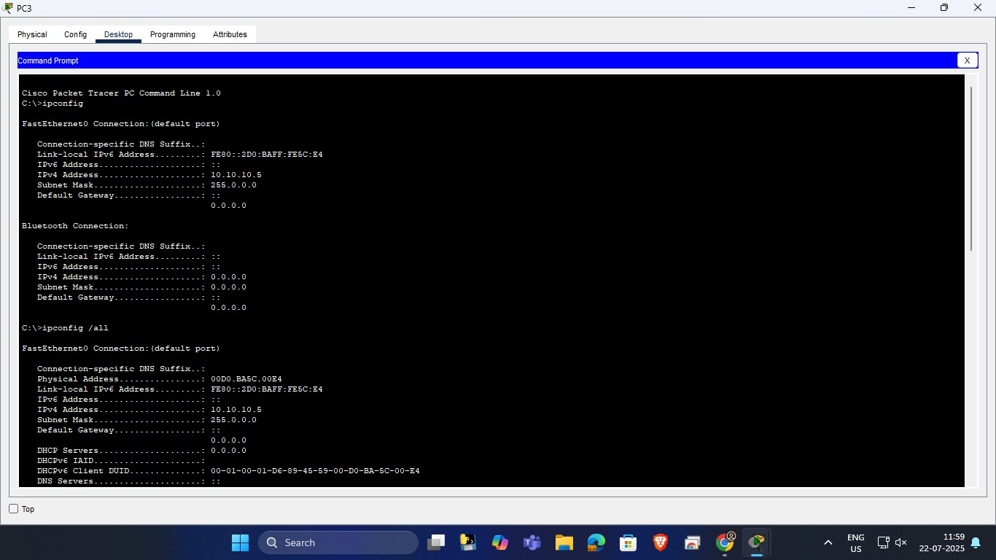

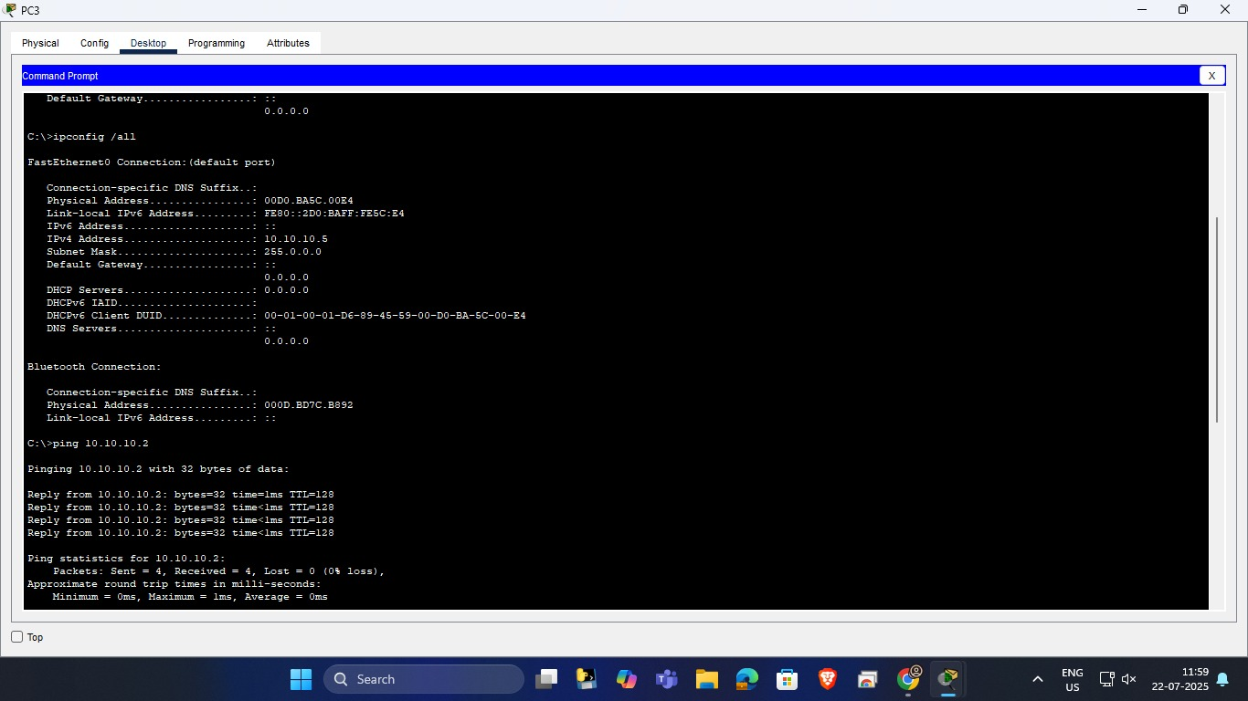

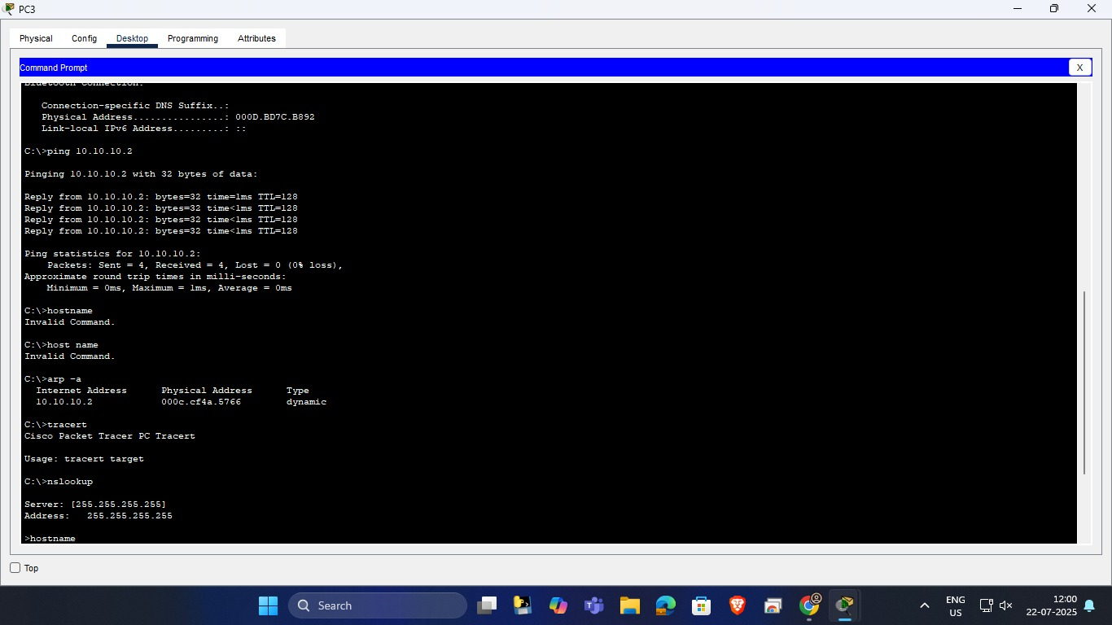

* **Bus topology:**

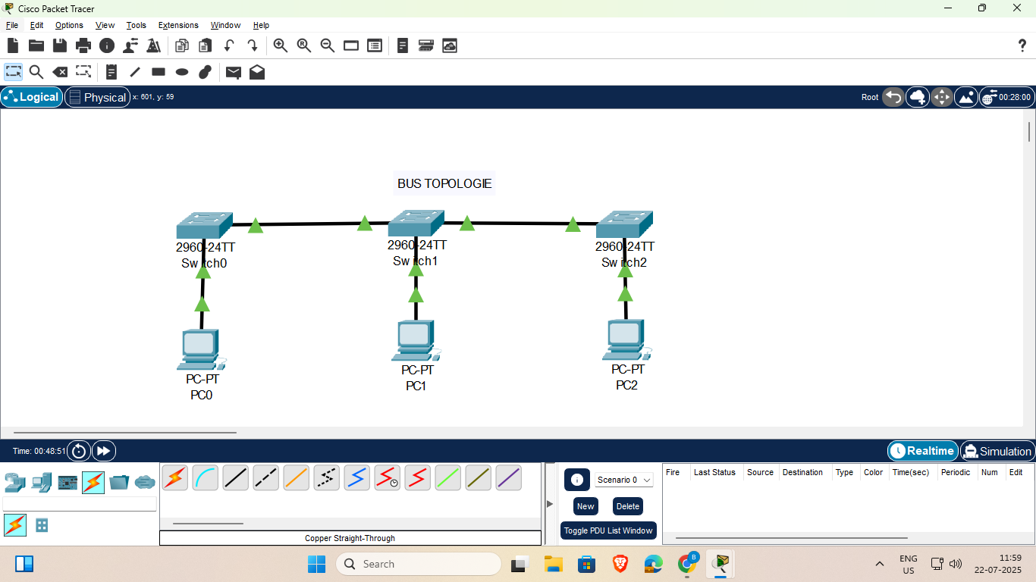

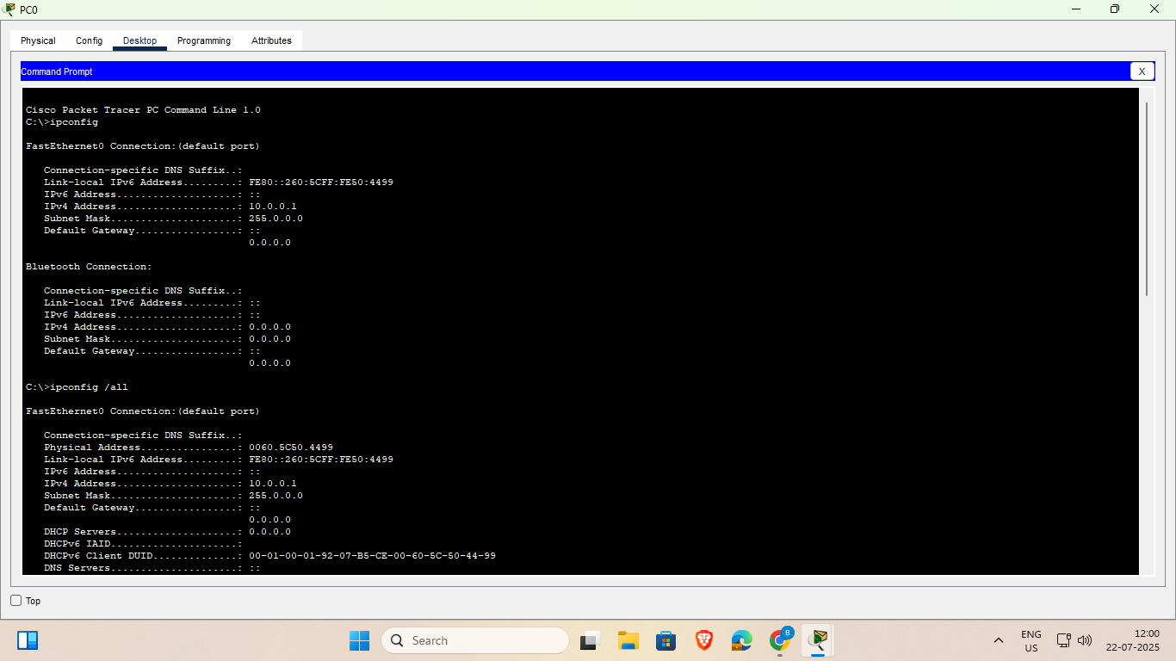

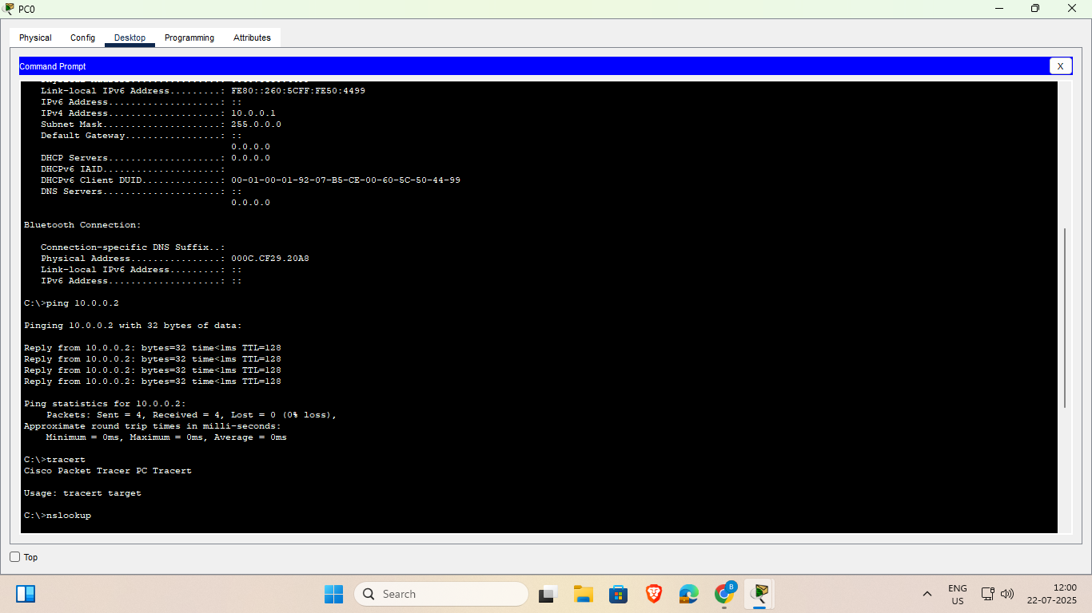

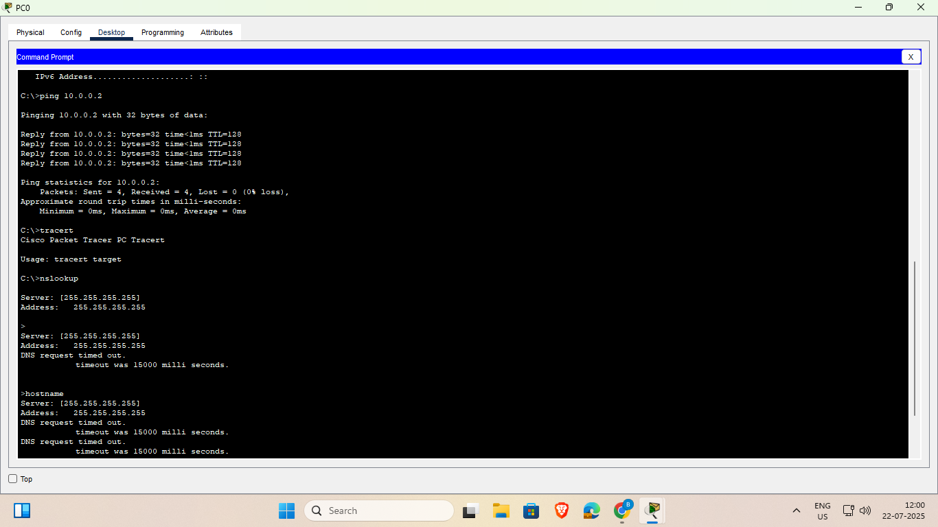

* **Ring Topology:**

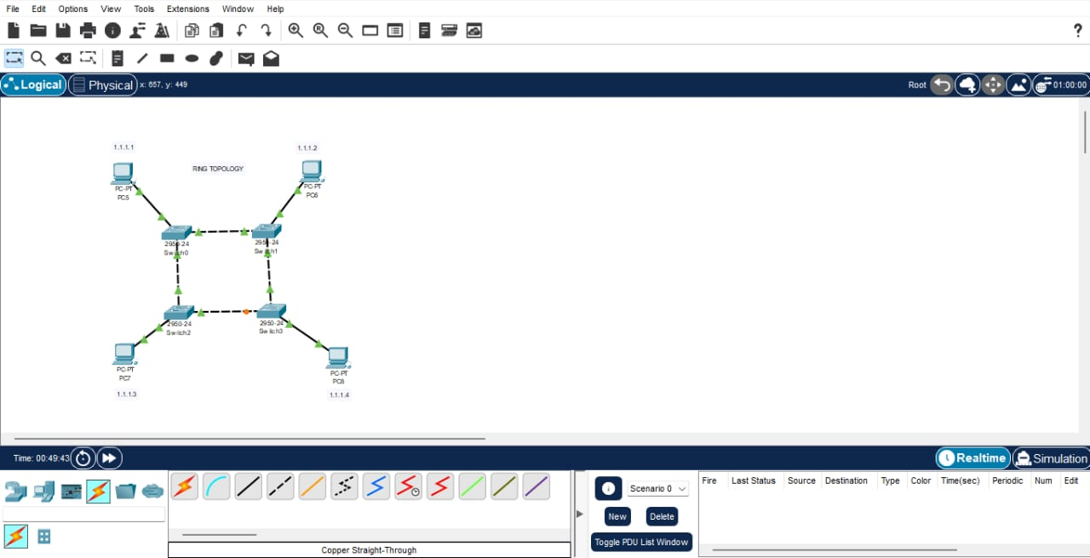

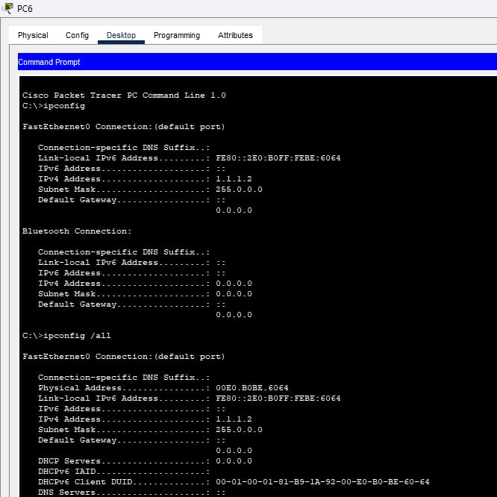

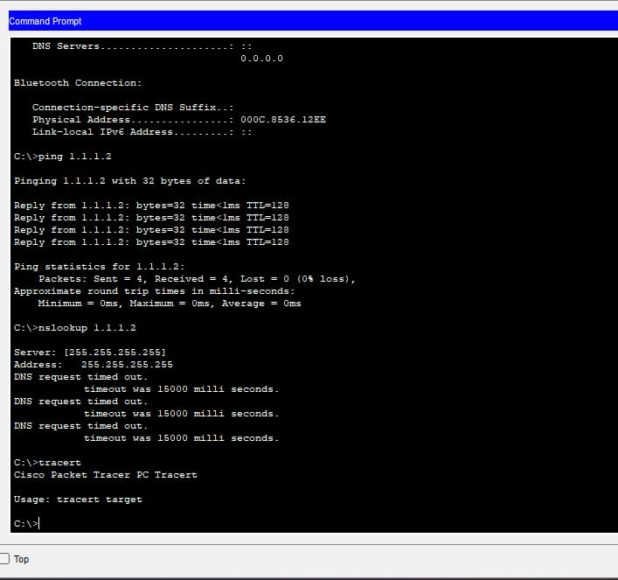

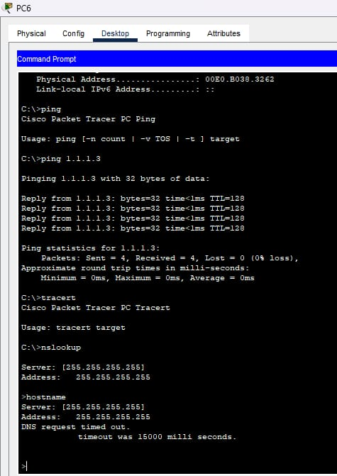

* **Hybrid Topology:**

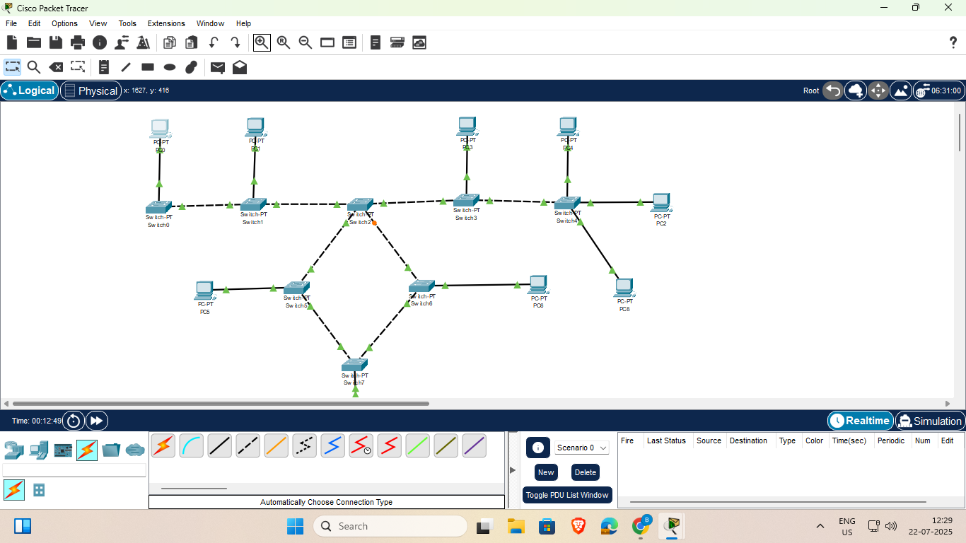

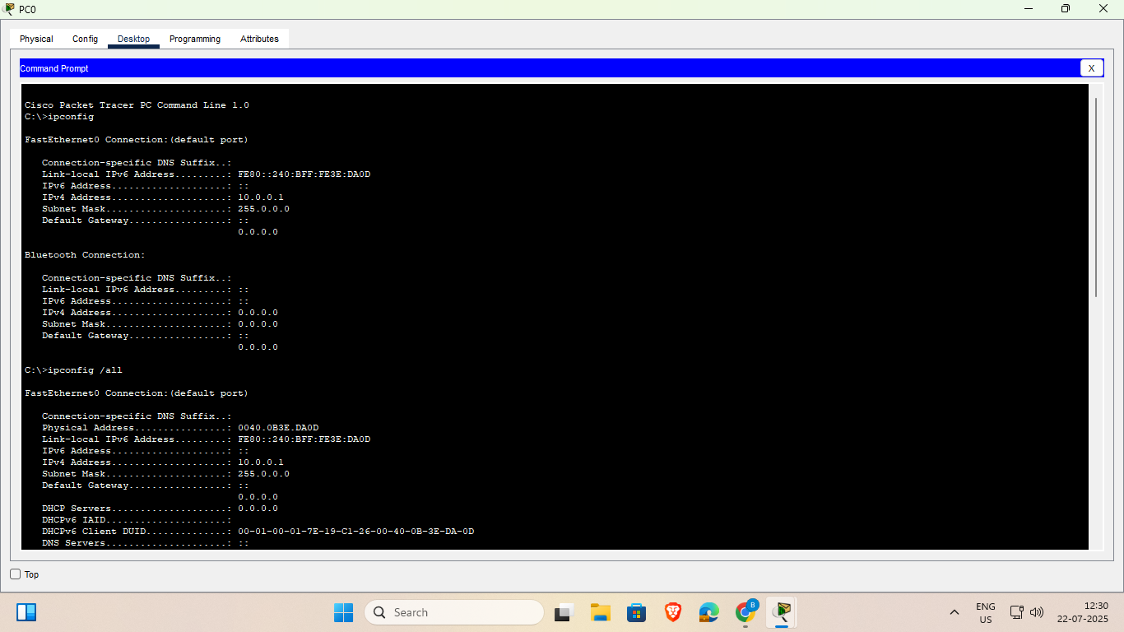





**Conclusion:**

From the above experiment, we conclude that to implement the simple topology network and

configure it for static routing protocol using packet tracer.

**Questions:**

**1. What is static routing?  
Ans:** Static routing is a method in which network routes are manually configured on a router by the network administrator, instead of being learned automatically.

**2. How can you test if static routing is working in Packet Tracer?  
Ans:** In Packet Tracer, static routing can be tested by using the ping command between devices to check if packets successfully reach their destination.

**3. Can a router forward packets between two interfaces in the same network?  
Ans:** No, a router cannot forward packets between two interfaces that belong to the same network.

**4. What is meant by “network topology” in networking?  
Ans:** Network topology refers to the physical or logical arrangement of computers, cables, and other devices in a network.

**5. Name any three types of physical network topologies.  
Ans:** Three types of physical network topologies are Bus, Star, and Ring.

**6. Which topology is most used in modern LANs? Why?  
Ans:** The Star topology is most commonly used in modern LANs because it is easy to manage, scalable, and faults can be quickly isolated without affecting the entire network.

**7. What is a hybrid topology?  
Ans**: A hybrid topology is a network design that combines two or more different types of topologies, such as star-bus or star-ring, to take advantage of their strengths.