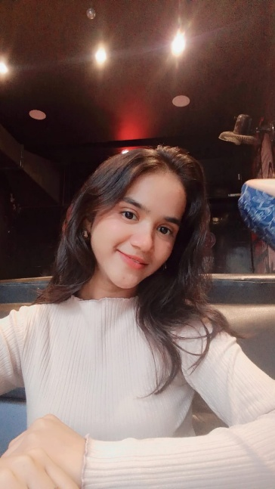**INTRODUCTION**

* Name – Neha Rampyare Gupta
* Meaning of name – Love
* Current Location – Bhayander east
* SSC Score – 93%
* HSC Score – 79.50%
* CET Score – 93 percentile
* Hobbies – Gardening, listening to music and walking and staying in nature
* Skills -

1. Technical skills: Frontend (Html, css ,Javascript)
2. Soft skill: Teamwork, time management and quick learning.

* Achievements –

1. Completed certification courses
2. Built 5+ frontend projects like To-Do App, Weather App, Clock App, etc.

* Internship details - **Prodigy Infotech** (Remote) — *[June, 2025]*
  + 1. Completed a 1-month virtual internship focused on frontend development
    2. Built responsive web pages using **HTML**, **CSS**, and **JavaScript**
* Goal - “My goal in life is to become a confident full stack developer, create innovative solutions, and live a balanced life with continuous learning and self-growth.”
* Expectation from PCE - I expect the Professional Communication subject to help me improve my speaking, writing, and interpersonal skills for both academic and workplace success.
* Suggestion for PCE - More interactive sessions, group activities, and real-life communication practice should be included to make the subject more engaging and useful.