

**Basic Linux Commands Assignments**

**Assignment-1**

Connect and disconnect with login Access

* What happens when you login a non-existent users or username?

Provide Screenshot and What you understand, explain in short brief?

**Ans:**

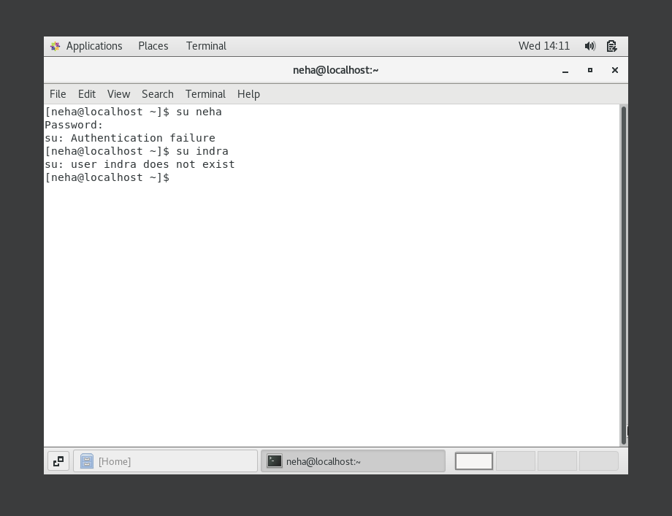

When we try to login with non-existent username then “user _name does not exist” error comes.

**Assignment-2**

Password changing

Login into your account and then change password?

Change your password into **IneuR0n#42** and hit the **Enter** key

Explain what happen and give screenshot?

**Ans:** To changes password we use command “Sudo passwd *user_name”.* Then it ask of user password. Then Asking for new password, and Re-Enter new password.

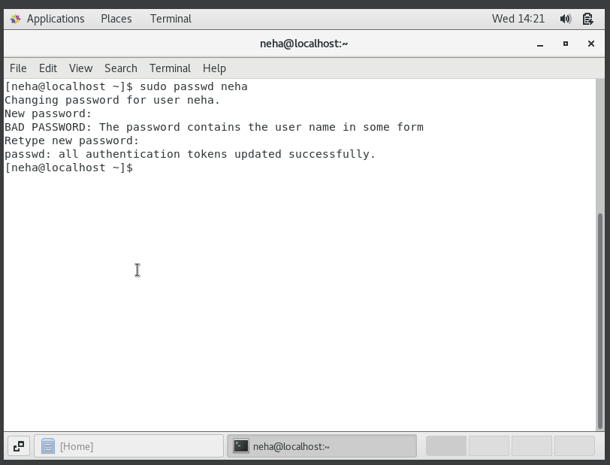

* + Try again to change password but use like password ***1234*** or ***abcd***
    - Explain what happen and give screenshot?

**Ans:**

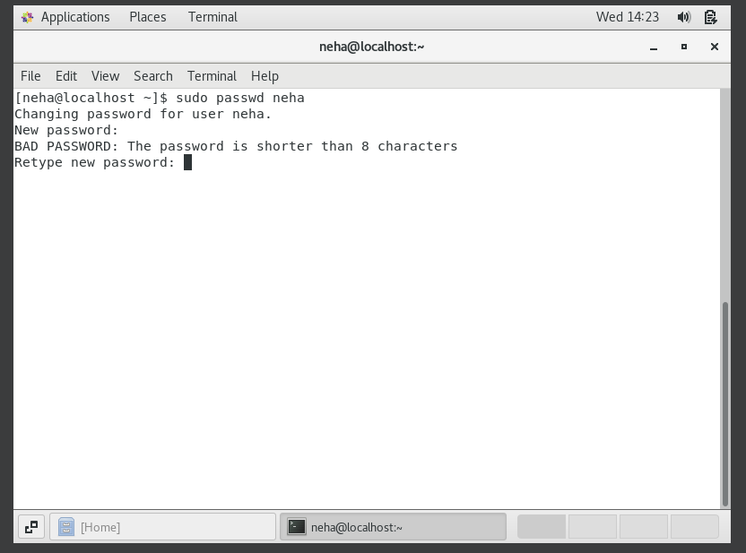

It shows password is shorter than 8 characters.

* + Try again to change password but now don’t use any password just hit **Enter** key
    - Explain what happen and give screenshot?

**Ans:**

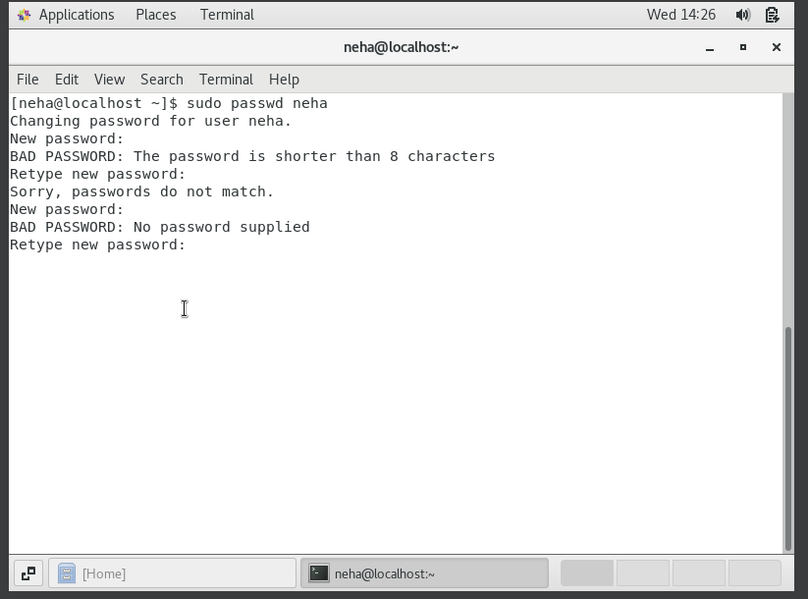

**Assignment-3**

Working with Directories

* Enter the command **cd /** and then **ls** and then hit **Enter** key
  + Take screenshot and explain what output we got?

**Ans:**

* + 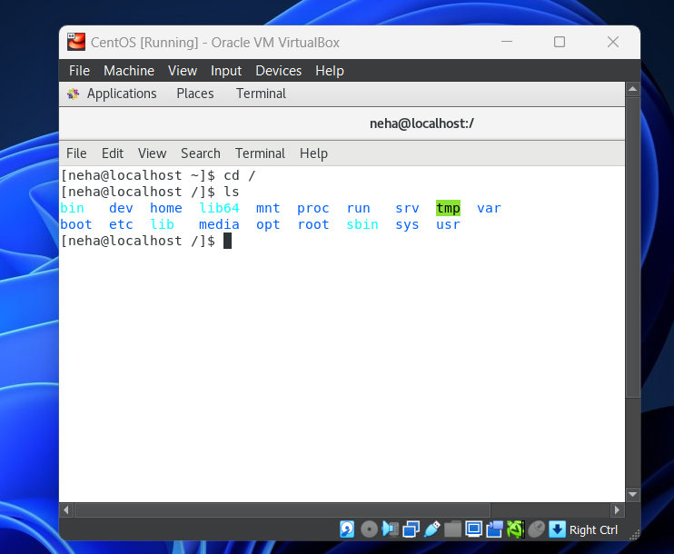

To navigate the root directory.

* Enter the command now **cd /home** and then hit **Enter** key
  + Do **ls,** provide screenshot and explain what is **/home** directory used for?

**Ans:**

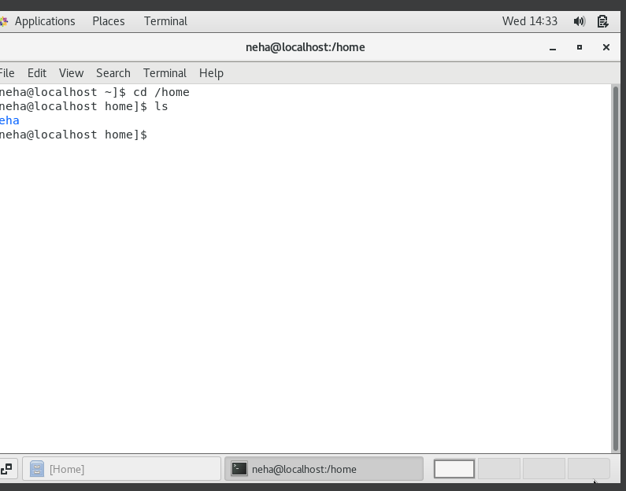

In /home directory ,all users root directory

* Enter **cd ..** and hit **Enter** key [ *Note: here we have space after cd then use double dot*]
  + Check what happen and give screenshot?

**Ans:**

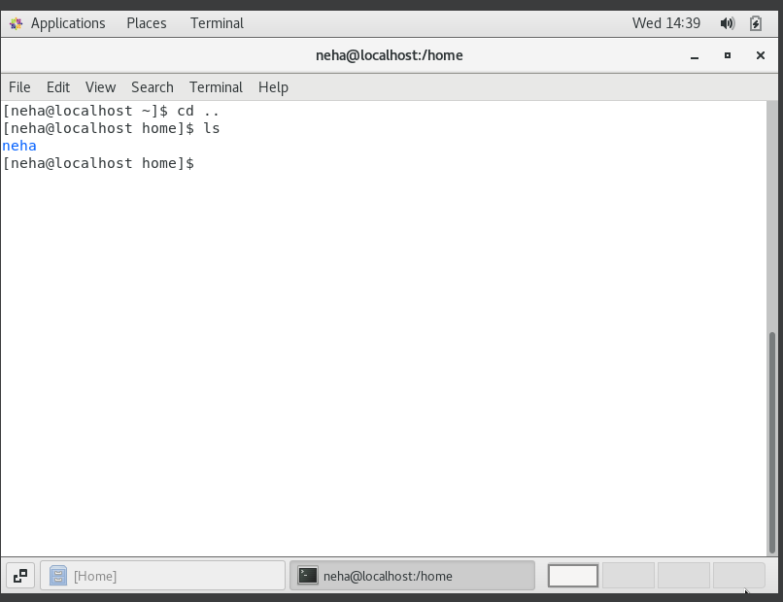

When enter **“cd .. “** command used for go to one directory back.

* Now enter **cd /var/www/html** and then type **cd** and hit **Enter** key
  + Explain what happen and give screenshot?

**Ans:**

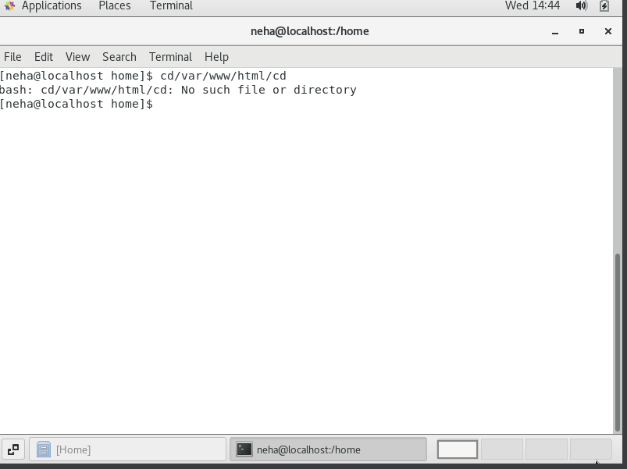

* Now type **cd /root** and then hit **Enter** key
  + Do **ls,** check any output we have on screen if yes then take screenshot?

**Ans:**

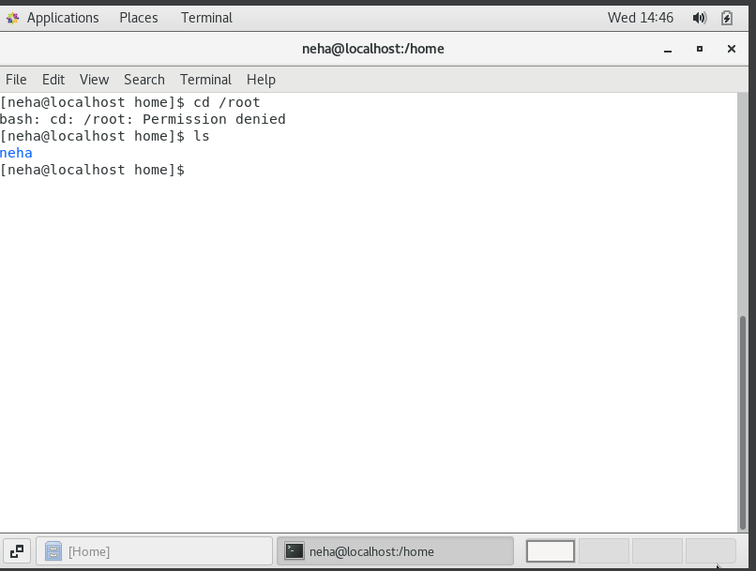

**SAssignment-4**

Working with File Listing

* Go to **cd /etc** and type **ls**
  + Take screenshot and explain what files you have seeing?

**Ans:**

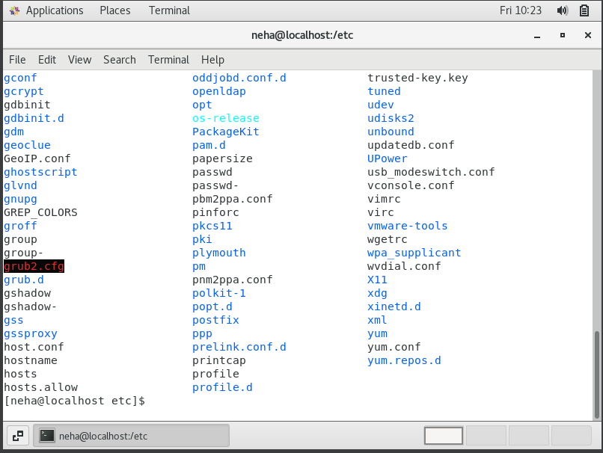

* + Take screenshot and explain what different output you found compare to previous command you used?

**Ans:**

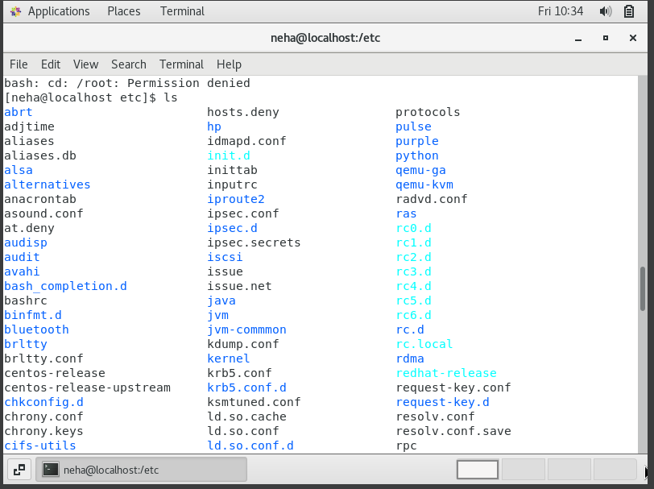

* Then type **ls -al** and hit **Enter** key
  + Take screenshot and explain what new file or directory you found?

**Ans:**

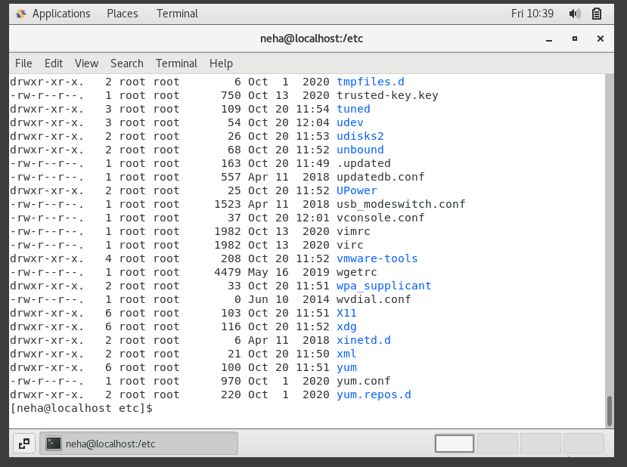

* Then use **ls -i** and hit **Enter** key
  + Now see what different output its shows and take screenshot?

**Ans:**

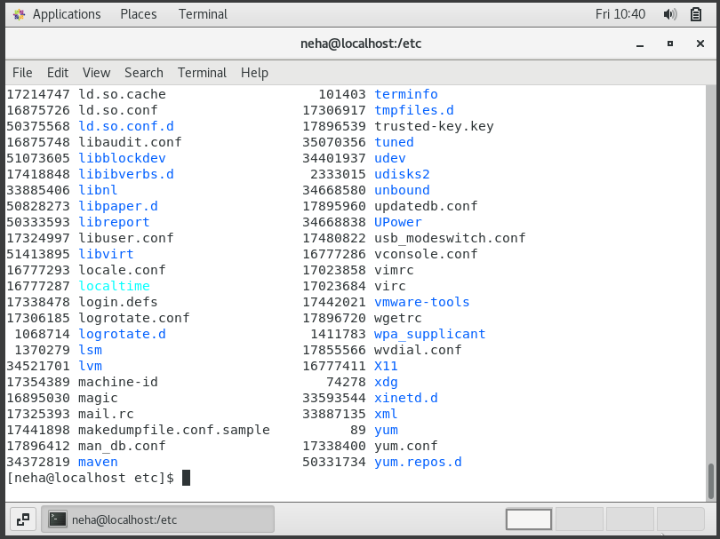

* Then use **ls –help** and see other options about **ls** command
  + Explore it and try with other attribute we can use with **ls** command

**Ans:**

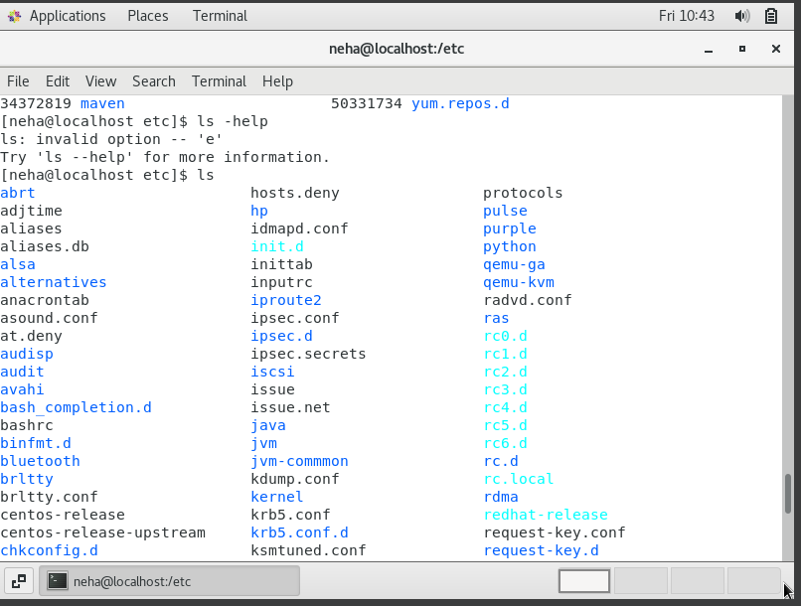

**Assignment-5**

Know where you are and where you working

*Here we use* ***pwd, cd and ls*** *as combine task to understand where you working on terminal and how you can switch from one directory to another one.*

* Open terminal after restart the linux
  + Check which location you working, type **pwd** and take screenshot

**Ans:**

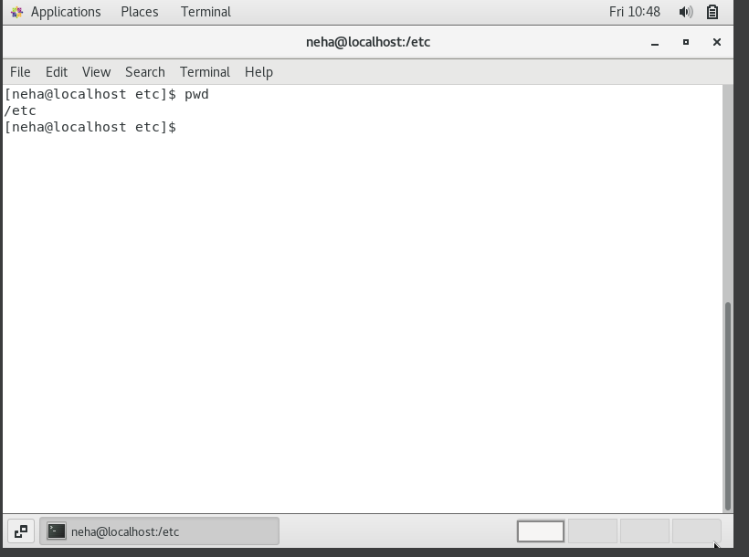

* Now use **cd /var** and hit **Enter** key
  + Do **ls,** and see what output comes, give screenshot?

**Ans:**

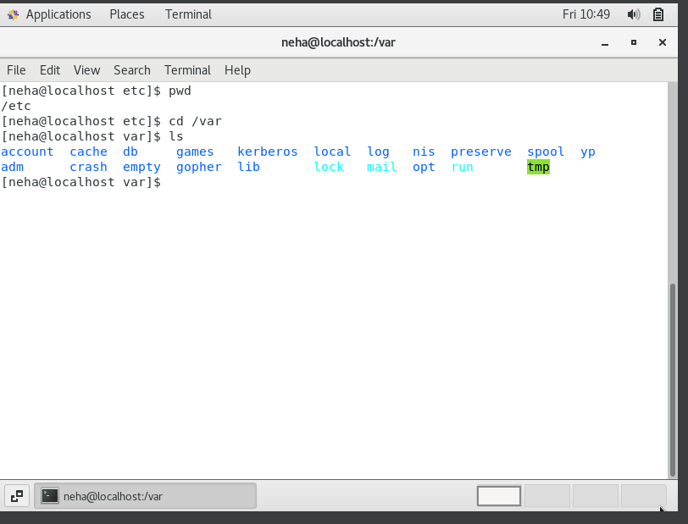

* Do explore other help options of each command to learn more other things we can do with these commands