PROJECT REPORT ON
“TASKFLOW - Team Task Management Portal”

Submitted to DR. Manmohan Singh Bengaluru City University

In Partial Fulfilment for the Award of B.C.A Degree By
NEHA S
(U18GG23S0096)
SHAMBHAVI L
(U18GG23S0080)
SANJAY B
(U18GG23S0261)

Under the guidance of
Assoc. Prof Amitha K N

Department of Computer Science
Seshadripuram First Grade College
Yelahanka New Town, Bengaluru

C.A., Site No.26, SH 9, Yelahanka New Town, Bengaluru,
Karnataka 560064


Seshadripuram First Grade College
Yelahanka New Town Bengaluru 560064
Permanently affiliated to Dr. Manmohan Singh Bengaluru City University and recognized by UGC under 2(f) &12(B) NAAC accredited A⁺ Grade. ISO Certified 9001:2015, AICTE approved Institution

COLLEGE CERTIFICATE

This is to certify that this Project report on TaskFlow-Team Task Management Portal is carried out by NEHA S, Student of VI Semester B.C.A. bearing Reg No. U18GG23S0096 has successfully completed.
The Project report is submitted to the Dr. Manmohan Singh Bengaluru City University in the Academic Year 2025-26, in partial fulfilment of successful completion of VI semester B.C.A and award of Bachelor of Computer Application Degree of Dr. Manmohan Singh Bengaluru City University.

Dr. S N VENKATESH | PROF REKHA RAICHAL | ASSOC.PROF AMITHA K N
[Principal] | [Head of Department] | [Guide]


Seshadripuram First Grade College
Yelahanka New Town Bengaluru 560064
Permanently affiliated to Dr. Manmohan Singh Bengaluru City University and recognized by UGC under 2(f) &12(B) NAAC accredited A⁺ Grade. ISO Certified 9001:2015, AICTE approved Institution

COLLEGE CERTIFICATE

This is to certify that this Project report on TaskFlow-Team Task Management Portal is carried out by SHAMBHAVI L, Student of VI Semester B.C.A. bearing Reg No. U18GG23S0080 has successfully completed.
The Project report is submitted to the Dr. Manmohan Singh Bengaluru City University in the Academic Year 2025-26, in partial fulfilment of successful completion of VI semester B.C.A and award of Bachelor of Computer Application Degree of Dr. Manmohan Singh Bengaluru City University.

Dr. S N VENKATESH | PROF REKHA RAICHAL | ASSOC.PROF AMITHA K N
[Principal] | [Head of Department] | [Guide]

Seshadripuram First Grade College
Yelahanka New Town Bengaluru 560064
Permanently affiliated to Dr. Manmohan Singh Bengaluru City University and recognized by UGC under 2(f) &12(B) NAAC accredited A⁺ Grade. ISO Certified 9001:2015, AICTE approved Institution

COLLEGE CERTIFICATE

This is to certify that this Project report on TaskFlow-Team Task Management Portal is carried out by SANJAY B, Student of VI Semester B.C.A. bearing Reg No. U18GG23S0261 has successfully completed.
The Project report is submitted to the Dr. Manmohan Singh Bengaluru City University in the Academic Year 2025-26, in partial fulfilment of successful completion of VI semester B.C.A and award of Bachelor of Computer Application Degree of Dr. Manmohan Singh Bengaluru City University.

Dr. S N VENKATESH | PROF REKHA RAICHAL | ASSOC.PROF AMITHA K N
[Principal] | [Head of Department] | [Guide]

DECLARATION BY STUDENT

I hereby declare that this Project report on “TaskFlow-Team Task Management Portal” is a combined teamwork done by me under the guidance of Assoc. Prof Amitha K N, and no part of it has been submitted for many other degree purpose or published in any other from till date is being submitted in partial fulfilment after requirements for completion of VI semester course work in the program of study BCA.
All corrections/selections indicated for internal assessment have been incorporated in the report. The plagiarism check has been done for the report and below the given threshold.

Place: BENGALURU
Date:

Name and Signature of the candidate:
NEHA S
DECLARATION BY STUDENT

I hereby declare that this Project report on “TaskFlow-Team Task Management Portal” is a combined teamwork done by me under the guidance of Assoc. Prof Amitha K N, and no part of it has been submitted for many other degree purpose or published in any other from till date is being submitted in partial fulfilment after requirements for completion of VI semester course work in the program of study BCA.
All corrections/selections indicated for internal assessment have been incorporated in the report. The plagiarism check has been done for the report and below the given threshold.

Place: BENGALURU
Date:

Name and Signature of the candidate:
SHAMBHAVI L

DECLARATION BY STUDENT

I hereby declare that this Project report on “TaskFlow-Team Task Management Portal” is a combined teamwork done by me under the guidance of Assoc. Prof Amitha K N, and no part of it has been submitted for many other degree purpose or published in any other from till date is being submitted in partial fulfilment after requirements for completion of VI semester course work in the program of study BCA.
All corrections/selections indicated for internal assessment have been incorporated in the report. The plagiarism check has been done for the report and below the given threshold.

Place: BENGALURU
Date:

Name and Signature of the candidate:
SANJAY B

ACKNOWLEDGEMENT

We would like to dutifully express our sincere thanks to Dr. S N Venkatesh, Principal of SESHADRIPURAM FIRST GRADE COLLEGE for the generous support and help. We express our sincere thanks to Assoc.Prof Mrs. Rekha Raichal, and HOD of Computer Science Department for the recurring support.

We consider this as a privilege to express our gratitude to esteemed guide Prof. Amitha K N and our sincere thanks to all teaching and non-teaching staff of department without whom this project could never be a success, and for creating friendly ambience in laboratory. We are also very grateful to our parents and friends for that valuable encouragement throughout the project.

The organizational study was carried out by us, in partial fulfilment for the successful completion of VI semester B.C.A of Bengaluru City University. This report is not submitted to any other university for the award of any Degree.

NEHA S
SHAMBHAVI L
SANJAY B

PROJECT REPORT ON
TASKFLOW – TEAM TASK MANAGEMENT PORTAL

INDEX

SL.NO | CONTENTS | PAGE NO
1 | Introduction | 1
2 | Project Overview | 2-4
3 | System Study | 5
4 | Objectives of the Project | 6-7
5 | Feasibility study and System Requirements | 8
6 | System Design | 9-11
7 | ER Diagram | 12-16
8 | Use Case Diagram | 17-21
9 | Data Flow Diagram (DFD) | 22-27
10 | Flowchart | 28-33
11 | Coding Implementation | 34-38
12 | Database Tables | 39-41
13 | Testing | 42-45
14 | Output Screens | 46-53
15 | Future Enhancements | 54
16 | Conclusion | 55
17 | Bibliography | 56-57

ABSTRACT
The TaskFlow – Team Task Management Portal is a web-based application developed to simplify task organization, project monitoring, and team collaboration within organizations and academic environments. In many workplaces and student project teams, managing tasks manually often leads to communication gaps, missed deadlines, lack of transparency, and reduced productivity. Traditional methods such as maintaining records through spreadsheets or paper-based tracking systems are inefficient and difficult to manage when multiple users are involved. This project aims to provide a centralized, efficient, and user-friendly platform for managing projects and team activities digitally.
The system allows administrators or team leaders to create projects, assign tasks to team members, monitor task progress, and manage deadlines effectively. Team members can log in to the portal, view assigned tasks, update task status, submit work updates, and communicate progress in real time. The portal improves coordination among team members and ensures that project activities are organized systematically. Additionally, the system generates progress reports and provides dashboard-based monitoring for better project management and performance tracking.
From a technical perspective, the system is developed using modern web technologies to ensure responsiveness, accessibility, and efficiency. The frontend is implemented using HTML, CSS, Bootstrap, and JavaScript to provide an interactive and user-friendly interface. The backend is developed using Python with the Flask framework to handle server-side operations, authentication, and task processing. A MySQL database is used to securely store user information, project details, task records, and progress updates. The modular architecture of the system allows future enhancements such as notification systems, file sharing, calendar integration, and mobile support.

CHAPTER 1
INTRODUCTION
In today’s digital era, organizations, educational institutions, and business teams increasingly depend on technology to improve productivity, communication, and task management. Managing projects and tasks manually often creates difficulties such as lack of coordination, missed deadlines, improper communication, and inefficient monitoring of work progress. Traditional methods like maintaining records in notebooks, spreadsheets, or paper-based systems are time-consuming and difficult to manage when multiple users are involved.
The TaskFlow – Team Task Management Portal is a web-based application developed to simplify project handling, task assignment, and team collaboration through an organized digital platform. The system enables administrators or team leaders to create projects, assign tasks to team members, monitor work progress, and manage deadlines effectively. Team members can log in to the system, view assigned tasks, update task status, and communicate their progress in real time.
The proposed system is designed with a user-friendly interface that allows easy access to all functionalities. It helps teams organize their workflow systematically and ensures that project activities are completed within the specified time. The portal also provides dashboard-based monitoring and reporting features that help administrators track overall project performance and team productivity efficiently.
The TaskFlow portal is developed using modern web technologies such as HTML, CSS, Bootstrap, and JavaScript for the frontend, while Python with the Flask framework is used for backend development. MySQL is used as the database to securely store user details, project information, task records, and progress updates. The system is designed to be scalable, secure, and efficient, making it suitable for academic institutions, startups, offices, and small organizations.
This project demonstrates the practical implementation of web development concepts, database management, and client-server architecture while providing a real-world solution for task and project management.

CHAPTER 2
PROJECT OVERVIEW
Overview of the Project
The TaskFlow – Team Task Management Portal is a web-based application designed to simplify project handling, task assignment, and team collaboration through a centralized digital platform. The system helps organizations, colleges, and project teams manage their work efficiently and systematically.
Purpose of the Project
The main purpose of this project is to:
- Improve team collaboration and communication
- Simplify task management and project tracking
- Reduce manual work and paperwork
- Help users complete tasks within deadlines
- Provide a centralized platform for monitoring project activities
Need for the Project
Traditional task management methods such as notebooks, spreadsheets, and manual communication create several difficulties, including:
- Lack of proper coordination among team members
- Difficulty in monitoring task progress
- Increased chances of missing deadlines
- Inefficient project management
- Data redundancy and loss of information
The proposed system overcomes these issues through an automated web-based solution.
Working of the System
The TaskFlow portal works through different modules and user roles.
Admin/Team Leader Functions:
- Create and manage projects
- Assign tasks to team members
- Set deadlines and priorities
- Monitor task progress
- Generate reports and project summaries
Team Member Functions:
- Login securely into the system
- View assigned tasks
- Update task status
- Submit progress updates
- Track completed and pending tasks
Main Modules of the System
The project consists of the following modules:
- User Authentication Module
- Project Management Module
- Task Assignment Module
- Progress Tracking Module
- Notification Module
- Report Generation Module
- Dashboard Management Module
Technologies Used
Frontend Technologies
- HTML
- CSS
- Bootstrap
- JavaScript
Backend Technologies
- Python
- Flask Framework
Database
- MySQL
Development Tools
- Visual Studio Code (VS Code)
- XAMPP / MySQL Server
Benefits of the System
- Centralized project management
- Better communication and collaboration
- Real-time task monitoring
- Improved productivity and efficiency
- User-friendly interface
- Secure data storage and management
Conclusion
The TaskFlow – Team Task Management Portal provides an efficient and organized solution for managing projects and team activities digitally. The system improves productivity, reduces manual effort, and ensures smooth workflow management within organizations and academic environments.

CHAPTER 3

SYSTEM STUDY
3.1 Problem Statement
Managing projects and tasks manually can lead to communication gaps, missed deadlines, and inefficient resource utilization. Organizations require a centralized system to monitor project activities and track task progress effectively.
3.2 Existing System
In the existing system, project and task management is often performed using spreadsheets, emails, or manual records. This approach makes tracking progress difficult and increases the chances of errors.
2.3 Limitations of Existing System
- Lack of centralized data management.
- Difficulty in tracking task progress.
- Increased chances of data duplication.
- Poor communication among team members.
- Time-consuming reporting process.
2.4 Proposed System
The proposed TaskFlow Portal provides a centralized platform for managing projects and tasks. Users can create projects, assign tasks, monitor progress, and generate reports. The system improves productivity, communication, and overall project management efficiency.

CHAPTER 4

OBJECTIVES OF THE PROJECT
Introduction
The main objective of the TaskFlow – Team Task Management Portal is to develop a web-based system that helps organizations, institutions, and project teams manage tasks and projects efficiently. The system aims to improve communication, coordination, productivity, and workflow management through a centralized digital platform.
Primary Objectives
1. To Develop a Centralized Task Management System
The project aims to provide a single platform where all project-related activities, task details, and user information can be managed efficiently.
2. To Simplify Project Management
The system helps administrators and team leaders create projects, assign tasks, and monitor project progress systematically.
3. To Improve Team Collaboration
The portal enhances communication and coordination among team members by allowing real-time updates and task tracking.
4. To Reduce Manual Work
The project eliminates the need for paper-based records and manual tracking methods, thereby saving time and reducing errors.
5. To Monitor Task Progress Efficiently
The system allows administrators to track completed, pending, and ongoing tasks through dashboards and reports.
6. To Maintain Secure Data Storage
The portal securely stores user details, project information, and task records using a database management system.
7. To Improve Productivity and Efficiency
By organizing workflow and managing deadlines effectively, the system helps increase overall productivity.
Secondary Objectives
1. To Provide User Authentication
The system ensures secure access through login and registration functionalities for different users.
2. To Generate Reports
The project provides project status reports and performance summaries for better monitoring and decision-making.
3. To Create a User-Friendly Interface
The application is designed with a simple and interactive interface for easy navigation and usage.
4. To Support Future Enhancements
The modular structure of the system allows future improvements such as notifications, file sharing, calendar integration, and mobile support.
Conclusion
The TaskFlow – Team Task Management Portal is designed to provide an efficient, secure, and user-friendly solution for managing projects and tasks digitally. The project focuses on improving workflow management, reducing manual effort, and enhancing collaboration among team members.

CHAPTER 5
FEASIBILITY STUDY AND SYSTEM REQUIREMENTS
5.1 Feasibility Study
Technical Feasibility
The project is developed using Python, Flask, HTML, CSS, JavaScript, and MySQL, which are widely available technologies.
Economic Feasibility
The system uses open-source software, reducing development and maintenance costs.
Operational Feasibility
The application provides a simple and user-friendly interface, making it easy for users to operate.
5.2 System Requirements
Software Requirements
- Operating System: Windows 10/11
- Programming Language: Python
- Framework: Flask
- Database: MySQL
- Frontend: HTML, CSS, JavaScript
- Browser: Google Chrome
Hardware Requirements
- Processor: Intel i3 or above
- RAM: 4 GB or above
- Storage: 20 GB free space
- Internet Connection

CHAPTER 6
SYSTEM DESIGN
6.1 System Architecture
The TaskFlow – Team Task Management Portal follows a three-tier architecture consisting of the Presentation Layer, Application Layer, and Database Layer.
Presentation Layer
The presentation layer provides the user interface through which users interact with the system. It is developed using HTML, CSS, and JavaScript.
Application Layer
The application layer contains the business logic of the system. It processes user requests, validates data, and communicates with the database. This layer is developed using Flask and Python.
Database Layer
The database layer stores all project-related information, including user details, project information, tasks, and assignments. MySQL is used as the database management system.
6.2 Modules Description
The system is divided into several modules to ensure efficient project and task management.
1. User Management Module
This module manages user registration, login, and authentication. It ensures that only authorized users can access the system.
Functions
- User Registration
- User Login
- Password Validation
- User Authentication
2. Project Management Module
This module allows project managers to create and manage projects within the system.
Functions
- Create Project
- Edit Project
- Delete Project
- View Project Details
3. Task Management Module
This module handles task creation and task tracking activities.
Functions
- Create Tasks
- Update Tasks
- Delete Tasks
- Track Task Progress
4. Task Assignment Module
This module enables project managers to assign tasks to team members and monitor task completion.
Functions
- Assign Tasks
- Reassign Tasks
- Monitor Assigned Tasks
- Update Task Status
5. Reporting Module
This module generates reports related to project progress and task completion.
Functions
- Generate Project Reports
- Generate Task Reports
- View Completion Statistics
- Performance Analysis
6.3 Advantages of Modular Design
- Easy maintenance
- Better scalability
- Improved performance
- Efficient resource management
- Enhanced user experience
6.4 Summary
The system architecture and modules work together to provide an efficient platform for managing projects and tasks. The modular design ensures flexibility, maintainability, and effective collaboration among team members.

CHAPTER 7
ER DIAGRAM

(Entity Relationship Diagram)
Introduction
An Entity Relationship (ER) Diagram is a graphical representation of the database structure. It illustrates how different entities in the system are related to each other. ER diagrams help developers understand data flow and relationships before implementing the database.
For the TaskFlow – Team Task Management Portal, the ER Diagram represents the relationships among Users, Projects, Tasks, and Assignments.
Objectives of ER Diagram
- Represent database entities visually.
- Define relationships among entities.
- Improve database understanding.
- Simplify database development.
- Reduce design errors.

Entities Used
1. User
Stores details of system users.
Attributes
- User_ID (Primary Key)
- Name
- Email
- Password
- Role
2. Project
Stores project information.
Attributes
- Project_ID (Primary Key)
- Project_Name
- Description
- Start_Date
- End_Date
3. Task
Stores task details.
Attributes
- Task_ID (Primary Key)
- Task_Name
- Description
- Priority
- Deadline
- Status
- Project_ID (Foreign Key)
4. Assignment
Stores task assignment information.
Attributes
- Assignment_ID (Primary Key)
- User_ID (Foreign Key)
- Task_ID (Foreign Key)
- Assigned_Date

Relationships
User → Assignment
Relationship Type: One-to-Many (1:M)
Explanation:
- One user can have multiple assignments.
- Each assignment belongs to one user.
Task → Assignment
Relationship Type: One-to-Many (1:M)
Explanation:
- One task can be assigned multiple times.
- Each assignment belongs to one task.
Project → Task
Relationship Type: One-to-Many (1:M)
Explanation:
- One project contains multiple tasks.
- Each task belongs to one project.

ER Diagram Representation
You can draw the following diagram in Word, Draw.io, Lucid chart, or any diagram tool.
+------------+
| USER |
+------------+
| User_ID PK |
| Name |
| Email |
| Password |
| Role |
+------------+
|
| 1
|
| M
+------------------+
| ASSIGNMENT |
+------------------+
| Assignment_ID PK |
| User_ID FK |
| Task_ID FK |
| Assigned_Date |
+------------------+
|
| M
|
| 1
+------------+
| TASK |
+------------+
| Task_ID PK |
| Task_Name |
| Description|
| Priority |
| Deadline |
| Status |
| Project_ID |
+------------+
|
| M
|
| 1
+---------------+
| PROJECT |
+---------------+
| Project_ID PK |
| Project_Name |
| Description |
| Start_Date |
| End_Date |
+---------------+

Benefits of ER Diagram
Better Understanding
Provides a clear view of data relationships.
Easier Development
Helps developers implement databases efficiently.
Reduced Errors
Identifies relationship issues before implementation.
Improved Maintenance
Makes future modifications easier.
Enhanced Documentation
Acts as a reference document during development.

Conclusion
The ER Diagram provides a clear representation of the relationships between Users, Projects, Tasks, and Assignments in the TaskFlow portal. It serves as a blueprint for database implementation and ensures proper data organization throughout the system.

CHAPTER 8
USE CASE DIAGRAM
Introduction
A Use Case Diagram is a UML (Unified Modeling Language) diagram that represents the interaction between users (actors) and the system. It helps identify the functionalities provided by the system and shows how users interact with those functionalities.
In the TaskFlow – Team Task Management Portal, the Use Case Diagram illustrates the activities performed by users and administrators within the system.
Objectives of Use Case Diagram
- Represent system functionality visually.
- Identify user interactions.
- Define system boundaries.
- Improve system understanding.
- Support requirement analysis.

Actors in the System
1. Administrator
The Administrator manages users, projects, and monitors overall system activities.
Responsibilities
- Login to the system.
- Manage users.
- Create projects.
- Assign tasks.
- Monitor progress.
- Generate reports.
2. User / Team Member
The User performs assigned project-related tasks.
Responsibilities
- Login to the system.
- View assigned tasks.
- Update task status.
- Track project progress.
- Manage personal profile.

Main Use Cases
Login
Allows users and administrators to access the system securely.
Manage Users
Administrator can add, update, or remove users.
Create Project
Administrator can create and manage projects.
Assign Tasks
Administrator assigns tasks to team members.
View Tasks
Users can view assigned tasks.
Update Task Status
Users can update task progress such as Pending, In Progress, or Completed.
Monitor Progress
Administrator tracks project completion and team performance.
Generate Reports
Administrator generates project reports.
Logout
Users can safely exit the system.

Use Case Diagram Representation
Draw the following diagram in Draw.io, Lucidchart, StarUML, or MS Word.
+--------------------------------+
| TASKFLOW MANAGEMENT SYSTEM |
+--------------------------------+

Administrator User

| |
| |
---------------- ----------------
| Login | | Login |
---------------- ----------------
| |
| |
---------------- ----------------
| Manage Users| | View Tasks |
---------------- ----------------
|
---------------- ----------------
|Create Project| |Update Task |
---------------- | Status |
| ----------------
---------------- |
| Assign Task | ----------------
---------------- |View Progress|
| ----------------
---------------- |
|Monitor Prog.| ----------------
---------------- | Logout |
|
----------------
|Generate Rep.|
----------------
|
----------------
| Logout |
----------------

Description of Use Cases
Use Case | Actor | Description
Login | Admin/User | Access the system
Manage Users | Admin | Add, edit, delete users
Create Project | Admin | Create project details
Assign Tasks | Admin | Allocate tasks to users
View Tasks | User | View assigned tasks
Update Task Status | User | Update progress of tasks
Monitor Progress | Admin | Track project completion
Generate Reports | Admin | Produce project reports
Logout | Admin/User | Exit the system

Advantages of Use Case Diagram
Easy Understanding
Provides a simple visual representation of system functionality.
Requirement Analysis
Helps identify user requirements clearly.
Better Communication
Improves communication between developers and stakeholders.
System Planning
Assists in software design and implementation.
Documentation
Acts as an important project reference document.

Conclusion
The Use Case Diagram of the TaskFlow – Team Task Management Portal clearly illustrates how administrators and users interact with the system. It helps in understanding system functionalities and serves as a foundation for system development and testing.

CHAPTER 9
DATA FLOW DIAGRAM (DFD)
Introduction
A Data Flow Diagram (DFD) is a graphical representation of how data moves through a system. It shows the flow of information between users, processes, databases, and outputs. DFD helps in understanding system functionality and data processing clearly.
For the TaskFlow – Team Task Management Portal, the DFD illustrates how project and task-related information flows between users and the system.

Objectives of DFD
- Represent data movement within the system.
- Identify system processes.
- Show interaction between users and databases.
- Simplify system analysis.

Components of DFD
External Entity
Represents users who interact with the system.
Examples:
- Administrator
- User / Team Member
Process
Represents activities performed by the system.
Examples:
- Login Validation
- Project Management
- Task Assignment
- Task Tracking
Data Store
Represents stored information.
Examples:
- User Database
- Project Database
- Task Database
Data Flow
Represents movement of data between entities, processes, and databases.
Examples:
- Login Details
- Project Information
- Task Updates
- Reports

DFD Level 0 (Context Diagram)
Description
Level 0 DFD provides a high-level overview of the entire system and shows interactions between external entities and the TaskFlow system.
DFD Level 0 Diagram
+------------------+
| Administrator |
+------------------+
|
|
V
+----------------------------------+
| TASKFLOW MANAGEMENT |
| SYSTEM |
+----------------------------------+
^
|
|
+------------------+
| User |
+------------------+
Explanation
- Administrator sends project and task information to the system.
- User receives assigned tasks and updates task status.
- The system processes all information and stores it in the database.

DFD Level 1
Description
Level 1 DFD breaks down the entire system into major processes.
DFD Level 1 Diagram
Administrator
|
V
+-------------------+
| User Authentication|
+-------------------+
|
V
+-------------------+
| Project Management|
+-------------------+
|
V
+-------------------+
| Task Assignment |
+-------------------+
|
V
+-------------------+
| Task Tracking |
+-------------------+
|
V
+-------------------+
| Report Generation |
+-------------------+

|
V

Databases
(User, Project, Task)

^
|
|

User
(View Tasks &
Update Status)

Process Descriptions
Process 1: User Authentication
Input
- Username
- Password
Output
- Access Granted
- Access Denied
Function
Validates user credentials before granting access.
Process 2: Project Management
Input
- Project Details
Output
- Project Records
Function
Creates and manages project information.
Process 3: Task Assignment
Input
- Task Details
- User Information
Output
- Assigned Tasks
Function
Allocates tasks to team members.
Process 4: Task Tracking
Input
- Task Status Updates
Output
- Updated Progress Information
Function
Tracks progress of assigned tasks.
Process 5: Report Generation
Input
- Project and Task Data
Output
- Project Reports
Function
Generates performance and progress reports.

Advantages of DFD
Better Visualization
Clearly shows data movement.
Easy Analysis
Helps identify system processes.
Error Detection
Helps identify missing processes and data flow issues.

Conclusion
The Data Flow Diagram provides a clear understanding of how data flows through the TaskFlow – Team Task Management Portal. It illustrates interactions between users, processes, and databases, helping developers design an efficient and reliable system.

CHAPTER 10
FLOWCHART
Introduction
A Flowchart is a graphical representation of the sequence of steps involved in a process. It helps visualize the workflow of a system and shows how different operations are connected. Flowcharts are useful for understanding system logic, identifying errors, and simplifying software development.
In the TaskFlow – Team Task Management Portal, the flowchart illustrates the process from user login to task management and report generation.

Objectives of Flowchart
- Represent system workflow visually.
- Simplify process understanding.
- Identify decision points.
- Improve system design.
- Assist developers during implementation.

Symbols Used in Flowchart
Symbol | Purpose
Oval | Start/End
Rectangle | Process
Diamond | Decision
Arrow | Flow Direction
Parallelogram | Input/Output

Flowchart Description
The workflow begins when the user accesses the system. The user enters login credentials, which are verified by the system. If the credentials are valid, the user gains access to the portal.
The Administrator can create projects, assign tasks, monitor progress, and generate reports. Team members can view assigned tasks and update task status. All information is stored and updated in the database.

Flowchart Diagram
┌─────────┐
│ START │
└────┬────┘
│
▼
┌─────────────────────┐
│ Enter Login Details │
└─────────┬───────────┘
│
▼
┌─────────────────────┐
│ Validate Credentials│
└─────────┬───────────┘
│
┌─────▼─────┐
│ Valid ? │
└─────┬─────┘
Yes │ No
│
▼ │
┌─────────────┐ │
│ Dashboard │ │
└──────┬──────┘ │
│ │
│ ▼
│ ┌──────────────┐
│ │ Login Failed │
│ └──────┬───────┘
│ │
│ ▼
│ ┌──────────────┐
│ │ Re-enter ID │
│ └──────────────┘
│
▼
┌─────────────────────┐
│ Create/View Project │
└─────────┬───────────┘
│
▼
┌─────────────────────┐
│ Assign/View Tasks │
└─────────┬───────────┘
│
▼
┌─────────────────────┐
│ Update Task Status │
└─────────┬───────────┘
│
▼
┌─────────────────────┐
│ Monitor Progress │
└─────────┬───────────┘
│
▼
┌─────────────────────┐
│ Generate Reports │
└─────────┬───────────┘
│
▼
┌─────────────────────┐
│ Logout │
└─────────┬───────────┘
│
▼
┌─────────┐
│ END │
└─────────┘

Step-by-Step Workflow
Step 1: Start
The user opens the TaskFlow portal.
Output
System displays the login page.
Step 2: Login
The user enters username and password.
Input
- Username
- Password
Output
Credentials sent for verification.
Step 3: Authentication
The system validates user credentials.
Decision
- Valid Credentials → Access Granted
- Invalid Credentials → Login Failed
Step 4: Dashboard Access
After successful login, the user enters the dashboard.
Functions
- Access projects
- Access tasks
- View notifications
Step 5: Project Management
Administrator can:
- Create projects
- Update projects
- Delete projects
Step 6: Task Management
Administrator assigns tasks to users.
Users can:
- View assigned tasks
- Check deadlines
- Track priorities
Step 7: Task Status Update
Users update task progress.
Status Examples
- Pending
- In Progress
- Completed
Step 8: Progress Monitoring
Administrator monitors:
- Task completion
- User performance
- Project status
Step 9: Report Generation
System generates project reports and summaries.
Outputs
- Task Reports
- Project Reports
- Progress Reports
Step 10: Logout
The user exits the system securely.

Advantages of Flowchart
Better Communication
Helps explain processes to developers and stakeholders.
Error Identification
Makes it easier to identify logical errors.
Improved Documentation
Acts as a reference for future maintenance.

Conclusion
The flowchart provides a visual representation of the TaskFlow – Team Task Management Portal workflow. It clearly demonstrates the sequence of operations from login to task management and report generation, helping in system understanding and implementation.

CHAPTER 11
CODING IMPLEMENTATION
Introduction
Coding Implementation is the process of converting system design into executable program code. It involves developing modules, writing backend logic, integrating databases, and implementing user interfaces.
For the TaskFlow – Team Task Management Portal, coding implementation is carried out using Python Flask, HTML, CSS, JavaScript, and MySQL.
Objectives of Coding Implementation
- Develop a functional web application.
- Implement project management features.
- Manage user authentication.
- Connect frontend with backend.
- Store and retrieve data from the database.
Technologies Used
Technology | Purpose
Python | Backend Development
Flask | Web Framework
HTML | Page Structure
CSS | Styling
JavaScript | Client-side Interaction
MySQL | Database Management

1. Database Connection Code
Purpose
Establishes a connection between Flask and MySQL database.
Explanation
- Connects Flask application to MySQL.
- Creates a database cursor.
- Enables execution of SQL queries.
2. User Login Module
Purpose
Authenticates users before granting access.
Explanation
- Receives login credentials.
- Verifies credentials from database.
- Redirects user to dashboard.
- Displays error for invalid login.

3. Project Creation Module
Purpose
Allows administrators to create projects.
Explanation
- Receives project information.
- Inserts data into database.
- Saves project details permanently.

4. Task Creation Module
Purpose
Creates new tasks within projects.
Explanation
- Creates tasks.
- Stores task information.
- Maintains project workflow.

5. Task Assignment Module
Purpose
Assigns tasks to users.
Explanation
- Maps users with tasks.
- Maintains assignment records.
- Supports team collaboration.

6. Task Status Update Module
Purpose
Allows users to update task progress.
Explanation
- Updates task progress.
- Tracks completion status.
- Helps monitor project activities.

7. Report Generation Module
Purpose
Generates project and task reports.
Explanation
- Retrieves task information.
- Displays project reports.
- Supports performance monitoring.

HTML Login Page Sample
<!DOCTYPE html>
<html>
<head>
<title>Login</title>
</head>

<body>

<form method="POST">

<input type="email"
name="email"
placeholder="Email">

<input type="password"
name="password"
placeholder="Password">

<button type="submit">
Login
</button>

</form>

</body>
</html>

Advantages of Coding Implementation
Easy Maintenance
Code can be modified easily.
Better Scalability
Supports future enhancements.
Improved Performance
Efficient processing of user requests.

Testing During Implementation
The following tests were performed:
- Login Testing
- Project Creation Testing
- Task Assignment Testing
- Status Update Testing
- Report Generation Testing
All modules performed successfully with expected outputs.

Conclusion
The coding implementation of the TaskFlow – Team Task Management Portal successfully integrates Flask, MySQL, HTML, CSS, and JavaScript to create a complete web-based project management system. The implementation ensures secure user access, efficient task management, and reliable project tracking functionality.

CHAPTER 12
DATABASE TABLES
Introduction
Database tables are used to store and manage information in the TaskFlow – Team Task Management Portal. The database is developed using MySQL and contains tables for users, projects, tasks, and task assignments.

1. User Table
Purpose
Stores information about registered users.
Field Name | Data Type | Key
user_id | INT | PK
name | VARCHAR(100) | -
email | VARCHAR(100) | Unique
Sample Record
user_id | name | role
1 | Admin | Admin
2 | Rahul | User

2. Project Table
Purpose
Stores project details.
Field Name | Data Type | Key
project_id | INT | PK
project_name | VARCHAR(100) | -
Sample Record
project_id | project_name
101 | Website Portal
102 | Inventory System

3. Task Table
Purpose
Stores task-related information.
Field Name | Data Type | Key
task_id | INT | PK
task_name | VARCHAR(100) | -
deadline | DATE | -
Sample Record
task_id | task_name | status
201 | Login Module | Completed
202 | Dashboard Design | In Progress

4. Assignment Table
Purpose
Stores task assignment details.
Field Name | Data Type | Key
assignment_id | INT | PK
user_id | INT | FK
task_id | INT | FK
Sample Record
assignment_id | user_id | task_id
1 | 2 | 201
2 | 3 | 202

Table Relationships
- One Project can contain multiple Tasks.
- One User can have multiple Task Assignments.
- Each Assignment links a User and a Task.

Advantages
- Organized data storage.
- Fast data retrieval.
- Easy database management.
Conclusion
The database tables provide a structured method for storing users, projects, tasks, and assignment information. Proper table design ensures efficient data management and smooth operation of the TaskFlow – Team Task Management Portal.
CHAPTER 13
TESTING
Introduction
Testing is the process of verifying and validating the TaskFlow – Team Task Management Portal to ensure that all modules function correctly and meet the project requirements. It helps identify errors, improve system performance, and ensure a smooth user experience.
Objectives of Testing
- Verify that all functionalities work correctly.
- Identify and fix software defects.
- Ensure data accuracy and consistency.
- Validate user requirements.
- Improve system reliability and performance.
Types of Testing Performed
1. Unit Testing
- Tests individual modules independently.
- Ensures each function works as expected.
- Performed during development.
Examples:
- User Registration Module
- Login Module
2. Integration Testing
- Tests interaction between modules.
- Ensures data flows correctly between components.
Examples:
- Login → Dashboard
- Project Creation → Task Assignment
3. System Testing
- Tests the complete application as a whole.
- Verifies overall system functionality.
Examples:
- User logs in and manages tasks successfully.
- Project manager creates projects and assigns tasks.
4. User Acceptance Testing (UAT)
- Conducted by end users.
- Ensures the system meets user expectations.
Outcome:
- Users can easily create, assign, and track tasks.
Test Cases
Test Case 1: User Login
Test Case ID | TC01
Module | Login
Input | Valid Email & Password
Expected Result | User Login Successful
Actual Result | User Login Successful
Status | Pass
Test Case 2: User Registration
Test Case ID | TC02
Module | Registration
Input | Valid User Details
Expected Result | Account Created
Actual Result | Account Created
Status | Pass

Test Case 3: Create Project
Test Case ID | TC03
Module | Project Management
Input | Project Details
Expected Result | Project Created
Actual Result | Project Created
Status | Pass
Test Case 4: Create Task
Test Case ID | TC04
Module | Task Management
Input | Task Details
Expected Result | Task Added Successfully
Actual Result | Task Added Successfully
Status | Pass
Test Case 5: Assign Task
Test Case ID | TC05
Module | Task Assignment
Input | User and Task Selection
Expected Result | Task Assigned Successfully
Actual Result | Task Assigned Successfully
Status | Pass
Test Summary
Module | Result
Registration | Pass
Login | Pass
Project Management | Pass
Task Management | Pass
Task Assignment | Pass
Dashboard | Pass
Conclusion
The TaskFlow – Team Task Management Portal was thoroughly tested using different testing methods. All modules performed successfully and produced the expected results. The testing process confirmed that the system is reliable, efficient, and ready for deployment.

CHAPTER 14
OUTPUT SCREENS
Introduction
Output screens represent the graphical user interfaces of the TaskFlow – Team Task Management Portal. These screens demonstrate the successful execution of various functionalities such as user registration, login, project management, task assignment, and task tracking. The screenshots provide visual proof that the system works according to the requirements.
1. Home Page
Description
The Home Page is the first screen displayed when the application is opened. It provides navigation options for Login and Registration.
Features
- User-friendly interface
- Navigation menu
- Login and Register buttons
- Responsive design
Screenshot
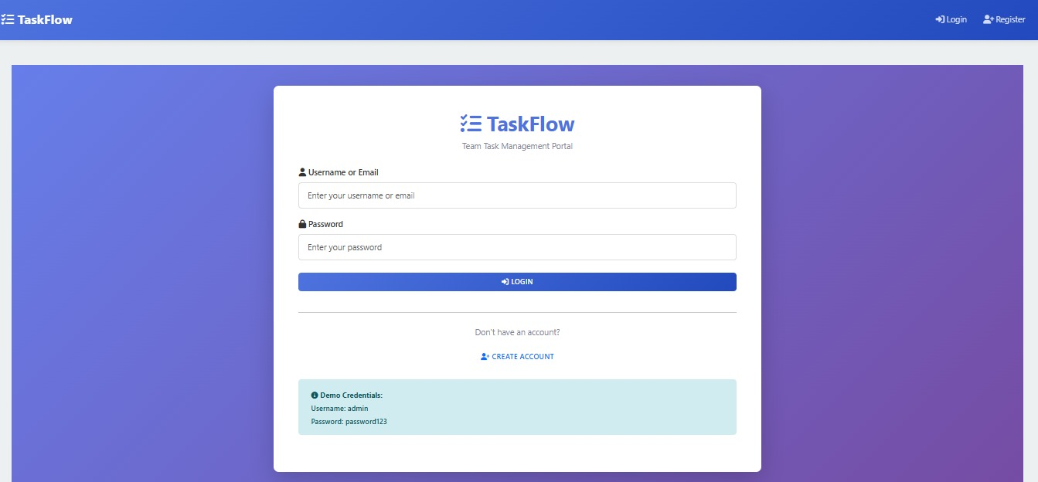
2. User Registration Page
Description
This page allows new users to create an account by providing personal information.
Features
- Username field
- Email field
- Password field
- Submit button
- Input validation
Screenshot
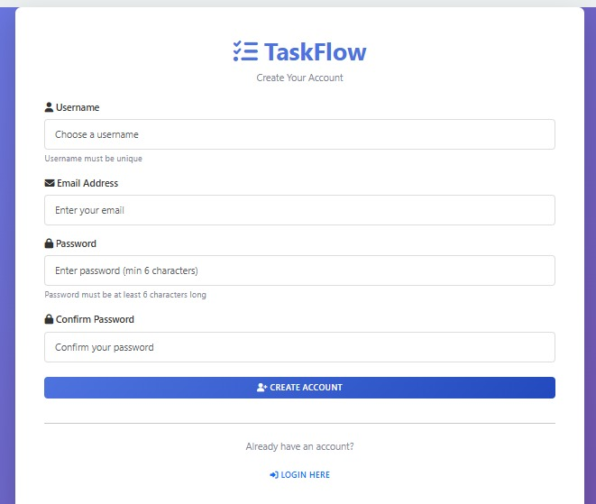
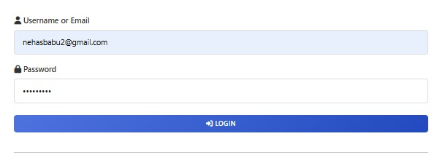
3. User Login Page
Description
Registered users can access the system through the Login Page using valid credentials.
Features
- Email field
- Password field
- Login button
- Authentication validation
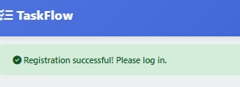
4. Dashboard Page
Description
The Dashboard provides an overview of projects, tasks, and user activities.
Features
- Total Projects
- Total Tasks
- Completed Tasks
- Pending Tasks
- Quick Navigation
Screenshot
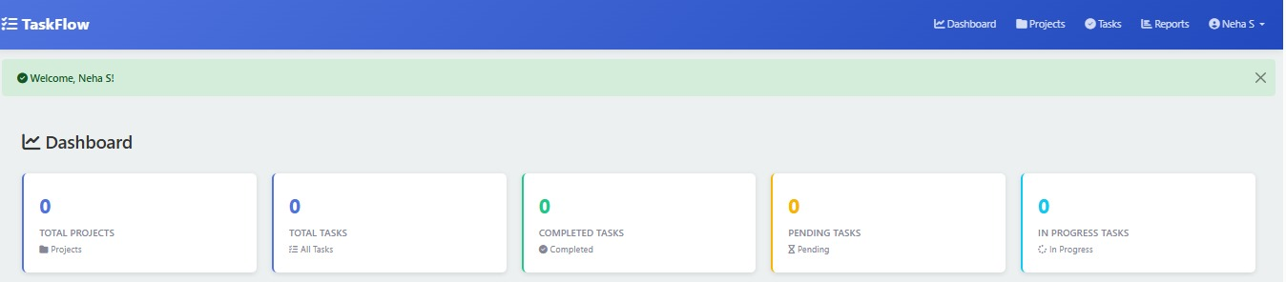
5. Project Management Page
Description
This page enables users to create, edit, and manage projects.
Features
- Add Project
- Update Project
- Delete Project
- View Project List
Screenshot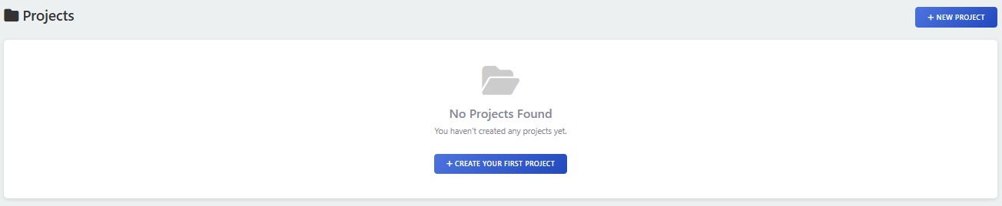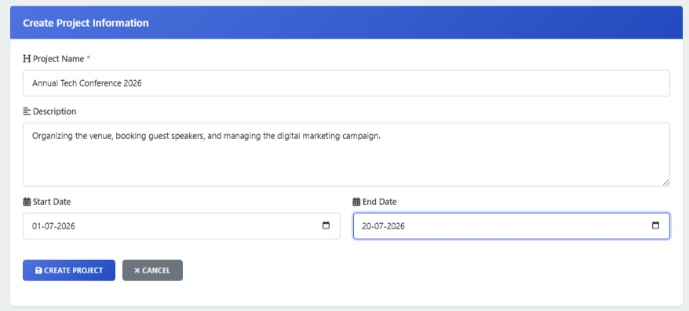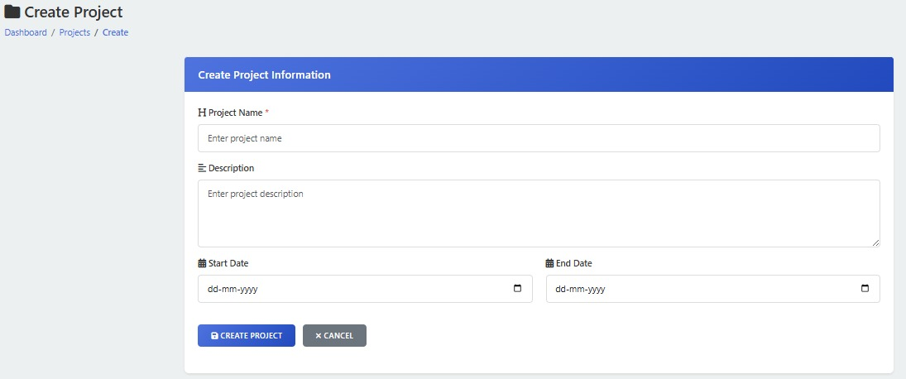
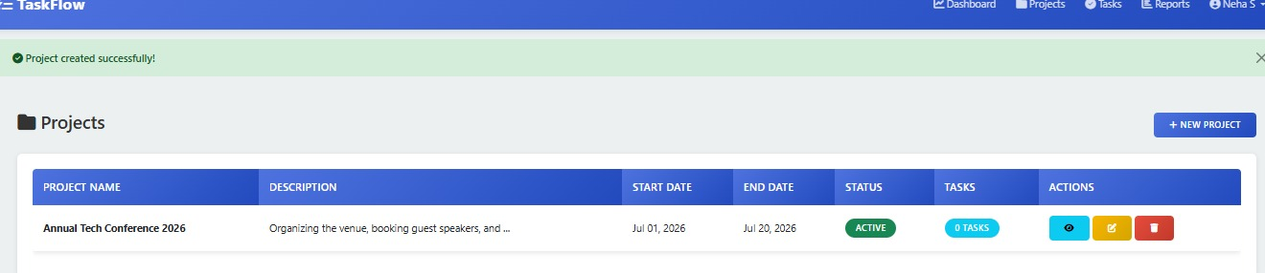
6. Task Creation Page
Description
Users can create tasks and assign them to team members.
Features
- Task Name
- Description
- Due Date
- Priority Selection
- Save Button
Screenshot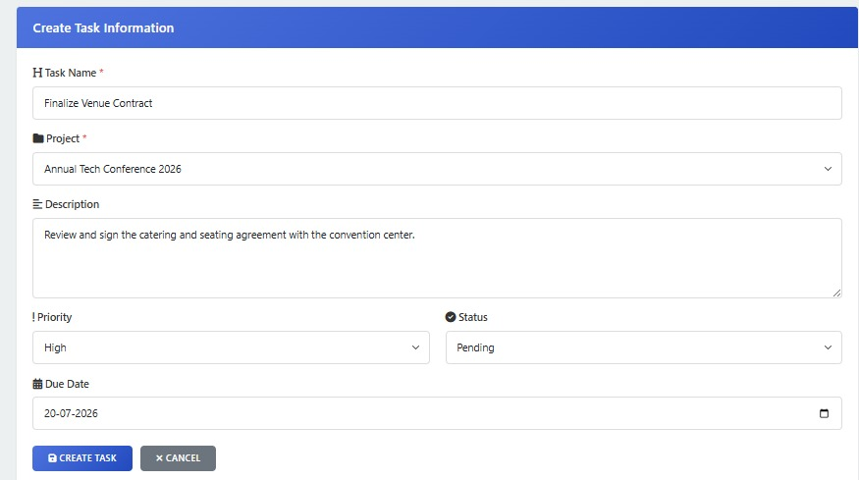
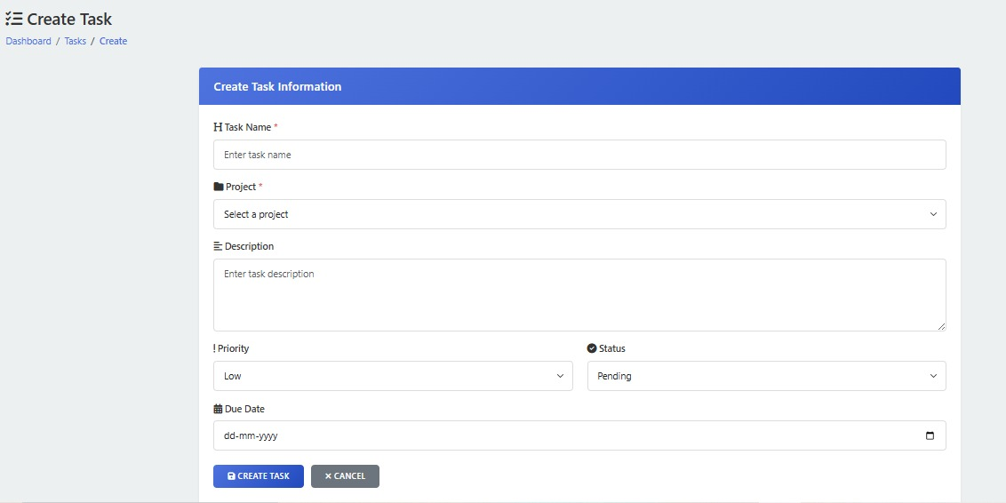
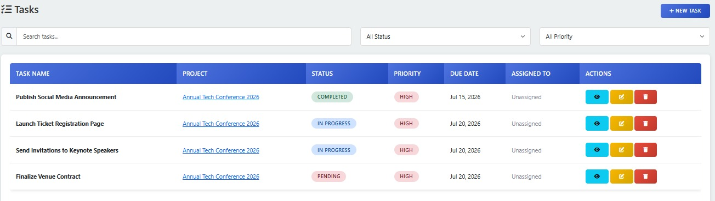
7. Task Assignment Page
Description
Project managers can assign tasks to team members.
Features
- Select User
- Select Task
- Assign Button
- Assignment Status
Screenshot
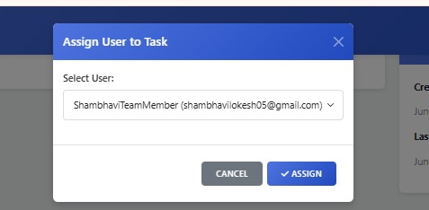
8. Task Tracking Page
Description
This page allows users to monitor the progress of assigned tasks.
Features
- Task Status
- Progress Tracking
- Due Date Monitoring
- Completion Percentage
Screenshot
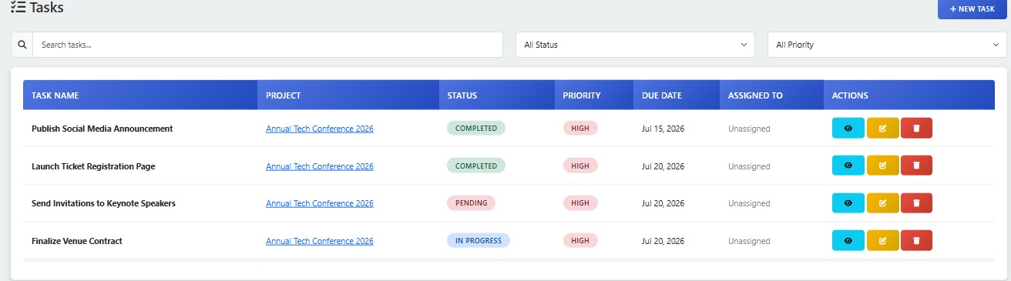
9. Reports Page
Description
The Reports module generates summaries of project and task activities.
Features
- Project Reports
- Task Reports
- Completion Statistics
- Performance Overview
Screenshot
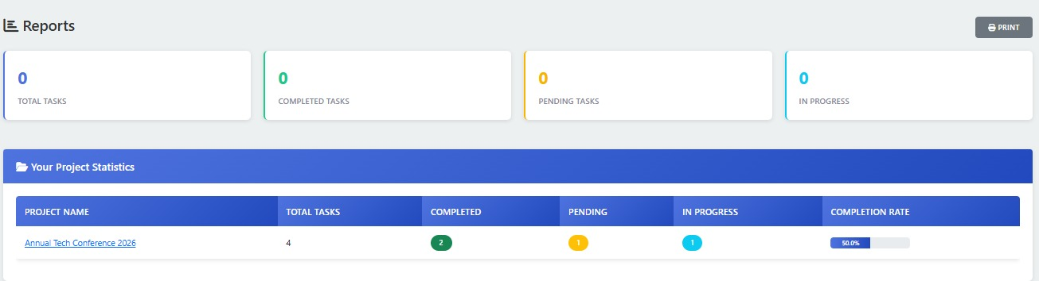
Conclusion
The output screens demonstrate the successful implementation of all major modules of the TaskFlow – Team Task Management Portal. The screenshots verify that the system functions correctly and provides a user-friendly environment for project and task management.

CHAPTER 15
FUTURE ENHANCEMENTS
The TaskFlow – Team Task Management Portal can be further enhanced by incorporating advanced features that improve productivity, collaboration, and project tracking. One possible enhancement is the integration of real-time notifications to alert users whenever tasks are assigned, updated, or completed. This will help team members stay informed about project activities and deadlines.
The system can also be extended with a role-based access control mechanism, allowing administrators, project managers, and team members to have different levels of access and permissions. Integration with email and mobile notifications can improve communication among team members and ensure timely updates.
Another enhancement is the addition of project analytics and reporting dashboards that provide graphical representations of task progress, employee performance, and project completion rates. Features such as file sharing, document management, and calendar integration can further improve team collaboration.
In the future, cloud deployment and mobile application support can be implemented to allow users to access the system from anywhere. Artificial Intelligence-based task prioritization and workload management can also be introduced to help managers allocate resources more effectively and improve overall project efficiency.

CHAPTER 16
CONCLUSION
The TaskFlow – Team Task Management Portal was developed to provide an efficient solution for managing projects and tasks within an organization. The system simplifies task assignment, monitoring, and tracking by providing a centralized platform where users can manage project-related activities effectively.
The application successfully implements essential features such as user authentication, project management, task management, task assignment, status tracking, and reporting. These features help improve team coordination, reduce manual effort, and ensure that projects are completed within the specified timelines.
The system was designed using modern web technologies and follows a structured approach to database management and software development. It provides a user-friendly interface that enables users to perform operations easily and efficiently.
Overall, the TaskFlow portal achieves its primary objective of improving productivity, enhancing collaboration among team members, and providing better visibility into project progress. The project demonstrates how technology can be utilized to streamline task management processes and support effective project execution in organizations.

CHAPTER 17
BIBLIOGRAPHY
1. Flask Documentation
The official Flask documentation was used to understand the framework architecture, routing mechanisms, template rendering, session management, and database integration. It provided detailed guidance for developing the web application and implementing various project functionalities.
Website: https://flask.palletsprojects.com
2. MySQL Documentation
The MySQL documentation served as a reference for database creation, table design, query execution, and database management. It helped in understanding relational database concepts and implementing efficient data storage for the project.
Website: https://dev.mysql.com/doc
3. HTML5 Documentation
HTML5 documentation was used for designing the structure of web pages and creating user-friendly interfaces. It provided information about forms, input controls, semantic elements, and page layout techniques used in the project.
Website: https://developer.mozilla.org/en-US/docs/Web/HTML
4. CSS Documentation
CSS documentation was referred to for styling the web application and improving the visual appearance of pages. It helped in implementing responsive layouts, formatting elements, and enhancing the overall user experience.
Website: https://developer.mozilla.org/en-US/docs/Web/CSS
5. JavaScript Documentation
JavaScript documentation was utilized to add interactivity and dynamic behavior to the web application. It provided guidance for client-side validation, event handling, and improving user interaction with the system.
Website: https://developer.mozilla.org/en-US/docs/Web/JavaScript
6. Bootstrap Documentation
Bootstrap documentation was used to create a responsive and mobile-friendly user interface. It provided ready-to-use components, grid systems, navigation elements, forms, and styling utilities that improved the application's design.
Website: https://getbootstrap.com/docs
7. SQLAlchemy Documentation
SQLAlchemy documentation was referred to for connecting the Flask application with the MySQL database. It helped in implementing Object Relational Mapping (ORM), database operations, and efficient data management within the system.
Website: https://www.sqlalchemy.org
8. Python Documentation
The official Python documentation was used to understand programming concepts, libraries, modules, and syntax required for developing the project. It served as the primary reference for backend development and application logic.
Website: https://docs.python.org
9. Software Engineering Concepts and System Analysis & Design Reference Materials
Various software engineering concepts and system analysis methodologies were studied during the project development process. These resources helped in requirement gathering, system design, feasibility analysis, testing, and documentation preparation.
Reference Sources:
- https://www.geeksforgeeks.org/software-engineering
- https://www.tutorialspoint.com/software_engineering
- https://www.javatpoint.com/software-engineering-tutorial
10. Online Resources, Tutorials, and Technical Articles
Various online tutorials, technical blogs, developer forums, and educational websites were consulted throughout the project. These resources provided practical examples, troubleshooting solutions, implementation techniques, and best practices for successful project development.
Reference Sources:
- https://stackoverflow.com
- https://www.tutorialspoint.com
- https://github.com

