Digital Twin Database System for Diabetes Patient Management
Database Management Systems – UCS310
Degree & Year: BE(2nd Year)

Submitted By:

Neha Bansal – 1024030306

Kavish Arora – 1024030302

Bhavya Jindal – 1024030295

Submitted to:
MS. DAMINI ARORA
Class Group: - 2C22

Department of Computer Science and Engineering
THAPAR INSTITUTE OF ENGINEERING AND TECHNOLOGY, (A
DEEMED TO BE UNIVERSITY), PATIALA, PUNJAB
INDIA
Academic Year: 2025–2026

2. Introduction
Diabetes is a chronic medical condition that requires continuous monitoring of blood glucose levels, insulin dosage, diet, and physical activity. The concept of a Digital Twin in healthcare represents a virtual representation of a patient using historical and real-time data.
This project focuses on developing a database-driven Digital Twin system for diabetes patients. A Database Management System (DBMS) is essential for storing structured medical data securely, ensuring data integrity, reducing redundancy, and enabling efficient retrieval compared to traditional file-based systems.

3. Problem Statement

Existing diabetes management systems often rely on manual logs or fragmented digital tools, which lead to data inconsistency, redundancy, and lack of centralized analysis.

There is a need for a structured and centralized relational database system that can efficiently store, manage, and retrieve patient health data to support better monitoring and decision-making.

4. Objectives of the Project

• To design a database using Entity–Relationship (ER) modeling
• To convert the ER model into relational tables with primary and foreign keys
• To apply normalization up to Third Normal Form (3NF)
• To implement the database using SQL (DDL & DML)
• To use PL/SQL constructs such as procedures, triggers, and cursors
• To ensure data consistency using constraints and transaction management

5. Scope of the Project

The primary focus of the project is backend database implementation.

The system includes:

Patient data management

Glucose monitoring records

Insulin dosage tracking

Appointment scheduling

A basic user interface is included for interaction and demonstration purposes. Advanced frontend features and real-time device integration are beyond the scope of this project.

6. Proposed System Description

The proposed system is a centralized relational database that represents each diabetes patient as a structured digital entity. The system allows administrators and doctors to insert, update, and retrieve patient data efficiently.

Key features include:

Centralized data storage

Efficient data retrieval

Reduced redundancy

Improved data consistency

Support for analytical features based on stored data
7. Database Design
7.1 Entity–Relationship (ER) Diagram
Entities include:
- PATIENT (patient_id, name, age, gender, diabetes_type)
- DOCTOR (doctor_id, name, specialization)
- GLUCOSE_RECORD (record_id, patient_id, glucose_level, date)
- INSULIN_DOSAGE (dosage_id, patient_id, units, time)
- APPOINTMENT (appointment_id, patient_id, doctor_id, date, status)
Relationships:
- One-to-Many between PATIENT and GLUCOSE_RECORD
- One-to-Many between PATIENT and INSULIN_DOSAGE
- Many-to-One between APPOINTMENT and DOCTOR

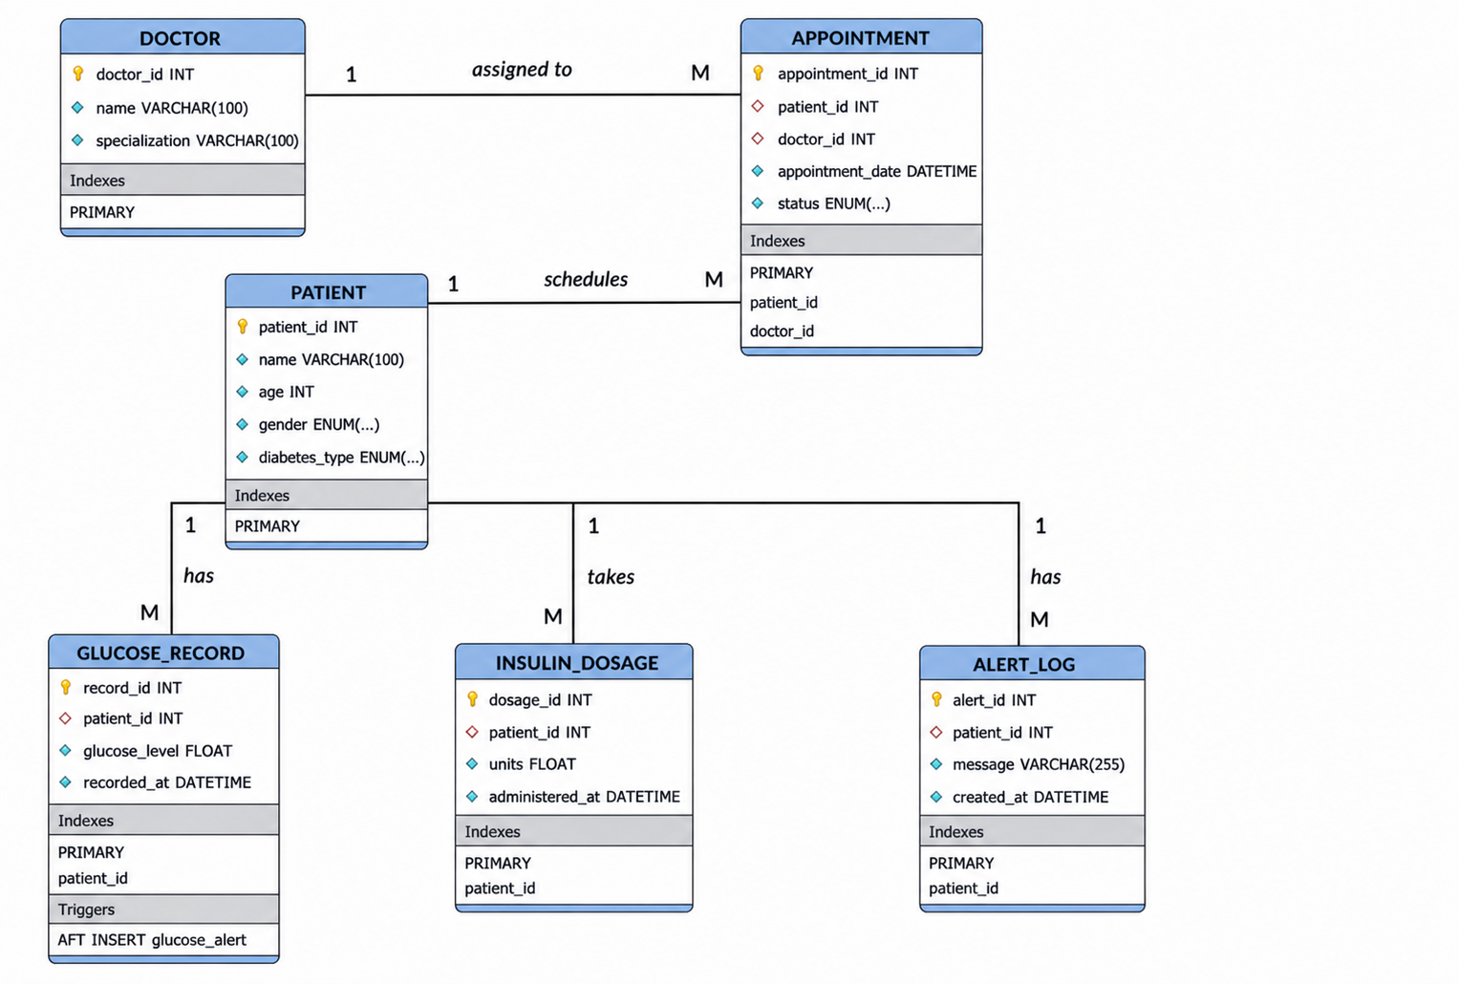

7.2 Relational Schema
- PATIENT (patient_id PK, name, age, gender, diabetes_type)
- DOCTOR (doctor_id PK, name, specialization)
- GLUCOSE_RECORD (record_id PK, patient_id FK, glucose_level, date)
- INSULIN_DOSAGE (dosage_id PK, patient_id FK, units, time)
- APPOINTMENT (appointment_id PK, patient_id FK, doctor_id FK, date, status)

8. Normalization

The database design has been normalized up to Third Normal Form (3NF) to eliminate redundancy and ensure data integrity.

Functional Dependencies

The main functional dependencies identified in the system are:

patient_id → name, age, gender, diabetes_type

doctor_id → name, specialization

record_id → patient_id, glucose_level, recorded_at

dosage_id → patient_id, units, administered_at

appointment_id → patient_id, doctor_id, appointment_date, status

alert_id → patient_id, message, created_at

First Normal Form (1NF)

A relation is in 1NF if:

All attributes contain atomic (indivisible) values

There are no repeating groups or multivalued attributes

In this database:

Each table stores single-valued attributes

Example: One glucose level per row in GLUCOSE_RECORD

No column contains multiple values

Therefore, all relations satisfy 1NF

Second Normal Form (2NF)

A relation is in 2NF if:

It is in 1NF

All non-key attributes are fully functionally dependent on the primary key

In this database:

All tables use single-attribute primary keys (no composite keys)

Hence, partial dependency does not exist

Example:

In PATIENT, all attributes depend entirely on patient_id

In GLUCOSE_RECORD, all attributes depend on record_id

Therefore, all relations satisfy 2NF

Third Normal Form (3NF)

A relation is in 3NF if:

It is in 2NF

There are no transitive dependencies (non-key attributes depending on other non-key attributes)

In this database:

Patient details are stored only in PATIENT table

Doctor details are stored only in DOCTOR table

GLUCOSE_RECORD, INSULIN_DOSAGE, and APPOINTMENT tables store only foreign keys, not redundant data

Example:

In APPOINTMENT, doctor details are not stored redundantly; only doctor_id is used

In GLUCOSE_RECORD, patient details are not duplicated

Therefore, no transitive dependency exists

9. Database Implementation

9.1 SQL Implementation

• DDL Commands: CREATE, ALTER, DROP
• DML Commands: INSERT, UPDATE, DELETE

SELECT queries include:

Joins

Subqueries

Aggregate functions

GROUP BY, HAVING

Views

9.2 PL/SQL Components

• Stored Procedures
• Functions
• Triggers
• Cursors
• Exception Handling
9.3 PL/SQL Implementation
The project implements core PL/SQL concepts as required:
• Triggers
- glucose_alert: Generates alert when glucose level exceeds 300
- log_insulin_overdose: Detects high insulin dosage
• Stored Procedures
- AddPatientWithDoctor: Inserts patient and assigns doctor automatically
- LogGlucoseReading: Logs glucose and triggers alerts
- GetPatientHistory: Retrieves patient medical history
• Functions
- GetRiskLevel: Determines risk category based on glucose
• Cursor
- ShowAllPatientAvgGlucose: Iterates and calculates average glucose
• Exception Handling
- Implemented using EXIT HANDLER to ensure stability
This ensures that business logic is handled at the database level.

“Business logic is implemented using stored procedures, triggers, and functions instead of relying on the application layer.”

10. Transaction Management & Concurrency

The system ensures ACID properties using:

COMMIT

ROLLBACK

SAVEPOINT

- Atomicity: Transactions complete fully or not at all
- Consistency: Constraints maintain valid data
- Isolation: Transactions are independent
- Durability: Changes persist after commit

Basic concurrency control mechanisms are used to maintain data consistency during simultaneous operations.

11. Tools & Technologies Used

MySQL (Database)

SQL & PL/SQL

Node.js + Express (Backend)

HTML, CSS, JavaScript (Frontend)

12. Actual Outcomes of the Project

• A fully functional and normalized relational database was successfully implemented up to Third Normal Form (3NF), ensuring reduced redundancy and improved data integrity.

• Efficient data retrieval was achieved using SQL queries including joins, subqueries, and aggregation functions.

• Backend operations such as insertion, updating, and deletion of records were successfully implemented using SQL and PL/SQL.

• Automation features such as data handling and logical processing were implemented using procedures and triggers.

• Transaction management ensured data consistency using ACID properties.

• The system successfully demonstrates how a structured database can support organized storage, retrieval, and analysis of healthcare data.

• Additional analytical features were integrated for demonstration purposes to show how stored data can be used for basic insights and decision support.

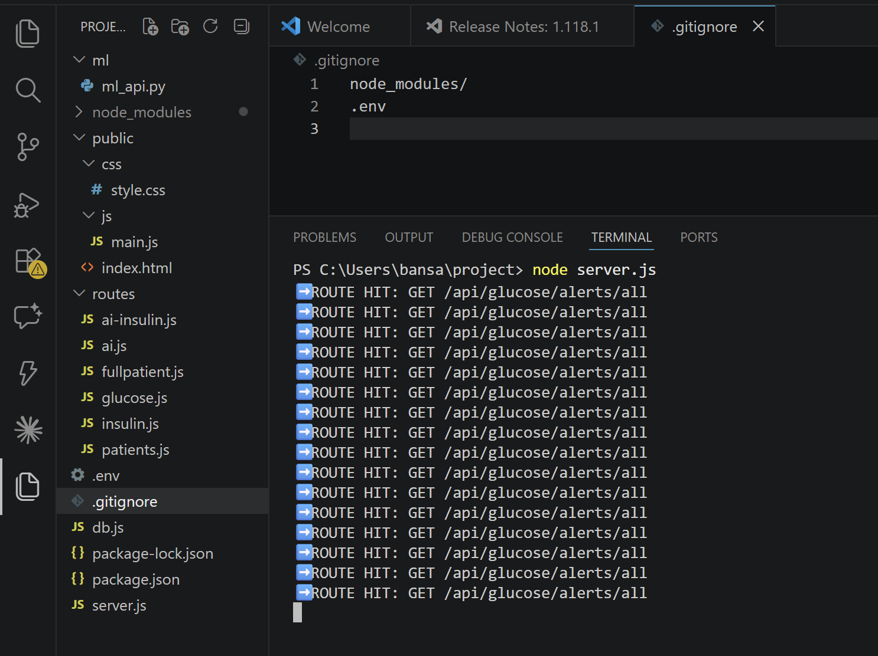
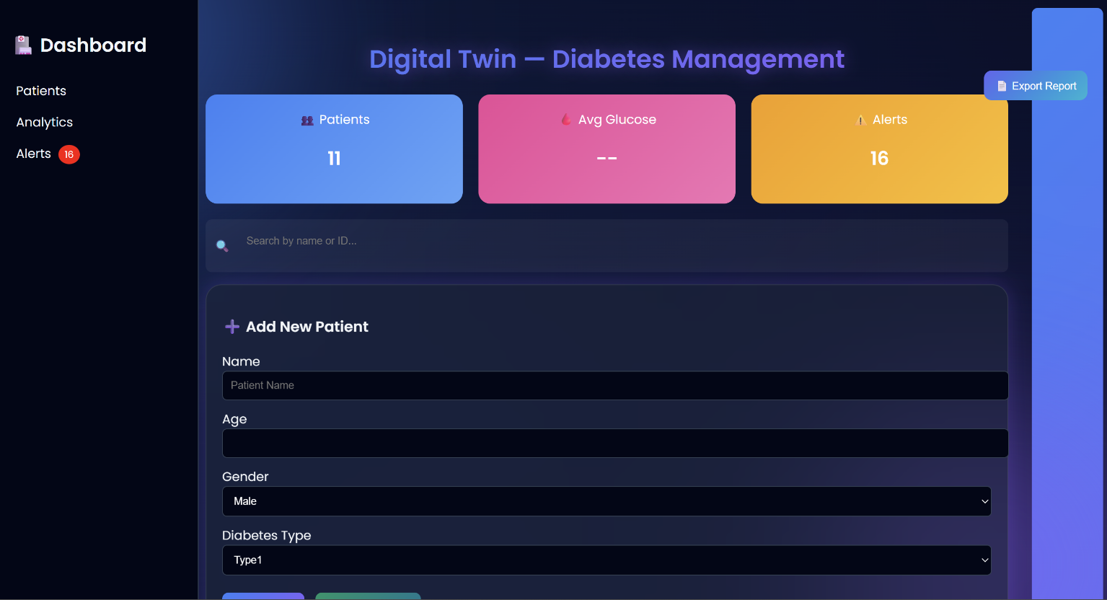
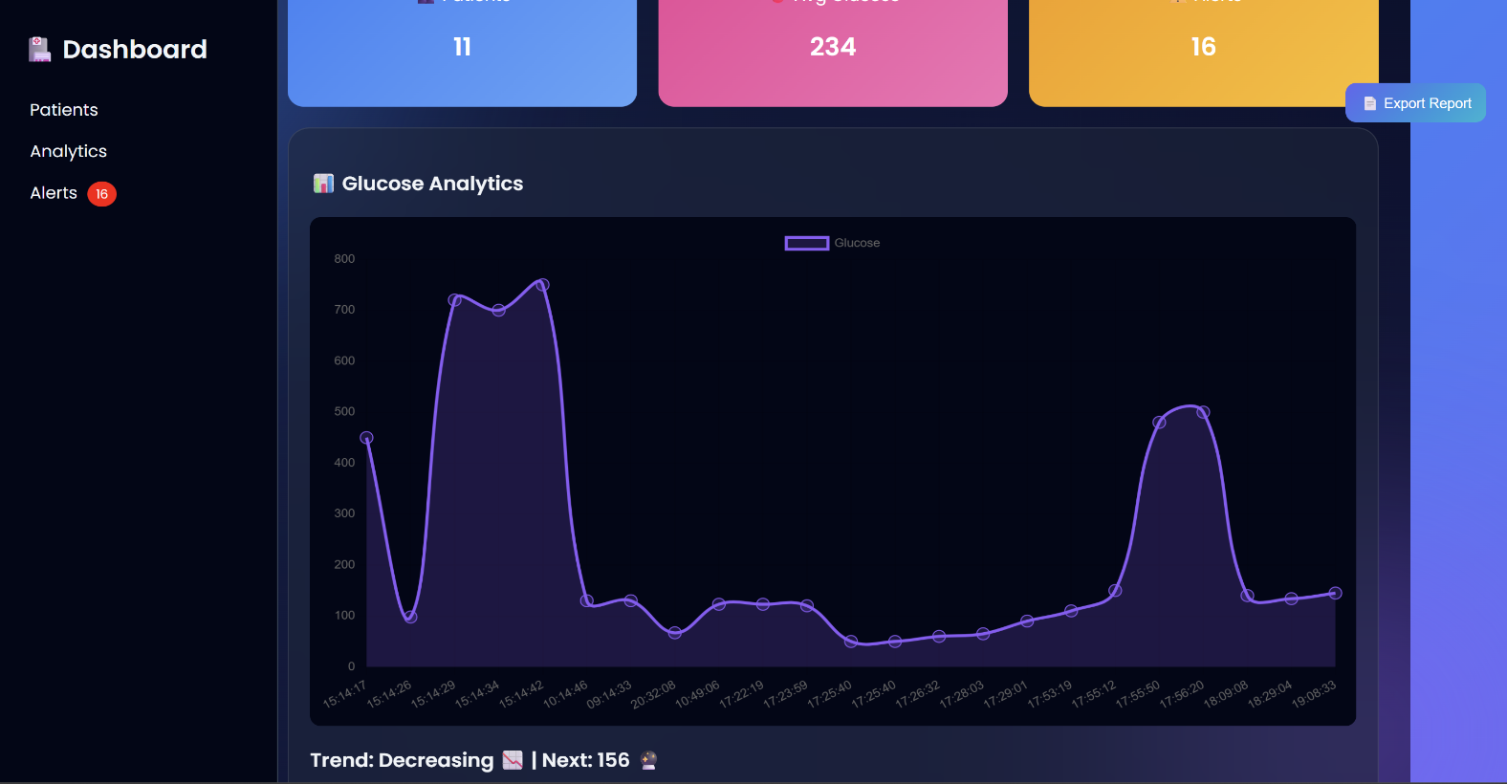

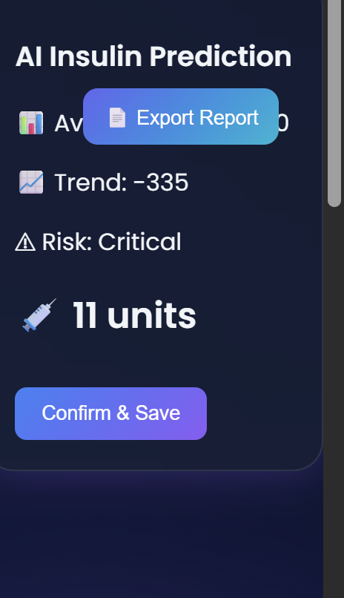
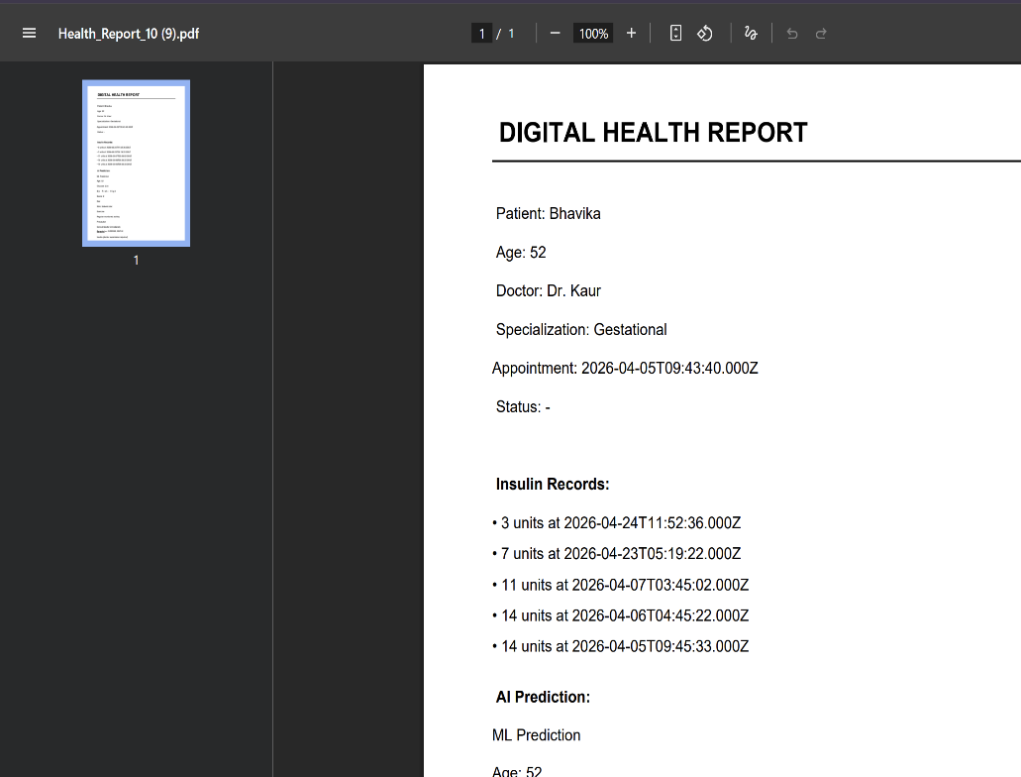

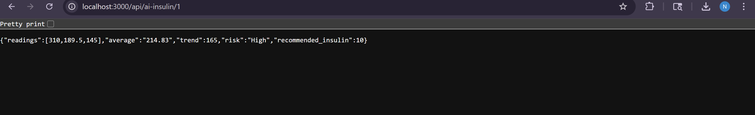
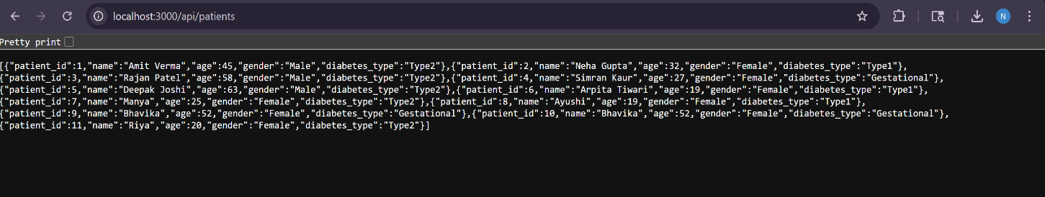
14.Conclusion
This project successfully demonstrates how a Database Management System integrated with PL/SQL and Machine Learning can be used to build an intelligent healthcare solution.
The system ensures efficient data storage, retrieval, and processing while maintaining data integrity through normalization and ACID properties.
It highlights the practical application of DBMS concepts in real-world scenarios.

