Hospital Patient Monitoring System
A Course Project Report
Submitted in partial fulfillment of the completion of the course
23CS302PC303 – High Performance Computing
In III Year II Semester B.Tech – CSE
Submitted by
SHAIK NEHA FARIYAL
(Roll Number:2303a51598)
Under the supervision of
Dr. Sri Raman Kothuri
Associate Professor, SoCS&AI
Academic Year: 2025–2026
Department of Computer Science and Artificial Intelligence
SR University
Warangal, Telangana, India

INDEX
1. Introduction
2. Problem Statement
3. Methodology / Procedure
4. System Architecture
5. Client and Server Configuration
6. Implementation (Server and Client Code)
7. Results and Output
8. Conclusion
9. References

1. INTRODUCTION:
High Performance Computing (HPC) is used to solve complex problems efficiently using centralized and distributed computing. In hospitals, multiple patients are monitored using different devices that generate health data such as heart rate, temperature, oxygen level, blood pressure, sugar level, and symptoms. Managing and analyzing this data separately can lead to delays and inefficiencies.
In this project, a centralized hospital patient monitoring system is developed using HPC concepts. Multiple client systems representing patient monitoring units send health data to a centralized server. The server processes the data, detects diseases, and recommends treatments.
This project demonstrates HPC concepts including:
• Distributed input from multiple clients
• Centralized processing
• Real‑time data aggregation
• Disease detection
• Treatment recommendation
This system improves efficiency, accuracy, and real‑time decision‑making in healthcare monitoring.

2. PROBLEM STATEMENT:
In hospitals, patient health data is generated continuously from multiple monitoring devices. If each device works independently, it becomes difficult to analyze patient conditions centrally.
This can lead to:
• Delay in disease detection
• Delay in treatment
• Poor patient monitoring
The objective of this project is to design a centralized HPC system where multiple clients send patient data to a central server, and the server detects diseases and recommends treatment.

3. METHODOLOGY:
3.1 Client System:
Each client represents a patient monitoring unit.
It collects patient data including:
• Heart Rate
• Temperature
• Oxygen Level
• Blood Pressure
• Sugar Level
• Symptoms
3.2 Server System:
The central HPC server receives data from multiple clients.
The server performs:
• Data processing
• Disease detection
• Treatment recommendation
3.3 Procedure:
1. Server starts and waits for clients
2. Client sends patient data
3. Server receives data
4. Server analyzes disease
5. Server recommends treatment
6. Server sends response to client
3.4 HPC Usage:
This project demonstrates HPC centralized processing and distributed computing.

4. SYSTEM ARCHITECTURE:
Client Systems (Patient Monitors)
↓
Network
↓
Centralized HPC Server
↓
Disease Detection
↓
Treatment Recommendation

5. CLIENT AND SERVER CONFIGURATION:
Server Configuration:
Processor: Intel i5
RAM: 8 GB
Operating System: Windows
Software: Python 3.13
Client Configuration:
Processor: Intel i3
RAM: 4 GB
Operating System: Windows
Software: Python 3.13

6. IMPLEMENTATION:
Server Code and Client Code used in this project are attached here.
Server.py code
import socket

server = socket.socket(socket.AF_INET, socket.SOCK_STREAM)

server.setsockopt(socket.SOL_SOCKET, socket.SO_REUSEADDR, 1)

server.bind(("0.0.0.0", 9999))

server.listen(5)

print("HPC Centralized Hospital Server Started...")
print("Waiting for patients...\n")

while True:

client, addr = server.accept()

print("\nConnected from:", addr)

data = client.recv(1024).decode()

print("Received Data:", data)

try:

name = data.split("|")[0].split(":")[1]

heart = int(data.split("|")[1].split(":")[1])

temp = float(data.split("|")[2].split(":")[1])

oxygen = int(data.split("|")[3].split(":")[1])

bp = data.split("|")[4].split(":")[1]

sugar = int(data.split("|")[5].split(":")[1])

symptoms = data.split("|")[6].split(":")[1].lower()

disease = ""
treatment = ""
status = ""

# Disease detection

if heart > 120 or "chest pain" in symptoms:

disease = "Heart Attack"

status = "CRITICAL"

treatment = """ICU Admission
ECG Monitoring
Aspirin
Beta Blockers"""

elif temp > 39 and "cough" in symptoms:

disease = "COVID-19"

status = "CRITICAL"

treatment = """Isolation
Oxygen Therapy
Antiviral Drugs"""

elif oxygen < 90:

disease = "Pneumonia"

status = "CRITICAL"

treatment = """Oxygen Therapy
Antibiotics"""

elif sugar > 250:

disease = "Diabetes"

status = "CRITICAL"

treatment = """Insulin Therapy
Sugar Monitoring"""

elif "breathing problem" in symptoms:

disease = "Asthma"

status = "CRITICAL"

treatment = """Inhaler
Oxygen Therapy"""

elif "paralysis" in symptoms:

disease = "Stroke"

status = "CRITICAL"

treatment = """Emergency Care
CT Scan"""

# NEW SYMPTOMS ADDED BELOW

elif "headache" in symptoms:

disease = "Migraine"

status = "MODERATE"

treatment = """Pain Killers
Rest
Neurologist Consultation"""

elif "vomiting" in symptoms:

disease = "Food Poisoning"

status = "CRITICAL"

treatment = """IV Fluids
ORS
Antibiotics"""

elif "cold" in symptoms:

disease = "Common Cold"

status = "STABLE"

treatment = """Steam Inhalation
Rest
Paracetamol"""

elif "dizziness" in symptoms:

disease = "Low Blood Pressure"

status = "CRITICAL"

treatment = """IV Fluids
Salt Intake
Monitoring"""

elif temp > 38:

disease = "Fever"

status = "MODERATE"

treatment = """Paracetamol
Rest"""

elif "high" in bp:

disease = "Hypertension"

status = "MODERATE"

treatment = """BP Control Medicine"""

else:

disease = "Normal"

status = "STABLE"

treatment = """No immediate treatment required"""

print("\n===== HPC CENTRAL REPORT =====")

print("Patient:", name)

print("Disease:", disease)

print("Status:", status)

print("Treatment:", treatment)

print("==============================")

response = f"""

Patient Name: {name}

Detected Disease: {disease}

Patient Status: {status}

Treatment Required:

{treatment}

"""

client.send(response.encode())

except Exception as e:

print("Error:", e)

client.send("Error in processing data".encode())

client.close()
CLIENT 1 CODE:
import socket

name = input("Enter Patient Name: ")

heart = input("Enter Heart Rate: ")

temp = input("Enter Temperature: ")

oxygen = input("Enter Oxygen Level: ")

bp = input("Enter Blood Pressure: ")

sugar = input("Enter Sugar Level: ")

symptoms = input("Enter Symptoms: ")

message = f"Name:{name}|Heart:{heart}|Temp:{temp}|Oxygen:{oxygen}|BP:{bp}|Sugar:{sugar}|Symptoms:{symptoms}"

client = socket.socket()

client.connect(("10.3.69.44", 9999))

client.send(message.encode())

response = client.recv(1024).decode()

print(response)

client.close()

CLIENT 2 CODE:
import socket

name = input("Enter Patient Name: ")

heart = input("Enter Heart Rate: ")

temp = input("Enter Temperature: ")

oxygen = input("Enter Oxygen Level: ")

bp = input("Enter Blood Pressure: ")

sugar = input("Enter Sugar Level: ")

symptoms = input("Enter Symptoms: ")

message = f"Name:{name}|Heart:{heart}|Temp:{temp}|Oxygen:{oxygen}|BP:{bp}|Sugar:{sugar}|Symptoms:{symptoms}"

client = socket.socket()

client.connect(("10.3.69.44", 9999))

client.send(message.encode())

response = client.recv(1024).decode()

print(response)

client.close()

7. RESULTS AND OUTPUT:
The system successfully:
• Receives data from multiple clients
• Detects diseases
• Recommends treatment
• Demonstrates HPC centralized computing
Client 01 output:
BEFORE:
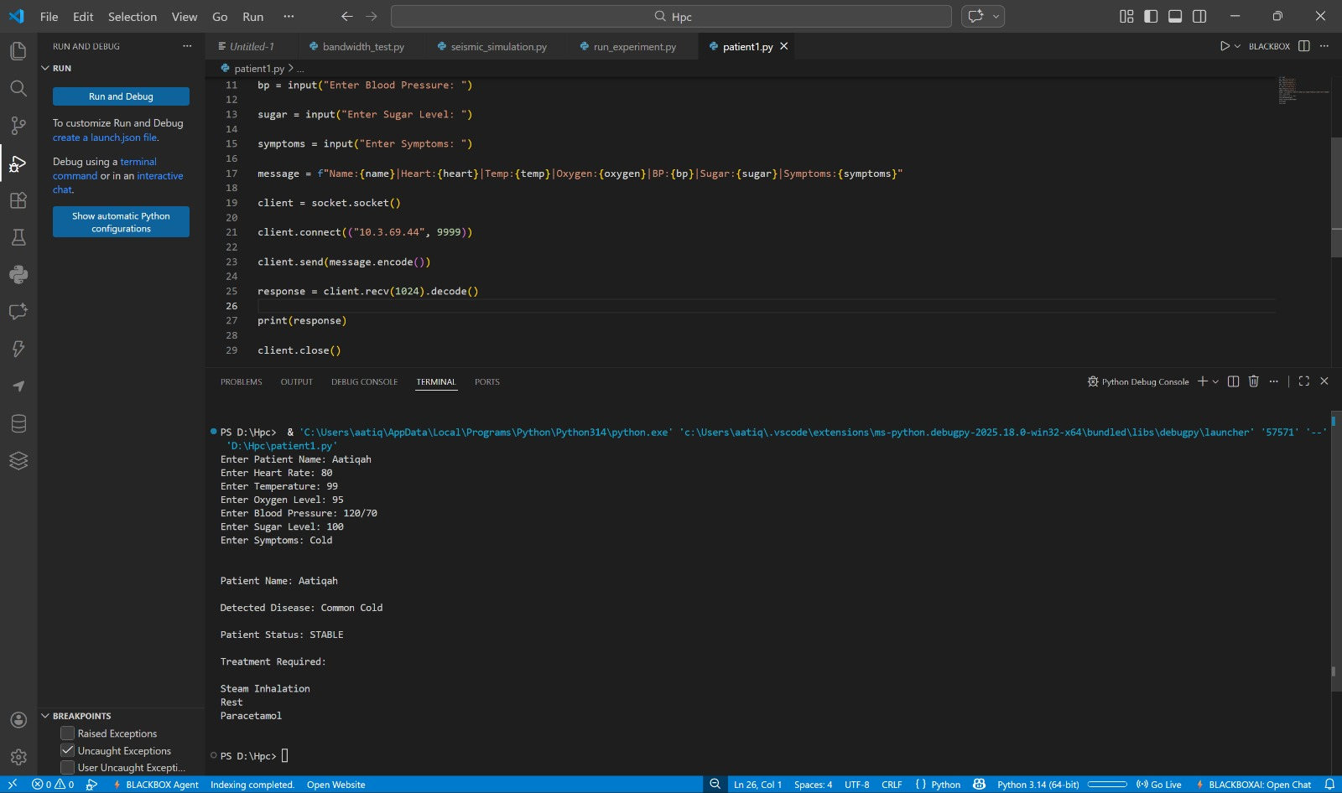
AFTER:
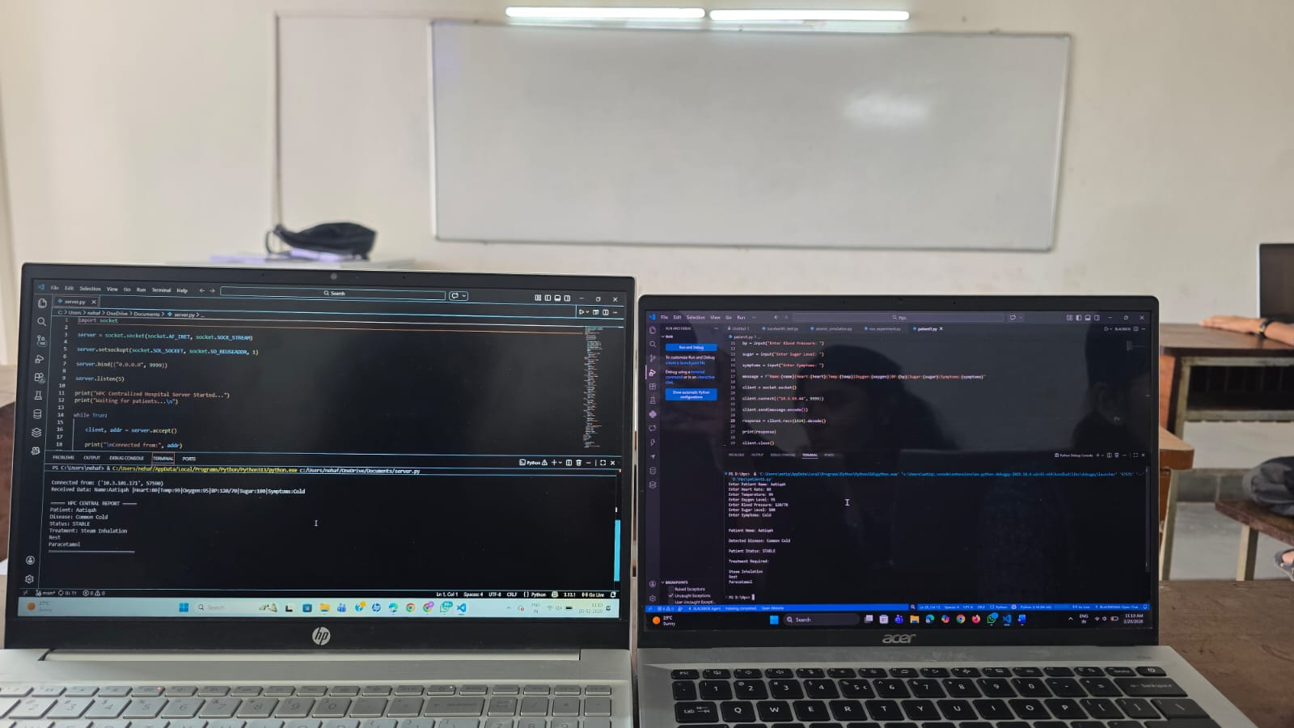
Server output:

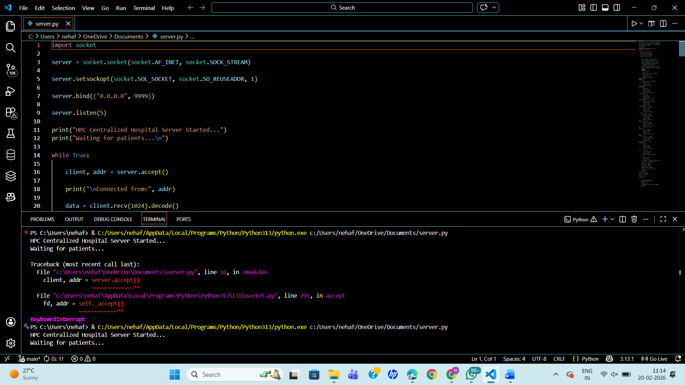

AFTER:
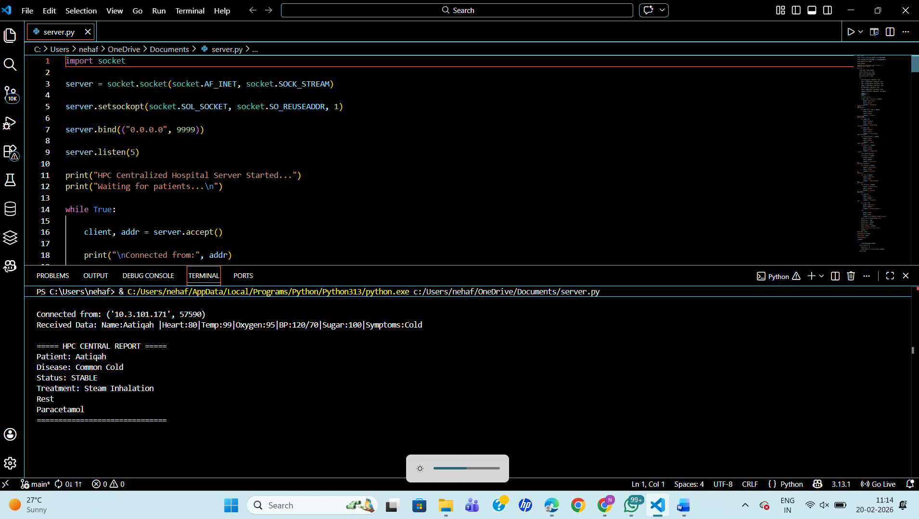

8. CONCLUSION:
The project demonstrates a centralized hospital monitoring system using HPC. It successfully processes data from multiple clients and recommends treatment. This improves healthcare monitoring efficiency.

9. REFERENCES:
1. Python Documentation
2. High Performance Computing Notes
3. Distributed Systems Concepts
4. SR University Course Material

