Ques 1:How are inline and block elements different from each other?

Sol 1:

Block Elements: These elements cover the width of complete page and always starts from the new line.

Inline Elements:These elements do not cover the width of complete page instead just take the required space.

<html>
<head>
<title>Inline and External block elements</title>
</head>
<body>
<div style="border:2px solid yellow">
<p>Hello my name is <span style="color: indianred; border:1px solid orange">Neha Goel</span>.</p>
</div>
<div style="border: 2px solid green;">
<p>Just for testing another block level element.</p>
</div>
</body>
</html>

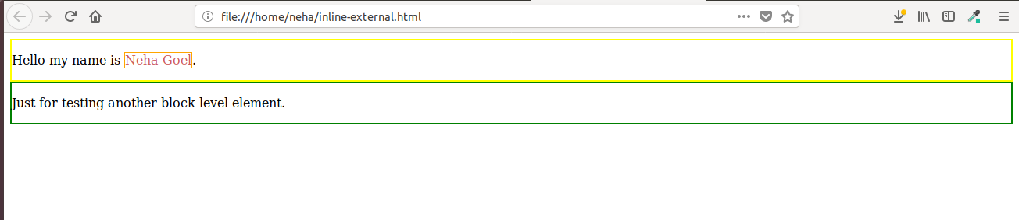
Ques 2:Explain the difference between visibility:hidden and display:none
Sol 2:

display:none
Without deleting the elements,the elements are hidden.No space is occupied.

Ex:
<html>
<head>
<style>
h3 {
display:none;
}
</style>
</head>
<body>
<h2>visible heading</h2>
<h3>Heading hidden</h3>
<p>The hidden heading do not occupies space after hiding it.</p>
</body>
</html>

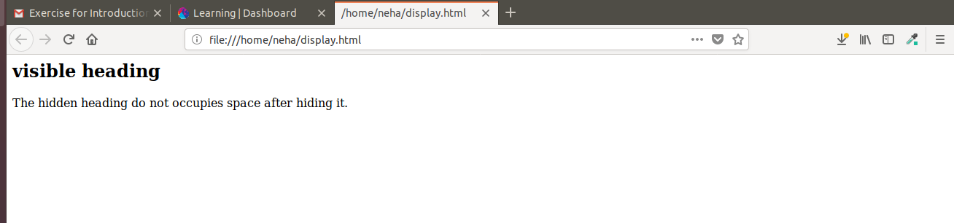

Visibility:hidden
It also hides the elements but effects the layout by occupying space.

Ex:
<html>
<head>
<style>
h3 {
visibility: hidden;
}
</style>
</head>
<body>
<h2>visible heading</h2>
<h3>Heading hidden</h3>
<p>The hidden heading occupies space after hiding it.</p>
</body>
</html>

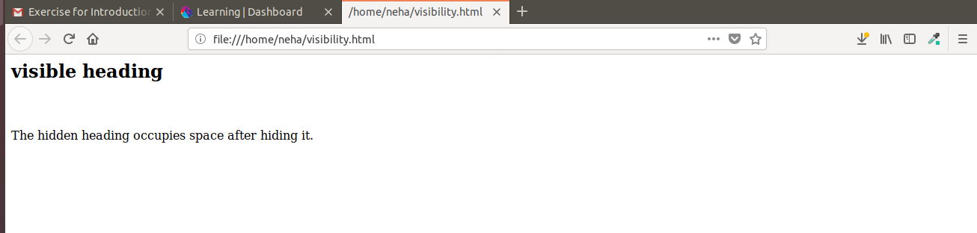

Ques 3:Explain the clear and float properties.

Sol 3:

Float Property: This property is used for the alignment of content on the page.It accepts 4 values i.e.
left-the element floats to the left
right-the element floats to the right
none-it is default,in this the element does not float
inherit-it takes the vlaue of parent float property

Ex:
<html>
<head>
<title>Float Property</title>
</head>
<body>
<p>Left</p>
<img style="float:left; width:50px; height:50px;" src="/home/neha/Desktop/flower.jpg" alt="FLOWER"><br><br>
<p>Right</p>
<img style="float:right; width:50px; height:50px;" src="/home/neha/Desktop/flower.jpg" alt="FLOWER"><br>
<p>Inherit</p>
<img style="float:inherit; width:50px; height:50px;" src="/home/neha/Desktop/flower.jpg" alt="FLOWER"><br>
<p>Both</p>
<img style="float:both; width:50px; height:50px;" src="/home/neha/Desktop/flower.jpg" alt="FLOWER"><br>
</body>
</html>

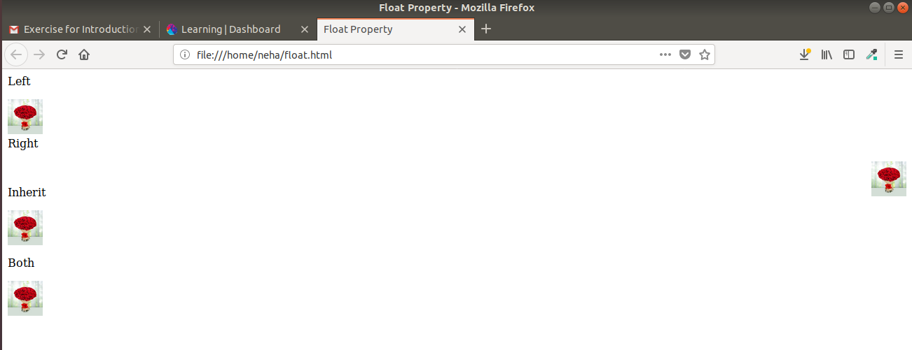

Clear Property: This property sets the elemnts which can be float. The value of clear must be decided on the basis on float value assigned. It takes 5 values i.e.:
none-this is default,it allows floating on both the sides.
Left-floating elements are not permitted on left side.
right-floating elements are not permitted on right side.
Both-floating not allowed on either sides.
Inherit-it inherits the value of the parent.

Ques 4:explain difference between absolute, relative,fixed and static.

Sol 4:

It specifies the element positioning method.

static: the elemenets are positioned according to the normal flow of the page.This is default.

Relative: It will adjust the element away from its normal position.

Fixed: the position of the element do not change even if the page in scrolled up or down.

Absolute: It moves along with the scrolling of the page.

Ex:
<html>
<head>
<style>
div.static {
position: static;
border: 3px solid red;
}
div.relative {
position: relative;
border: 3px solid green;
}
div.fixed {
position: fixed;
border: 3px solid blue;
}
div.absolute {
position: absolute;
border: 3px solid yellow;
}
</style>
</head>
<body>
<p>Paragraph tag.</p>

<div class="static">
This div element has position: static;
</div>

<div class="relative">
This div element has position: relative;
</div>

<div class="fixed">
This div element has position: fixed;
</div>
<br>
<div class="absolute">
This div element has position: absolute;
</div>

</body>
</html>

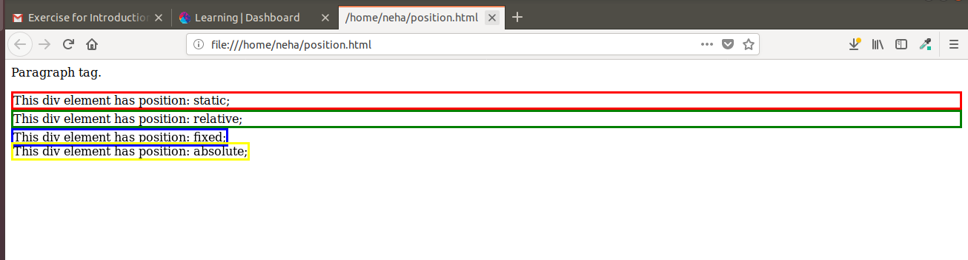

Ques 5:Write the HTML code to create a table in which there are 4 columns( ID , Employee Name, Designation, Department) and at least 6 rows. Also do some styling to it.

Sol 5:

table.html

<html>
<head>
<title>Table</title>
<link rel="stylesheet" type="text/css" href="table-style.css">
</head>
<body>
<div>

<h2>Sample Table</h2>
<table>
<tr>
<th>ID</th>
<th>Employee Name</th>
<th>Designation</th>
<th>Department</th>
</tr>
<tr>
<td>1</td>
<td>Neha</td>
<td>Software Engineer</td>
<td>IT</td>
</tr>
<tr>
<td>2</td>
<td>Anil</td>
<td>Accountant</td>
<td>Accounts</td>
</tr>
<tr>
<td>3</td>
<td>Shilpa</td>
<td>Analyst</td>
<td>Statistics</td>
</tr>
<tr>
<td>4</td>
<td>Rajan</td>
<td>Designer</td>
<td>Graphics</td>
</tr>
<tr>
<td>5</td>
<td>Mukul</td>
<td>Trainee</td>
<td>IT</td>
</tr>
<tr>
<td>6</td>
<td>Nitu</td>
<td>Doctor</td>
<td>Medical</td>
</tr>
</table>
</div>
</body>
</html>

table-style.css

table,th,td{
border: 2px solid black;
border-collapse: collapse;
padding: 10px;
margin: auto;
margin-top: 20px;
}
th{
color:green;
}
h2{
text-align: center;
}

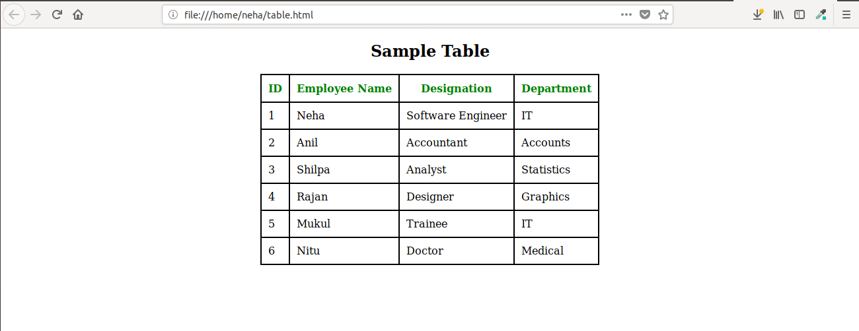
Ques 6:Why do we use meta tags?

Sol 6:

Meta tag is used to provide data about the html page. It is similar to metadata which is data about data.
The information of meta tag is not diaplayed on the web browser instead it is used by the browsers,search engines for recognising the web page or web servers.
It containes information like description of the page,author of the document,keywords,last modified,etc.
This tag is written under head tag.

Ex:
<html>
<head>
<meta name="metadata" content="Example of using meta tag">
<title>Meta tags</title>
</head>
<body>
<h2>Meta tag</h2>
</body>
</html>

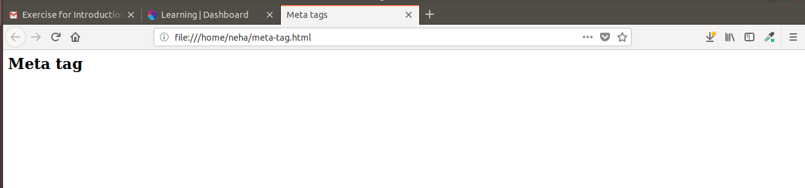

Ques 7:Explain box model.

Sol 7:

CSS box model is a box that wraps all the elemnts of HTML page.It contains margins,borders,padding and the actucal content.
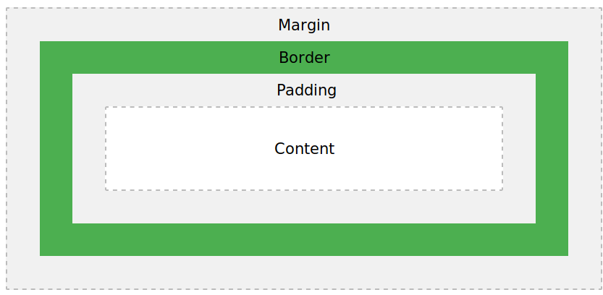

Ex:

<!DOCTYPE html>
<html>
<head>
<style>
div {
background-color: grey;
width: 300px;
border: 15px solid red;
padding: 50px;
margin: 20px;
}
</style>
</head>
<body>

<h2>Demonstrating the Box Model</h2>

<div>
this is a document to demonstrate box model.
</div>

</body>
</html>

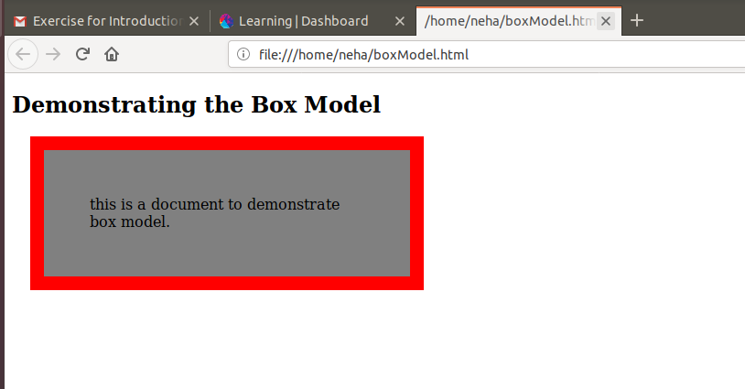

Ques 8: What are the different types of CSS Selectors?

Sol 8:

CSS Selectors are used for styling the content of the page.Various CSS selectors are:-

a. CSS Id Selector
Tags are assigned with a unique Id and this Id is used to select the text and apply styling to that content of the page.

Eg:

<html>
<head>
<title>Id Selector</title>
<style>
#para{
color:brown;
}
</style>
</head>
<body>
<h2>Id Selector</h2>
<p id="para">
A non-access modifier. Used for classes and methods: An abstract class cannot be used to create objects (to access it, it must be inherited from another class).
</p>
</body>
</html>
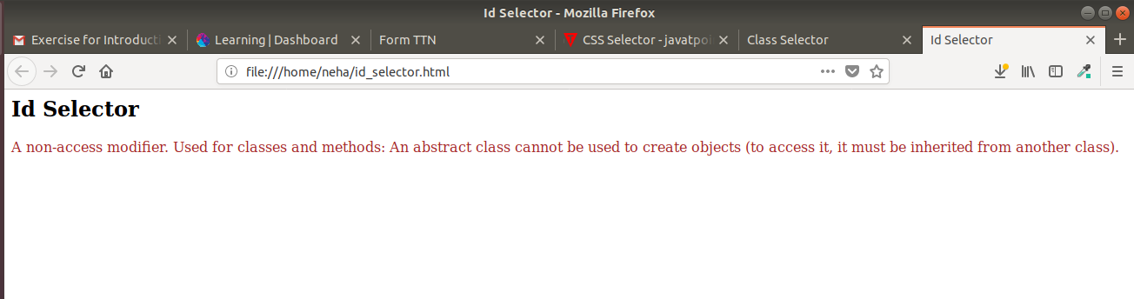

b. CSS Element Selector
The content of the page is selected using the element name.

Eg:
<html>
<head>
<title>Element Selector</title>
<style>
h2{
text-align: center;
}
p{
color:green;
}
</style>
</head>
<body>
<h2>Element Selector</h2>
<p id="para">
A non-access modifier. Used for classes and methods: An abstract class cannot be used to create objects (to access it, it must be inherited from another class).
</p>
</body>
</html>

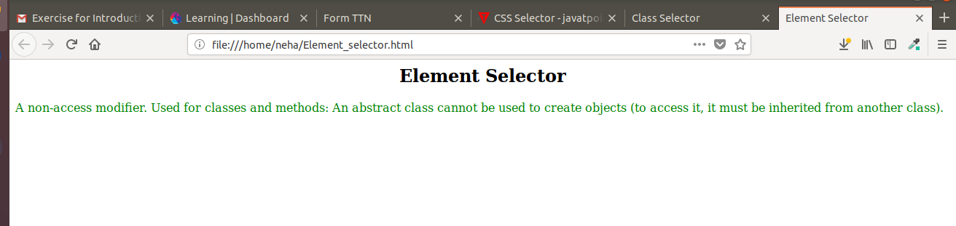

c. CSS Group Selector
This selector is used when same styling is required to be applied to multiple tags.We can group the elements and write the styling code only once and it will get applied to all the grouped elements..

Eg:
<html>
<head>
<title>Group Selector</title>
<style>
p,h2{
text-align: center;
color:yellow;
}
</style>
</head>
<body>
<h2>Group Selector</h2>
<p>
A non-access modifier. Used for classes and methods: An abstract class cannot be used to create objects (to access it, it must be inherited from another class).
</p>
</body>
</html>

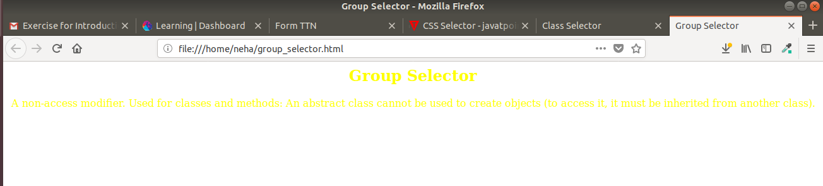

d. CSS Class Selector
Class name is assigned to the tag.Same class name can be applied to multiple tags.

Eg:
<html>
<head>
<title>Class Selector</title>
<style>
h2{
text-align: center;
}
.para{
text-align: center;
color:red;
}
</style>
</head>
<body>
<h2>Class Selector</h2>
<p class="para">
A non-access modifier. Used for classes and methods: An abstract class cannot be used to create objects (to access it, it must be inherited from another class).
</p>
</body>
</html>

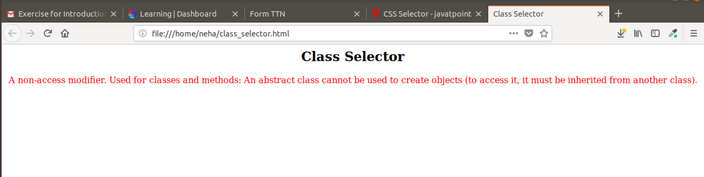
e. CSS Universal Selector
If any styling is required to be applied to complete html file Universal Selector is used.

Eg:
<html>
<head>
<title>Universal Selector</title>
<style>
*{
text-align: center;
color:green;
}
</style>
</head>
<body>
<h2>Universal Selector</h2>
<h3>To The New</h3>
<p>
A non-access modifier. Used for classes and methods: An abstract class cannot be used to create objects (to access it, it must be inherited from another class).
</p>
</body>
</html>

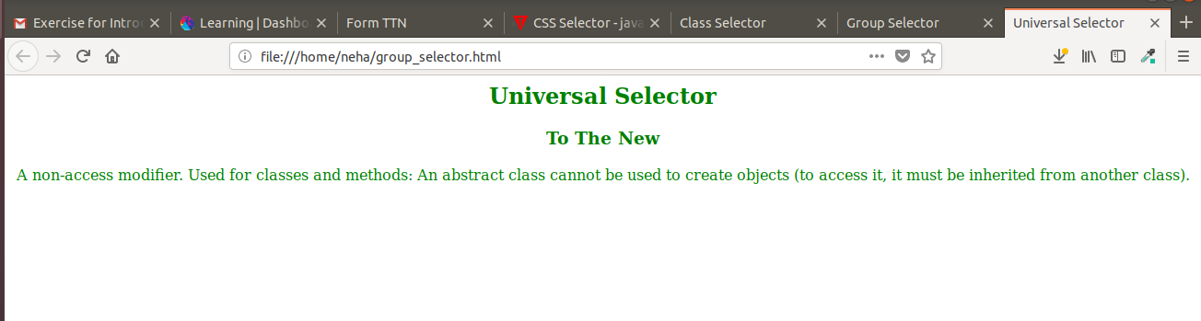

Ques 9:Define Doctype.

Sol 9:

The <!DOCTYPE> is used to specify the version of html being used.It must be the first line in the html file befor the html tag.It is the instruction that is given to the browser.

Ex:
<!DOCTYPE html>
<html>
<head>
<meta name="metadata" content="Example of using meta tag">
<title>Meta tags</title>
</head>
<body>
<h2>Meta tag</h2>
</body>
</html>

Ques 10:Explain 5 HTML5 semantic tags.

Sol 10:

5 semantuc tags used in this example are:

<header> : Specifies header of the document.
<nav> : Defines navigation links.
<figure> : Used to add an iamge in the document.
<figcaption> : Usd to add a small description of the image added.
<footer> :Specifies footer of the document.

Semantics.html

<html>
<head>
<title>Semantic Tags</title>
<link rel="stylesheet" type="text/css" href="semantics-style.css">
</head>
<body>
<header>
<h2>To The New</h2>
</header>
<nav>
<a href="#">Home</a>
<a href="#">About Us</a>
<a href="#">Contact Us</a>
</nav>
<figure>
<img src="/home/neha/Desktop/flower.jpg" alt="flower">
<figcaption>Fig1-Red Roses</figcaption>
</figure>
<footer id="page-footer">
<section id="container">
<div id="copyright">
Copyright &#169;2009-2017-All Rights Reserved-To The New
</div>
</section>
</footer>
</body>
</html>

semantics-style.css

nav{
background-color: black;
height: 25px;
padding: 5px;
}
h2{
background-color: gray;
}
a{
text-decoration: none;
color: white;
padding-right: 10px;
}
#container{
background-color: darkgray;
height: 30px;
padding: 5px;
}
img{
height: 260px;
width: 260px;
}
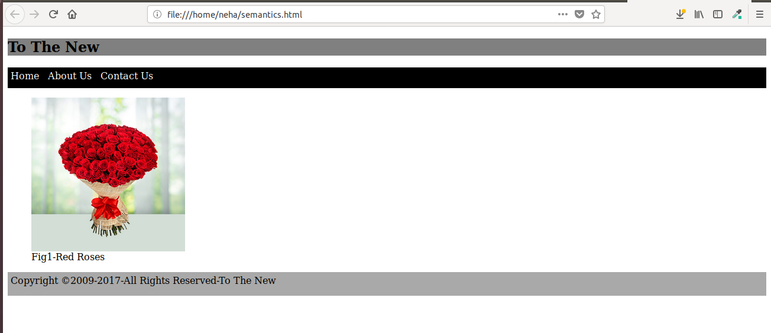

Ques 11: Create HTML for web-page.jpg (check resources, highest weightage for answers)

Sol 11:

html file:
ttn.html

css file
style.css

Ques 12:Create HTML for form.png

Sol 12:

html file:
form.html

css file:
form-style.html

