Ques 1: Prompt for amount, interest rate and no. of years and calculate simple interest.

Sol 1:

<html>
<head>
<title>Simple Interest</title>
</head>
<body>
<h3>Calculate Interest</h3>
<input type="button" value="enter values & calculate" onclick="interest_cal()">
<script>
function interest_cal()
{
var p=prompt("Enter principle");
var r=prompt("Enter rate");
var t=prompt("Enter time");
var i=p*r*t/100;
document.writeln("Simple interest is:", +i);
}
</script>
</body>
</html>

OUTPUT:

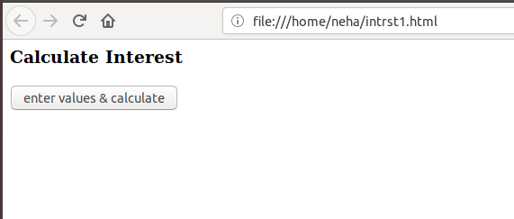

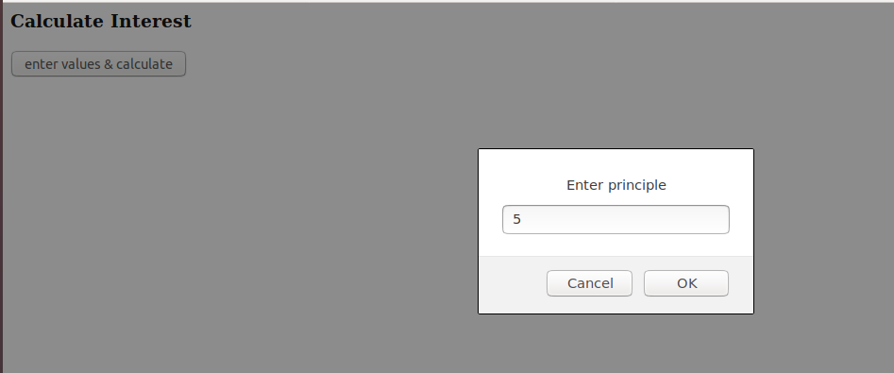

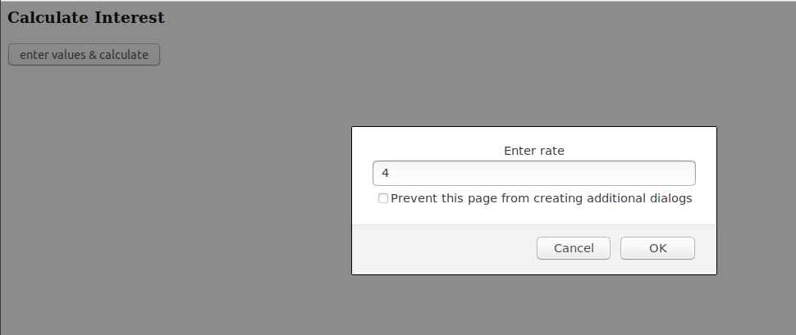

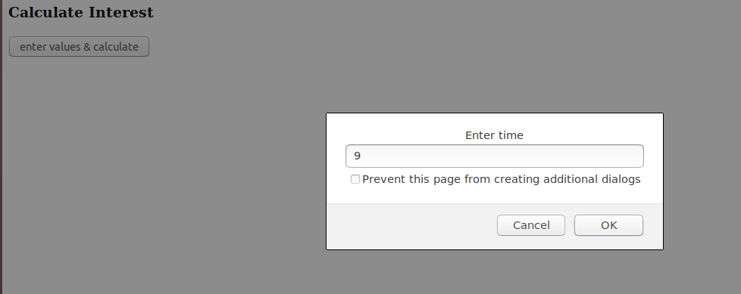

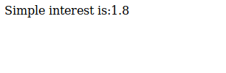

Ques 2: is palindrome string

Sol 2:

<html>
<head>
<title>Palindrome</title>
</head>
<body>
<script>
function palindrome(){

var str=prompt("Enter string to check:");
var str1=str.toLowerCase();
var rev=str1.split('').reverse().join('');
if(str==rev)
{
alert("palindrome");
}
else
{
alert("not a palindrome");
}
}
</script>
<input type="button" value="Enter string" onclick="palindrome()">
</body>
</html>

OUTPUT:

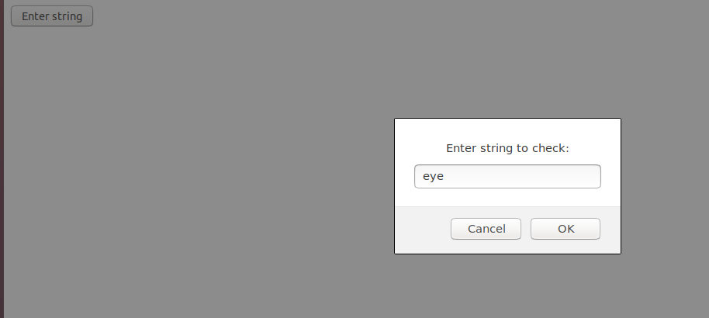

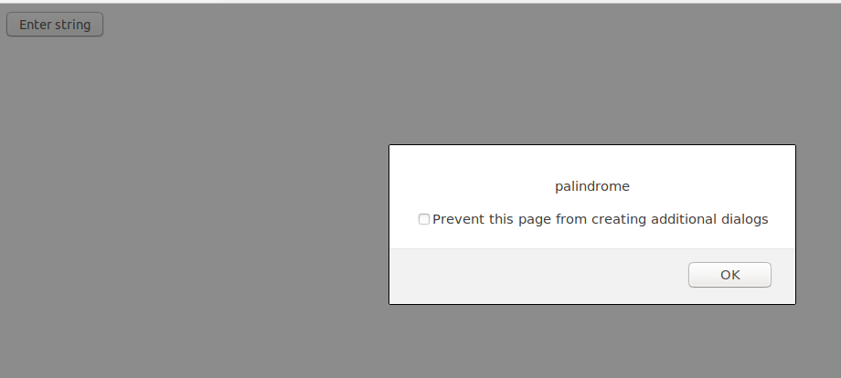

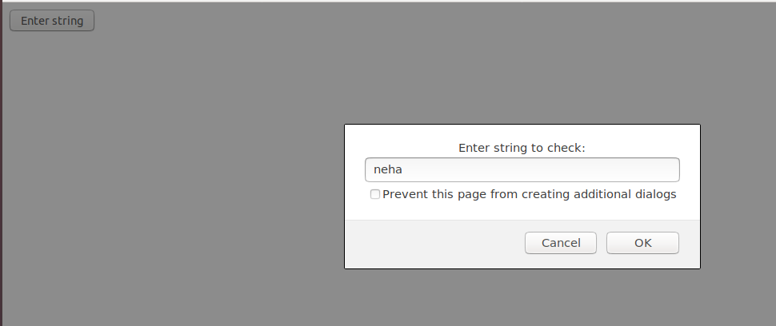



Ques 3:Area of circle

Sol 3:

<html>
<head>
<title>Circle</title>
</head>
<body>
<label>Radius of circle:</label>
<input type="text" id="rad" >
<input type="button" value="Find" onclick="circle_area()">
<script>
function circle_area(){

var area=document.getElementById("rad").value;
var ar=2*3.14*area;
window.alert("Area of circle with radius is:"+ar);

}
</script>
</body>
</html>

OUTPUT:

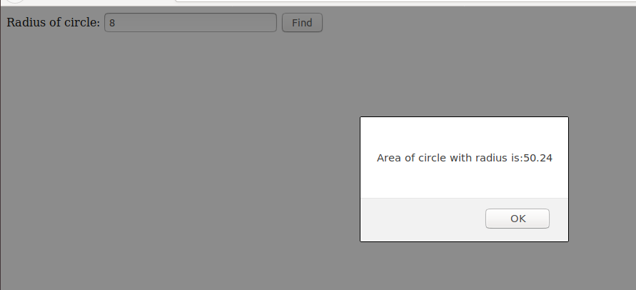

Ques 4:Copy information of one object to another and log it to console.

Sol 4:

<html>
<head>
<title>Console Log</title>
</head>
<body>
<button name="submit" value="Submit" onclick="parent()">Submit</button>
<script >
function parent(){
var val1=new Date();
var val2=copy(val1);
console.log("val1:"+val1 + "\ncopied val2:"+val2);
}

function copy(obj){
if (null == obj || "object" != typeof obj) return obj;
var copy1 = obj.constructor();
for (var attr in obj) {
if (obj.hasOwnProperty(attr)) copy1[attr] = obj[attr];
}
return copy1;
}
</script>
</body>
</html>

OUTPUT:

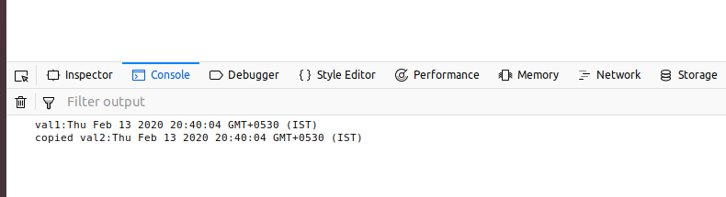

Ques 5: Create a list of objects of Employee with info as follow :
- Name, age, salary ,DOB
- filter all employees with salary greater than 5000
- group employee on the basis of their age
- fetch employees with salary less than 1000 and age greater than 20. Then give them an increment 5 times their salary
Sol 5:

<html>
<body>
<button name="Create" value="Create" onclick="create()">Create</button> Name, age, salary ,DOB<br><br>
<button name="Show" value="Show" onclick="filter()">Filter</button> filter all employees with salary greater than 5000<br><br>
<button name="group" value="group" onclick="group()">Group by age</button> Group employee on the basis of their age
<br><br>
<button name="increment" value="increment" onclick="increment()">Increment salary by 5 times</button> fetch employees with salary less than 1000 and age greater than 20. Then give them an increment 5 times their salary.
<br><br>
<div id="_div"></div>
<script>
{
var employee;
function create() {
employee = [
{ Name: 'neha', Age: 25,Salary: 20000, DOB: '07/08/1995'},
{ Name: 'sonal', Age: 22,Salary: 5000, DOB: '22/7/1998'},
{ Name: 'vijay', Age: 27,Salary: 15000, DOB: '22/11/1993'},
{ Name: 'shivam', Age: 25,Salary: 5000, DOB: '11/8/1995'},
{ Name: 'abhishek', Age: 26,Salary: 200, DOB: '22/9/1994'},
{ Name: 'vishesh', Age: 25,Salary: 1000, DOB: '22/8/1995'},
];
var i;
var table = "<TABLE border=2px cellspacing=5><thead><tr><th>NAME</th><th>AGE</th><th>SALARY</th><th>DOB</th></tr></thead>";
for(i=0; i<employee.length;i++){
table+="<tr>";
table+="<td>"+ employee[i].Name+"</td>";
table+="<td>"+ employee[i].Age+"</td>";
table+="<td>"+ employee[i].Salary+"</td>";
table+="<td>"+ employee[i].DOB+"</td>";
table+="</tr>";
}
table+="</TABLE>";
document.getElementById("_div").innerHTML = table;
}
function filter() {
var i;
var table = "<TABLE border=2px cellspacing=5><thead><tr><th>NAME</th><th>AGE</th><th>SALARY</th><th>DOB</th></tr></thead>";
for(i=0; i<employee.length;i++){
if(employee[i].Salary>5000) {
table+="<tr>";
table+="<td>"+ employee[i].Name+"</td>";
table+="<td>"+ employee[i].Age+"</td>";
table+="<td>"+ employee[i].Salary+"</td>";
table+="<td>"+ employee[i].DOB+"</td>";
table+="</tr>";
}
}
table+="</TABLE>";
document.getElementById("_div").innerHTML = table;
}
function group() {
var table;
var emp = employee.reduce((r, a) => {
r[a.Age] = [...r[a.Age] || [], a];
return r;
}, {});
table = "<TABLE border=2px cellspacing=5><thead><tr><th>Group</th><th>NAME</th><th>AGE</th><th>SALARY</th><th>DOB</th></tr></thead>";
for(var i in emp) {
table+="<td rowspan="+(emp[i].length+1)+">"+i+"</td>";
for( var e in emp[i]) {
table+="<tr>";
table+="<td>"+ emp[i][e].Name+"</td>";
table+="<td>"+ emp[i][e].Age+"</td>";
table+="<td>"+ emp[i][e].Salary+"</td>";
table+="<td>"+ emp[i][e].DOB+"</td>";
table+="</tr>";
}
}
table+="</TABLE>";
document.getElementById("_div").innerHTML = table;
}
function increment() {
var i;
var table = "<TABLE border=2px cellspacing=5><thead><tr><th>NAME</th><th>AGE</th><th>SALARY</th><th>DOB</th></tr></thead>";
for(i=0; i<employee.length;i++){
if(employee[i].Salary<1000 && employee[i].Age>20) {
employee[i].Salary *=5;
table+="<tr>";
table+="<td>"+ employee[i].Name+"</td>";
table+="<td>"+ employee[i].Age+"</td>";
table+="<td>"+ employee[i].Salary+"</td>";
table+="<td>"+ employee[i].DOB+"</td>";
table+="</tr>";
}
}
table+="</TABLE>";
document.getElementById("_div").innerHTML = table;
}
}
</script>
</body>
</html>

OUTPUT:

- Name, age, salary ,DOB
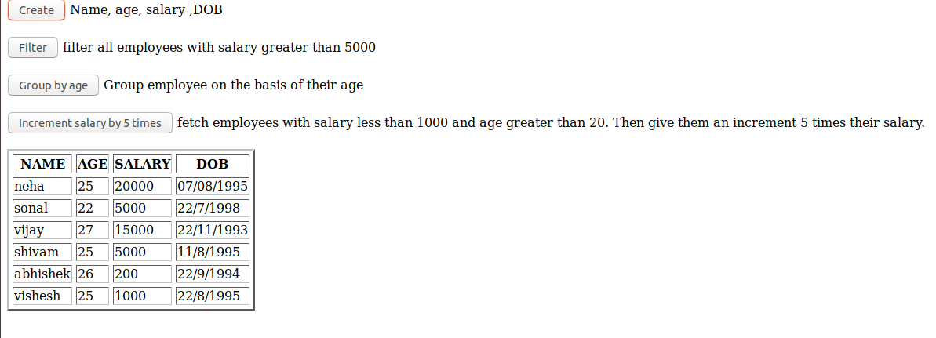

- filter all employees with salary greater than 5000
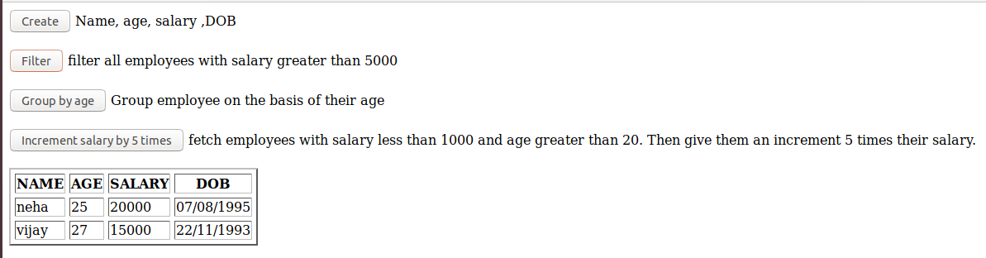

- group employee on the basis of their age

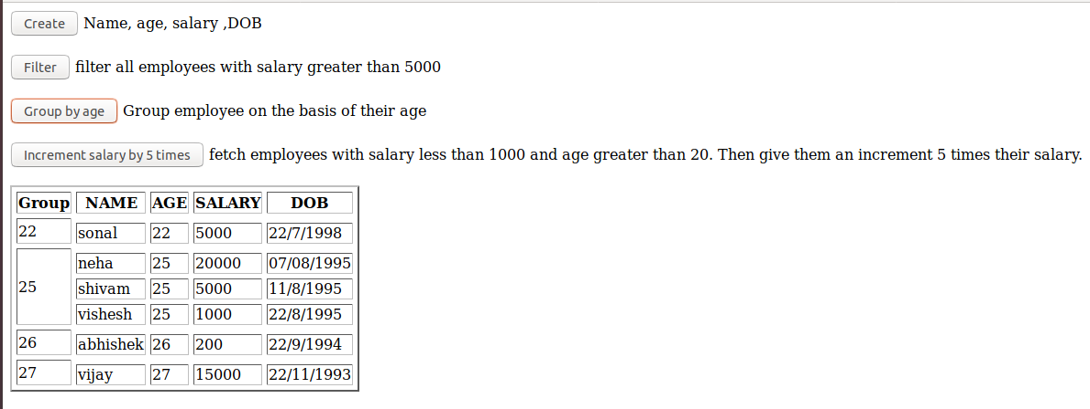

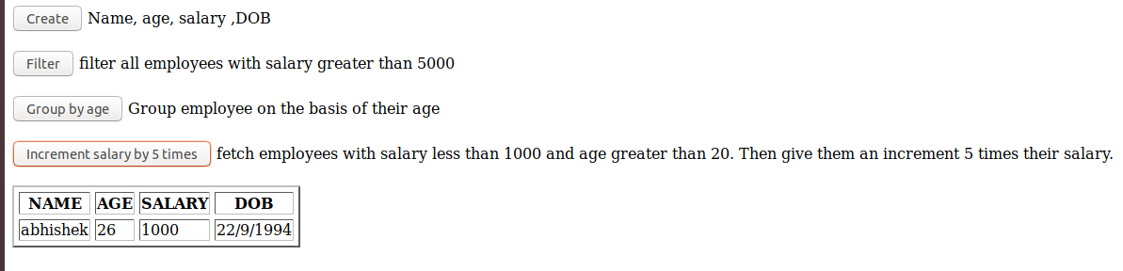
- fetch employees with salary less than 1000 and age greater than 20. Then give them an increment 5 times their salary.

