Task 4
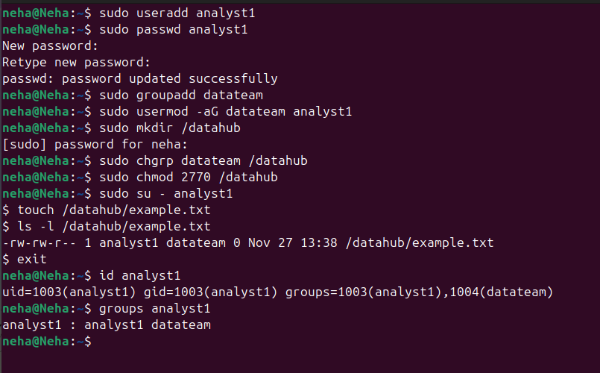
(bonus included in above image)

