Task 7
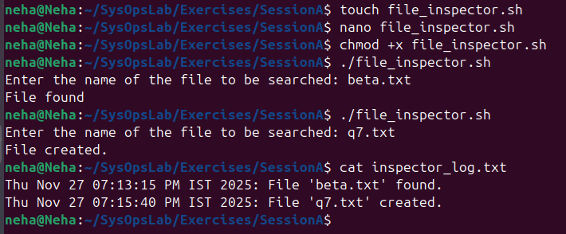
(bonus included above)
file_inspector.sh
