Task 13
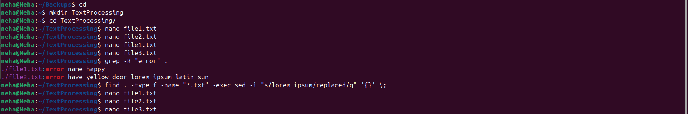

file1.txt (before grep, awk, and sed commands)
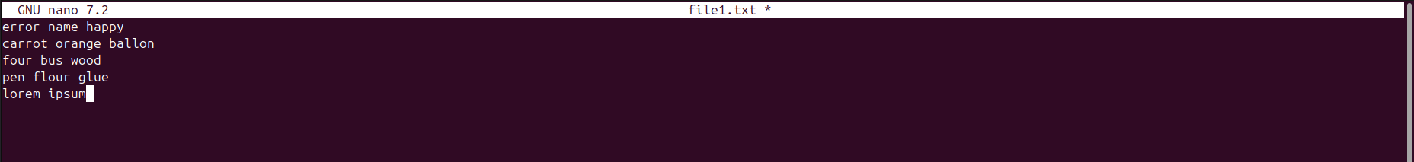

file2.txt (before grep, awk, and sed commands)

file3.txt (before grep, awk, and sed commands)

file1.txt (after grep, awk, and sed commands)

file2.txt (after grep, awk, and sed commands)

file3.txt (after grep, awk, and sed commands)


Bonus challenge:
