Task 12
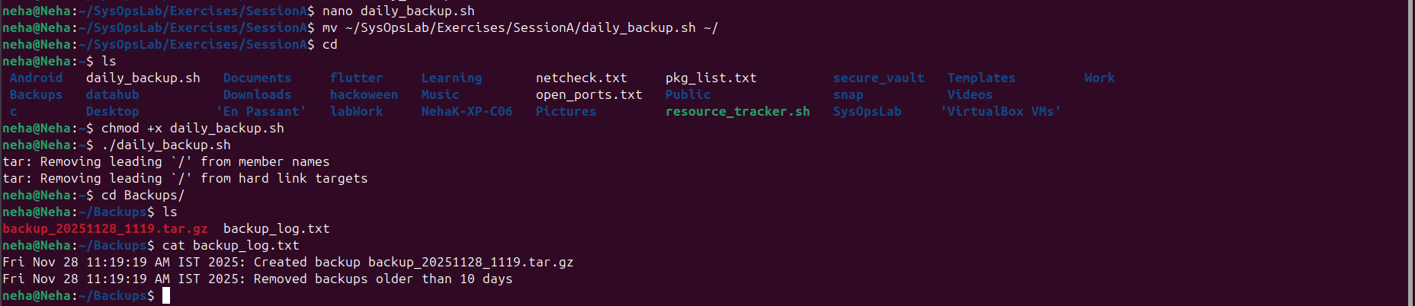

daily_backup.sh
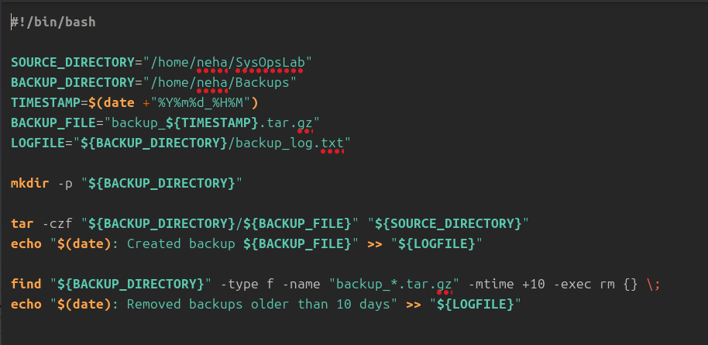

Bonus challenge:
backup_log.txt


