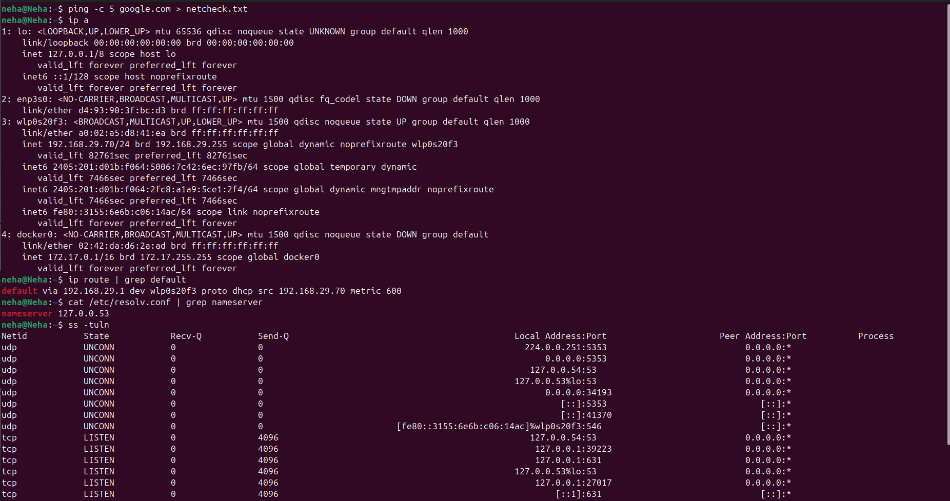
Task 6

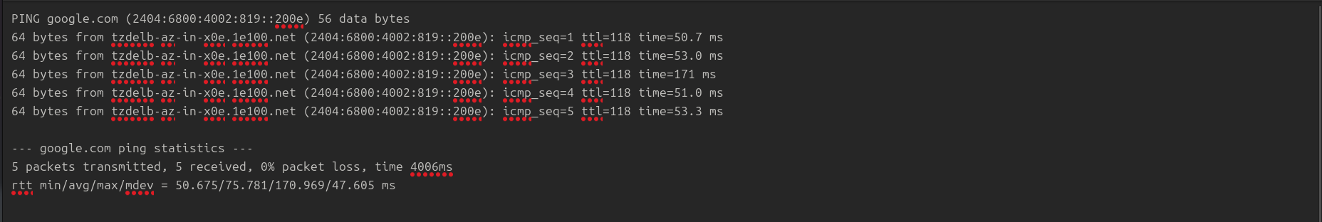
netcheck.txt

Bonus:
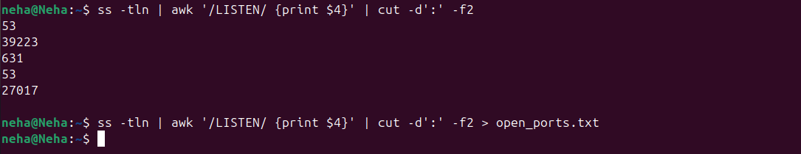

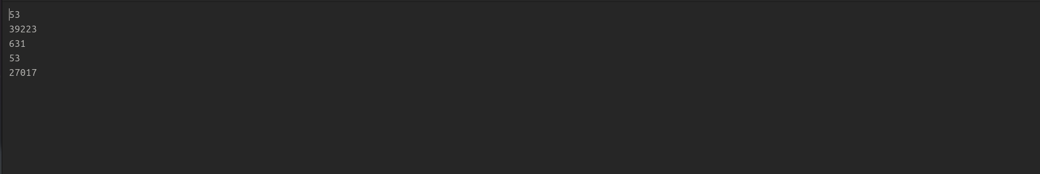

open_ports.txt

