Advanced Database Systems Lab

Assignment 03

Title : MySQL /PSM Review and Object Relational Databases

Name : Neha Pintu Kharat

Batch : T-2

PRN : 21510024

Aim / Objective : To review MySQL /PSM and Object Relational Databases

Theory : MySQL is a widely used open-source relational database management system, known for its adherence to the relational database model and ACID compliance. It supports multiple storage engines, offering flexibility based on specific use cases. Persistent Stored Modules (PSM) is an extension to MySQL, enabling the creation of stored procedures, functions, and triggers with procedural constructs. While MySQL does not inherently support all features of object-oriented databases, its extensibility and support for PSM allow developers to implement complex logic within the database. For applications requiring advanced object-oriented features, exploring dedicated Object-Relational Database Management Systems (ORDBMS) like PostgreSQL or Oracle might be considered for a more comprehensive solution.

The university management system consists of three users:Student,Instructor and the Advisor and all given certain privileges to the database.

ScreenShots:

1]Tables created and used in this management system:

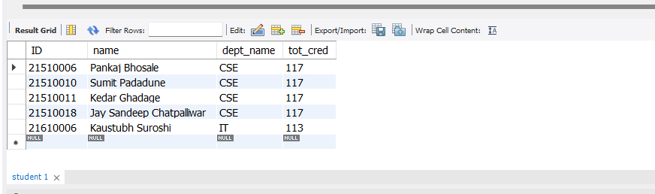

2]Detailed University Schema:

3]Frontend Screenshots:









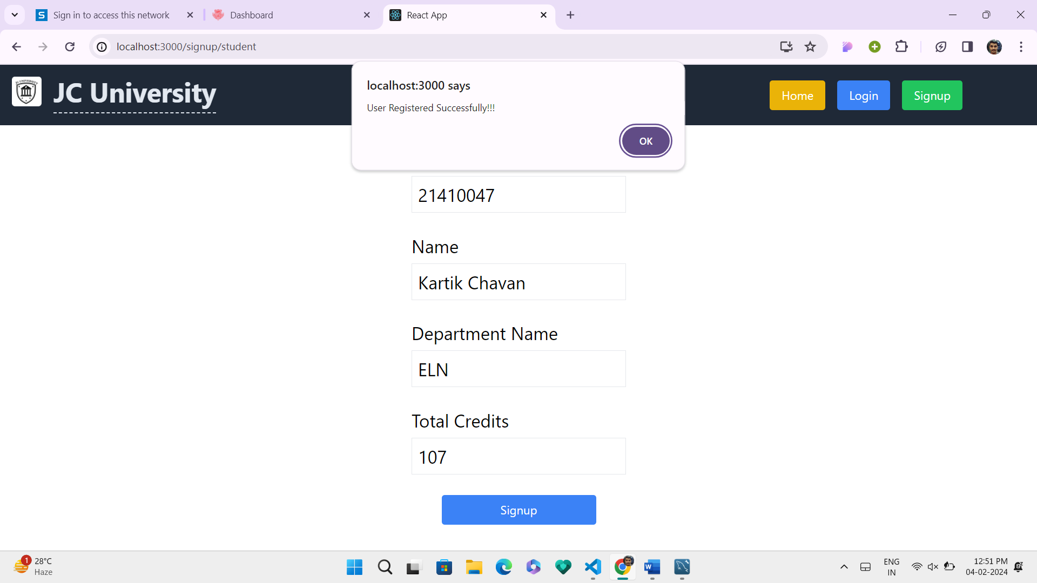

End of the assignment