**Advanced Database Systems Lab**

**Assignment 08**

**Distributed Database Systems**

Name : Neha Pintu Kharat

PRN : 21510024

Class : TY CSE

Title : Configuration of Distributed Database in a cluster using MYSQL InnoDB Cluster Management.

Theory :

InnoDB, MySQL's storage engine, embodies core theories ensuring robust database management. Central to its design are the ACID properties, guaranteeing Atomicity, Consistency, Isolation, and Durability of transactions. Leveraging multi-versioning concurrency control (MVCC), InnoDB enables concurrent access to data while maintaining consistency and isolation levels adjustable via transaction isolation settings. Its row-level locking mechanism minimizes contention by locking individual rows rather than entire tables, enhancing concurrency. The buffer pool caches frequently accessed data and indexes in memory, optimizing query performance. Transaction logs facilitate crash recovery, ensuring data durability by replaying changes after system failures. Supporting foreign key constraints and auto-increment columns, InnoDB enforces referential integrity and generates unique values automatically. Its clustered index organization enhances query performance by physically ordering data on disk. Understanding these principles is fundamental for effective database design, implementation, and management within InnoDB.

Steps followed for creating clusters and sandboxing the localhost:

1] The localhost is sandboxed to three instances having ports 3310 , 3320 , 3330.The name of the cluster is ‘devCluster’ .

Screenshots :

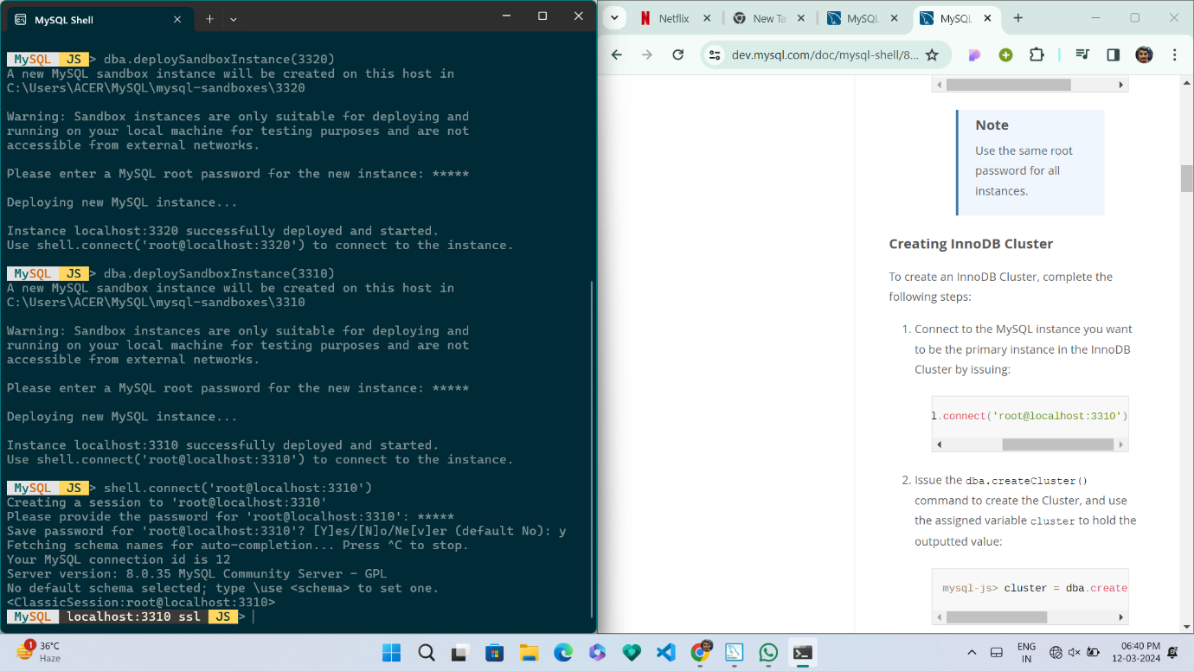

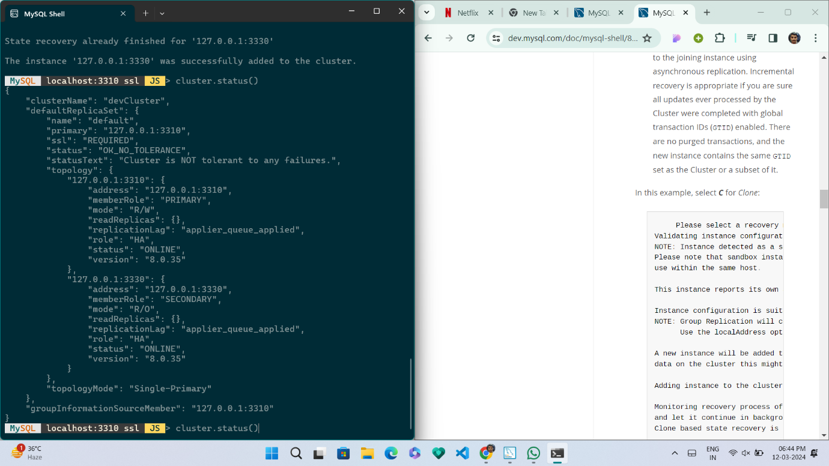

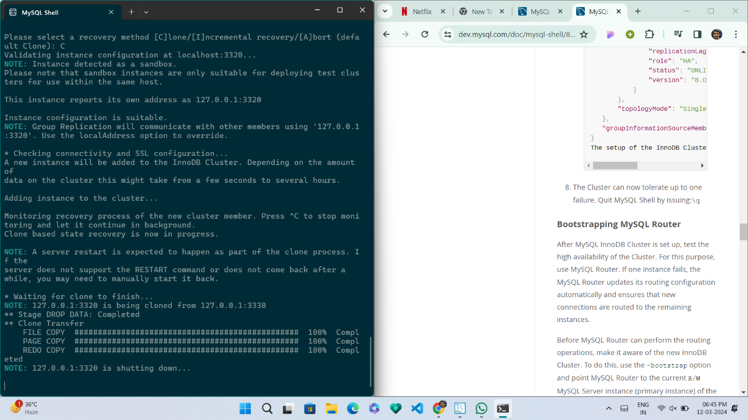

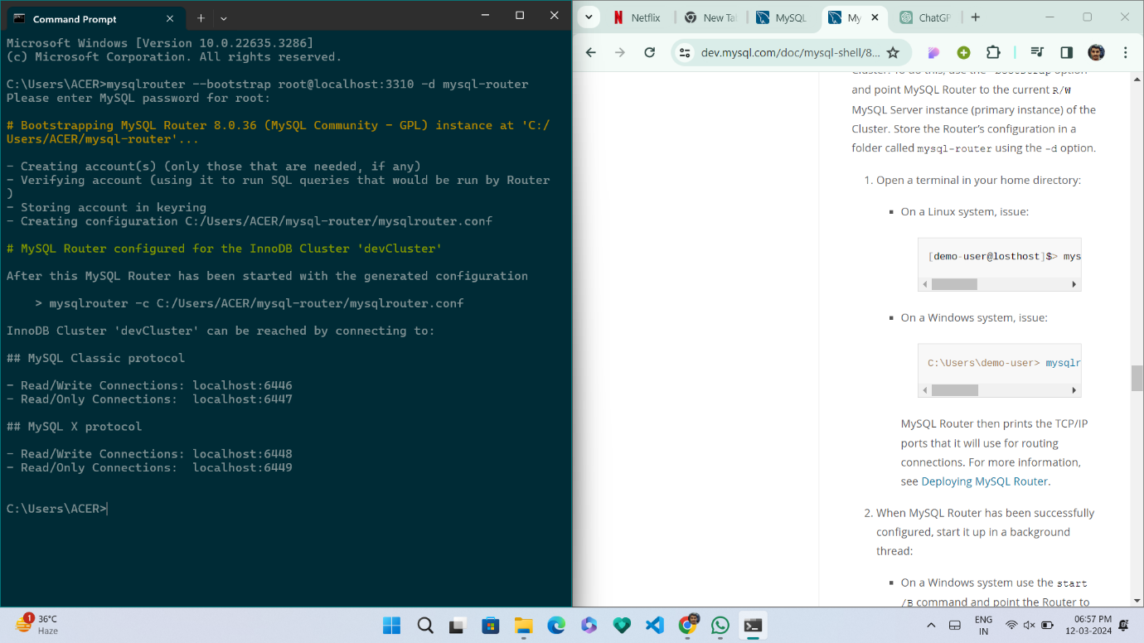

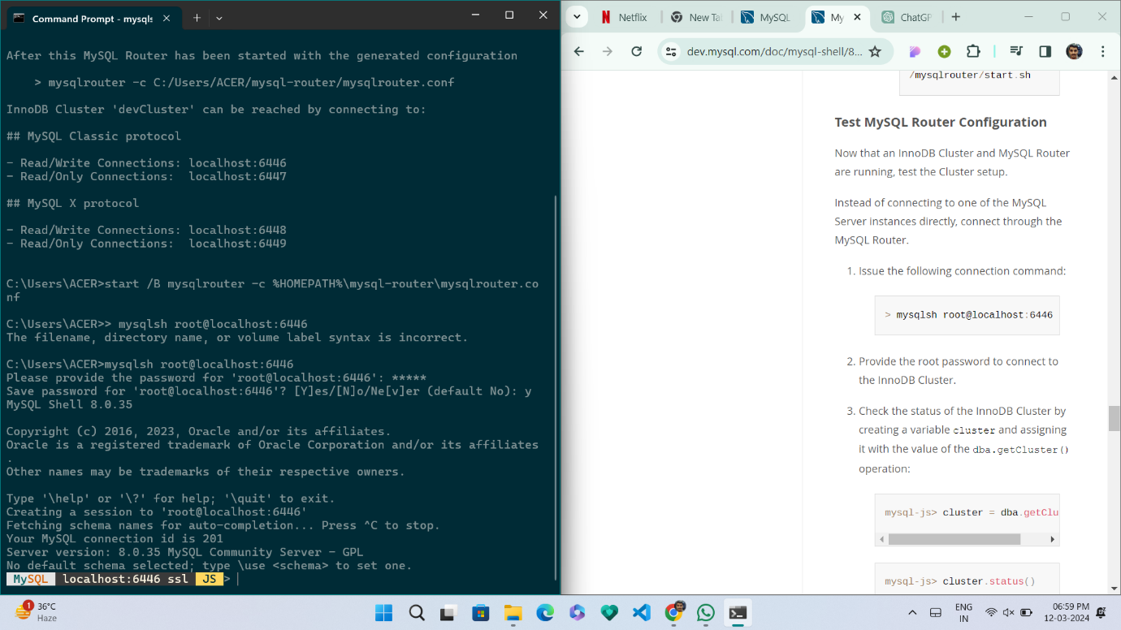

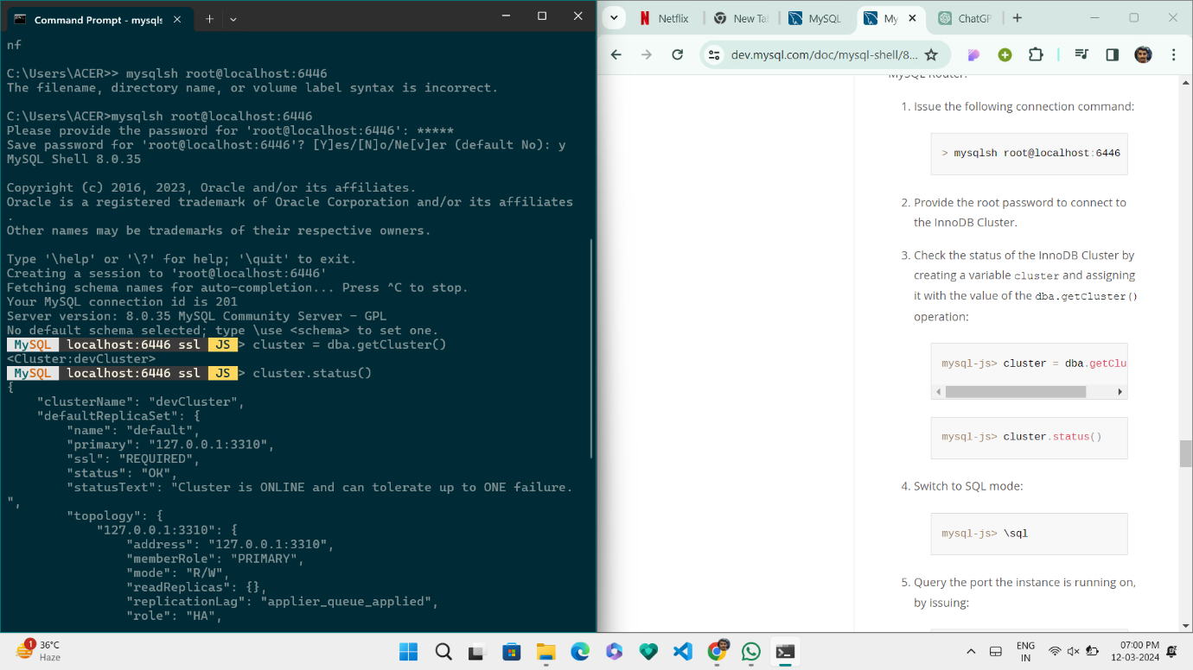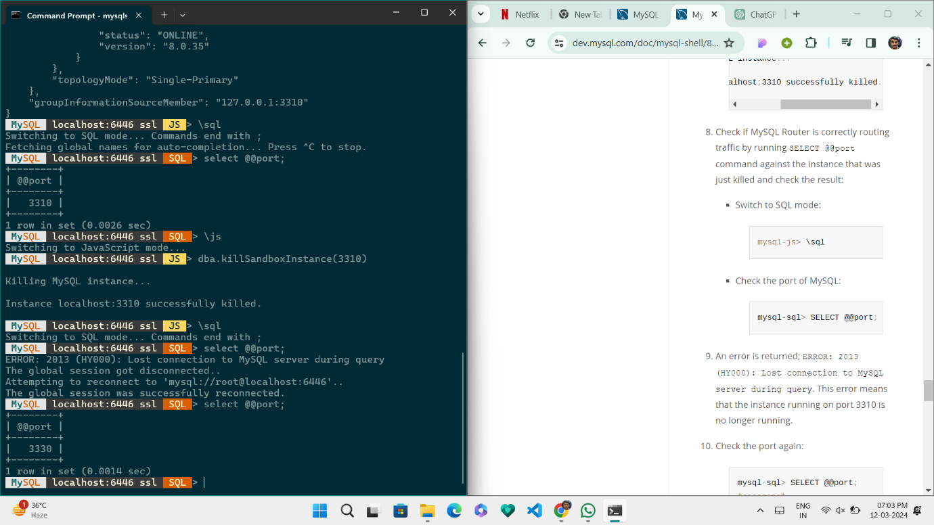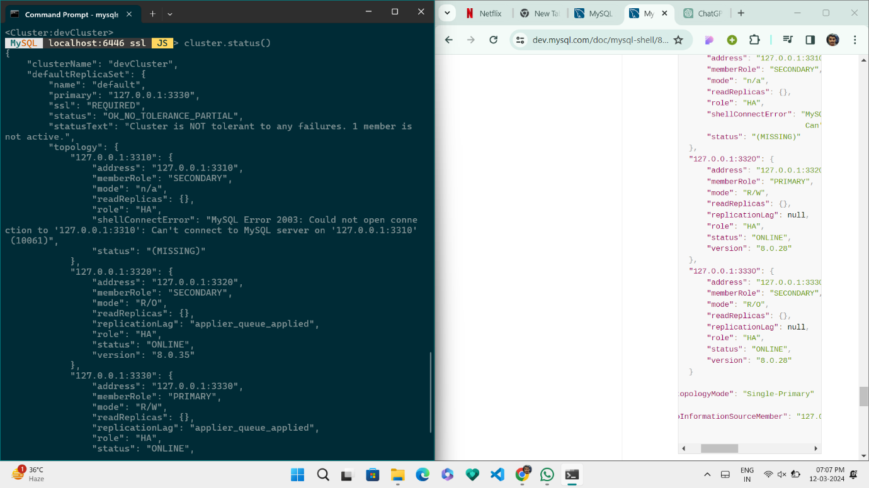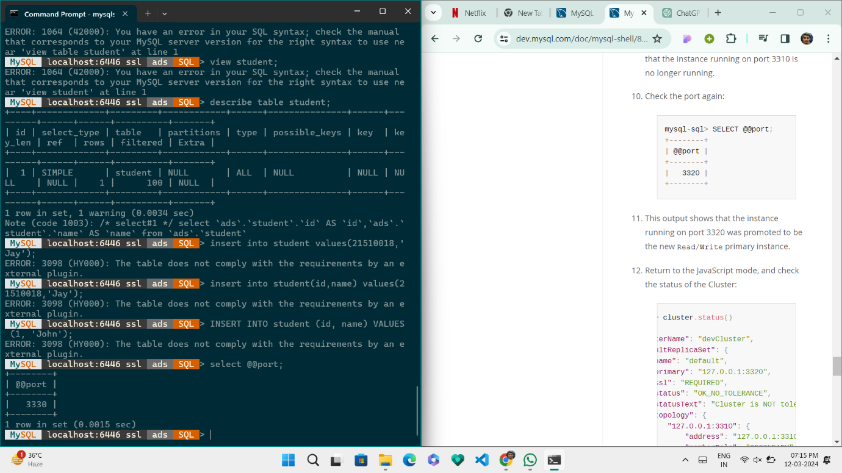

End of Assignment…