**Assignment 11**

**PRN – 21510024**

**Batch – T5**

Consider the “**Research Papers Database”** scenario as follows :

The research papers have authors (often more than one). Most papers have a classification (what the paper is about). The classifications form a hierarchy in several levels (for example, the classification “Databases” has the subclassifications “Relational” and “Object-Oriented”). A paper usually has a list of references, which are other papers. These are called citations.

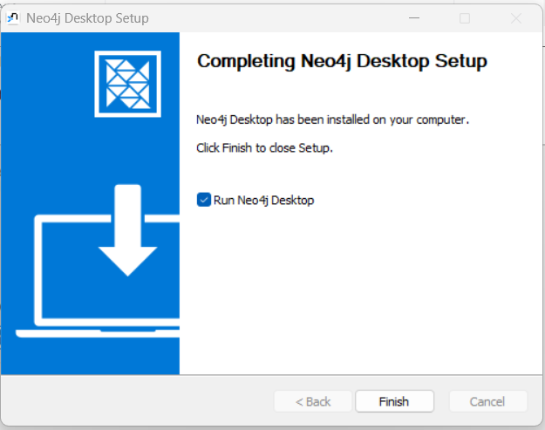

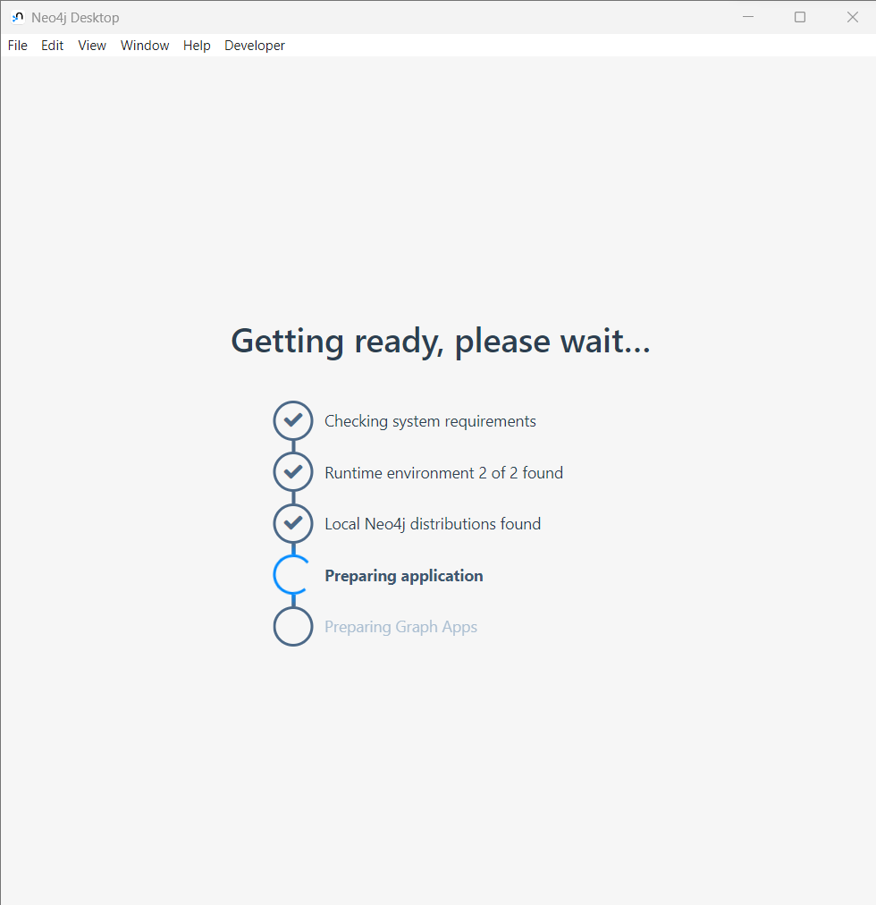

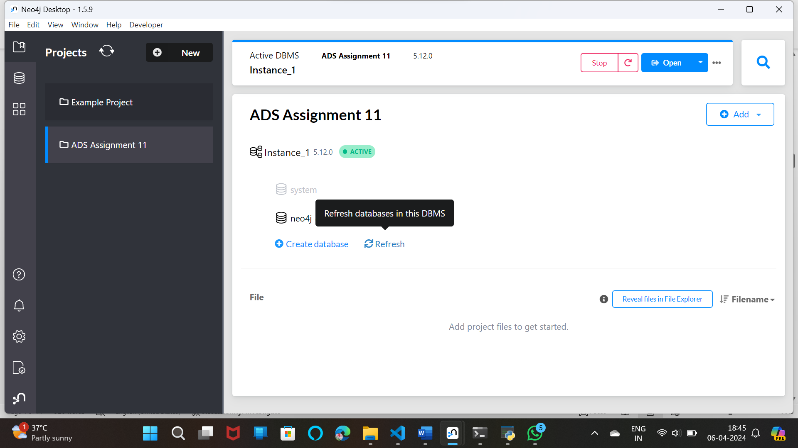

LOAD CSV WITH HEADERS FROM

'https://raw.githubusercontent.com/ngshya/datasets/master/cora/cora_content.csv'

AS line FIELDTERMINATOR ','

CREATE (:Paper {id: line.paper_id, class: line.label})

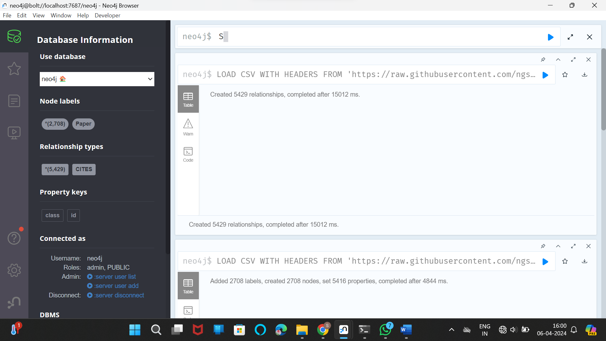

LOAD CSV WITH HEADERS FROM

'https://raw.githubusercontent.com/ngshya/datasets/master/cora/cora_cites.csv'

AS line FIELDTERMINATOR ','

MATCH (citing_paper:Paper {id: line.citing_paper_id}),(cited_paper:Paper {id: line.cited_paper_id})

CREATE (citing_paper)-[:CITES]->(cited_paper)

LOAD CSV WITH HEADERS FROM

'https://raw.githubusercontent.com/ngshya/datasets/master/cora/cora_content.csv'

AS line FIELDTERMINATOR ','

CREATE (:Paper {id: line.paper_id, class: line.label})

call db.schema.visualization

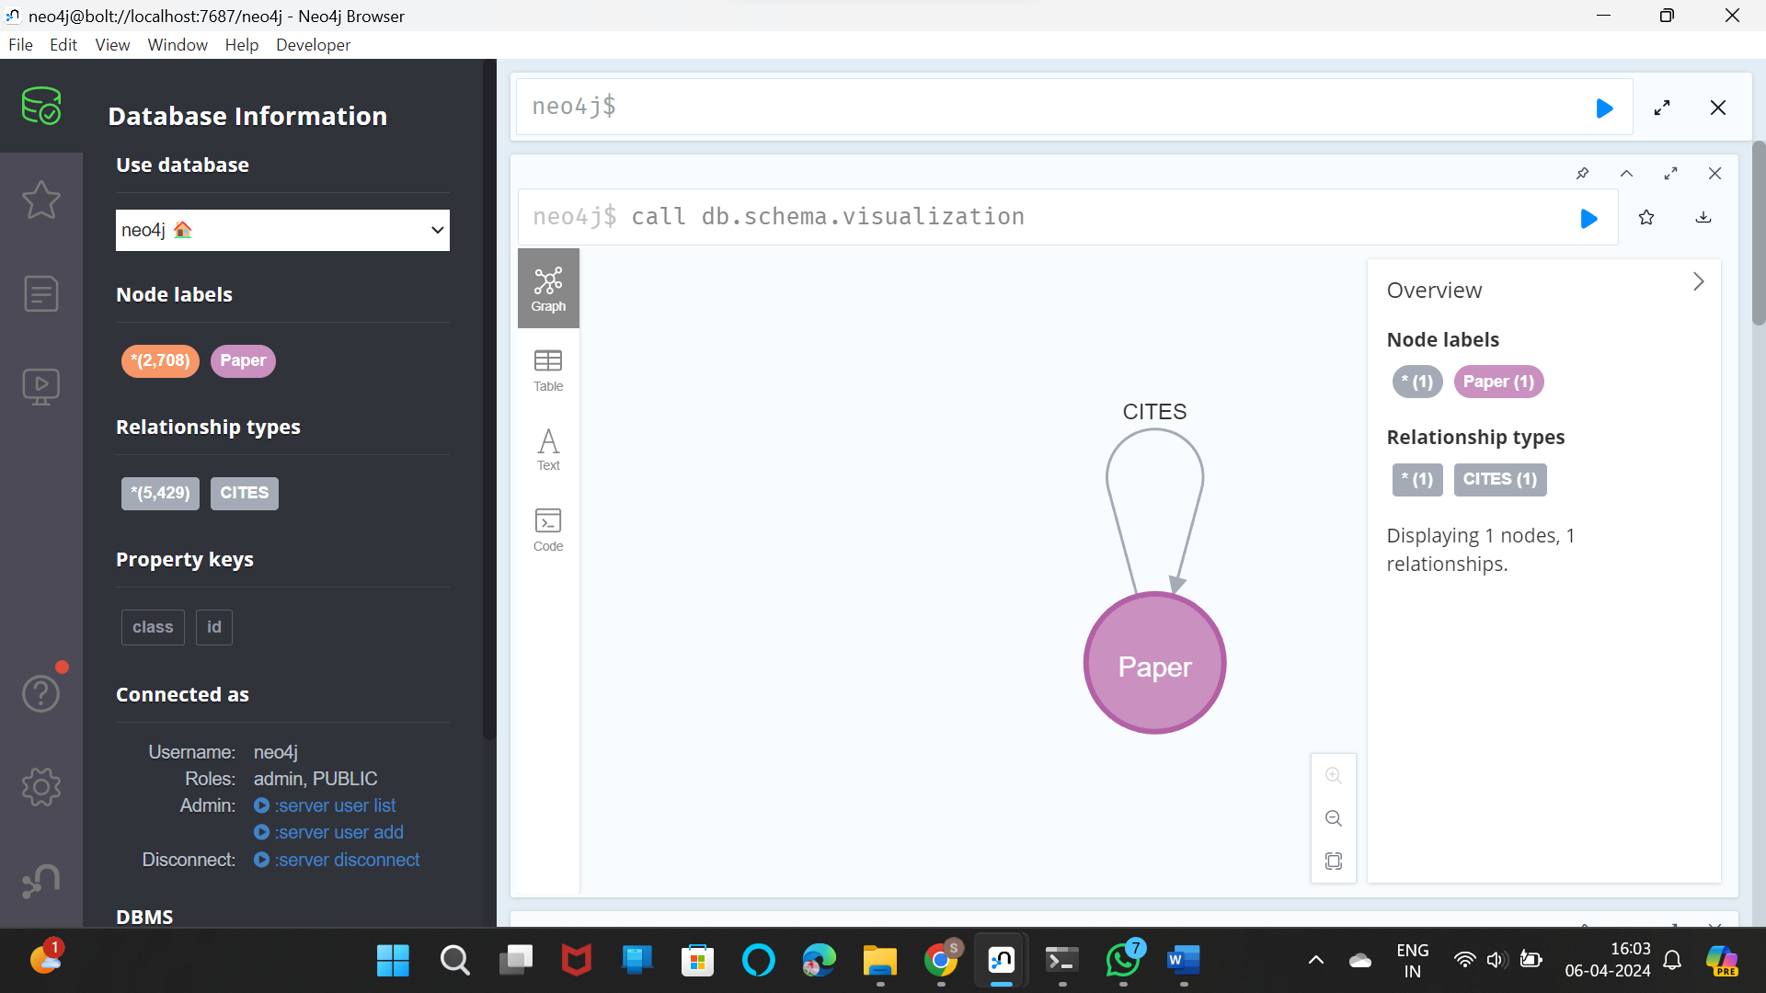

CREATE CONSTRAINT FOR (p:Paper) REQUIRE p.id Is UNique

CREATE CONSTRAINT FOR (a:Author) REQUIRE a.name Is UNIQUE

CREATE CONSTRAINT FOR (c:Classification) REQUIRE c.name Is UNIQUE

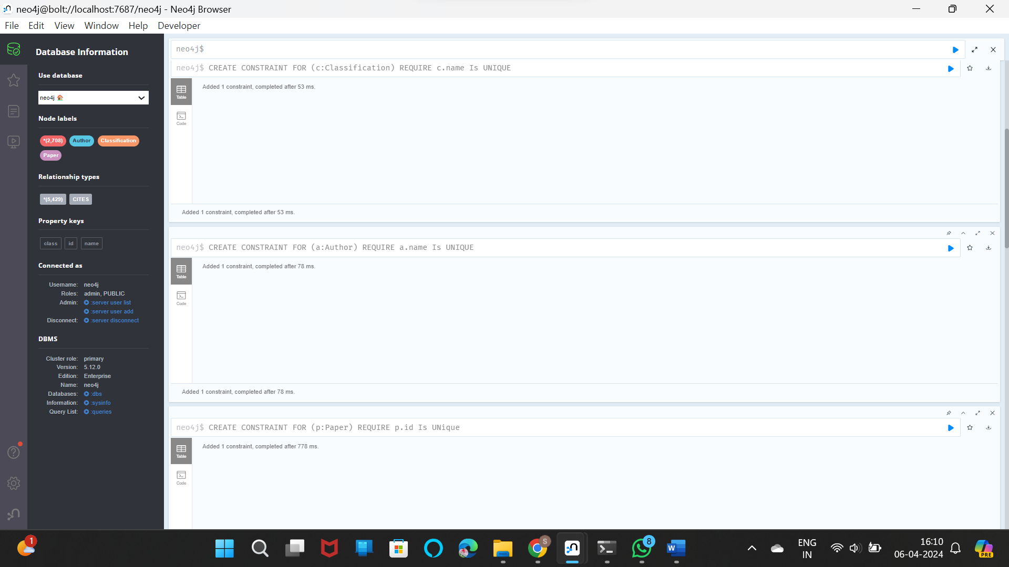

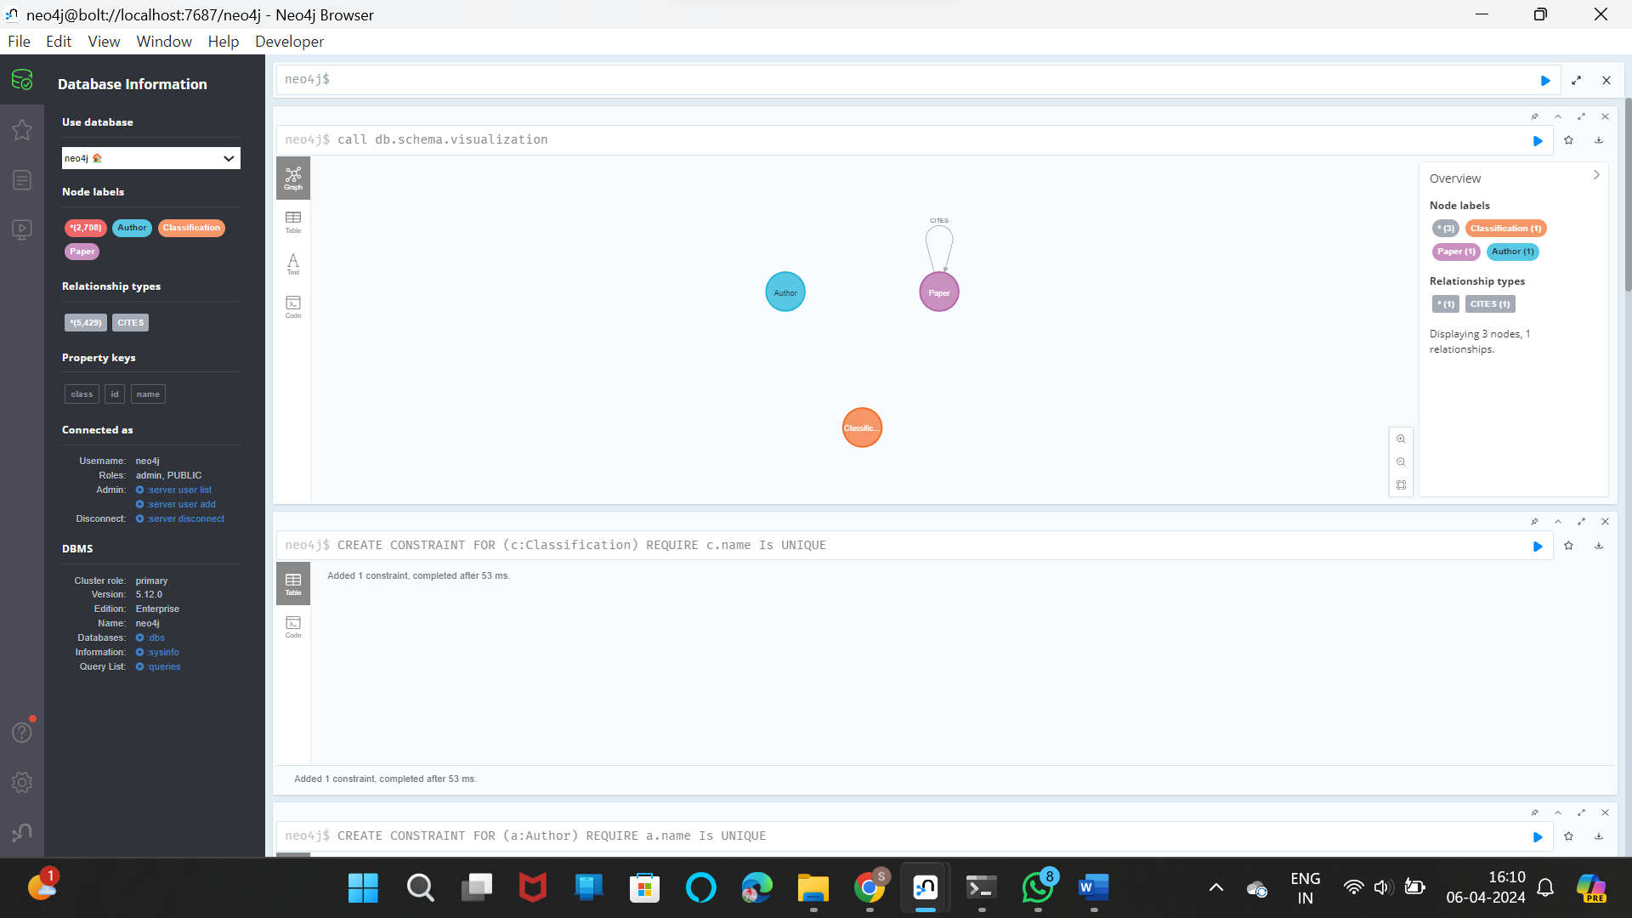

MATCH (p:Paper) RETURN DISTINCT p.class ORDER BY p.class

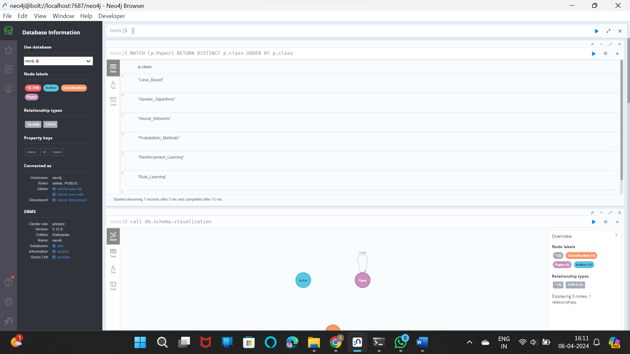

MATCH p=()-[r:CITES]->() RETURN p

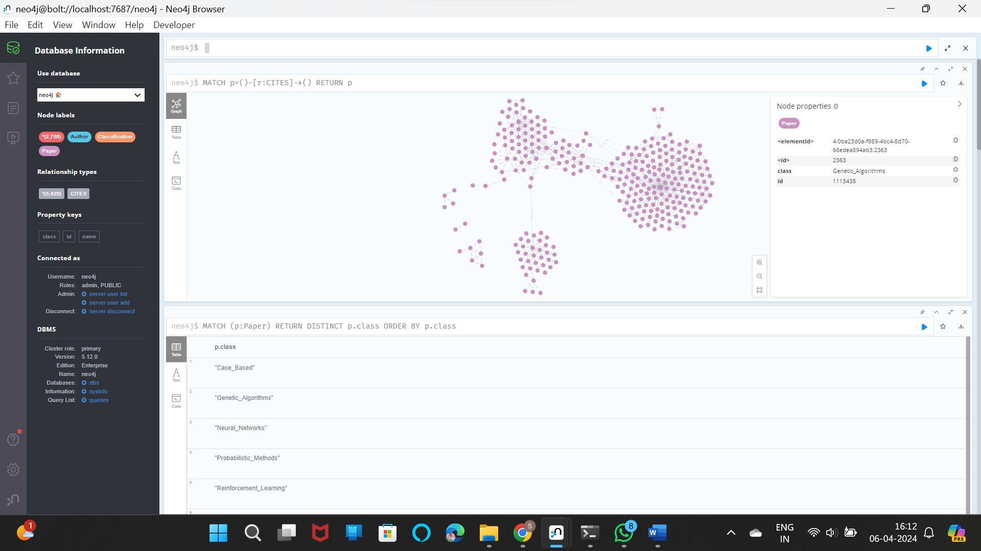

Python Application -

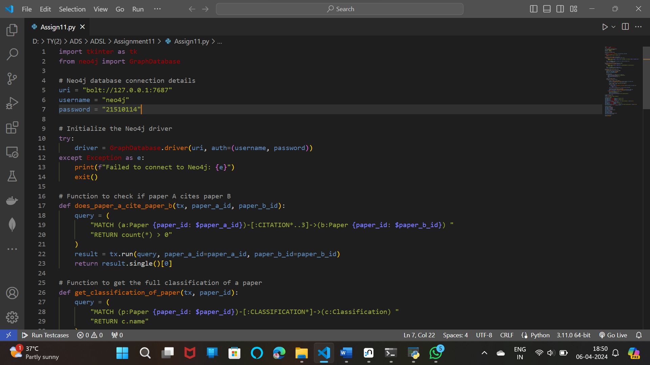

Output -

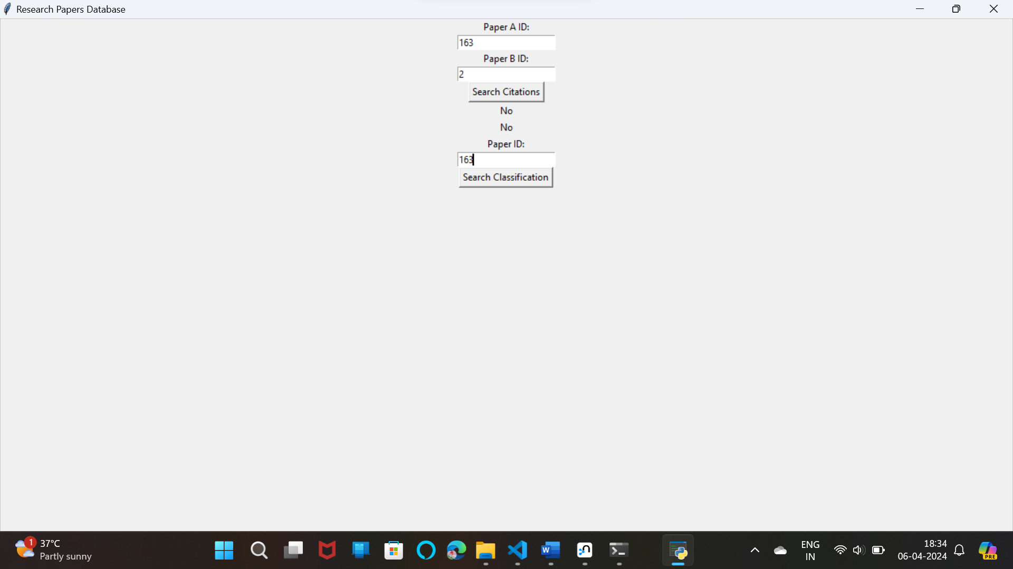

**Step. 1]**

LOAD CSV WITH HEADERS FROM 'https://raw.githubusercontent.com/ngshya/datasets/master/cora/cora_content.csv' AS line FIELDTERMINATOR ','

MERGE (c:Classification {name: line.label})

**Step. 2]**

LOAD CSV WITH HEADERS FROM 'https://raw.githubusercontent.com/ngshya/datasets/master/cora/cora_content.csv' AS line FIELDTERMINATOR ','

MATCH (p:Paper {id: line.paper_id})

MERGE (c:Classification {name: line.label})

MERGE (p)-[:HAS_CLASSIFICATION]->(c)

**Step. 3]**

MATCH (c:Classification)--(p:Paper)

RETURN c.name AS ClassificationName, p.id AS PaperID

LIMIT 10

**To check whether there is self loop or not:-**

MATCH (p:Paper)-[r:CITES]->(p)

RETURN p.id AS PaperID