Software Requirements Specification

# **1. Introduction**

# **1.1 Purpose**

The intended audience for this SRS includes all of the stakeholders in the PES Times project. The document will be used by team developing the project as the specification from which to implement the working program code. The document will also be used by the development as a statement of what functionality will be delivered during the project. The document will be used as a deliverable for the academic portion of the Software Engineering class and graded for its quality.

## **1.2 Scope**

The PES Times is a web based portal that will keep the students of PES college abreast of the upcoming events of college in a convenient and consolidated manner. The portal will allow the students to track all upcoming events being organised by various clubs and keep track of their participation. It will also have a feature that will allow for book exchange among the students of PES. It will not be available as an application on mobile systems.

## **1.3 Definitions, Acronyms, and Abbreviations**

PES: People’s Education Society

Newsfeed: The continuous stream of upcoming events displayed when a user logs in.

## **2. General Description**

# **2.1 Product Perspective**

PES Times is a web portal made solely for the students of PES to track and manage ongoing events on campus. It aims to replace the current scenario of sparse groups on social networking sites and other websites of various clubs. The system is designed to have four main roles around the portal as shown in the diagram. The interactions between the portal and the user as illustrated as follows.

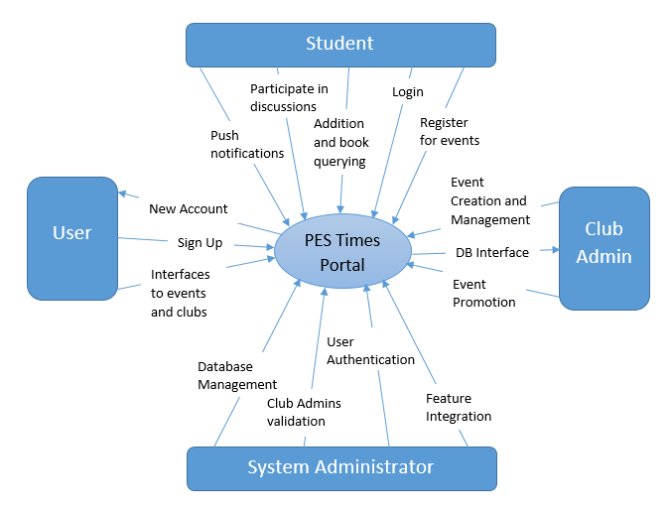

***Fig 1: Context diagram for PES portal***

## It is important to note that Students and Club Admins have the basic interfaces to clubs and events. Students have some additional benefits in comparison to users without account as specified and Club Admins have a separate interface to perform event management. User authentication is done only to the extent of identifying and verifying the users and their passwords if they have accounts in the website.

## **2.2 Product Features**

FE-1: One-click event registration

FE-2: Multiple clubs interfacing

FE-3: Sign-up for new users

FE-4: Log-in for existing users

FE-5: Event creation and management

FE-6: Event interfacing

FE-7: Discussion forum

FE-8: Club info-graphic

FE-8: Event Promotion

FE-9: Push notifications

FE-10: Registration database management

FE-11: Book-exchange database management

FE-12: Book-addition and query



## **2.3 User Characteristics**

|  |  |
| --- | --- |
| **College Student** | Student of the particular college for which the website has been developed will use it for the following purposes.   * To check the various events organized by different clubs * They need to log in to avail the services * They have the options to browse events under the name of the club or category * If they want to participate in any one them, they will be able to register through the registration link provided * A logged in student can also start a discussions by commenting under that event which he/she attended or wishes to attend. * They can put up the name of the books they want to sell on the website and can look for the book names they want to purchase from the fellow other students as well. |
| **User** | The students from different colleges or any user without a login can view the websites but cannot register for the events or participate in any forum anywhere on the webpage. Logins are given only to students belonging to PES. |
| **Club Administrator** | Club administrator is a special student who, along with the above privileges will also be the head of one of the many clubs of the college. He would be given special privileges like creating, updating and deleting an event. When a club admin logs in, his username will be verified as the admin with the already present information on the database. This will enable the admin to access the administrator page of his registered club and their activities inside it. |
| **System Administrator** | System administrator will keep a track on the working of the website and is responsible to integrate any new features on the same. Also, if a new club emerges and needs to be put on the web page, the club administrator has to contact the system administrator to do the same. |

## **2.4 Operating Environment**

|  |  |
| --- | --- |
| **OE-1:** | The system is not dependent on geographical areas. |
| **OE-2:** | The system shall operate in the newest versions of all web browsers. |
| **OE-3:** | The logged in user (same college student) can access all the features as compared to the students from different colleges. |
| **OE-4:** | Data is generated from the registration link (online forms) as well as the information generating during the booking for a book to buy or a book to sell. |
| **OE-5:** | Continuous service is preferred, but as long as there is no data loss, minor interruptions can be tolerated. |
| **OE-6:** | Javascript, Bootstrap, HTML/CSS is used for generating the user interface for the system. |
| **OE-7:** | Django Framework is used for creation of databases to store the information from the registration links and book exchange features. |
| **OE-8:** | To allow the students to fill up the required information to participate in events online Google Forms will be generated with the information fields provided by the club admins. |

## **2.5 General Constraints**

## The pes times portal will not be able to operate if there is no connection to the server. It needs a good framework without which it cannot interact with the database. The logged in user should be able to access all the features as compared to users from different colleges. Continuous service is required. Data loss and interruptions limit the operating environment.

Another limiting constraint will be its availability as an application on mobile phones.

**2.6 Assumptions and Dependencies**

Assumptions:

* Will be used by the students of the college. i.e. the primary target audience
* Students and Club Admins should have the basic interfaces to clubs and events.
* The PES times portal should be able to operate on the newest versions of all the web browsers.
* A database is one another such assumption needed to manage and store the number of event registrations, to retrieve and add events etc. The PES times portal uses django as the basic framework that interacts with the mysql database.
* The system administrator will keep track of the website and integrate new features into the website as and when needed. Eg. If another feature besides the book exchange feature needs to be added.
* Club administrators should be able to access the page of his/her club along with the activities in it.

Dependencies:

* The users depend on the clubs and the newsfeed for information, the events for interfacing and the database for registration.
* The developers depend on the software tools being used. i.e. javascript, html, css, django and bootstrap.
* The club administrators depend on the new events they can create and the promotions of such events and the students who will register for such events.

## **3. Specific Requirements**

## **3.1 Functional Requirements**

* What the system does:
  + Keep track and display all the events – past, present and future.
  + Details about all the clubs.
  + Facility to allow the users with an account to register for events.
  + Notifications for events.
  + Admin specific functions:
    - Creation of events
    - Managing the events
    - Updating the details and gallery for the clubs/events
  + Book exchange: provision for students to exchange books among themselves.
* What the system doesn’t do:
  + If an event requires a monetary transaction, the student needs to submit the fees in person – the club doesn’t have support for online transaction.
  + Similarly for book exchange, online transaction facility is not provided.

## **3.2 Non-Functional Requirements**

* Performance – depends on the server load and the bandwidth of the user
* Scalability – non-scalable, in general, because the usage of the portal is limited to PES
* Availability – a server is required to be up 24x7
* Recoverability – a backup has to be maintained of all the data up and running on the server
* Security – basic USN and password login, no more security provided
* Interoperability – interdependency between databases, e.g.: database for events has club ID (PK from club database)
* Data Integrity – normalized databases ensure the integrity of data
* Reliability – handled by the admins of the different clubs, so discrepancy might creep in due to some miscreants
* Usability – a simple UI makes the portable usable by anyone and everyone
* Environmental – web-based application

## **3.3 External Interface Requirements**

* User Interface:
  + The Web application developed will be mobile friendly and enticing with the latest materialistic design.
  + Users can navigate between Newsfeed, book exchange section, specific club activities page via the navigation drawer
  + In addition to the navigation tabs present at the top of the page.
  + Users will be redirected to the events registration page on clicking on a particular event on the news feed.Users will be able to register themselves for a particular event with just the click of a button
* Software Interface:
  + **Database** - The system shall communicate with a database for the following operations
    - To retrieve the most latest and upcoming events from the list of events to populate the news feed.
    - To manage event registrations - stats about the no of registrations etc.
    - To allow the club admins to create and add new events to the list of events.
  + **AJAX** - The system shall use the AJAX concept for the following
    - load images of past events only when the user demands it.
    - To fetch more events/activities from the database when the user scrolls to the end of the newsfeed and then extend the feed with the asynchronously fetched data.
    - To retrieve and display the list of sellers when a user searches for a particular book in book exchange section.
  + **Django**
    - To manage the entire backend and the interaction with the database.
    - Processing the response to the queries made by the user and converting it to the standard JSON string format before sending it back to the client.
    - Read the data from the database, filter it and order it.
    - Django ORM : allows a developer to write Python code instead of SQL to create, read, update and delete data and schemas in their database - can speed up web application development, especially at the beginning of a project.
  + **Twitter Bootstrap**
    - To make the webpages highly responsive and furnish them with materialistic styling/design.