**EXPERIMENT 1**

Create a topology and simulate sending a simple PDU from source to destination using hub and switch as connecting devices and demonstrate ping message.

**1.1 Hub**

**1.1.1 Topology**

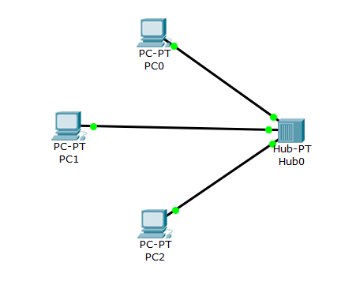

**1.1.2 Simulation**

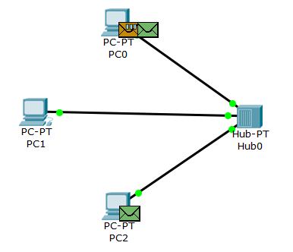

Simulation- in progress

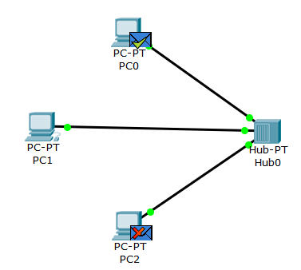

Simulation successful(PDU sent from host PC0 to host PC1)

**1.1.3 Output**

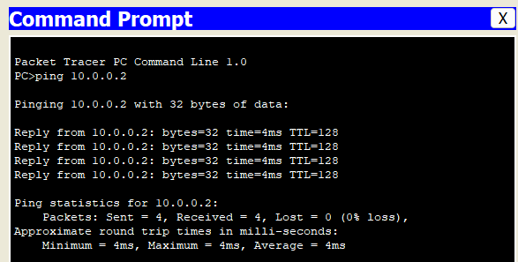

ping PC1(10.0.0.2) from PC0(10.0.0.1)

**1.2 Switch**

**1.2.1 Topology**

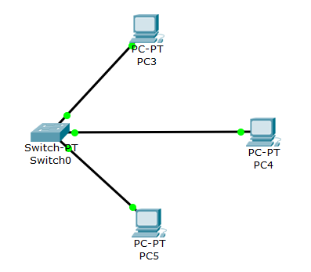

**1.2.2 Simulation**

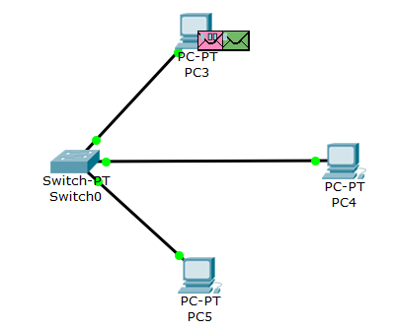

Simulation- in progress

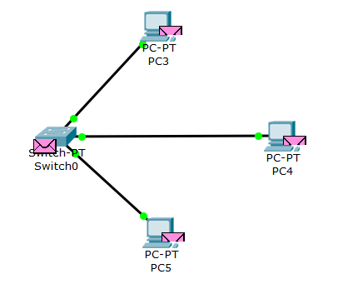

Simulation successful

**1.2.3 Output**

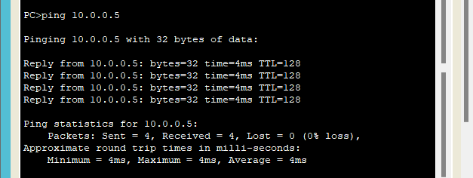

ping PC4(10.0.0.5) from PC3(10.0.0.4)

**1.3 Hybrid (Switch and Hub)**

**1.3.1 Topology**

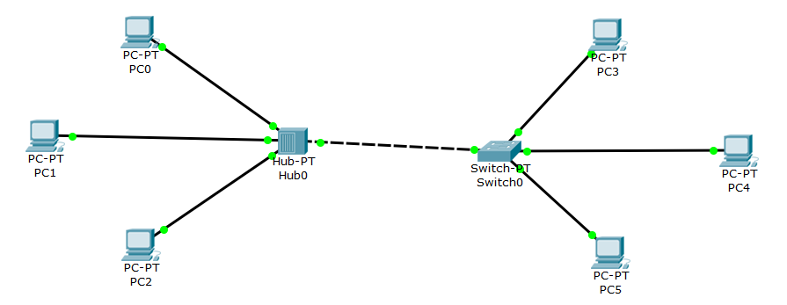

**1.3.2 Simulation**

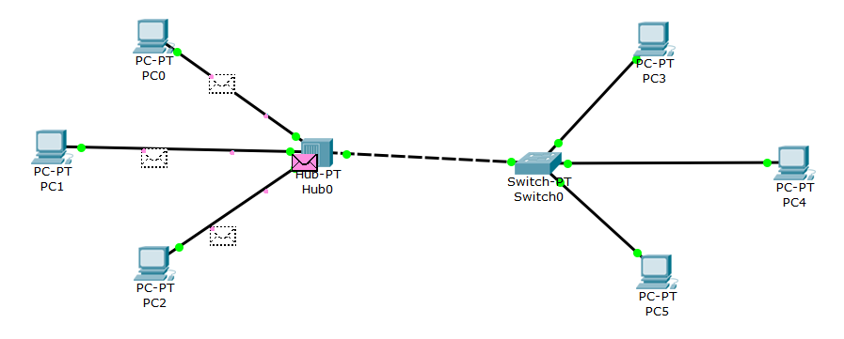

Simulation successful

**1.3.3 Output**

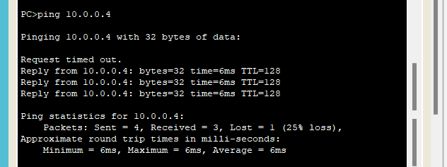

ping PC3(10.0.0.4) from PC0(10.0.0.1)

**EXPERIMENT 2**

Configure IP address to routers in packet tracer. Explore the following messages: request timed out and reply.

**2.1 Topology**

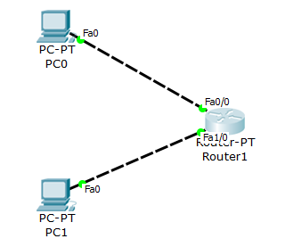

**2.2 CLI commands to configure IP address to routers**

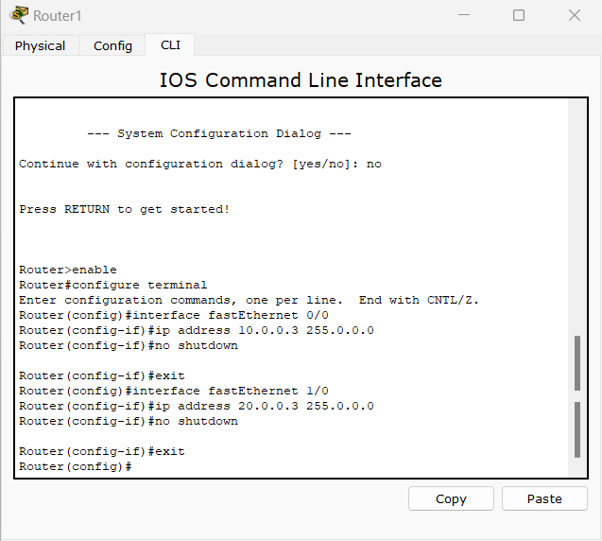

**2.3 Simulation**

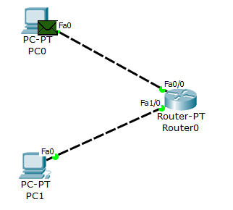

Simulation- in progress

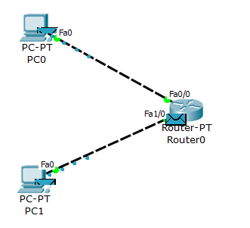

Simulation sucessful

**2.4 Output**

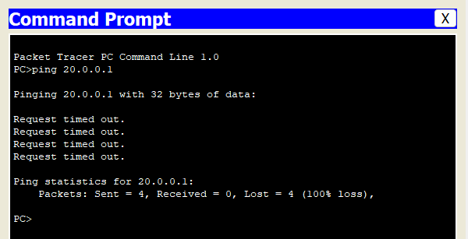

Gateway of end devices is not set after configuring the router. PC0(10.0.0.1) does not receive an acknowledgement message from PC1(20.0.0.1)

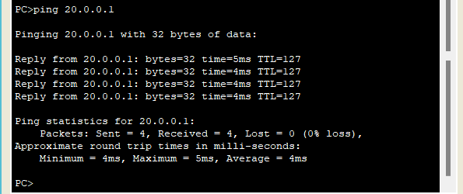

ping PC1(20.0.0.1) from PC0(10.0.0.1)(After the routers are configured and the gateways of end devices are set correctly)

**EXPERIMENT 3**

Configure default route, static route to the Router.

**3.1 Static Routing**

**3.1.1 Topology**

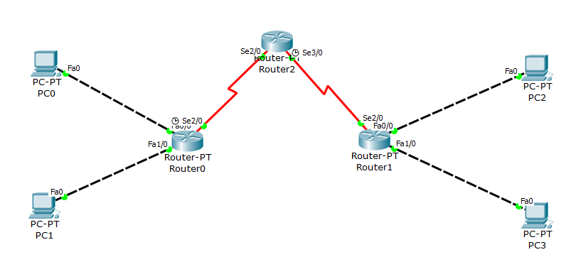

**3.1.2 CLI Commands to configure the routers**

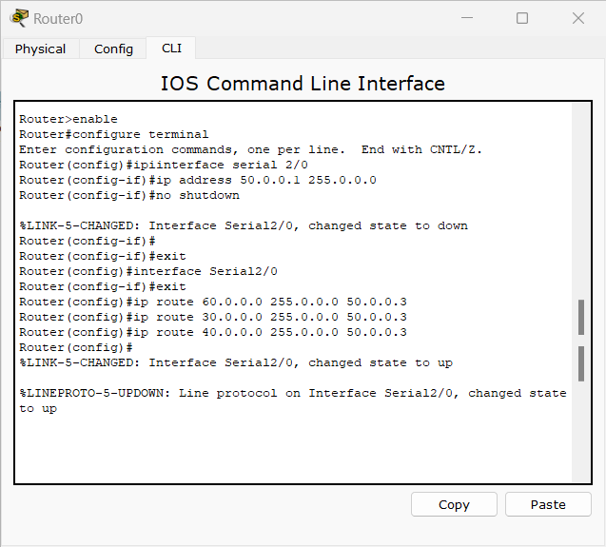

Configuring Router0

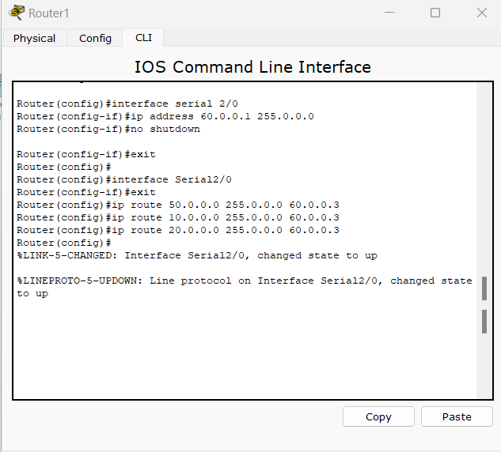

Configuring Router1

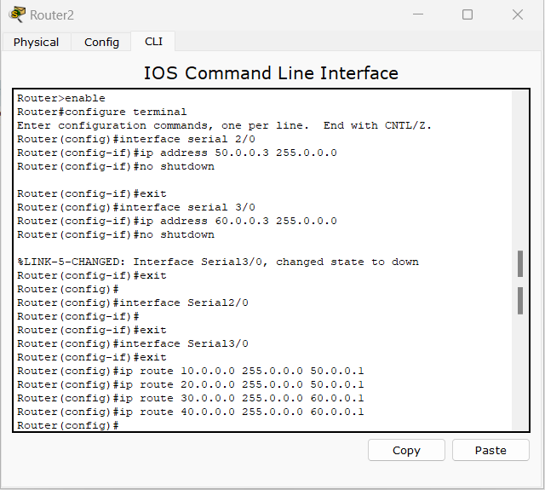

Configuring Router2

**3.1.3 Simulation**

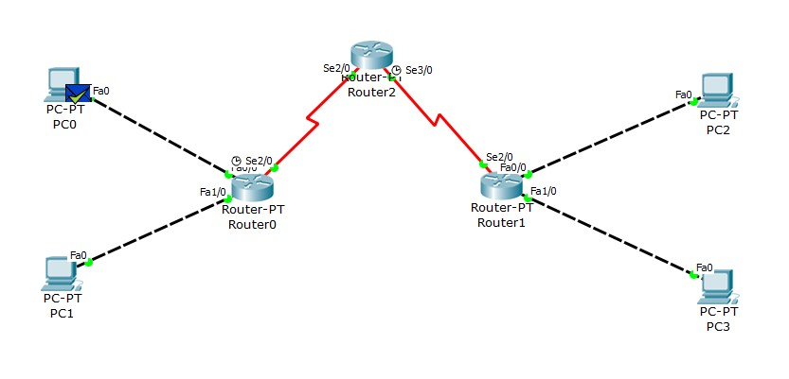

Simulation successful(PDU sent from PC0(10.0.0.1) to PC2(30.0.0.1))

**3.1.4 Output**

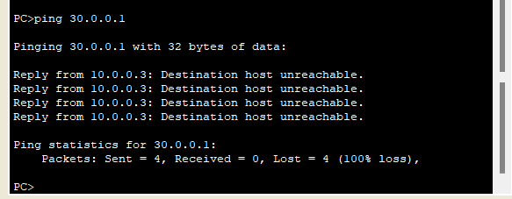

PDU sent from PC0(10.0.0.1) to PC2(30.0.0.1) but Router0 is not configured to deliver the packets(no ip route)

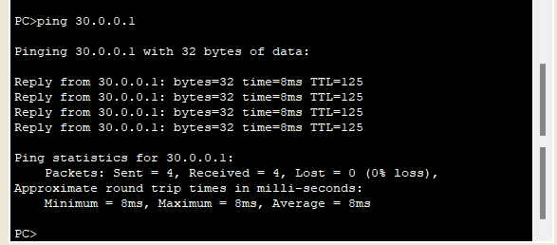

ping PC2(30.0.0.1) from PC(10.0.0.1) after all the routers are configured

**3.2 Default Routing**

**3.2.1 Topology**

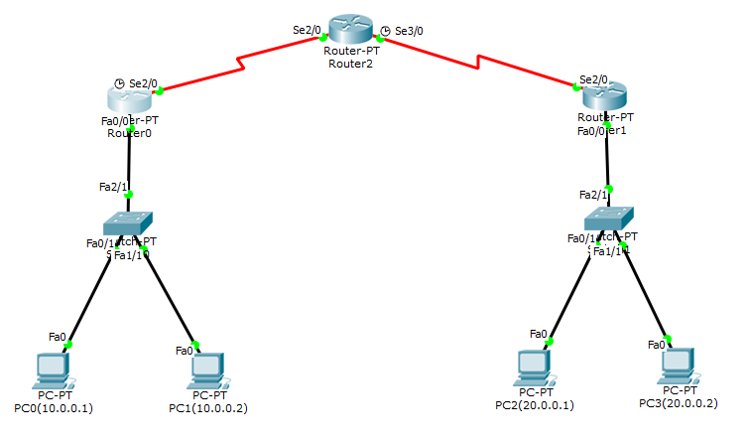

**3.2.2 CLI Commands to configure the routers**

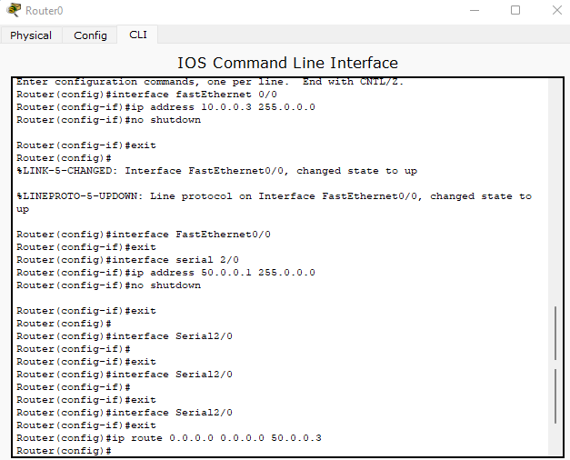

Configuring Router0 (Default routing)

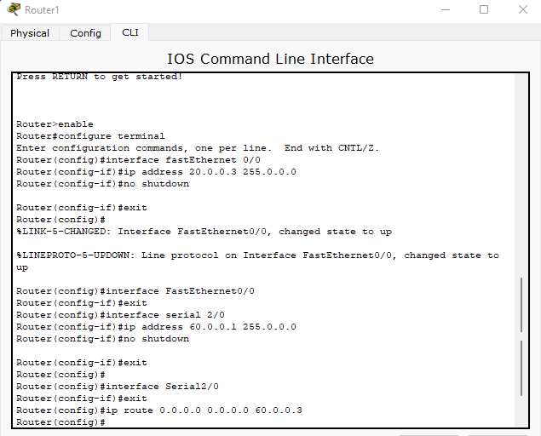

Configuring Router1 (Default routing)

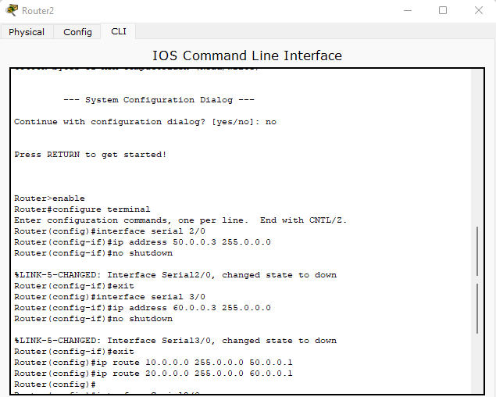

Configuring Router2

**3.2.3 Simulation**

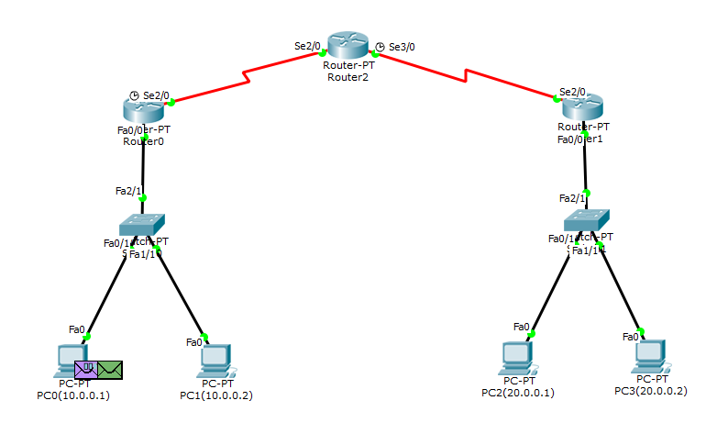

Simulation- in progress( PDU sent from PC0 to PC2)

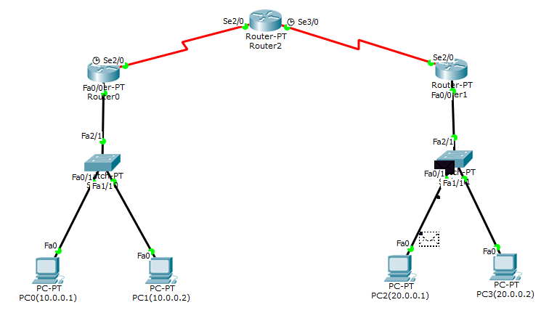

Simulation successful

**3.2.4 Output**

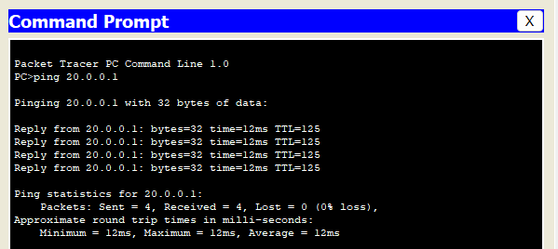

ping PC2(20.0.0.1) from PC0(10.0.0.1)