Week1-Car insurance

create database 1BM21CS113_Insurance;

use 1BM21CS113_Insurance;

create table Person

(

driver_id varchar (20),

name varchar (20),

address varchar (30));

alter table Person

add primary key(driver_id);

create table Car

(

reg_num varchar (15) primary key,

model varchar (20),

year int);

create table owns

(

driver_id varchar (20),

reg_num varchar (15),

primary key (driver_id, reg_num),

foreign key(driver_id) references Person(driver_id),

foreign key(reg_num) references Car(reg_num));

create table Accident

(

report_num varchar (20) primary key,

accident_date date,

location varchar (30));

create table participated

(

driver_id varchar (20),

reg_num varchar (15),

report_num varchar (20),

primary key (driver_id, reg_num, report_num),

damage_amount double,

foreign key(driver_id) references Person(driver_id),

foreign key(reg_num) references Car(reg_num),

foreign key(report_num) references Accident(report_num));

desc Person;

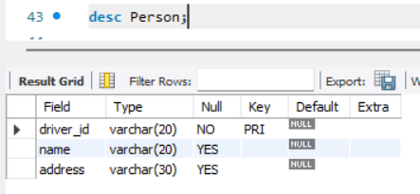

desc Car;

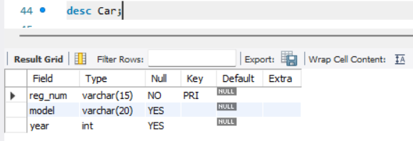

desc owns;

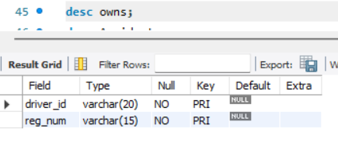

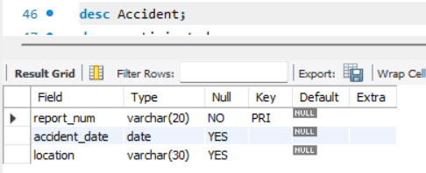desc Accident;

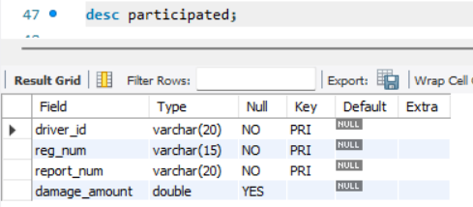desc participated;

insert into Person values ('A01', 'Ramesh','RR nagar');

insert into Person values ('A02', 'Suresh', 'Rajajinagar');

insert into Person values ('A03', 'Raghu', 'Jainagar');

insert into Person values ('A04', 'Ramchandra', 'Uttrahalli');

insert into Person values ('A05','Chandu','Nagarbhavi');

select * from Person;

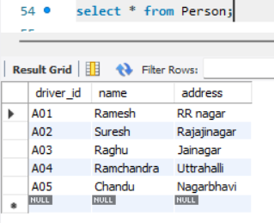

insert into Car values('KA04MB2345','Q1',2013);

insert into Car values('KA08N1254','Q2',2015);

insert into Car values('KA07MB2634','Q3',2015);

insert into Car values('KA02MB7123','Q4',2017);

insert into Car values('KA41N3089','Q5',2018);

select * from Car;

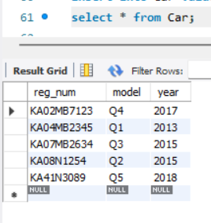

insert into owns values('A01','KA04MB2345');

insert into owns values('A02','KA08N1254');

insert into owns values('A03','KA07MB2634');

insert into owns values('A04','KA02MB7123');

insert into owns values('A05','KA41N3089');

select * from owns;

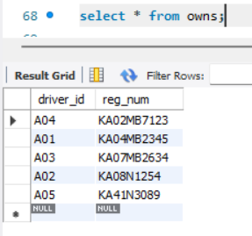

insert into Accident values('01', '2022-01-24', 'Banglore');

insert into Accident values('02', '2022-04-8', 'Hosur');

insert into Accident values('03', '2022-05-25', 'Electronic City');

insert into Accident values('04', '2022-09-19', 'Kanakpura Road');

insert into Accident values('05', '2022-07-07', 'Hosur');

select * from Accident;

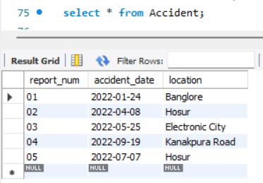

insert into participated values('A01','KA04MB2345','01',25000);

insert into participated values('A02','KA08N1254','02',30000);

insert into participated values('A03','KA07MB2634','03',10000);

insert into participated values('A04','KA02MB7123','04',20000);

insert into participated values('A05','KA41N3089','05',15000);

select * from participated;

