DBMS-LAB-WEEK3-BANK DATABASE

create database 1bm21cs113_bank;

use 1bm21cs113_bank;

create table branch

(

branch_name varchar(15) primary key,

branch_city varchar(15),

assets decimal);

create table BankAccount

(

accno int primary key,

branch_name varchar(15) not null,

foreign key(branch_name) references branch(branch_name),

balance decimal);

create table BankCustomer

(

customer_name varchar(25) primary key,

customer_street varchar(20),

city varchar(20));

create table Depositer

(

customer_name varchar(25),

accno int,

primary key(customer_name,accno),

foreign key(customer_name) references BankCustomer(customer_name),

foreign key(accno) references BankAccount(accno));

create table Loan

(

loan_no int primary key,

branch_name varchar(15),

foreign key(branch_name) references branch(branch_name),

amount decimal);

desc branch;

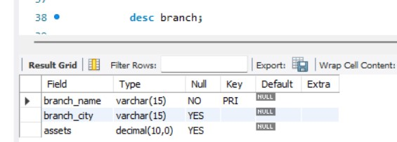

desc BankAccount;

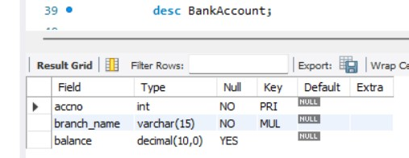

desc BankCustomer;

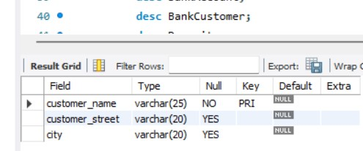

desc Depositer;

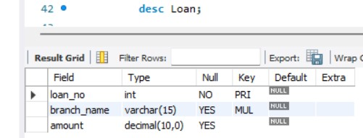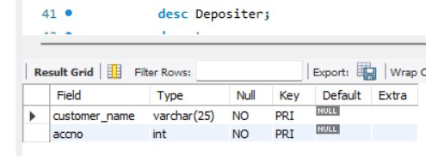

desc Loan;

insert into branch values("hdfc-Chamrajpet","Banglore",200000);

insert into branch values("hdfc-ShivajiRd","Mumbai",500000);

insert into branch values("hdfc-Jainagar","Banglore",350000);

insert into branch values("hdfc-RajivChowk","Delhi",500000);

insert into branch values("hdfc-JM","Delhi",600000);

select * from branch;

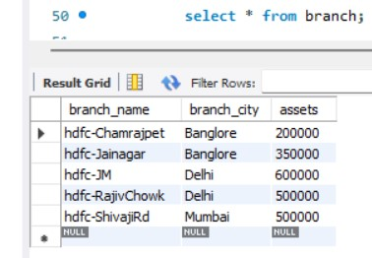

insert into BankAccount values(1,"hdfc-Chamrajpet",30000);

insert into BankAccount values(2,"hdfc-ShivajiRd",15000);

insert into BankAccount values(3,"hdfc-JM",20000);

insert into BankAccount values(4,"hdfc-ShivajiRd",15000);

insert into BankAccount values(5,"hdfc-RajivChowk",35000);

insert into BankAccount values(6,"hdfc-Chamrajpet",10000);

insert into BankAccount values(7,"hdfc-Chamrajpet",12000);

select * from BankAccount;

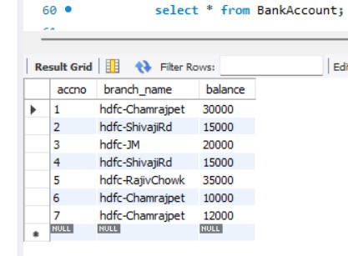

insert into BankCustomer values("Rahul","Teachers Layout","Banglore");

insert into BankCustomer values("Aditya","Kasturba Rd","Banglore");

insert into BankCustomer values("Kavita","Parliament Rd","Delhi");

insert into BankCustomer values("Karthik","Ashoka Rd","Mysore");

insert into BankCustomer values("Tejaswi","Jantarmantar","Delhi");

insert into BankCustomer values("Priya","Andheri","Mumbai");

select * from BankCustomer;

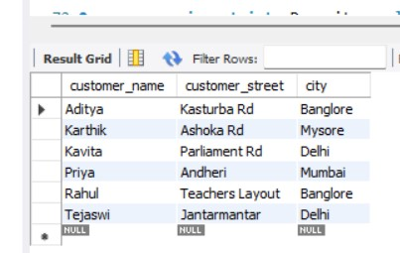

insert into Depositer values("Rahul",5);

insert into Depositer values("Aditya",3);

insert into Depositer values("Tejaswi",7);

insert into Depositer values("Kavita",4);

insert into Depositer values("karthik",6);

insert into Depositer values("Karthik",1);

insert into Depositer values("Priya",2);

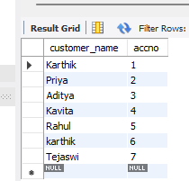select * from Depositer;

insert into Loan values(1,"hdfc-Chamrajpet",9000);

insert into Loan values(2,"hdfc-ShivajiRd",8000);

insert into Loan values(3,"hdfc-Jainagar",8500);

insert into Loan values(4,"hdfc-RajivChowk",9000);

insert into Loan values(5,"hdfc-JM",7000);

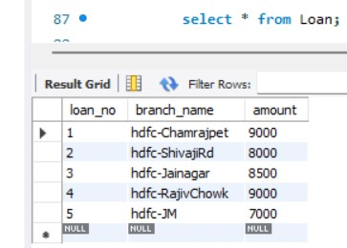select * from Loan;

Queries:

1.select branch_name, assets as "assets in lakhs"

from branch;

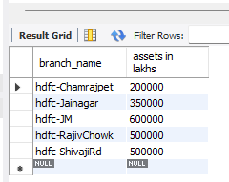

2. create view Total_Loan as

select branch_name, sum(amount) as "Total Loan"

from Loan

group by Branch_name;

select * from Total_Loan;

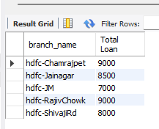

3. select d.customer_name

from Depositer d, BankAccount b

where d.accno=b.accno and b.branch_name="hdfc-Chamrajpet"

group by d.customer_name

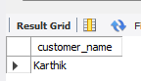having count(d.accno)>=2;

4. update BankAccount b (On spot Question)

set b.balance=b.balance+1000

where accno in(select d.accno from Depositer d, BankCustomer b

where d.customer_name=b.customer_name and b.city="Banglore");

select * from BankAccount;

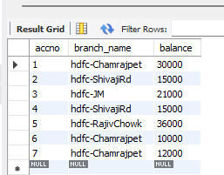

create table Borrower

(

customer_name varchar(25),

loan_no int,

primary key(customer_name,loan_no),

foreign key(customer_name) references BankCustomer(customer_name),

foreign key(loan_no) references Loan(loan_no)

);

insert into Borrower values("karthik",1);

insert into Borrower values("Priya",2);

insert into Borrower values("Aditya",3);

insert into Borrower values("Kavita",4);

select * from Borrower;

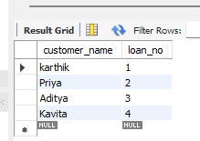

Week 4 task:

1.

select distinct d.customer_name

from Depositer d

where d.accno in (select b.accno

from BankAccount b, branch br

 where br.branch_name=b.branch_name and br.branch_city="Banglore");

2. select customer_name

from Borrower

where customer_name not in(select customer_name

from depositer);



3. select distinct customer_name

from depositer

where customer_name in(select bo.customer_name

from Borrower bo, Loan l, branch br

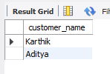 where l.loan_no=bo.loan_no and l.branch_name=br.branch_name and br.branch_city="Banglore");

4. select branch_name

from branch

where assets >(select max(assets)

from branch

where branch_city="Banglore"

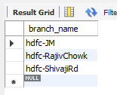group by branch_city);

6. update BankAccount

set balance= (5/100)*balance;

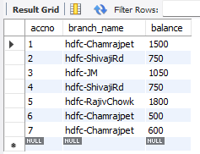 select * from BankAccount;

5.delete from Depositer

where accno in(select accno from BankAccount where branch_name in(select branch_name from branch where branch_city="Mumbai"));

delete from BankAccount

where branch_name in(select branch_name from branch where branch_city="Mumbai");

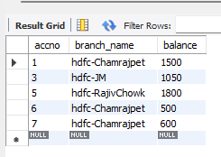select * from BankAccount;

On spot question:

delete from Depositer

where accno in(select accno from BankAccount where branch_name in(select branch_name from branch where branch_city="Banglore"));

delete from BankAccount

where branch_name in(select branch_name from branch where branch_city="Banglore");

delete from Loan

where branch_name in(select branch_name from branch where branch_city="Banglore");

delete from Borrower

where loan_no in(select loan_no from Loan);

delete from branch

where branch_city="Banglore";

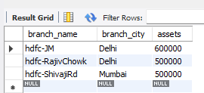select * from branch;