**LAB 1**

Write a python program to import and export data using Pandas library functions.

Importing data

Algorithm(Observation book)

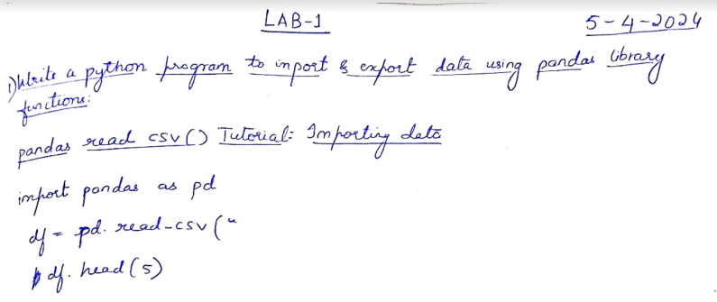

Code

import pandas as pd

df=pd.read_csv("/content/austinHousingData.csv")

df.head(5)

Output

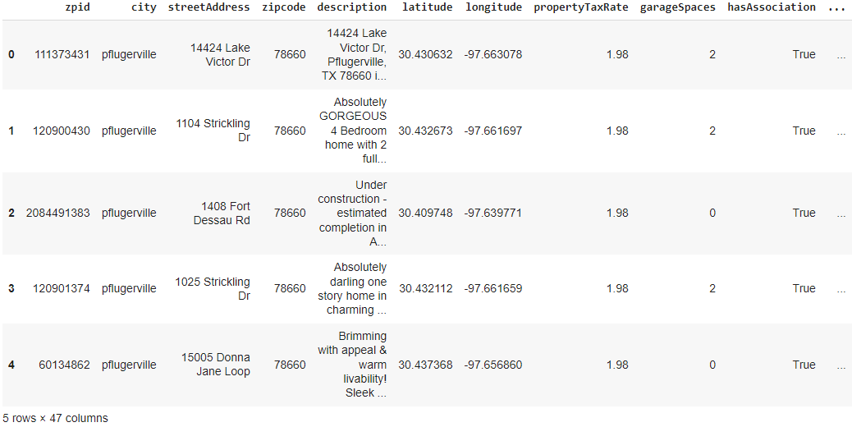

Exporting data

Algorithm(Observation book)

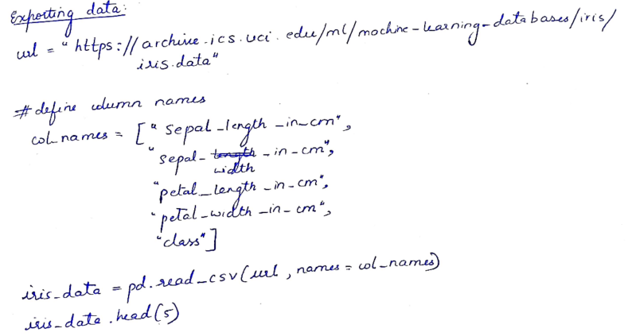

Code

url = “https://archive.ics.uci.edu/ml/machine-learning-databases/iris/iris.data”

# Define the column names

col_names = [“sepal_length_in_cm”,

            “sepal_width_in_cm”,

            “petal_length_in_cm”,

            “petal_width_in_cm”,

            “class”]

# Read data from URL

iris_data = pd.read_csv(url, names=col_names)

iris_data.head(5)

iris_data.to_csv(“/content/exported_irisData.csv”)

Output:

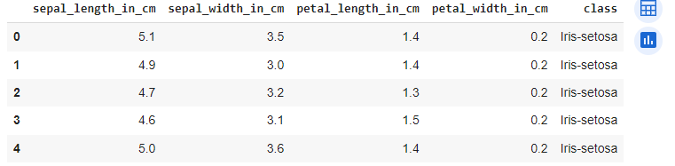

Demonstrate various data pre-processing techniques for a given dataset.

%matplotlib inline

import numpy as np

import pandas as pd

import matplotlib.pyplot as plt

import seaborn as sns

import sklearn

df1=pd.read_csv(“/content/Data.csv”)

df1.head(5)

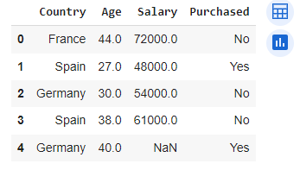

#Identifying and handling the missing values

df1.isnull().sum()

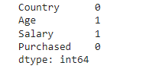

**LAB 2**

Use an appropriate dataset for building the decision tree(ID3) and apply this knowledge to classify a new sample.

Algorithm(Observation book)

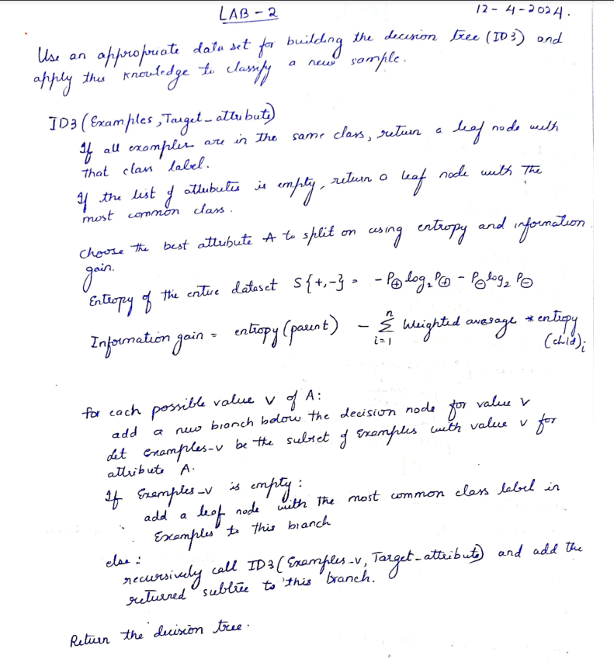

Code

# Importing the required libraries

import pandas as pd

import numpy as np

import math

data = pd.read_csv('/content/PlayTennis.csv')

def highlight(cell_value):

    '''

    Highlight yes / no values in the dataframe

    '''

    color_1 = 'background-color: pink;'

    color_2 = 'background-color: lightgreen;'

    if cell_value == 'no':

        return color_1

    elif cell_value == 'yes':

        return color_2

data.style.applymap(highlight)\

    .set_properties(subset=data.columns, **{'width': '100px'})\

    .set_table_styles([{'selector': 'th', 'props': [('background-color', 'lightgray'), ('border', '1px solid gray'),

                                                    ('font-weight', 'bold')]},

     {'selector': 'tr:hover', 'props': [('background-color', 'white'), ('border', '1.5px solid black')]}])

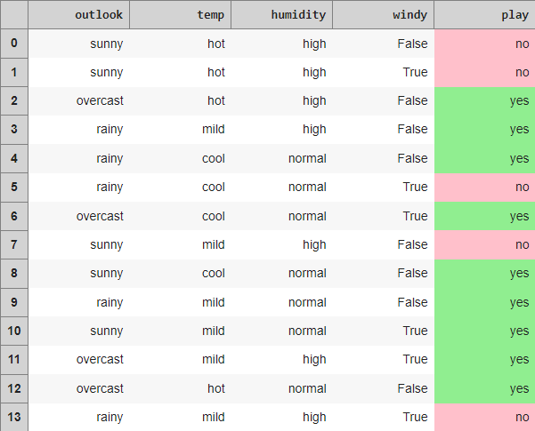

def find_entropy(data):

    """

    Returns the entropy of the class or features

    formula: - ∑ P(X)logP(X)

    """

    entropy = 0

    for i in range(data.nunique()):

        x = data.value_counts()[i]/data.shape[0]

        entropy += (- x * math.log(x,2))

    return round(entropy,3)

def information_gain(data, data_):

    """

    Returns the information gain of the features

    """

    info = 0

    for i in range(data_.nunique()):

        df = data[data_ == data_.unique()[i]]

        w_avg = df.shape[0]/data.shape[0]

        entropy = find_entropy(df.play)

        x = w_avg * entropy

        info += x

    ig = find_entropy(data.play) - info

    return round(ig, 3)

def entropy_and_infogain(datax, feature):

    """

    Grouping features with the same class and computing their

    entropy and information gain for splitting

    """

    for i in range(data[feature].nunique()):

        df = datax[datax[feature]==data[feature].unique()[i]]

        if df.shape[0] < 1:

            continue

        display(df[[feature, 'play']].style.applymap(highlight)\

                .set_properties(subset=[feature, 'play'], **{'width': '80px'})\

                .set_table_styles([{'selector': 'th', 'props': [('background-color', 'lightgray'),

                                                                ('border', '1px solid gray'),

                                                                ('font-weight', 'bold')]},

                                   {'selector': 'td', 'props': [('border', '1px solid gray')]},

                                   {'selector': 'tr:hover', 'props': [('background-color', 'white'),

                                                                      ('border', '1.5px solid black')]}]))

        print(f'Entropy of {feature} - {data[feature].unique()[i]} = {find_entropy(df.play)}')

    print(f'Information Gain for {feature} = {information_gain(datax, datax[feature])}')

#Computing entropy for the entire dataset

print(f'Entropy of the entire dataset: {find_entropy(data.play)}')



#Calculate the Information Gain for each feature.

#Outlook

entropy_and_infogain(data, 'outlook')

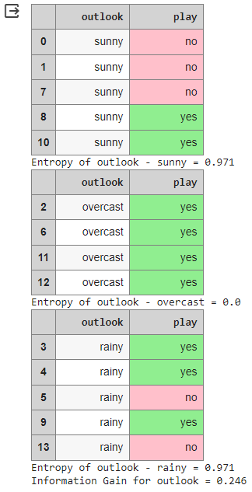

#Temp

entropy_and_infogain(data, 'temp')

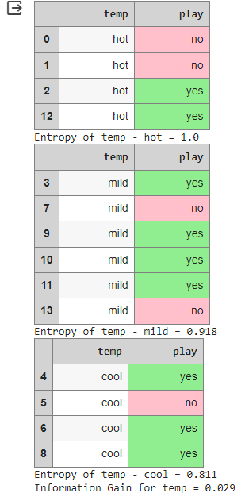

#Humidity

entropy_and_infogain(data, 'humidity')

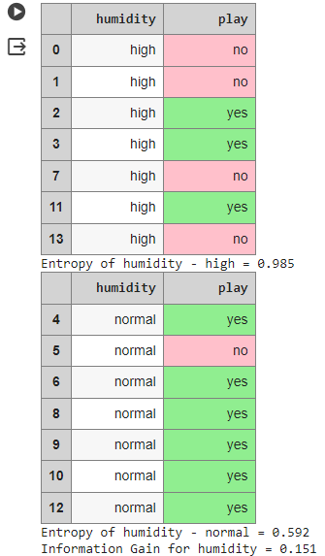

#Windy

entropy_and_infogain(data, 'windy')

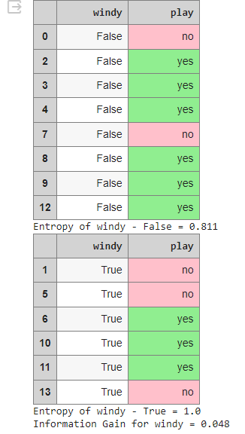

#Make a decision tree node using the feature with the maximum Information Gain.

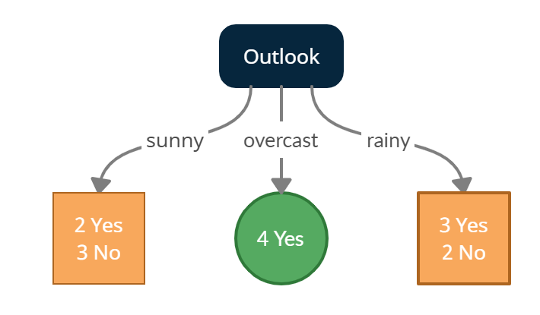

sunny = data[data['outlook'] == 'sunny']

sunny.style.applymap(highlight)\

    .set_properties(subset=data.columns, **{'width': '100px'})\

    .set_table_styles([{'selector': 'th', 'props': [('background-color', 'lightgray'), ('border', '1px solid gray'),

                                                    ('font-weight', 'bold')]},

     {'selector': 'tr:hover', 'props': [('background-color', 'white'), ('border', '1.5px solid black')]}])

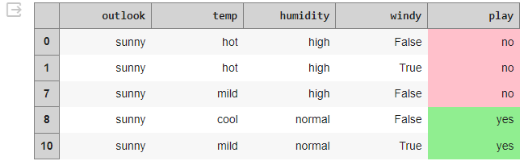

print(f'Entropy of the Sunny dataset: {find_entropy(sunny.play)}')



#temp

entropy_and_infogain(sunny, 'temp')

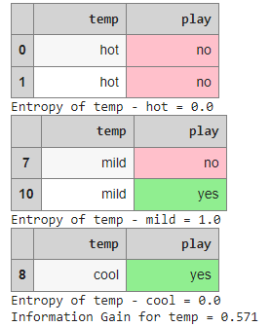

#Humidity

entropy_and_infogain(sunny, 'humidity')

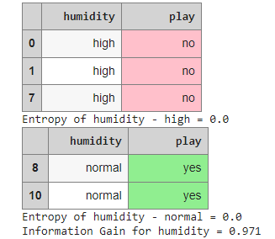

#Windy

entropy_and_infogain(sunny, 'windy')

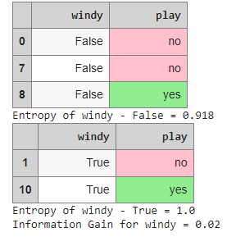

**#Making a decision tree node using the feature which has the maximum Information Gain**

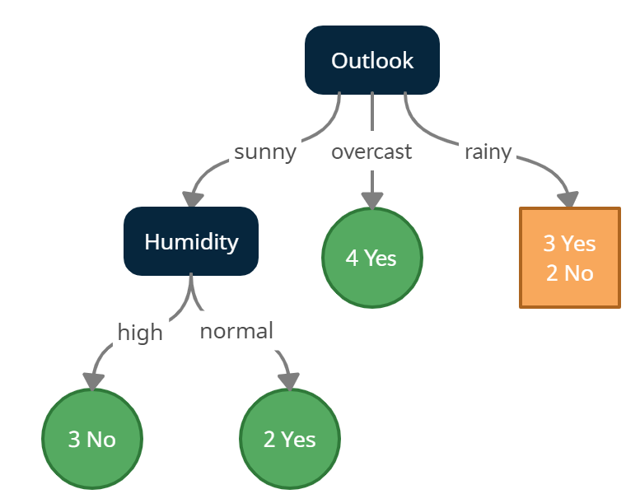

#Outlook - Rainy

rainy = data[data['outlook'] == 'rainy']

rainy.style.applymap(highlight)\

    .set_properties(subset=data.columns, **{'width': '100px'})\

    .set_table_styles([{'selector': 'th', 'props': [('background-color', 'lightgray'), ('border', '1px solid gray'),

                                                    ('font-weight', 'bold')]},

     {'selector': 'tr:hover', 'props': [('background-color', 'white'), ('border', '1.5px solid black')]}])

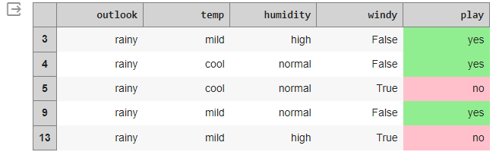

print(f'Entropy of the Rainy dataset: {find_entropy(rainy.play)}')



#temp

entropy_and_infogain(rainy, 'temp')

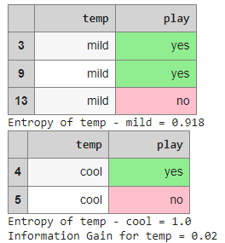

#Humidity

entropy_and_infogain(rainy, 'humidity')

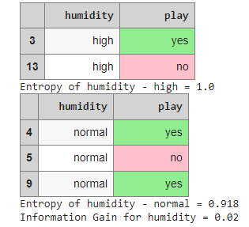

#Windy

entropy_and_infogain(rainy, 'windy')

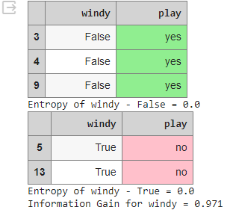

**#Making a decision tree node using the feature which has the maximum Information Gain.**

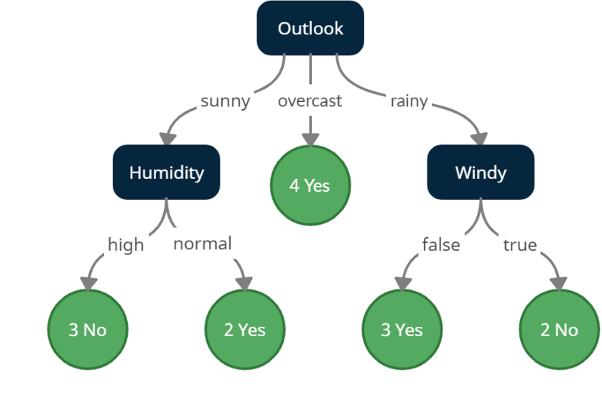

**LAB 3**

Build KNN Classification model for a given dataset.

Algorithm(Observation book)

Code

import numpy as np

import pandas as pd

iris = pd.read_csv("/content/Iris.csv") #Load Data

iris.drop('Id',inplace=True,axis=1) #Drop Id column

iris.head(5)

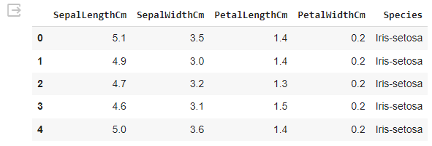

X = iris.iloc[:,:-1] #Set our training data

y = iris.iloc[:,-1] #Set training labels

class KNN:

    def __init__(self, n_neighbors=5):

        self.n_neighbors = n_neighbors

    def euclidean_distance(self, x1, x2):

        return np.linalg.norm(x1 - x2)

    def fit(self, X_train, y_train):

        self.X_train = X_train

        self.y_train = y_train

    def predict(self, X):

        # Create empty array to store the predictions

        predictions = []

        # Loop over X examples

        for x in X:

            # Get prediction using the prediction helper function

            prediction = self._predict(x)

            # Append the prediction to the predictions list

            predictions.append(prediction)

        return np.array(predictions)

    def _predict(self, x):

        # Create empty array to store distances

        distances = []

        # Loop over all training examples and compute the distance between x and all the training examples

        for x_train in self.X_train:

            distance = self.euclidean_distance(x, x_train)

            distances.append(distance)

        distances = np.array(distances)

        # Sort by ascendingly distance and return indices of the given n neighbours

        n_neighbors_idxs = np.argsort(distances)[: self.n_neighbors]

        # Get labels of n-neighbour indexes

        labels = self.y_train[n_neighbors_idxs]

        labels = list(labels)

        # Get the most frequent class in the array

        most_occuring_value = max(labels, key=labels.count)

        return most_occuring_value

def train_test_split(X, y, random_state=42, test_size=0.2):

    # Get number of samples

    n_samples = X.shape[0]

    # Set the seed for the random number generator

    np.random.seed(random_state)

    # Shuffle the indices

    shuffled_indices = np.random.permutation(np.arange(n_samples))

    # Determine the size of the test set

    test_size = int(n_samples * test_size)

    # Split the indices into test and train

    test_indices = shuffled_indices[:test_size]

    train_indices = shuffled_indices[test_size:]

    # Split the features and target arrays into test and train

    X_train, X_test = X[train_indices], X[test_indices]

    y_train, y_test = y[train_indices], y[test_indices]

    return X_train, X_test, y_train, y_test

X_train, X_test, y_train, y_test = train_test_split(X.values, y.values, test_size = 0.2, random_state=42) #split the  data into traing and validating

model = KNN(7)

model.fit(X_train, y_train)

def compute_accuracy(y_true, y_pred):

    y_true = y_true.flatten()

    total_samples = len(y_true)

    correct_predictions = np.sum(y_true == y_pred)

    return (correct_predictions / total_samples)

predictions = model.predict(X_test)

accuracy = compute_accuracy(y_test, predictions)

print(f" our model got accuracy score of : {accuracy}")

our model got accuracy score of : 0.9666666666666667

model.predict([[7.7,2.6,6.9,2.3]])

Implement Linear and Multi-Linear Regression algorithm using appropriate dataset.

Linear regression

Algorithm(Observation book)

Code

import math

import numpy as np

import pandas as pd

import plotly.express as px

import pickle

# Load the training and test datasets

train_data = pd.read_csv('/content/train.csv')

test_data = pd.read_csv('/content/test.csv')

# Remove rows with missing values

train_data = train_data.dropna()

test_data = test_data.dropna()

train_data.head()

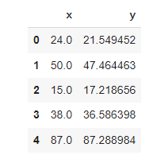

# Set training data and target

X_train = train_data['x'].values

y_train = train_data['y'].values

# Set testing data and target

X_test = test_data['x'].values

y_test = test_data['y'].values

def standardize_data(X_train, X_test):

    """

    Standardizes the input data using mean and standard deviation.

    Parameters:

        X_train (numpy.ndarray): Training data.

        X_test (numpy.ndarray): Testing data.

    Returns:

        Tuple of standardized training and testing data.

    """

    # Calculate the mean and standard deviation using the training data

    mean = np.mean(X_train, axis=0)

    std = np.std(X_train, axis=0)

    # Standardize the data

    X_train = (X_train - mean) / std

    X_test = (X_test - mean) / std

    return X_train, X_test

X_train, X_test = standardize_data(X_train, X_test)

X_train = np.expand_dims(X_train, axis=-1)

X_test = np.expand_dims(X_test, axis=-1)

class LinearRegression:

  def __init__(self, learning_rate, convergence_tol=1e-6):

        self.learning_rate = learning_rate

        self.convergence_tol = convergence_tol

        self.W = None

        self.b = None

  def initialize_parameters(self, n_features):

        """

        Initialize model parameters.

        Parameters:

            n_features (int): The number of features in the input data.

        """

        self.W = np.random.randn(n_features) * 0.01

        self.b = 0

  def forward(self, X):

        """

        Compute the forward pass of the linear regression model.

        Parameters:

            X (numpy.ndarray): Input data of shape (m, n_features).

        Returns:

            numpy.ndarray: Predictions of shape (m,).

        """

        return np.dot(X, self.W) + self.b

  def compute_cost(self, predictions):

        """

        Compute the mean squared error cost.

        Parameters:

            predictions (numpy.ndarray): Predictions of shape (m,).

        Returns:

            float: Mean squared error cost.

        """

        m = len(predictions)

        cost = np.sum(np.square(predictions - self.y)) / (2 * m)

        return cost

  def backward(self, predictions):

        """

        Compute gradients for model parameters.

        Parameters:

            predictions (numpy.ndarray): Predictions of shape (m,).

        Updates:

            numpy.ndarray: Gradient of W.

            float: Gradient of b.

        """

        m = len(predictions)

        self.dW = np.dot(predictions - self.y, self.X) / m

        self.db = np.sum(predictions - self.y) / m

  def fit(self, X, y, iterations, plot_cost=True):

    assert isinstance(X, np.ndarray), "X must be a NumPy array"

    assert isinstance(y, np.ndarray), "y must be a NumPy array"

    assert X.shape[0] == y.shape[0], "X and y must have the same number of samples"

    assert iterations > 0, "Iterations must be greater than 0"

    self.X = X

    self.y = y

    self.initialize_parameters(X.shape[1])

    costs = []

    for i in range(iterations):

            predictions = self.forward(X)

            cost = self.compute_cost(predictions)

            self.backward(predictions)

            self.W -= self.learning_rate * self.dW

            self.b -= self.learning_rate * self.db

            costs.append(cost)

            if i % 100 == 0:

                print(f'Iteration: {i}, Cost: {cost}')

            if i > 0 and abs(costs[-1] - costs[-2]) < self.convergence_tol:

                print(f'Converged after {i} iterations.')

                break

    if plot_cost:

            fig = px.line(y=costs, title="Cost vs Iteration", template="plotly_dark")

            fig.update_layout(

                title_font_color="#41BEE9",

                xaxis=dict(color="#41BEE9", title="Iterations"),

                yaxis=dict(color="#41BEE9", title="Cost")

            )

            fig.show()

    def predict(self, X):

      return self.forward(X)

    def save_model(self, filename=None):

        """

        Save the trained model to a file using pickle.

        Parameters:

            filename (str): The name of the file to save the model to.

        """

        model_data = {

            'learning_rate': self.learning_rate,

            'convergence_tol': self.convergence_tol,

            'W': self.W,

            'b': self.b

        }

        with open(filename, 'wb') as file:

            pickle.dump(model_data, file)

    @classmethod

    def load_model(cls, filename):

        """

        Load a trained model from a file using pickle.

        Parameters:

            filename (str): The name of the file to load the model from.

        Returns:

            LinearRegression: An instance of the LinearRegression class with loaded parameters.

        """

        with open(filename, 'rb') as file:

            model_data = pickle.load(file)

        # Create a new instance of the class and initialize it with the loaded parameters

        loaded_model = cls(model_data['learning_rate'], model_data['convergence_tol'])

        loaded_model.W = model_data['W']

        loaded_model.b = model_data['b']

        return loaded_model

lr = LinearRegression(0.01)

lr.fit(X_train, y_train, 10000)

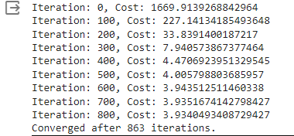

**LAB 4**

Implement logistic regression using appropriate dataset.