**LAB 1**

Write a python program to import and export data using Pandas library functions.

Importing data

Observation book-snapshot

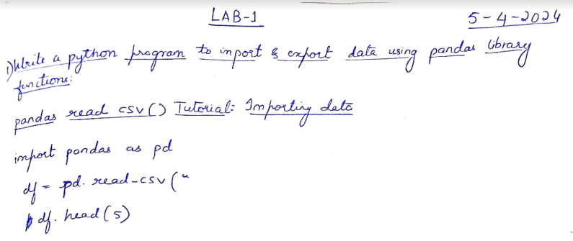

Code

import pandas as pd

df=pd.read_csv("/content/austinHousingData.csv")

df.head(5)

Output:

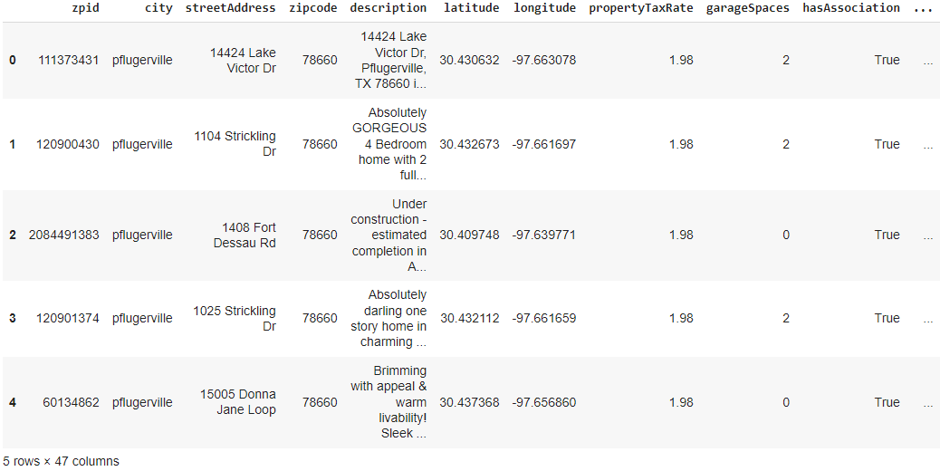

Exporting data

Observation book-snapshot

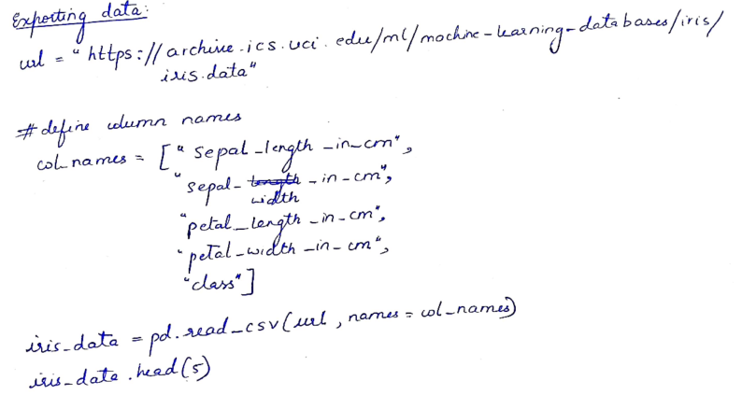

Code

url = "https://archive.ics.uci.edu/ml/machine-learning-databases/iris/iris.data"

# Define the column names

col_names = ["sepal_length_in_cm",

            "sepal_width_in_cm",

            "petal_length_in_cm",

            "petal_width_in_cm",

            "class"]

# Read data from URL

iris_data = pd.read_csv(url, names=col_names)

iris_data.head(5)

iris_data.to_csv("/content/exported_irisData.csv")

Output:

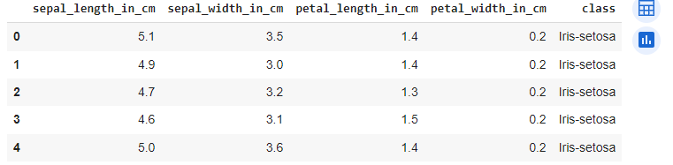

Demonstrate various data pre-processing techniques for a given dataset.

%matplotlib inline

import numpy as np

import pandas as pd

import matplotlib.pyplot as plt

import seaborn as sns

import sklearn

df1=pd.read_csv("/content/Data.csv")

df1.head(5)

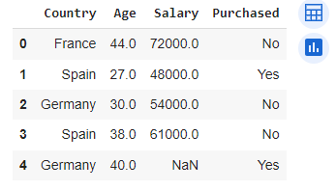

#Identifying and handling the missing values

df1.isnull().sum()

