**Write a Selenium Java script to automate the following scenario.**

1. Write a Selenium Java script to automate the following scenario:

* Write the code to launch ChromeDriver, maximize the window, and navigate to the https://iqueryui.com/datepicker/ URL

* Switch to the iframe that contains the datepicker

* Write the code to select the next month from the datepicker

* Write the code to select the date "22" from the date picker

* Close the browser window and quit the WebDriver instance

* print the selected date on console as output

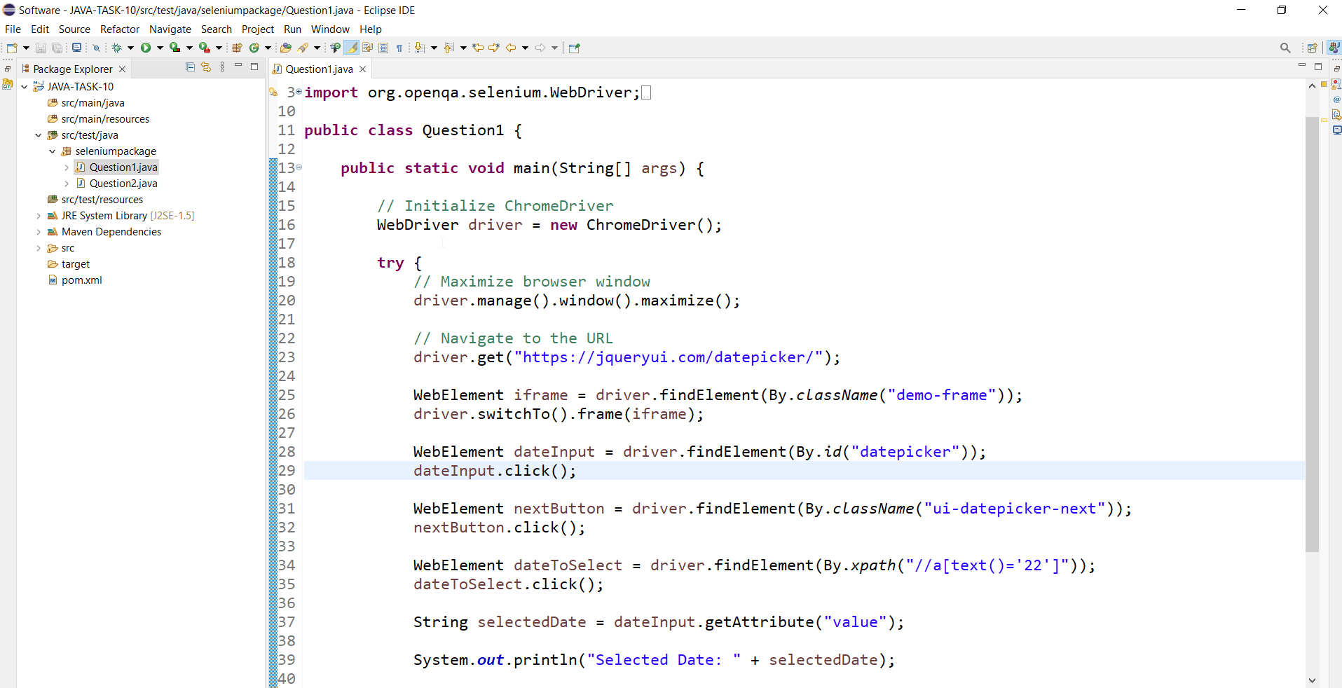

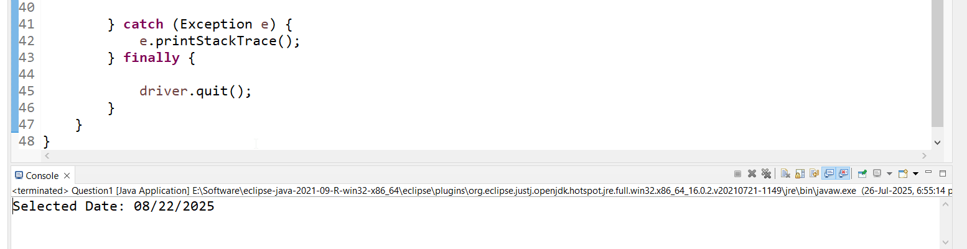

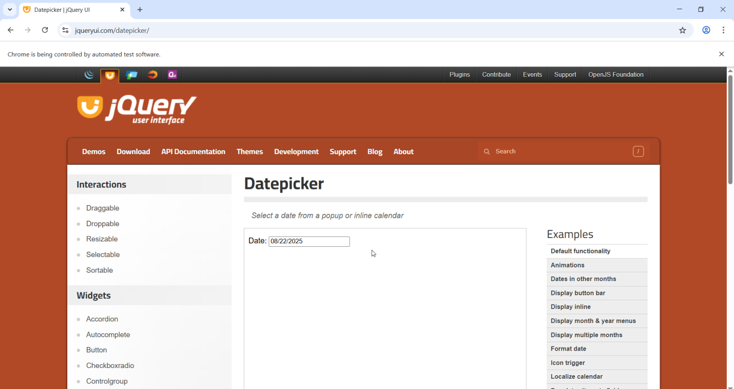

2).To Automated Drag and Drop Operation using Selenium Java.

Steps to be performed:

1. Open the Chrome/Firefox/Safari browser.

2. Navigate to the jQueryUI droppable website (https://jqueryui.com/droppable/).

3. Find the source element with the text "Drag me to my target" and the target element with the text "Drop here".

4. Perform the drag and drop operation from the source element to the target element.

5. Verify that the drag and drop operation is successful by checking the color property of the target element's CSS.

6. Verify that the text of the target element has changed to "Dropped!" after the drop

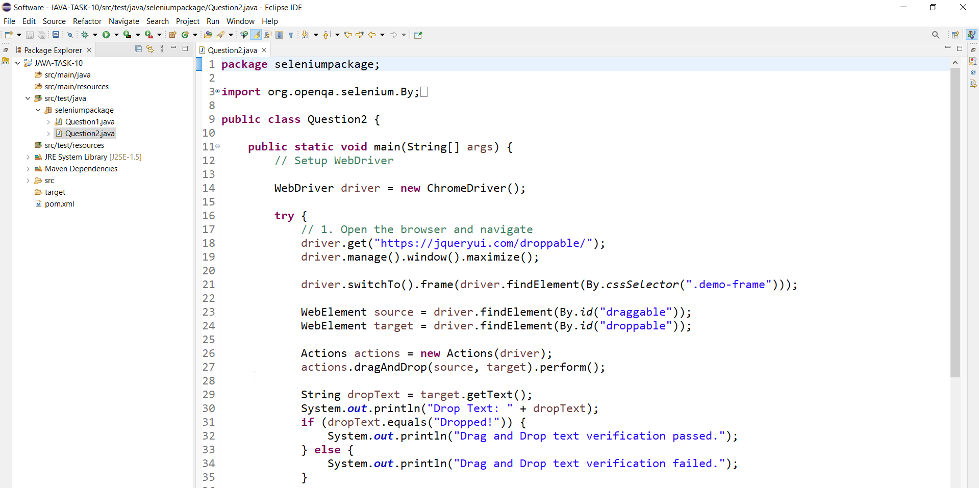

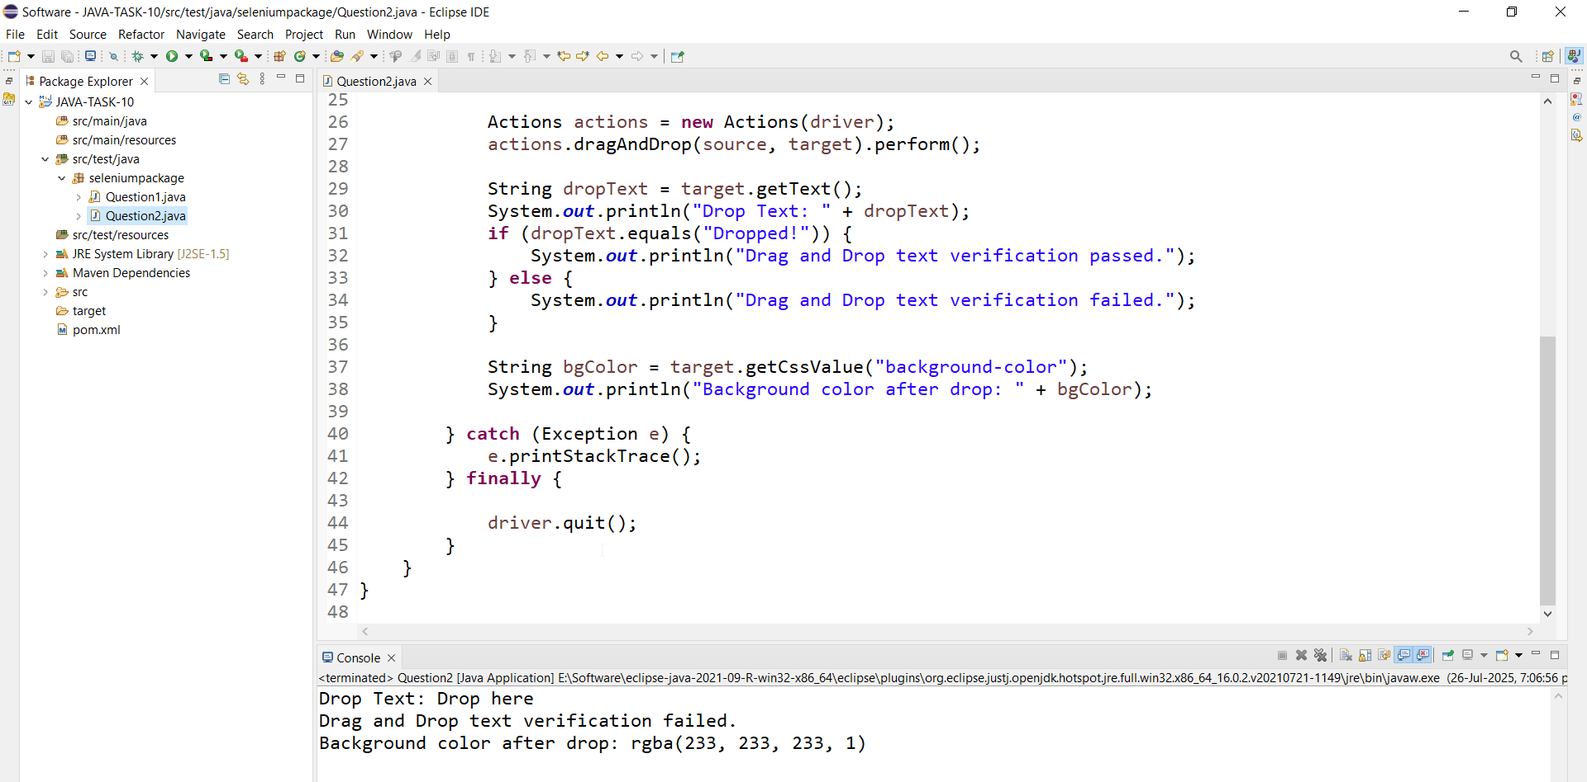

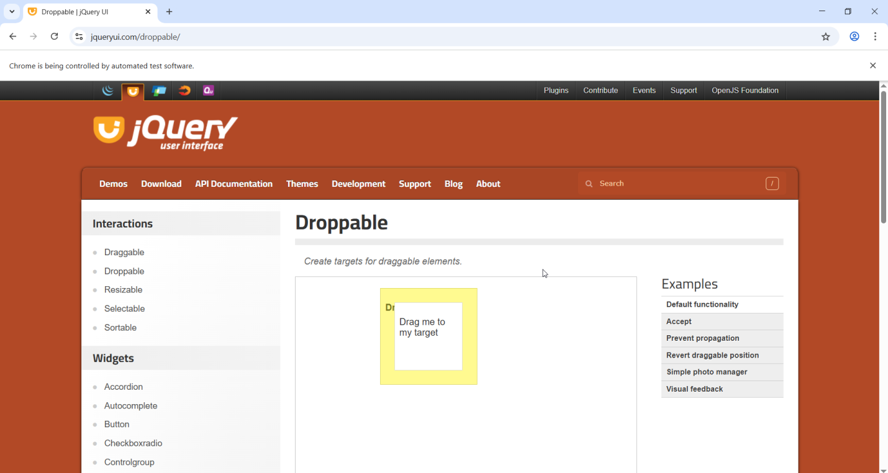

Automate Signup and Login process for https://www.guvi.in/

Steps:

* Launch the website https://www.guvi.in/ using Selenium WebDriver.

* Locate the Signup button on the top right corner of the page and click on it.

* Fill in the signup form with required details like name, email, password, ete.

* Click on the "Signup" button to submit the form.

* Wait for the page to load and verify that the user is registered successfully.

* Locate the Login button on the top right corner of the page and click on it.

* Fill in the login form with the email and password used during registration.

* Click on the "Login" button to submit the form.

* Wait for the page to load and verify that the user is logged in successfully.

* Close the browser.

Hint: You can use the WebDriver's findElement) and sendKeys) methods to locate and fill in the form fields, and use the click) method to click on buttons. You can also use the get Title) method to verify the page title after registration and login.

Note:Use dummy user id and password.

