**LAB Assignment – 1**

1. Write a program to print your first_name, middle_name, Last_name, DOB, class, Div, contact_number, email_id.

**Ans:**

class p1_PErsonal_Details

{

     public static void main(String args[])

    {

        String first_name = "Kanani";

        String middle_name = "Neha";

        String last_name = "Hasmukhbhai";

        String dob = "31/08/2006";

        String class_name = "Sy BCA-A";

        String div = "A";

        String contact_number = "7383845296";

        String email_id = "bca2023neha2004@tnraocollege.org";

        System.out.println("First Name: " + first_name);

        System.out.println("Middle Name: " + middle_name);

        System.out.println("Last Name: " + last_name);

        System.out.println("Date of Birth: " + dob);

        System.out.println("Class: " + class_name);

        System.out.println("Division: " + div);

        System.out.println("Contact Number: " + contact_number);

        System.out.println("Email ID: " + email_id);

    }

}

**Output:**

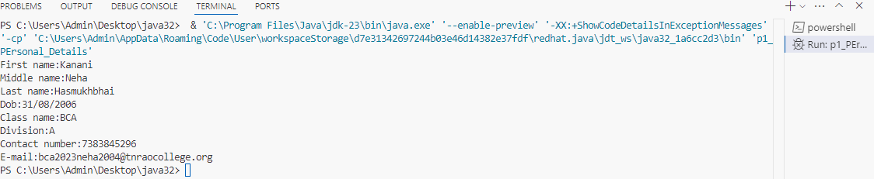

1. Write a program to demonstrate all data types.

**Ans:**

class J2_DataType

{

    public static void main(String args[])

    {

        byte byteValue = 120;

        short shortValue = 32000;

        int intValue = 100000;

        long longValue = 1000000000L;

        float floatValue = 3.14f;

        double doubleValue = 3.14159;

        char charValue = 'A';

        boolean booleanValue = true;

        String stringValue = "Hello, Java!";

    System.out.println("Byte value: " + byteValue);

        System.out.println("Short value: " + shortValue);

        System.out.println("Int value: " + intValue);

        System.out.println("Long value: " + longValue);

        System.out.println("Float value: " + floatValue);

        System.out.println("Double value: " + doubleValue);

        System.out.println("Char value: " + charValue);

        System.out.println("Boolean value: " + booleanValue);

        System.out.println("String value: " + stringValue);

    }

}

**Output:**

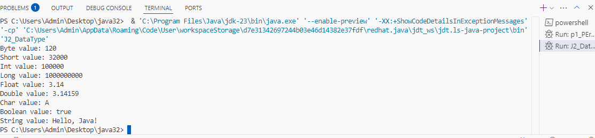

1. Write a program to demonstrate all types of literals.

**Ans:**

class J3_literals

{

    public static void main(String args[])

    {

        int count=987;

        float floatValue = 3.14f;

                double doubleValue = 3.14159;

        int hexval = 0x1F;

            int binary = 011010;

        int octalval=067;

        char alpha = 'A';

        String str = "Hello, World!";

        boolean boolval=true;

        String StruName=null;

        char ch1 = '\u0021';

        char ch2=1456;

        System.out.println("Integer Literal: " + count);

        System.out.println("Float Literal: " + floatValue);

                System.out.println("Double Literal: " + doubleValue);

        System.out.println("Hexadecimal Literal: " + hexval);

        System.out.println("Binary Literal: " + binary);

        System.out.println("Octal Literal: " + octalval);

        System.out.println("Character Literal: " + alpha);

        System.out.println("String Literal: " + str);

        System.out.println("Boolean Literal: " + boolval);

        System.out.println("String Literal: " + StruName);

        System.out.println("Character Literal: " + ch1);

        System.out.println("Character Literal: " + ch2);

        System.out.println("\t" + "Black slash");

    }

}

**Output:**

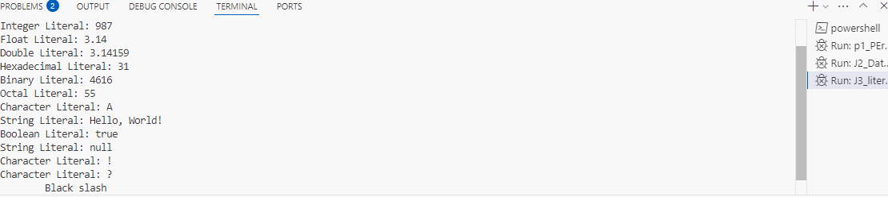

1. Write a program to calculate area of circle.

**Ans:**

class J4_AreaOfCircle

{

    public static void main(String[] args)

    {

            double radius = 5;

            double pi = 3.14159;

            double area = pi * radius * radius;

            System.out.println("The area of the circle is: " + area);

    }

}

**Output:**

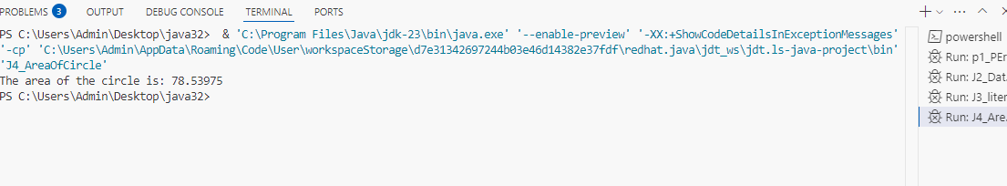

1. Write a program to perform all arithmetic operations. (+, - ,*, /, %).

**Ans:**

class J5_ArithmeticOperations

{

    public static void main(String[] args)

    {

            int num1 = 10;

            int num2 = 5;

            int sum = num1 + num2;

            int sub = num1 - num2;

            int mul = num1 * num2;

            int div = num1 / num2;

            int remainder = num1 % num2;

            System.out.println("Addition: " + sum);

            System.out.println("Subtraction: " + sub);

            System.out.println("Multiplication: " + mul);

            System.out.println("Division: " + div);

            System.out.println("Modulus: " + remainder);

    }

}

**Output:**

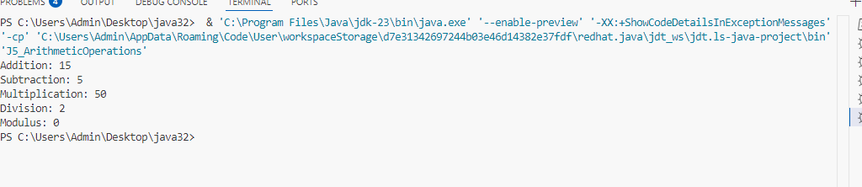

1. Write a program to calculate area of triangle.

**Ans:**

class J6_AreaofTriangle

{

    public static void main(String[] args)

    {

            double base = 10.0;

            double height = 5.0;

        double area = 0.5 * base * height;

    System.out.println("The area of triangle is: " + area);

    }

}

**Output:**

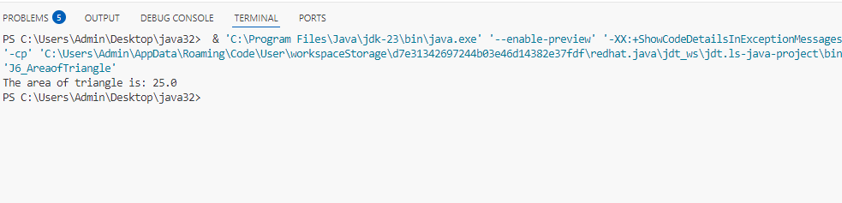

1. Write a program to perform following arithmetic expression. a. 10*10/5+3-1*4/2

**Ans:**

class J7_ArithmeticExpression

{

    public static void main(String[] args)

    {

            int result = 10 * 10 / 5 + 3 - 1 * 4 / 2;

        System.out.println("Result of the expression: " + result);

        }

}

**Output:**

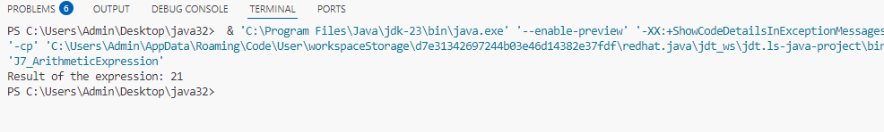

1. Write a program to check whether the number is positive or negative or zero.

**Ans:**

class J8_NumberCheck

{

    public static void main(String[] args)

    {

        int number = 20;

        if (number > 0)

        {

                  System.out.println("The number is positive.");

            }

        else if (number < 0)

        {

                  System.out.println("The number is negative.");

            }

        else

        {

                  System.out.println("The number is zero.");

            }

        }

}

**Output:**

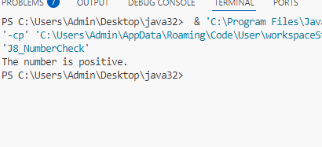

1. Write a program that takes a number (1-7) and prints the corresponding day of the week using a switch statement.

**Ans:**

class J9_SwitchCase

{

    public static void main(String[] args)

        {

            int day = 3;

            String dayString;

            switch(day)

        {

    case 1:

            dayString = "Monday";

            break;

        case 2:

            dayString = "Tuesday";

            break;

        case 3:

            dayString = "Wednesday";

            break;

        case 4:

            dayString = "Thursday";

            break;

        case 5:

            dayString = "Friday";

            break;

        case 6:

            dayString = "Saturday";

            break;

        case 7:

            dayString = "Sunday";

            break;

        default:

            dayString = "Invalid day";

        }

        System.out.println(dayString);

    }

}

**Output:**

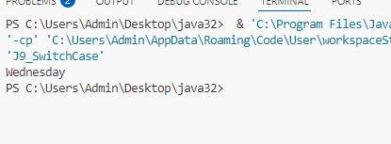

1. Write a program to print 1 to 100 number using do…while loop.

**Ans:**

class J10_dowhileloop

{

    public static void main(String[] args)

    {

            int i = 1;

            do

        {

                  System.out.println(i);

                  i++;

            } while (i <= 100);

        }

}

**Output:**

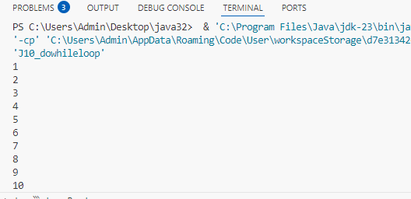

1. Write a program to print following pattern.

**Ans:**

**(A):**

class  J11_1Pattern

{

  public static void main(String[] args)

  {

          int rows = 5;

          for (int i = 1; i <= rows; i++)

    {

               for (int j = 1; j <= i; j++)

                 {

                   System.out.print(j);

                 }

                 System.out.println();

        }

    }

}

**Output:**

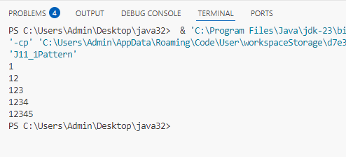

**(B):**

class  J11_2Pattern

{

    public static void main(String[] args)

    {

          int rows = 5;

      for (int i = 1; i <= rows; i++)

      {

            for (int j = 1; j <= i; j++)

            {

                char ch = (char) ('A' + j - 1);

                System.out.print(ch);

            }

            System.out.println();

        }

    }

}

**Output:**

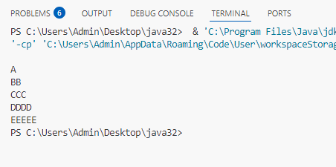

**(C):**

class J11_2Pattern

{

    public static void main(String[] args)

    {

        int n = 5; // Number of lines

        for (int i = 0; i < n; i++)

         {

            // Print the first part of the pattern (A, AB, ABC, etc.)

            for (int j = 0; j <= i; j++)

            {

                System.out.print((char) ('A' + j));

            }

            // Print the last 'A'

            if (i > 0)

            {

                System.out.print('A');

            }

              System.out.println();

         }

    }

}

**Output:**

