**Tutorial No: 1**

**Title:** Java script for simple calculator

**Name:** Neha Vinayak More

**Div:** BE-E **Roll No:** 45

**Program:**

<html>

<head></head>

<body>

<h3><font color="Brown">Calculator</font color></h3>

<br/>

<form>

<table>

<tr>

<td colspan=4><input type=text Name="display"></td>

</tr>

<tr>

<td><input type=button value="0" OnClick="display.value+='0'"></td>

<td><input type=button value="1" OnClick="display.value+='1'"></td>

<td><input type=button value="2" OnClick="display.value+='2'"></td>

<td><input type=button value="+" OnClick="display.value+='+'"></td>

</tr>

<tr>

<td><input type=button value="3" OnClick="display.value+='3'"></td>

<td><input type=button value="4" OnClick="display.value+='4'"></td>

<td><input type=button value="5" OnClick="display.value+='5'"></td>

<td><input type=button value="-" OnClick="display.value+='-'"></td>

</tr>

<tr>

<td><input type=button value="6" OnClick="display.value+='6'"></td>

<td><input type=button value="7" OnClick="display.value+='7'"></td>

<td><input type=button value="8" OnClick="display.value+='8'"></td>

<td><input type=button value="x" OnClick="display.value+='*'"></td>

</tr>

<tr>

<td><input type=button value="9" OnClick="display.value+='9'"></td>

<td><input type=button value="C" OnClick="display.value=''"></td>

<td><input type=button value="=" OnClick="display.value=eval(display.value)"></td>

<td><input type=button value="/" OnClick="display.value+='/'"></td>

</tr>

</table>

</form>

</body>

</html>

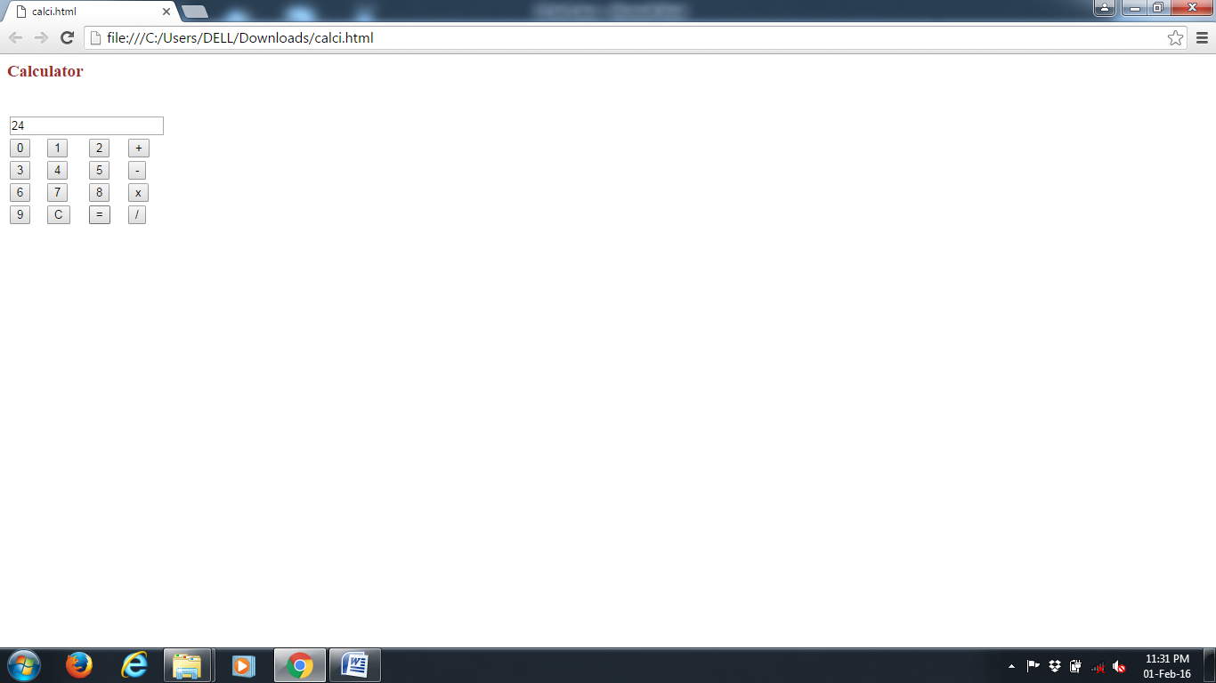**Output:**

