A CASE STUDY REPORT ON
Job Portal System
SUBMITTED TO
Artificial Intelligence and Data Science

As a part of fulfillment of CIE I Exam of Subject: Software Engineering

By
Shravani Vikas Bhoite 36009
Shital Baban Godse 36027
Sanskruti Subhash Ambekar 36002

Mrs. Rucha Shaiva


P.E.S’s MODERN COLLEGE OFENGINEERING,
SHIVAJINAGAR, PUNE 05
(An Autonomous Institute Affiliated to Savitribai Phule Pune University)
2026-27

CERTIFICATE

This is to certify that Ms. Shravani Vikas Bhoite, Shital Baban Godse, Sanskruti Subhash Ambekar, Roll No. 36009, 36027, 36002 of T.Y. B.Tech. A Division, has successfully completed the case study entitled “ Job Portal System ” as a bonafide work carried out in partial fulfillment of the requirements for the CIE-I Examination of the course Software Engineering (ADS01303) , prescribed under the T.Y. B.Tech. 2024 Pattern, during the academic year 2026–2027, Semester V.
The work presented in this case study is found to be satisfactory and fulfills the academic requirements prescribed for the course.

Mrs. Rucha Shaiva Prof. Shraddha Pandit
Subject Incharge HoD

Place: Pune
Date: 22/08/2026

CONTENTS

Chapter No. | Name of Chapter | Page No.
1 | Problem Understanding | 6
2 | Stakeholder Identification | 14
3 | Software Characteristics | 15
4 | Software Process Model Selection | 17
5 | Software Requirement Specification (SRS) | 19
6 | Requirement Traceability Matrix (RTM) | 21
7 | Requirement Modeling | 22
8 | Conclusion | 32
9 | References | 33

List of Tables

Table No. | Table Title | Page No.
Table 2.1 | Stakeholder Analysis | 14
Table 4.1 | Comparison of Software Process Models | 19
Table 6.1 | Requirement Traceability Matrix | 21
Table 7.1 | UC-01: User Login | 27
Table 7.2 | UC-02: Create Job Seeker Profile | 27
Table 7.3 | UC-03: Post Job | 28
Table 7.4 | UC-04: Search and Apply for Job | 28
Table 7.5 | UC-05: View Job Applications | 29
Table 7.6 | UC-06: Shortlist Candidate | 29
Table 7.7 | UC-07: Update Application Status | 30
Table 7.8 | UC-08: View Application Status | 30

List of figures

Figure No. | Figure Title | Page No.
Fig. 1.1 | Existing System Workflow | 8
Fig. 1.2 | Proposed Workflow | 11
Fig. 7.1 | Entity Relationship Diagram (ER Diagram) | 22
Fig. 7.2 | Context Diagram | 23
Fig. 7.3 | Data Flow Diagram – Level 0 | 24
Fig. 7.4 | Data Flow Diagram – Level 1 | 25
Fig. 7.5 | Use Case Diagram | 26
Fig. 7.5 | Analysis Class Diagram | 31

1. Problem Understanding

1.1 Problem Statement:

Finding a suitable job can be difficult for students, fresh graduates, and other job seekers. Many people search for jobs through different websites, social media, newspapers, or by directly contacting companies.
At the same time, companies also face problems while finding suitable candidates for their job openings. They may receive many applications, making it difficult and time-consuming to check each candidate manually.
In a normal job-search process, job seekers may not get proper information about available jobs, required skills, salary, location, or application status. Employers also need to spend a lot of time checking resumes and shortlisting suitable candidates.
There is a need for a centralized system where job seekers can create their profiles, search for suitable jobs, and apply online. Employers should also be able to post job vacancies, view applications, and select suitable candidates.
The proposed Job Portal System will provide a common platform for job seekers and employers. It will make the job-search and recruitment process easier, faster, and more organized.
The system will allow users to register, create profiles, search for jobs, apply for suitable positions, and track their applications. Employers will be able to post jobs, manage applications, and shortlist candidates.

1.2 Existing System:

The existing job-search process is usually a combination of online and manual methods. Job seekers may search for vacancies on different websites, social media platforms, newspapers, or through personal contacts.
The general workflow is as follows:

1. Job Seeker Searches for Job
The job seeker searches for available jobs based on their education, skills, experience, preferred location, and other requirements.

2. Job Seeker Finds a Job Vacancy
The job seeker checks different sources to find a suitable job vacancy.

3. Job Details are Checked
The job seeker reads the job description and checks details such as required qualifications, skills, salary, company name, and location.

4. Job Seeker Applies for the Job
If the job seems suitable, the candidate submits their resume or application to the company.

5. Employer Receives Applications
The employer receives applications from different candidates for the available position.

6. Employer Checks Applications Manually
The employer or HR staff checks the submitted resumes and candidate information manually.

7. Suitable Candidates are Shortlisted
After checking the applications, the employer selects candidates who appear suitable for the job.

8. Candidate is Contacted
The shortlisted candidate is contacted through phone, email, or another communication method for further steps such as an interview.

9. Application Status is Manually Tracked
The candidate may not always know whether the application is pending, shortlisted, rejected, or selected.

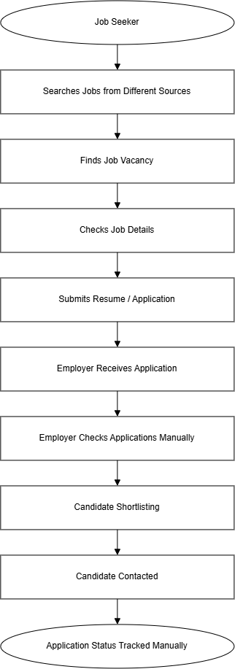

Fig 1.1. Existing System Workflow

1.3 Limitations of Existing System

• Searching Jobs from Different Sources:
Job seekers often have to check multiple websites and other sources to find suitable job opportunities.
• Time-Consuming Job Search:
Finding a suitable job can take a lot of time, especially when there are many job postings available.
• Manual Resume Checking:
Employers may have to manually check a large number of resumes, which takes additional time and effort.
• Difficulty in Finding Suitable Candidates:
It can be difficult for employers to quickly identify candidates whose skills and qualifications match the job requirements.
• Lack of Centralized Information:
Job details, candidate information, and application records may be stored in different places.
• Poor Application Tracking:
Job seekers may not have a proper way to check the current status of their applications.
• Delayed Communication:
Communication between candidates and employers may take time when it is handled through separate emails, phone calls, or messages.
• Duplicate Applications:
Candidates may apply for the same job through different sources, which can create confusion for employers.
• Manual Record Maintenance:
Maintaining candidate and job application records manually can make it difficult to find old information when needed.
• Limited Matching Between Jobs and Candidates:
The existing process may not provide an easy way to identify jobs based on a candidate's skills, education, experience, and preferences.
• Difficult Report Generation:
Preparing reports about job postings, applications, shortlisted candidates, and recruitment activities manually can require extra effort.

1.4 Proposed System

The proposed Job Portal System will provide a single platform for job seekers and employers. The main functions of the system are as follows:
- User Registration and Login: Job seekers, employers, and administrators can create accounts and log in to the system.
- Role-Based Access: Different users will have access to different features according to their role. For example, job seekers can apply for jobs, while employers can post jobs and manage applications.
- Job Seeker Profile: Job seekers can create and update their profile by adding information such as education, skills, experience, resume, and contact details.
- Employer Profile: Employers can create a company profile and provide information about their organization.
- Job Posting: Employers can add new job vacancies with details such as job title, required skills, qualification, salary, location, and job description.
- Job Search: Job seekers can search for jobs using different filters such as job title, skills, location, experience, and other requirements.
- Job Matching: The system can help identify suitable job opportunities based on the information provided by the job seeker and the requirements of the job.
- Online Job Application: Job seekers can apply for suitable jobs directly through the system.
- Application Management: Employers can view received applications and check candidate information and resumes.
- Candidate Shortlisting: Employers can shortlist suitable candidates based on their qualifications, skills, and experience.
- Application Status Update: The employer can update the application status, such as shortlisted, rejected, selected, or pending.
- Notifications: The system can notify users about new job postings, application updates, interview information, or other important activities.
- Application History: Job seekers can view the jobs they have applied for and check the status of their applications.
- Admin Management: The administrator can manage users, job postings, and other important system information.
The proposed system will reduce manual work and make the recruitment process more organized and easier to manage.

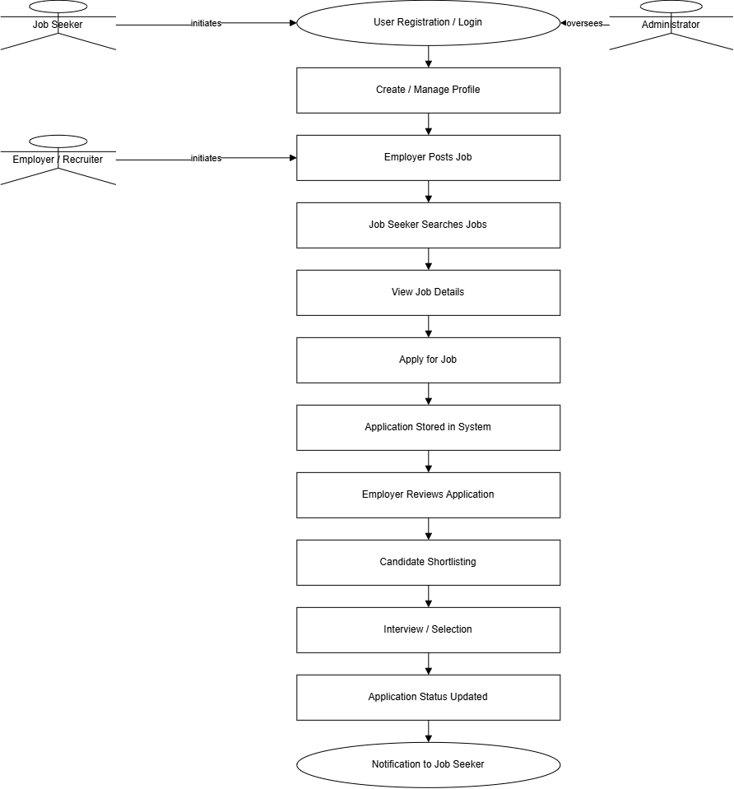

Fig 1.2. Proposed Workflow

1.5 Objectives

The main objectives of the proposed Job Portal System are:
- To provide a centralized platform where job seekers can search and apply for jobs.
- To allow job seekers to create and maintain their personal and professional profiles.
- To allow employers to create company profiles and post job vacancies.
- To make job searching easier by providing search and filtering options.
- To help employers find suitable candidates based on job requirements.
- To allow candidates to apply for jobs directly through the system.
- To help employers manage and review job applications in one place.
- To provide application status information to job seekers.
- To reduce the amount of manual work involved in the recruitment process.
- To improve communication between job seekers and employers through notifications and application updates.
- To maintain proper records of job postings, applications, candidates, and recruitment activities.
- To make the overall job-search and recruitment process faster, easier, and more organized.

1.6 Scope

The scope of the proposed Job Portal System covers the main activities involved in the job search and recruitment process. The system will provide user registration, login, and role-based access for job seekers, employers, and administrators. Job seekers will be able to create and update their profiles by adding details such as education, skills, experience, and resume. Employers will be able to create and manage their company profiles and post job vacancies with information such as job title, qualification, skills, salary, location, and job description.
The system will allow job seekers to search for suitable jobs using different search options and filters and apply for jobs by submitting their resumes and required information. Employers will be able to view and manage received applications and shortlist candidates based on job requirements. The system will also allow employers to update application statuses so that job seekers can track the progress of their applications. Notifications will be provided for new job postings, applications, interviews, and status updates.
The administrator will manage users, job postings, and other system activities. The system will also maintain organized records of users, companies, jobs, applications, shortlisted candidates, interviews, and other important recruitment activities. Overall, the scope of the system is focused on making the job search and recruitment process more organized, convenient, and easier to manage for both job seekers and employers.

1.7 Assumptions

The following assumptions are considered during the analysis and development of the proposed Job Portal System:
- Accurate User Information:
It is assumed that job seekers and employers will enter correct and genuine information into the system.
- Valid Job Information:
It is assumed that employers will provide correct information about job vacancies, qualifications, skills, salary, and other requirements.
- Authorized Users:
It is assumed that only registered and authorized users will access the system according to their assigned roles.
- Updated Job Postings:
It is assumed that employers will update or remove job postings when the vacancy is no longer available.
- Valid Resumes:
It is assumed that job seekers will upload their own and updated resumes.
- Internet Availability:
It is assumed that users will have a suitable internet connection while using the system.
- User Responsibility:
It is assumed that users will be responsible for the information they provide and the applications they submit.
- System Availability:
It is assumed that the system and its database will be available when users need to search, post, or apply for jobs.
- Employer Verification:
It is assumed that employers and job postings will be checked or managed according to the rules defined by the system administrator.
- Final Hiring Decision:
The final decision about selecting a candidate will remain with the employer. The system will only help in managing the recruitment process.

1.8 Constraints
The Job Portal System may face the following constraints:
- Technical Constraints:
The system depends on a stable internet connection, server availability, database performance, and proper functioning of the application.
- Operational Constraints:
The system depends on job seekers and employers entering and updating correct information. Incorrect or outdated information may affect job searching and recruitment.
- Security and Privacy Constraints:
The system will store personal information such as contact details, resumes, education, and employment information. Therefore, access to important information must be restricted to authorized users.
- Fake Job or Profile Information:
There may be a possibility of users providing false information or employers posting unsuitable job vacancies. Proper verification and reporting mechanisms may be required.
- Financial Constraints:
As an academic project, the system should preferably be developed using free or low-cost technologies. Advanced hosting and large-scale services may be limited because of budget restrictions.
- Schedule Constraints:
The system must be analyzed, designed, developed, tested, and documented within the given academic project timeline.
- Scalability Constraints:
The academic version of the system may support a limited number of users and job postings compared to a real-world commercial job portal.

2. Stakeholder Identification

2.1 Stakeholder Analysis

Stakeholder | Role | Responsibilities
Job Portal Administrator | Primary System Manager | Manages the overall job portal, monitors users and job postings, handles user access, and supervises the overall working of the system.
Employer/Recruiter | Primary System User | Creates company profiles, posts job vacancies, checks applications, shortlists suitable candidates, and updates application status.
Job Seeker/Candidate | Job Search and Application User | Creates a profile, adds education and skills, searches for suitable jobs, applies for jobs, uploads resumes, and checks application status.
System Administrator | Technical System Manager | Manages user accounts, system settings, database access, security, backups, and overall technical maintenance of the system.
Company/Organization | Job Provider | Provides job vacancies, job descriptions, required qualifications, skills, salary details, and other information related to available positions.
HR Personnel / Recruiter | Recruitment User | Reviews candidate applications, checks resumes, shortlists candidates, schedules interviews, and updates recruitment information.
Project Team / Developers | Development Team | Analyzes requirements, designs, develops, tests, and maintains the Job Portal System.

Table 2.1. Stakeholder Analysis

3. Software Characteristics

3.1 Nature of Software

The Job Portal System is a web-based application software designed to connect job seekers with employers and make the job search and recruitment process easier. It is an application-oriented, data-driven, user-centric, and event-driven system.
The system manages job seeker information, employer details, job postings, resumes, job applications, candidate profiles, application status, and recruitment activities. It responds to important events such as new job postings, new job applications, application status changes, and candidate shortlisting.
The software is designed to provide a centralized and organized platform for job seekers and employers. Its main purpose is to make job searching and recruitment faster, easier, and more organized.

3.2 Characteristics of Software

The Job Portal System should have the following important characteristics:
- User-Friendly: The system should provide a simple and easy-to-use interface for job seekers, employers, recruiters, and administrators.
- Reliable: The system should maintain accurate records of job postings, user profiles, resumes, and job applications so that users can depend on the information provided.
- Secure: Personal information such as user details, resumes, contact information, and company information should be protected from unauthorized access.
- Responsive: The system should quickly process job searches, applications, profile updates, and other user requests without unnecessary delay.
- Maintainable: The software should be easy to update, modify, and improve when the requirements of users or organizations change.
- Scalable: The system should support an increasing number of job seekers, employers, job postings, and applications without major performance problems.
- Available: The system should be accessible whenever users need to search for jobs, post vacancies, or check application status.
- Efficient: The system should reduce manual work by providing features such as job searching, online applications, candidate shortlisting, and application tracking.
- Accurate: The system should maintain correct information about job vacancies, candidate profiles, applications, and application status.

3.3 Software Quality Attributes

The Job Portal System should provide the following quality attributes:
- Reliability: The system should correctly maintain job postings, candidate information, applications, and application status. It should provide accurate information to both job seekers and employers.
- Security: Personal information related to job seekers, employers, resumes, and companies should be protected from unauthorized access. Role-based access should be provided to different users.
- Maintainability: The software should be easy to modify, update, and fix when system requirements or recruitment processes change.
- Portability: The application should be accessible on different devices and supported platforms such as computers, tablets, and smartphones.
- Performance: The system should quickly process job searches, profile updates, job applications, and other requests so that users do not have to wait unnecessarily.
- Scalability: The system should support an increasing number of users, job postings, companies, and applications without affecting its overall performance.
- Availability: The system should remain accessible whenever required, especially when job seekers need to search and apply for jobs or employers need to manage applications.
- Usability: The interface should be simple, clear, and easy to use for job seekers, employers, recruiters, and administrators.

3.4 Software Crisis Issues
The Job Portal System may face the following software crisis issues:
- Changing Requirements: Job seekers, employers, and recruiters may have different requirements, and these requirements may change during development. This may require changes in the system features and design.
- Data Accuracy Issues: Incorrect information in job postings, candidate profiles, resumes, or application status can create problems for both job seekers and employers.
- Reliability Issues: Failure to save applications correctly or update application status may affect the reliability of the system.
- Security Risks: Personal information such as contact details, resumes, education, and employment information must be protected from unauthorized access and misuse.
- System Complexity: Managing users, companies, job postings, resumes, applications, searching, shortlisting, notifications, and application status can make the system complex.
- Performance Issues: A large number of users searching for jobs or applying for jobs at the same time may affect system performance.
- Maintenance Difficulties: The system may require regular updates, bug fixing, database maintenance, and improvements as user requirements change.
- Testing Challenges: Different types of users, job postings, applications, search conditions, application statuses, and user roles need to be tested properly.
- Time and Resource Constraints: Developing and testing a complete job portal within a limited academic project timeline and available resources can be challenging.

3.5 Software Myths
Software myths are common but incorrect beliefs about software development. If these myths are followed, they can affect the quality, time, and success of the Job Portal System.
1. Customer Myths
- “The system requirements are simple, so detailed requirements are not necessary.”
Even though a job portal may look simple, clear requirements are needed for user registration, job posting, job searching, applications, resumes, candidate shortlisting, and application tracking.
- “Changes can be made at any time without affecting the project.”
Frequent changes in requirements can affect the system design, development time, testing, and overall project schedule.
2. Developer Myths
- “Once the software is working, the development is complete.”
A working system still requires proper testing, security checks, bug fixing, maintenance, and future improvements.
- “Adding more features will always make the system better.”
Unnecessary features can make the system more complicated and difficult to use. The focus should remain on important functions such as job searching, job posting, applications, and candidate management.
3. Management Myths
- “Adding more developers will always speed up development.”
New developers need time to understand the project requirements, design, and existing work. Adding more people does not always mean that the project will be completed faster.
- “The project can be completed quickly because it is only a software system.”
Even a job portal requires proper requirement analysis, design, development, testing, security, and documentation.
- “Once the project plan is prepared, no further changes are required.”
Software projects may require changes based on user feedback, testing results, and new requirements. Therefore, the project should allow some flexibility and continuous improvement.

4. Software Process Model Selection

4.1 Selected Process Model
For the Job Portal System, the Agile Software Development Model is selected as the Software Development Life Cycle (SDLC) model.
The Agile model supports incremental development, continuous testing, regular feedback, and flexibility in changing requirements. The system can be developed in small iterations, starting with important features such as user registration, login, job seeker profiles, and employer profiles. Later iterations can include job posting, job searching, online applications, candidate shortlisting, application tracking, and notifications.
This makes the Agile model suitable for developing a useful and user-friendly system where requirements and features can be improved continuously based on feedback and testing.

4.2 Justification
The Agile Software Development Model is appropriate for the Job Portal System for the following reasons:
- Changing Requirements: System requirements may change based on feedback from job seekers, employers, recruiters, and administrators. Agile allows such changes to be handled during development.
- Incremental Development: The system can be developed in small modules or iterations. For example, user registration and profiles can be developed first, followed by job posting, job searching, applications, shortlisting, and notifications.
- Continuous Testing: Each module can be tested during development. This helps identify errors related to job searching, applications, user accounts, and application status at an early stage.
- Regular User Feedback: Feedback from job seekers, employers, and other users can be collected after each iteration to improve the usability and functionality of the system.
- Early Delivery: A basic working version of the system can be developed early with essential features, while additional features can be added in later iterations.
- Easy Maintenance and Improvement: New features, changes, and improvements can be added in future iterations without changing the complete system.

4.3 Advantages
- Flexibility: Changes in system requirements can be handled easily during development.
- Early Delivery of Working Software: A basic working version of the system can be developed early with important features.
- Continuous Testing: Each module can be tested regularly to identify and fix errors at an early stage.
- Regular User Feedback: Feedback from job seekers, employers, and recruiters can be used to improve the system.
- Reduced Development Risk: Problems can be identified early through frequent testing and review.
- Easy Maintenance: Changes, improvements, and new features can be added in future iterations.
- Faster Response to Changing Requirements: Agile allows the development team to quickly adapt to new requirements.
- Incremental Development: Features such as user management, job posting, job searching, applications, shortlisting, and notifications can be developed step by step.

4.4 Limitations
- Requires Continuous User Involvement: Regular feedback from job seekers, employers, recruiters, and other users is required throughout the development process.
- Frequent Requirement Changes: Continuous changes in requirements may affect the development schedule and increase the effort required by the project team.
- Requires Effective Team Communication: Developers and stakeholders need to communicate regularly to make sure that all modules and requirements are properly understood.
- Less Predictable Cost and Schedule: Since requirements can change during development, it may be difficult to predict the exact time and resources required.
- Requires Regular Testing and Reviews: Each iteration needs proper testing and review to make sure that features such as job searching, applications, and candidate management work correctly.
- Documentation May Receive Less Emphasis: Agile focuses on working software, so proper documentation must be managed carefully for an academic project.
- Not Ideal for Completely Fixed Requirements: If all requirements are fixed from the beginning and no changes are expected, a more structured model may sometimes be easier to manage.

4.5 Comparison with Other Models

Process Model | Advantages | Limitations | Suitability for Job Portal System
Waterfall | Easy to plan and follows a fixed step-by-step process | Changes are difficult to make after development starts | Low
Incremental | Builds the system feature by feature | Different parts need to be planned and connected properly | High
Iterative | Allows the system to be improved again and again | Repeated testing and development may take more time | High
Evolutionary | Useful when requirements are not completely clear at the beginning | Managing the system can become difficult as it becomes larger | High
Concurrent | Different development activities can be done at the same time | Needs good coordination between team members | Moderate
Agile | Easy to adapt, supports user feedback, and allows regular testing | Needs regular communication and involvement from users | Very High

Table 4.1. Comparison of Software Process Models

5. Software Requirement Specification (SRS)
❖ Functional Requirements

- User Registration/Login: Allows users to register and log in.
- User Management: Manages user accounts and roles.
- Profile Management: Stores job seeker details, skills, experience, and resumes.
- Company Management: Stores employer and company information.
- Job Posting: Allows employers to add, update, and remove job vacancies.
- Job Search: Allows job seekers to search jobs using title, skills, location, and experience.
- Job Applications: Allows candidates to apply and employers to view applications.
- Candidate Shortlisting: Helps employers shortlist suitable candidates.
- Application Status: Allows employers to update and candidates to check application status.
- Notifications: Provides updates about jobs, applications, and interviews.
- Reports: Generates reports about jobs, applications, and candidates.

❖ Non-Functional Requirements

- Performance: The system should respond quickly to user requests.
- Security: User, resume, and company information should be protected.
- Reliability: The system should maintain accurate records.
- Availability: The system should be accessible when required.
- Usability: The interface should be simple and easy to use.
- Maintainability: The system should be easy to update and fix.
- Scalability: The system should support increasing users and data.
- Portability: The system should work on computers, tablets, and smartphones.

❖ External Interface Requirements

- User Interface: Provides interfaces for login, profiles, jobs, applications, and reports.
- Hardware Interface: Supports computers, laptops, tablets, and smartphones.
- Software Interface: Uses a database to store and retrieve system information.
- Communication Interface: Uses internet or network communication.

❖ System Features

- User Management: Manages users and access.
- Profile Management: Maintains job seeker and employer profiles.
- Job Management: Allows employers to manage job vacancies.
- Job Search: Helps candidates find suitable jobs.
- Job Applications: Allows candidates to apply for jobs.
- Candidate Management: Helps employers view and shortlist candidates.
- Application Tracking: Tracks application status.
- Notifications: Provides job and application updates.
- Reports: Provides job and recruitment information.
- Error Handling: Shows messages for invalid input or unavailable jobs.

❖ Data Requirements

- Database Requirements: Stores all important system information.
- Data Entities: User, Job Seeker, Employer, Company, Job, Resume, Application, Shortlist, Interview, and Notification.
- Data Storage: Stores information in an organized manner.
- Data Validation: Checks information before storing or processing it.
- Data Security: Protects stored information from unauthorized access.

Requirement Traceability Matrix (RTM)

Business Objective | Software Requirement ID | Software Requirement
Maintain accurate user information | FR-01 | The system shall allow job seekers, employers, recruiters, and administrators to register and log in.
Manage users and their access | FR-02 | The system shall manage user accounts, roles, and access permissions.
Maintain job seeker information | FR-03 | The system shall store and manage job seeker profile details such as education, skills, experience, contact information, and resume.
Maintain employer and company information | FR-04 | The system shall store and manage employer and company profile details.
Provide updated job vacancies | FR-05 | The system shall allow employers to create, update, and remove job postings.
Help users find suitable jobs | FR-06 | The system shall allow job seekers to search and filter available jobs.
Allow candidates to apply for jobs | FR-07 | The system shall allow job seekers to apply for suitable jobs and submit their resumes.
Help employers manage applications | FR-08 | The system shall allow employers to view and manage received job applications.
Identify suitable candidates | FR-09 | The system shall allow employers to shortlist candidates based on their qualifications, skills, and experience.
Track job application progress | FR-10 | The system shall allow employers to update application status and job seekers to view their application status.
Provide timely information to users | FR-11 | The system shall provide notifications for new jobs, application updates, interviews, and other important activities.
Support monitoring and decision-making | FR-12 | The system shall generate reports related to job postings, applications, candidates, and recruitment activities.

Table 6.1. Requirement Traceability Matrix

7. Requirement Modeling

7.1 Draw ER Diagram for proposed system
The ER Diagram represents the main data entities of the Job Portal System and their relationships. It shows how job seeker, employer, company, job, resume, application, shortlist, interview, and notification data are connected.

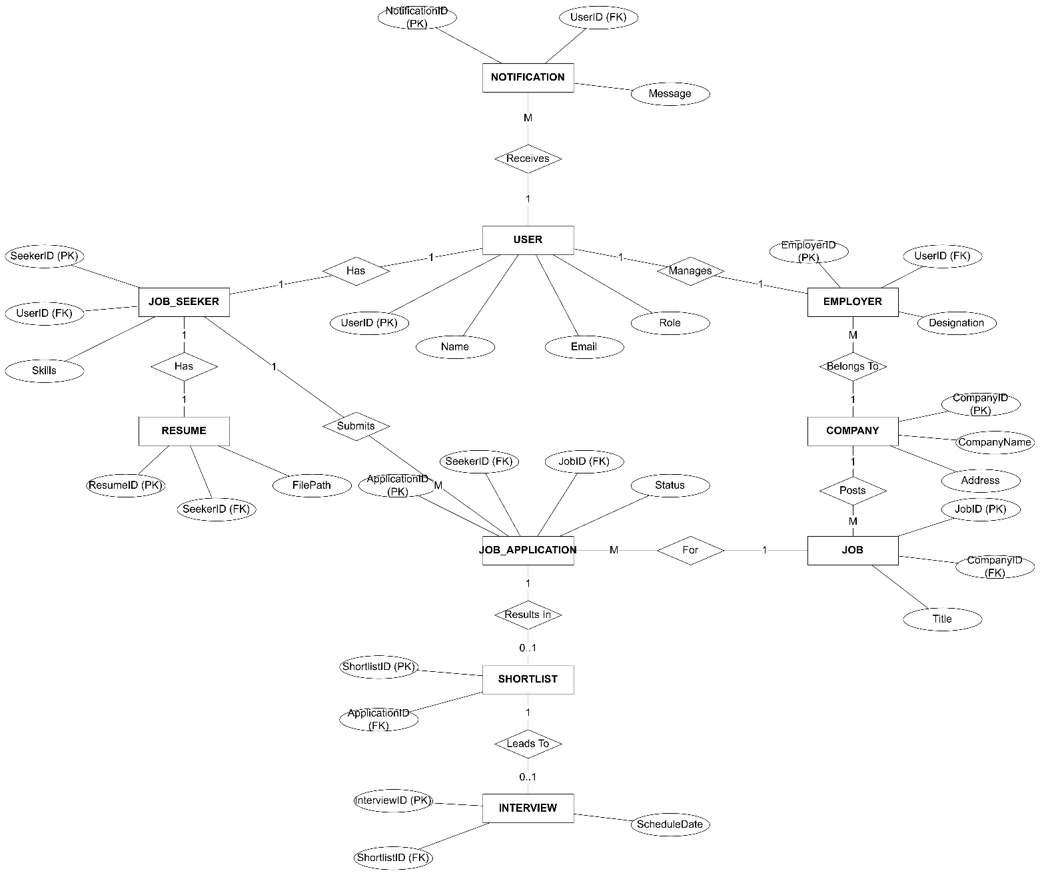

Fig 7.1. Entity Relationship Diagram (ER Diagram)

7.2 Draw DFD Diagram for proposed system

Context Free diagram
The Context Diagram shows the complete Job Portal System as one main process and the external users who interact with it.

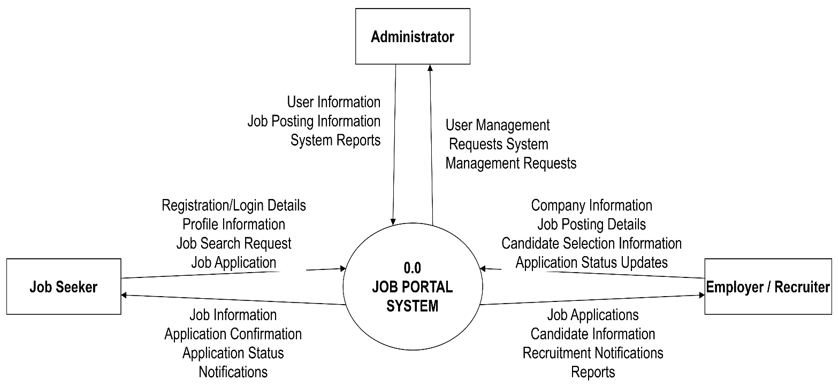

Fig 7.2. Context Diagram

DFD Level 0

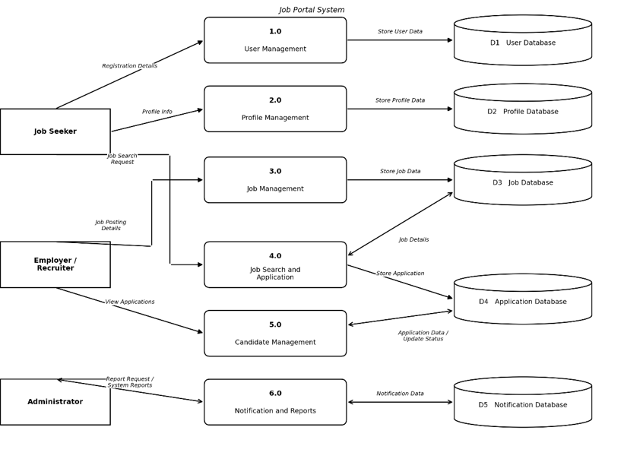

Fig 7.3. Data Flow Diagram – Level 0

DFD Level 1

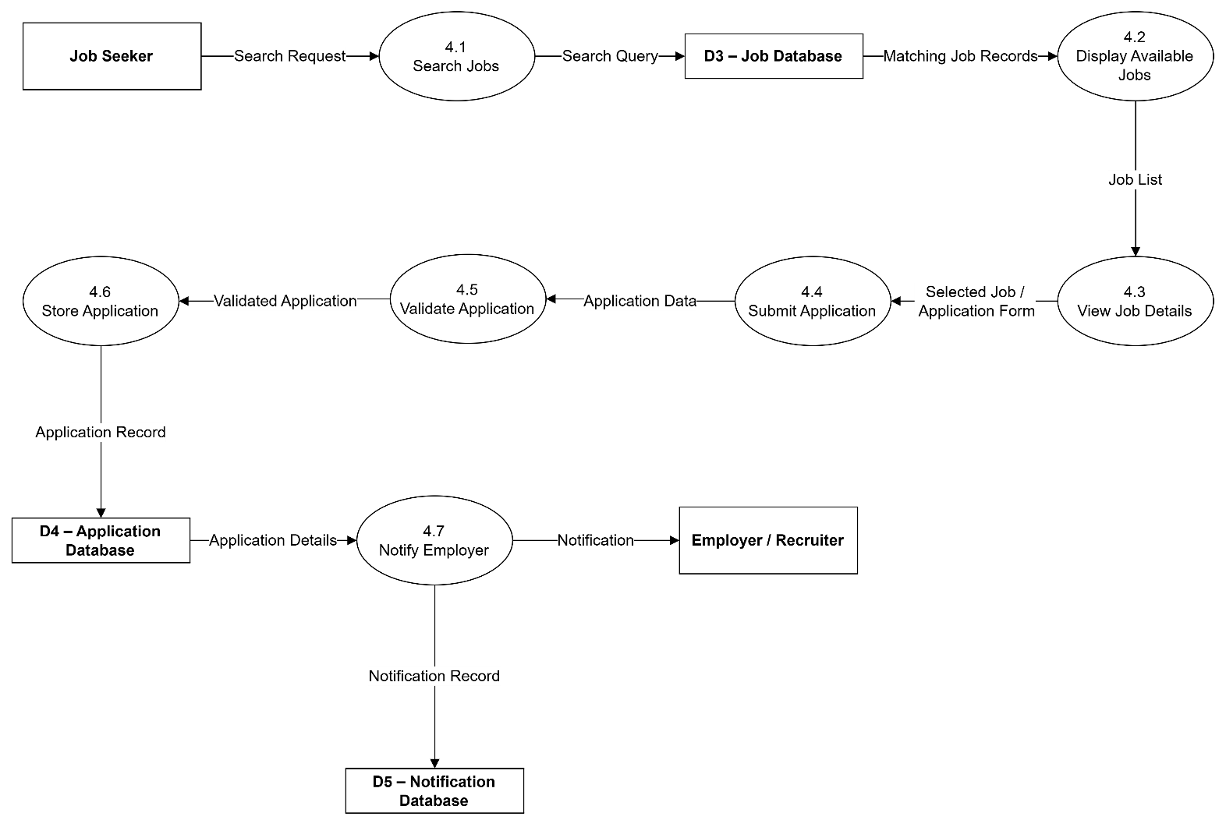

Fig 7.4. Data Flow Diagram – Level 1

7.3 Scenario-Based Modeling

Use Case Diagram
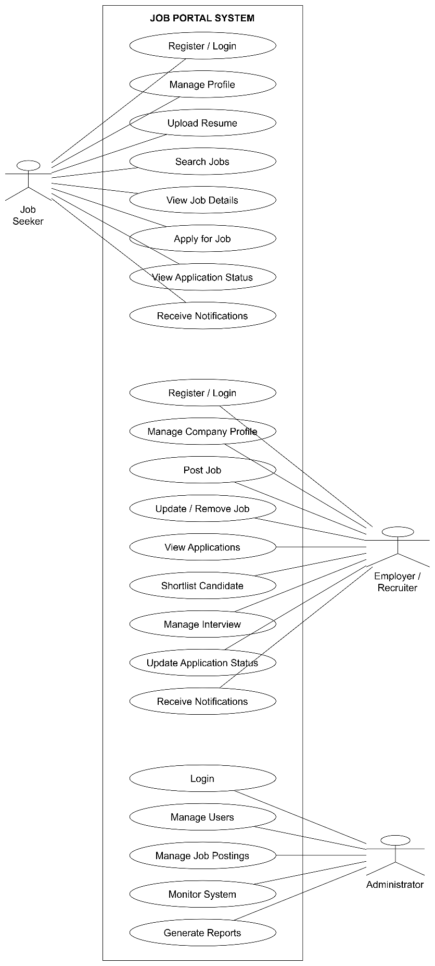

Fig 7.5. Use Case Diagram

Use Case Descriptions

Attribute | Description
Use Case ID | UC-01
Use Case Name | User Login
Primary Actor | Job Seeker / Employer / Administrator
Preconditions | User must have a registered account and valid login credentials.
Postconditions | User is authenticated and given access according to their role.
Basic Flow | 1. User enters username and password.  2. System checks the entered details.  3. System identifies the user's role.  4. System provides role-based access.  5. User is redirected to the appropriate dashboard.
Alternate Flow | If the login details are incorrect, the system displays an error message and asks the user to enter the details again.

Table 7.1. UC-01: User Login

Attribute | Description
Use Case ID | UC-02
Use Case Name | Create Job Seeker Profile
Primary Actor | Job Seeker
Preconditions | Job seeker must be registered and logged in.
Postconditions | Job seeker profile is created and stored in the system.
Basic Flow | 1. Job seeker opens the profile section.  2. User enters personal, education, skill, and experience details.  3. User uploads resume if required.  4. System checks the entered information.  5. System saves the profile.
Alternate Flow | If any required information is missing or invalid, the system displays an error message and asks the user to correct it.

Table 7.2. UC-02: Create Job Seeker Profile

Attribute | Description
Use Case ID | UC-03
Use Case Name | Post Job
Primary Actor | Employer / Recruiter
Preconditions | Employer must be registered and logged in.
Postconditions | Job vacancy is stored and becomes available to job seekers.
Basic Flow | 1. Employer selects the job posting option.  2. Employer enters job title, skills, qualification, salary, location, and other details.  3. System checks the entered information.  4. System stores the job posting.  5. Job becomes available for searching.
Alternate Flow | If required job information is missing or invalid, the system displays an error and asks the employer to correct it.

Table 7.3. UC-03: Post Job

Attribute | Description
Use Case ID | UC-04
Use Case Name | Search and Apply for Job
Primary Actor | Job Seeker
Preconditions | Job seeker must be logged in and suitable job postings must be available.
Postconditions | Job application is submitted and stored in the system.
Basic Flow | 1. Job seeker enters search criteria.  2. System displays matching jobs.  3. Job seeker selects a suitable job.  4. System displays job details.  5. Job seeker submits the application and resume.  6. System validates the application.  7. System stores the application.  8. Employer is notified about the new application.
Alternate Flow | If the job is no longer available or required information is missing, the system displays an appropriate message and does not submit the application.

Table 7.4. UC-04: Search and Apply for Job

Attribute | Description
Use Case ID | UC-05
Use Case Name | View Job Applications
Primary Actor | Employer / Recruiter
Preconditions | Employer must be logged in and job applications must exist.
Postconditions | Employer can view the applications received for the posted job.
Basic Flow | 1. Employer opens the application section.  2. System displays posted jobs.  3. Employer selects a job.  4. System displays received applications.  5. Employer views candidate details and resume.
Alternate Flow | If no applications are available, the system displays a message indicating that no applications have been received.

Table 7.5. UC-05: View Job Applications

Attribute | Description
Use Case ID | UC-06
Use Case Name | Shortlist Candidate
Primary Actor | Employer / Recruiter
Preconditions | Employer must be logged in and candidate applications must be available.
Postconditions | Selected candidate is marked as shortlisted.
Basic Flow | 1. Employer opens received applications.  2. Employer reviews candidate details and resume.  3. Employer selects a suitable candidate.  4. Employer marks the candidate as shortlisted.  5. System updates the candidate's application status.  6. Candidate receives a notification.
Alternate Flow | If the candidate does not meet the job requirements, the employer can leave the application unselected or update its status accordingly.

Table 7.6. UC-06: Shortlist Candidate

Attribute | Description
Use Case ID | UC-07
Use Case Name | Update Application Status
Primary Actor | Employer / Recruiter
Preconditions | Employer must be logged in and the candidate must have an existing application.
Postconditions | Application status is updated and the candidate is informed.
Basic Flow | 1. Employer opens the application list.  2. Employer selects a candidate.  3. Employer chooses the required status.  4. System saves the new status.  5. System sends a notification to the job seeker.
Alternate Flow | If the application cannot be found, the system displays an appropriate error message.

Table 7.7. UC-07: Update Application Status

Attribute | Description
Use Case ID | UC-08
Use Case Name | View Application Status
Primary Actor | Job Seeker
Preconditions | Job seeker must be logged in and must have submitted at least one application.
Postconditions | Current application status is displayed to the job seeker.
Basic Flow | 1. Job seeker opens the application section.  2. System retrieves submitted applications.  3. System displays the current status of each application.  4. Job seeker views the application details.
Alternate Flow | If the application cannot be found, the system displays an appropriate error message.

Table 7.8. UC-08: View Application Status

7.4 Class-Based Modeling

Analysis Class Diagram

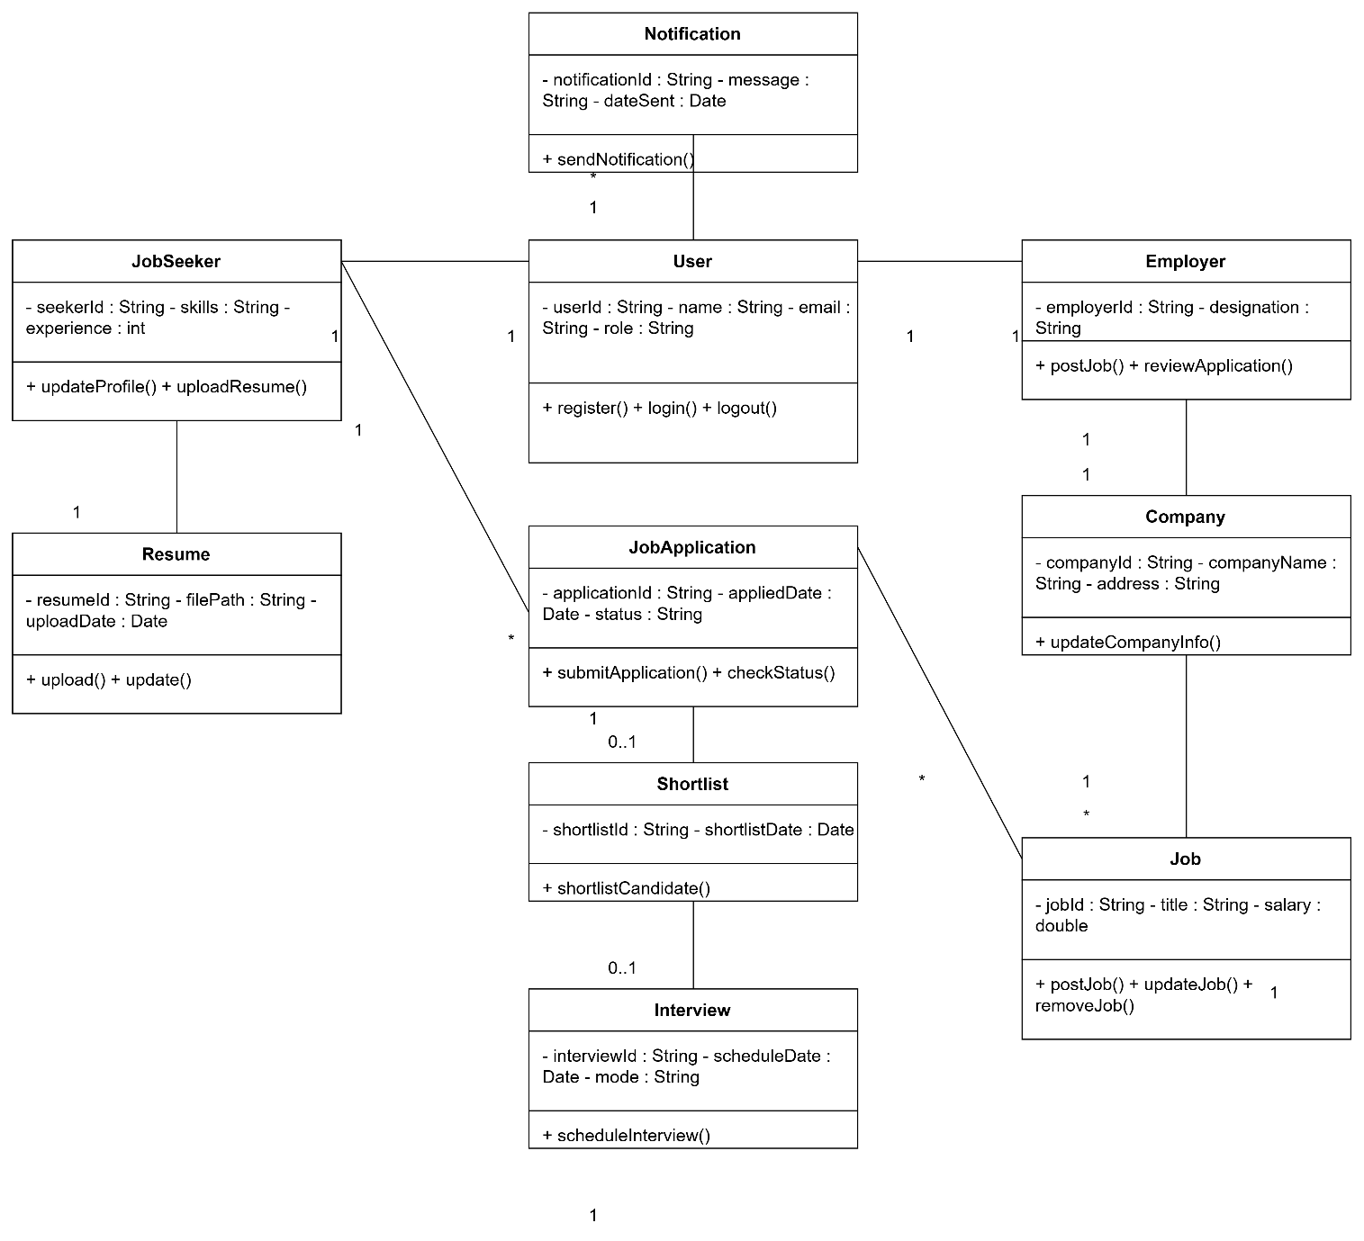

Fig 7.5. Analysis Class Diagram

8. Conclusion
The analysis of the existing job-search and recruitment process shows that finding jobs from different sources, managing resumes, checking applications manually, and communicating between job seekers and employers can take time and may cause delays or confusion.
The proposed Job Portal System provides a centralized platform where job seekers and employers can manage their activities more easily. The system includes user registration, profile management, job posting, job searching, online applications, candidate shortlisting, application status tracking, notifications, and report generation.
The proposed system is expected to provide several benefits. It can make searching and applying for suitable jobs faster and provide easy access to job vacancies in one place. It can reduce manual work for employers and recruiters and make candidate applications easier to manage. The system can also help employers shortlist suitable candidates quickly and allow job seekers to track their application status. Centralized management of users, companies, jobs, and applications can reduce errors in records. Notifications and updates can improve communication between job seekers and employers. Overall, the system can improve the efficiency and organization of the recruitment process.

● Future Scope
The system can be further improved in the future with:
- Mobile application for job seekers, employers, and recruiters.
- Email and SMS notifications for jobs, interviews, and application updates.
- AI-based job recommendations based on skills, education, and experience.
- Resume analysis for better candidate matching.
- Online interview facility using video calling.
- Advanced search and filtering for jobs and candidates.
- Integration with professional networking platforms.
- Analytics for job trends, applications, and recruitment activities.
- Company verification to reduce fake job postings and improve user trust.

9. References
[1] I. Sommerville, Software Engineering, 10th ed. Harlow, U.K.: Pearson Education, 2016.
[2] R. S. Pressman and B. R. Maxim, Software Engineering: A Practitioner's Approach, 8th ed. New York, NY, USA: McGraw-Hill Education, 2015.
[3] H. Gomaa, Software Modeling and Design: UML, Use Cases, Patterns, and Software Architectures. Cambridge, U.K.: Cambridge University Press, 2011.
[4] C. Larman, Applying UML and Patterns: An Introduction to Object-Oriented Analysis and Design and Iterative Development, 3rd ed. Upper Saddle River, NJ, USA: Prentice Hall, 2004.
[5] M. Fowler, UML Distilled: A Brief Guide to the Standard Object Modeling Language, 3rd ed. Boston, MA, USA: Addison-Wesley, 2004.
[6] Object Management Group, OMG Unified Modeling Language (OMG UML), Version 2.5.1. Needham, MA, USA: Object Management Group, 2017.
[7] I. Jacobson, G. Booch, and J. Rumbaugh, The Unified Software Development Process. Reading, MA, USA: Addison-Wesley, 1999.
[8] K. E. Wiegers and J. Beatty, Software Requirements, 3rd ed. Redmond, WA, USA: Microsoft Press, 2013.
[9] R. J. Madachy, Software Process Dynamics. Hoboken, NJ, USA: Wiley-IEEE Press, 2008.
[10] B. W. Boehm, “A spiral model of software development and enhancement,” Computer, vol. 21, no. 5, pp. 61–72, May 1988.
[11] M. Cohn, Agile Estimating and Planning. Upper Saddle River, NJ, USA: Prentice Hall, 2005.
[12] K. Schwaber and M. Beedle, Agile Software Development with Scrum. Upper Saddle River, NJ, USA: Prentice Hall, 2002.
[13] J. Highsmith, Agile Software Development Ecosystems. Boston, MA, USA: Addison-Wesley, 2002.
[14] Agile Alliance, “What is Agile?,” Agile Alliance. [Online]. Available: Agile Alliance
[15] Scrum.org, “What is Scrum?,” Scrum.org. [Online]. Available: Scrum Guide and Scrum resources
[16] Object Management Group, “Unified Modeling Language (UML),” OMG. [Online]. Available: OMG UML

[17] IEEE Computer Society, Guide to the Software Engineering Body of Knowledge (SWEBOK Guide), Version 3.0. Los Alamitos, CA, USA: IEEE Computer Society, 2014.
[18] IEEE, IEEE Std 830-1998: IEEE Recommended Practice for Software Requirements Specifications. New York, NY, USA: IEEE, 1998.
[19] R. T. Futrell, D. F. Shafer, and L. I. Shafer, Quality Software Project Management. Upper Saddle River, NJ, USA: Prentice Hall, 2002.
[20] R. Mall, Fundamentals of Software Engineering, 5th ed. New Delhi, India: PHI Learning, 2018.

