**ASE-Problem set 2**

**Video Rental System**

**Name: Naveena Madepally**

**Student Id : 16280573**

1. **Class Diagram for Video Rental System:**

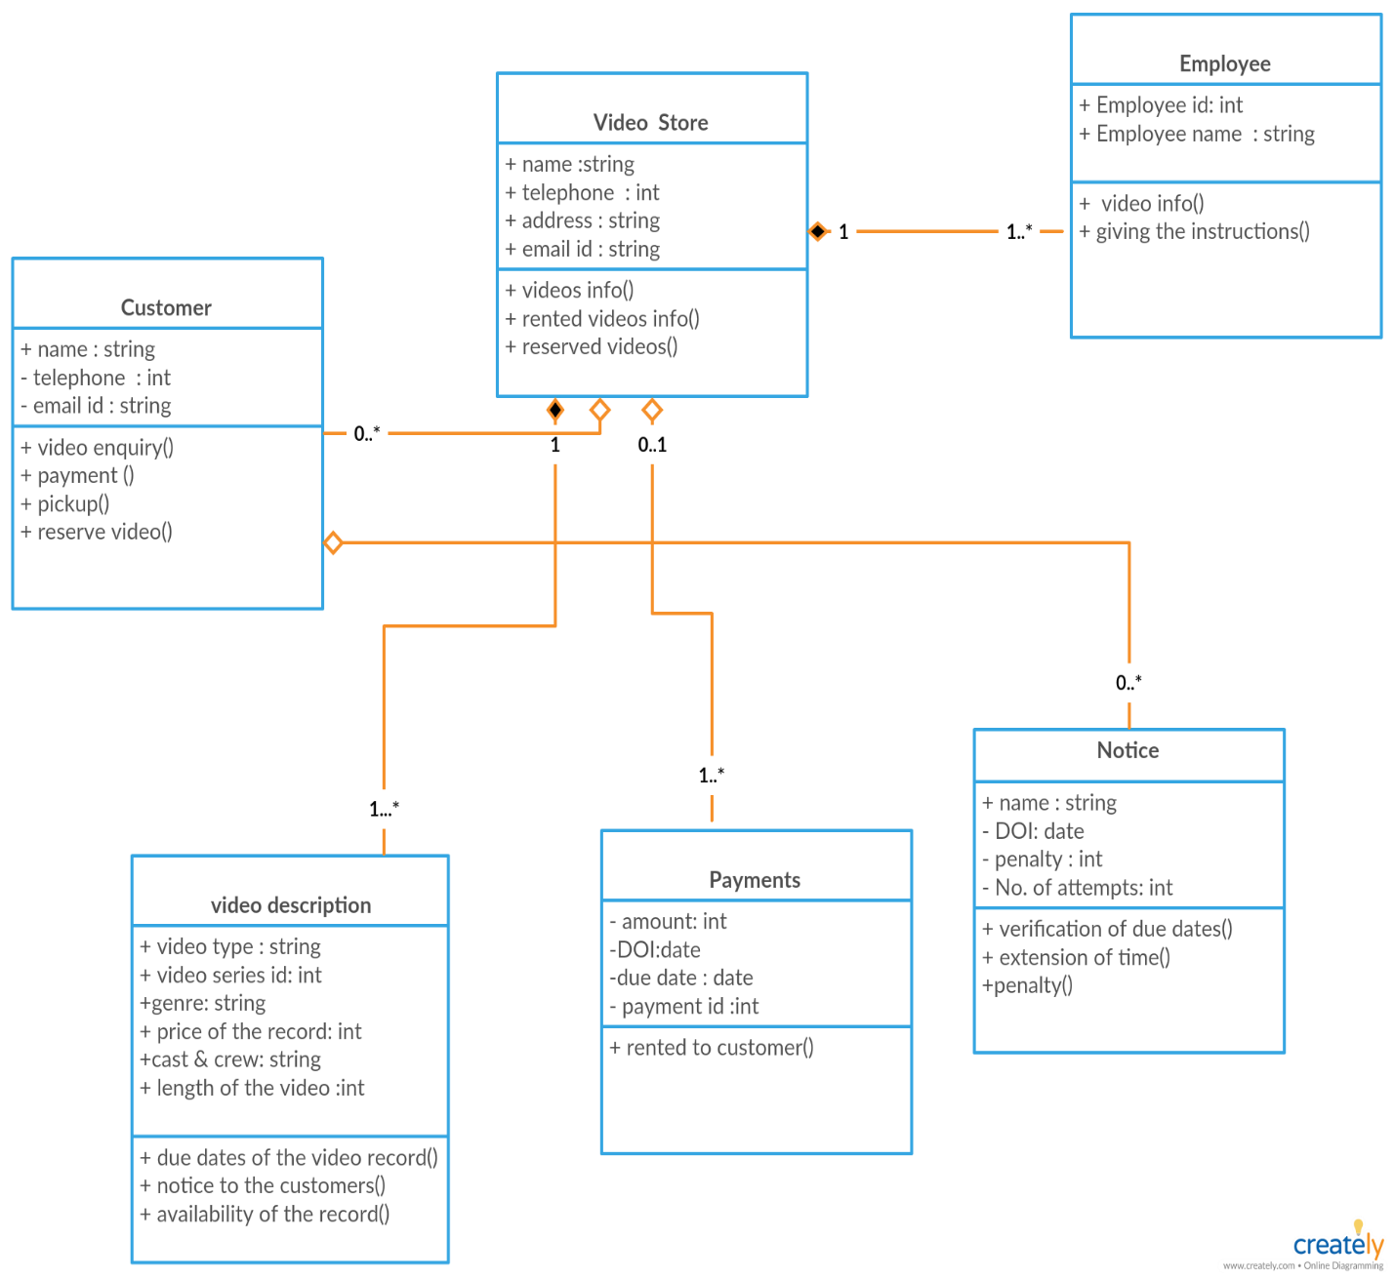

1. **Difference between Aggregation and composite relationship using video store**

* **Aggregation** impliesa relationship where the child can exist independently of the parent.
* **Composition** implies a relationship where the child cannot exist independent of the parent.
* A video store has aggregation relationship with payments and notices because without video store there will not be any payments and notice
* A video store has composition relationship with videos and employee because without video store videos and employee can still exists.

1. **Sequence diagram for renting movie from a video store**

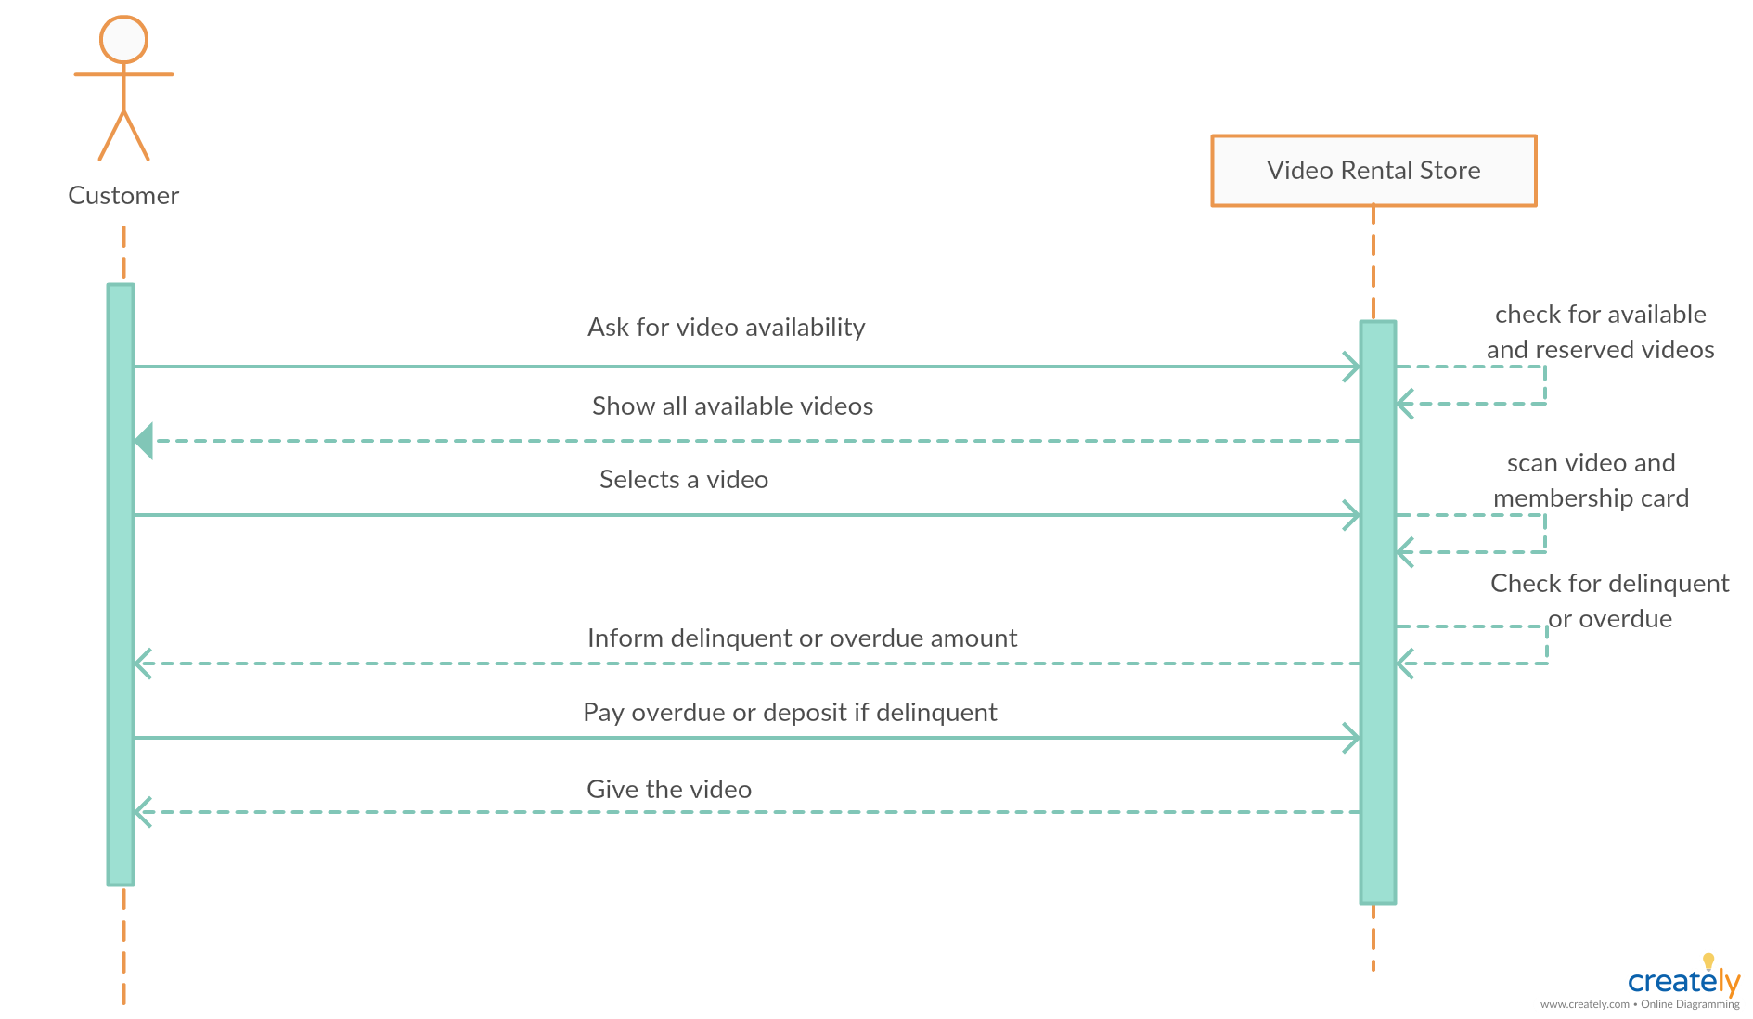

1. **Activity diagram that describes renting a movie form video store.**

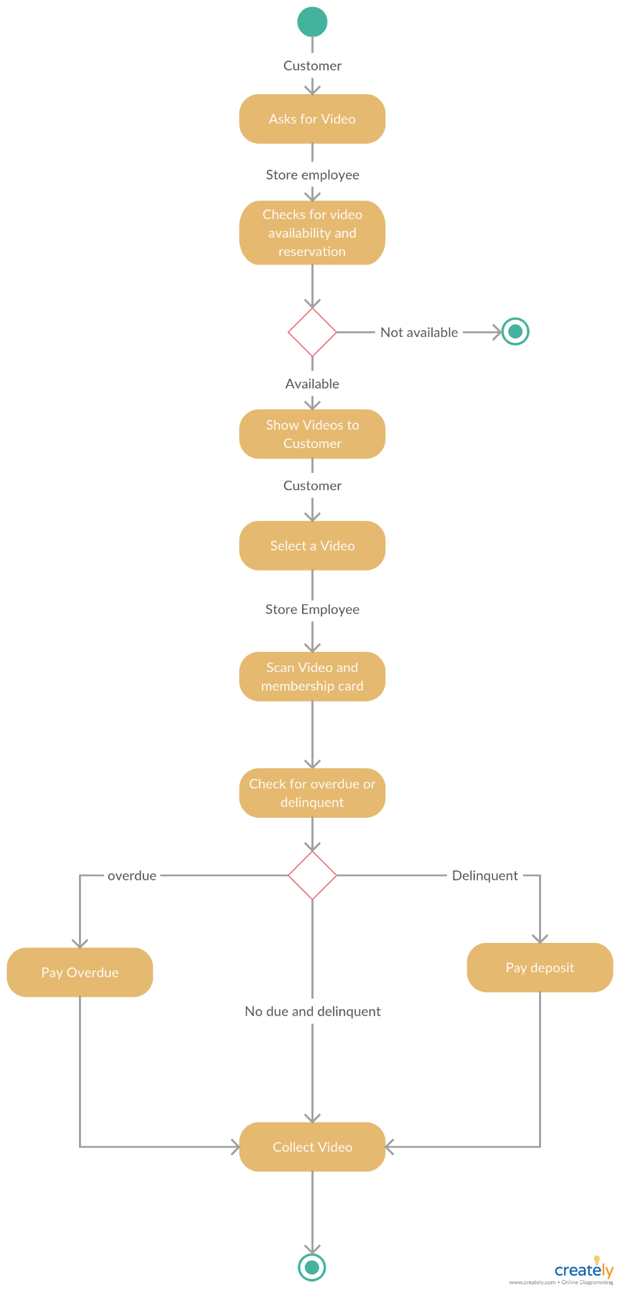

1. **State diagram that describes lifetime of a video in video store.**

