Answer 1)

[ec2-user@ip-172-31-30-34 ~]$ docker --version

Docker version 19.03.6-ce, build 369ce74

Answer 2)

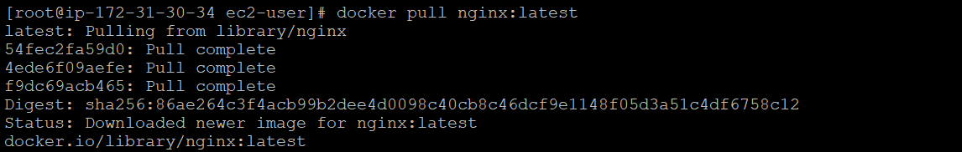

Answer 3)

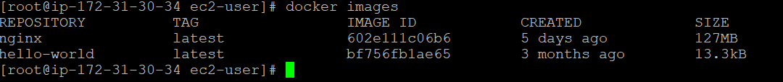

Answer 4) docker inspect nginx | grep Id

602e111c06b6934013578ad80554a074049c59441d9bcd963cb4a7feccede7a5

Answer 5)



Answer 6)



Answer 7)

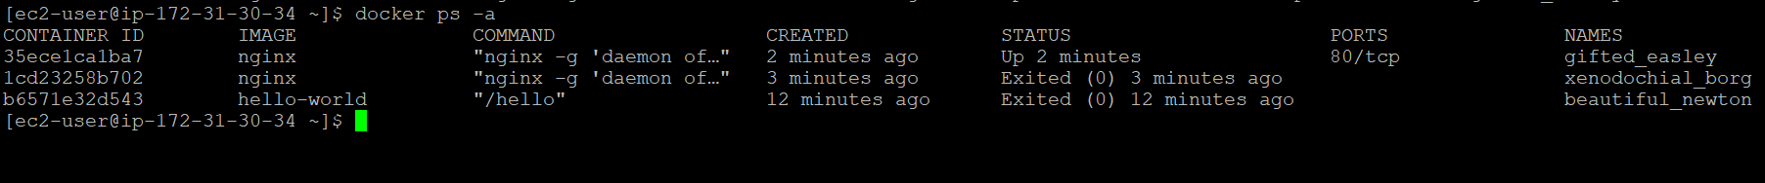

Answer 8)

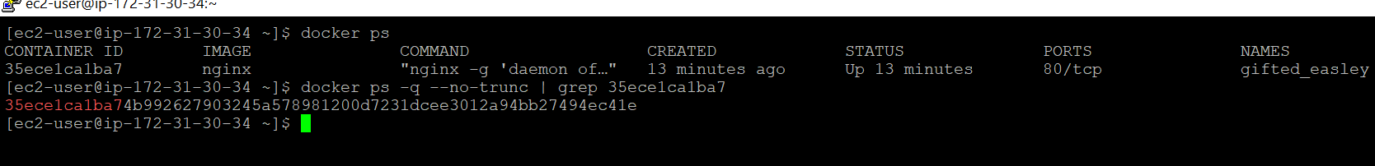

Answer 9)

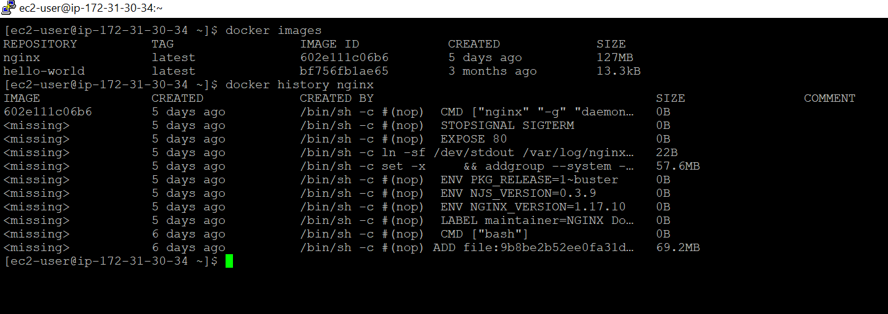

Answer 10)

[ec2-user@ip-172-31-30-34 ~]$ docker run -itd --rm -p 8888:8080 tomcat:7

39f4af81195a0e654c69f30e0b7437bd847eac885a8b0c1a977e23080b257ef2

Answer 11)



Answer 12) docker inspect 6d486ccdaf88

"Ports": {

"8080/tcp": [

{

"HostIp": "0.0.0.0",

"HostPort": "8888"

}

]

},

Answer 13) 8888

Answer 14) curl http://localhost:8080

Answer 15)

[ec2-user@ip-172-31-30-34 ~]$ docker images

REPOSITORY TAG IMAGE ID CREATED SIZE

tomcat 7 b25a0010e9d8 4 days ago 529MB

Answer 16)

"Env": [

"PATH=/usr/local/tomcat/bin:/usr/local/openjdk-8/bin:/usr/local/sbin:/usr/local/bin:/usr/sbin:/usr/bin:/sbin:/bin",

"LANG=C.UTF-8",

"JAVA_HOME=/usr/local/openjdk-8",

"JAVA_VERSION=8u252",

"JAVA_BASE_URL=https://github.com/AdoptOpenJDK/openjdk8-upstream-binaries/releases/download/jdk8u252-b09/OpenJDK8U-jdk_",

"JAVA_URL_VERSION=8u252b09",

"CATALINA_HOME=/usr/local/tomcat",

"TOMCAT_NATIVE_LIBDIR=/usr/local/tomcat/native-jni-lib",

"LD_LIBRARY_PATH=/usr/local/tomcat/native-jni-lib",

"GPG_KEYS=05AB33110949707C93A279E3D3EFE6B686867BA6 07E48665A34DCAFAE522E5E6266191C37C037D42 47309207D818FFD8DCD3F83F1931D684307A10A5 541FBE7D8F78B25E055DDEE13C370389288584E7 61B832AC2F1C5A90F0F9B00A1C506407564C17A3 713DA88BE50911535FE716F5208B0AB1D63011C7 79F7026C690BAA50B92CD8B66A3AD3F4F22C4FED 9BA44C2621385CB966EBA586F72C284D731FABEE A27677289986DB50844682F8ACB77FC2E86E29AC A9C5DF4D22E99998D9875A5110C01C5A2F6059E7 DCFD35E0BF8CA7344752DE8B6FB21E8933C60243 F3A04C595DB5B6A5F1ECA43E3B7BBB100D811BBE F7DA48BB64BCB84ECBA7EE6935CD23C10D498E23",

"TOMCAT_MAJOR=7",

"TOMCAT_VERSION=7.0.103",

"TOMCAT_SHA512=3a02bf074fd5a00e751b1229cffdf7c7d9ee52ab825ddecb1e5b766d40999f08be5d3758704333a922c593b139bce51feb8b33924731aacf3acebba8beb5cce8"

],

Answer 17)

|  |
| --- |
|  |
| docker inspect 2ce73c4841193dfe9166ac14514f02be5149f2ceb324e02b73fc4652849100fd | grep ExposedPort |
|  |

8080

Answer 18 )

[ec2-user@ip-172-31-30-34 ~]$ docker ps

CONTAINER ID IMAGE COMMAND CREATED STATUS PORTS NAMES

fe76161f1661 tomcat:7 "catalina.sh run" 10 seconds ago Up 9 seconds 0.0.0.0:801->8080/tcp unruffled_merkle

39f4af81195a tomcat:7 "catalina.sh run" 22 minutes ago Up 22 minutes 0.0.0.0:8888->8080/tcp condescending_payne

35ece1ca1ba7 nginx "nginx -g 'daemon of…" 3 hours ago Up 3 hours 80/tcp gifted_easley

[ec2-user@ip-172-31-30-34 ~]$

Answer 19)

[ec2-user@ip-172-31-30-34 ~]$ docker pull ubuntu:18.04

18.04: Pulling from library/ubuntu

23884877105a: Pull complete

bc38caa0f5b9: Pull complete

2910811b6c42: Pull complete

36505266dcc6: Pull complete

Digest: sha256:3235326357dfb65f1781dbc4df3b834546d8bf914e82cce58e6e6b676e23ce8f

Status: Downloaded newer image for ubuntu:18.04

docker.io/library/ubuntu:18.04

[ec2-user@ip-172-31-30-34 ~]$ docker pull ubuntu:19.10

19.10: Pulling from library/ubuntu

cbdc015de259: Pull complete

35f8707632bb: Pull complete

6b786d087f83: Pull complete

31fb3cd05fdd: Pull complete

Digest: sha256:6859e3f7b06393b0f3e3a7af893ee882e40582fdce2d7e23d504ba191fada7fd

Status: Downloaded newer image for ubuntu:19.10

Answer 20)

[ec2-user@ip-172-31-30-34 ~]$ docker run -p ubuntu:19.10 /bin/bash

root@7ef4e75b0ef0:

Answer 21)

[ec2-user@ip-172-31-30-34 ~]$ docker run -d ubuntu:18.04 /bin/bash

6b90c4f8a2a0e6ce1ea9fcddc8a8dc0e10143d7522928d0dea24ff8d828982fd

Answer 22)

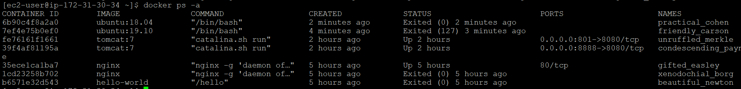

Answer 23)



Answer 24)

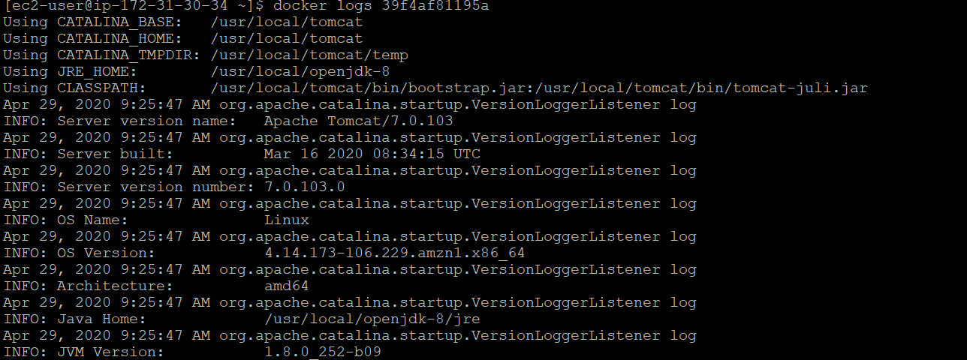

Answer 25)

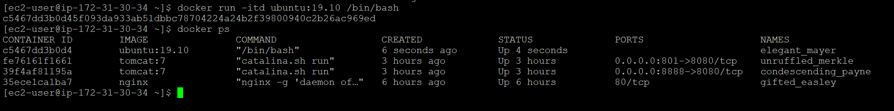

Answer 26)

[ec2-user@ip-172-31-30-34 ~]$ docker exec –user root -it c5467dd3b0d4 /bin/bash

root@c5467dd3b0d4:/#

Answer 27)

root@c5467dd3b0d4:/# mkdir Neha

Answer 28)

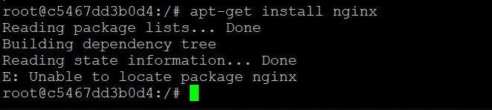

Answer 35)



Answer 36)

[ec2-user@ip-172-31-30-34 ~]$ docker run -itd ubuntu:19.10.1 /bin/bash

f5a575d743aefd09d0457837e0f5cac9fcf204ef9d83246b00974e24331198fe



Answer 37)

[ec2-user@ip-172-31-30-34 ~]$ docker stop fe76161f1661 39f4af81195a

fe76161f1661

39f4af81195a

[ec2-user@ip-172-31-30-34 ~]$

Answer 38)



docker run -it -d -p 8080:8080 -v /root/index.html:/usr/local/tomcat/webapps/ROOT/index.jsp --name tomcat tomcat:latest

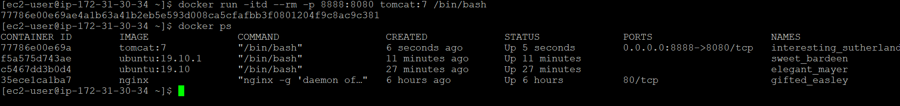

Answer 39)-a : docker images –a

docker container ls --format='{{json .}}'

-f and –q: docker images -q

Answer 40)

-a: [ec2-user@ip-172-31-30-34 ~]$ docker ps –a

docker ps -f status=running

-s: docker ps –s

-q: docker ps -q --no-trunc | grep f5a575d743ae

docker ps -n 2

l: docker ps –l

docker ps –s

Answer 41)

docker cp sample.war 77786e00e69a/opt

docker network create mynet

docker history cc7ef7b7b6ec

docker login

docker top 77786e00e69a

Answer 42)

docker container stop $(docker container ls -aq)

docker container rm $(docker container ls -aq)

Answer 43)

docker rmi -f $(docker images -q)

Answer 44) vi Dockerfile

[ec2-user@ip-172-31-30-34 ~]$ docker build --tag build:1.0 .

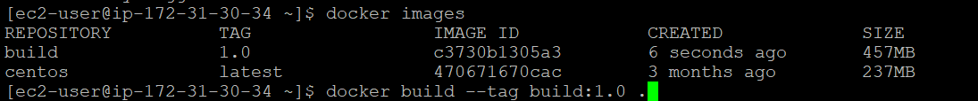

docker run --detach --name bb build:1.0