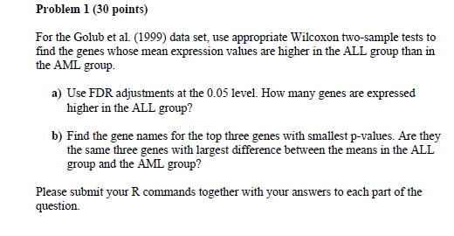

Solutions:

a) The no. of genes expressed higher in ALL group after the FDR adjustment at 0.05 level is 407.

The R code for 1a) is :

> # load the data

> data(golub, package='multtest')

> gol.fac<-factor(golub.cl, level=0:1, labels=c("ALL","AML"))

>

> #for Wilcoxon two-sample tests

> wilcox.data=NULL

> for (i in 1:3051){

+ wilcox.data[i]<-wilcox.test (golub[i,] ~gol.fac, paired=F, alternative="greater")$p.value

+ }

There were 12 warnings (use warnings() to see them)

>

> # to find the genes expressed higher in ALL group

>

> gene.exp<-wilcox.data<0.05

> sum(gene.exp)

[1] 698

>

> fdr.wilcox<-p.adjust(p=wilcox.data, method="fdr")

> sum(fdr.wilcox<0.05)

[1] 407

b) The top three genes names with smallest p-value :

> non.fdr<- order(wilcox.data, decreasing=FALSE)

> print("Gene names for genes with top 3 smallest p-values before FDR adjustment")

[1] "Gene names for genes with top 3 smallest p-values before FDR adjustment"

> golub.gnames[non.fdr[1:3],2]

[1] "TCF3 Transcription factor 3 (E2A immunoglobulin enhancer binding factors E12/E47)"

[2] "Macmarcks"

[3] "VIL2 Villin 2 (ezrin)"

|  |
| --- |
| > fdr.AML<- order(fdr.wilcox, decreasing=FALSE)  > print("Gene names for genes with top 3 smallest p-values after FDR adjustment")  [1] "Gene names for genes with top 3 smallest p-values after FDR adjustment"  > golub.gnames[fdr.AML[1:3],2]  [1] "Macmarcks"  [2] "VIL2 Villin 2 (ezrin)"  [3] "TCF3 Transcription factor 3 (E2A immunoglobulin enhancer binding factors E12/E47)"  > ALL.mean = apply(golub[, gol.fac=="ALL"], 1, mean)  > AML.mean = apply(golub[, gol.fac=="AML"], 1, mean)  > Difference<- ALL.mean - AML.mean  > diff.order<- order(Difference, decreasing=TRUE)  > print("Largest difference")  [1] "Largest difference"  > golub.gnames[diff.order[1:3],2]  [1] "TCL1 gene (T cell leukemia) extracted from H.sapiens mRNA for Tcell leukemia/lymphoma 1"  [2] "MB-1 gene"  [3] "GB DEF = (lambda) DNA for immunoglobin light chain" |
|  |
| |  | | --- | | > | |

* They are not the same three genes with largest difference between the means in the ALL group and the AML group.

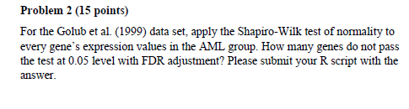

Solution: For p-values greater 0.05 we do not reject the NULL HYPOTHESIS as

Values follow normal distribuution

The No. of genes that do not pass the test at 0.05 level with FDR adjustment is 225

The R code for the problem is:

|  |
| --- |
| > # load the data  > data(golub, package='multtest')  > gol.fac<-factor(golub.cl, level=0:1, labels=c("ALL","AML"))  >  > #applying the test  > shapiro.test<- apply (golub[, gol.fac=="AML"], 1, function(x) {  + shapiro.test(x)$p.value })  >  > # get fdr p values  > fdr<- p.adjust(p=shapiro.test, method="fdr")  >  > # calculating and printing the number of genes that failed test  >  > print("the genes do not pass the test at 0.05 level with FDR adjustment")  [1] "the genes do not pass the test at 0.05 level with FDR adjustment"  > print(sum(fdr<0.05))  [1] 225 |
|  |
| |  | | --- | | > | |

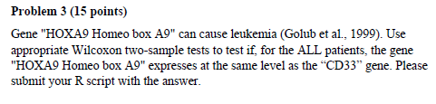

Solution:

> # load the data

> data(golub, package='multtest')

> gol.fac<-factor(golub.cl, level=0:1, labels=c("ALL","AML"))

>

> # getting the row index of genes

> HOX<- grep("HOXA9 Homeo box A9",golub.gnames[,2])

> print("the row index of HOXA9 Homeo box A9 ")

[1] "the row index of HOXA9 Homeo box A9 "

> print(HOX)

[1] 1391

> CD33<- grep("CD33",golub.gnames[,2])

> print(" the row index of CD33 is")

[1] " the row index of CD33 is"

> print(CD33)

[1] 808

>

>

> # applying the test

>

> wilcox.test<-wilcox.test (x= golub[1391, gol.fac=="ALL"], y= golub[808, gol.fac=="ALL"], paired=T, alternative="two.sided")

Warning message:

In wilcox.test.default(x = golub[1391, gol.fac == "ALL"], y = golub[808, :

cannot compute exact p-value with zeroes

> print(wilcox.test)

Wilcoxon signed rank test with continuity correction

data: golub[1391, gol.fac == "ALL"] and golub[808, gol.fac == "ALL"]

V = 62, p-value = 0.01242

alternative hypothesis: true location shift is not equal to 0

As p-value 0.01242 we accept the NULL HYPOTHESIS and conclude that the 2 genes do not express at different levels

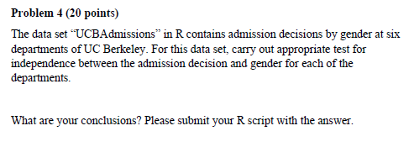

Solutions:

We can conclude that, considering level of significance at 0.05

For department A:

p-value = 5.205e-05 , which is very small, so the NULL HYPOTHESIS of independence can be rejected, which in turns menas that gender and Admissions are dependent

For the other departments ( B – E):

p-value = p = 0.7705, 0.4262, 0.6378, 0.3687, 0.6404 respectively.

These values are greater than 0.05.

Thus the NULL HYPOTHESIS of independence cannot be rejected, which means the gender and admissions are probably independent.

The R code for the problem is :

#loading the source

source("http://www.bioconductor.org/biocLite.R")

abiocLite()

library(datasets);

> str(UCBAdmissions)

table [1:2, 1:2, 1:6] 512 313 89 19 353 207 17 8 120 205 ...

- attr(*, "dimnames")=List of 3

..$ Admit : chr [1:2] "Admitted" "Rejected"

..$ Gender: chr [1:2] "Male" "Female"

..$ Dept : chr [1:6] "A" "B" "C" "D" ...

>

> Dept <- c("Dept = A","Dept = B", "Dept = C", "Dept = D", "Dept = E", "Dept = F")

>

> for (i in 1:6 ){

+ print(Dept[i])

+ Dept.Data <- matrix(c(UCBAdmissions[1,1,i], UCBAdmissions[2,1,i], UCBAdmissions[1,2,i],

+ UCBAdmissions[2,2,i]), nrow=2, dimnames=list("Admit"=c("Admitted","Rejected"),

+ "Gender"=c("Male","Female")))

+ # applying the chi-square test and fisher test and printing the data

+ print(Dept.Data)

+ print(chisq.test(Dept.Data))

+ print(fisher.test(Dept.Data))

+ }

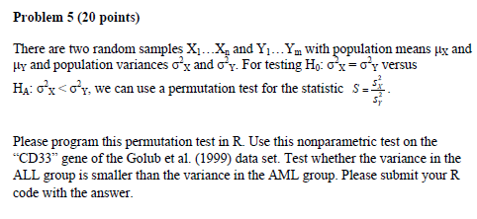

Solutions:

As the p-value is 0.0355

We conclude that the variance of ALL is less that variance of AML i.e.

Var(ALL) < Var(AML) and thus we accept the ALTERNATE HYPOTHESIS .

The R code for the problem is :

|  |
| --- |
| > library(gtools)  > #load the data  > data(golub, package = "multtest")  > gol.fac <- factor(golub.cl,levels=0:1, labels= c("ALL","AML"))  > #find the row index  > gene <- grep("gene_name",golub.gnames[,2])  >  > data <- golub[gene,]  > n <- length(data)  >  > T.obs <- var(data[gol.fac=="ALL"]) / var(data[gol.fac=="AML"])  > #observe statistic  > n.perm = 2000  > T.perm = NULL  > for(i in 1:n.perm) {  + data.perm = sample(data, n, replace=F)  + T.perm[i] = var(data.perm[gol.fac=="ALL"]) / var(data.perm[gol.fac=="AML"])  + }  >  > mean(T.perm <= T.obs)  [1] NA  >  > # applying the above formula to CD33 gene |
|  |
| |  | | --- | |  | |
| > # loading data  > data(golub, package = "multtest")  > gol.fac <- factor(golub.cl,levels=0:1, labels= c("ALL","AML"))  >  > # finding row index  > CD33 <- grep("CD33",golub.gnames[,2])  >  > data <- golub[CD33,]  > n <- length(data)  > # observe statistic  > T.obs <- var(data[gol.fac=="ALL"]) / var(data[gol.fac=="AML"])  >  > n.perm = 2000  > T.perm = NULL  > for(i in 1:n.perm) {  + data.perm = sample(data, n, replace=F)  + T.perm[i] = var(data.perm[gol.fac=="ALL"]) / var(data.perm[gol.fac=="AML"])  + }  > # p-value  > mean(T.perm <= T.obs)  [1] 0.0355 |
|  |
| |  | | --- | | > | |