CPD-3454 Term Project Design Document

# BLACKJACK

## Group Details

1. Neha (c0646567- Coordinator)
2. Bino Oommen Samuel (c0647015)
3. Revathi Rajendran  (c0643680)

# **READ ME**

The scripts folder contains all the sql scripts that are required to run the simulation.

First of all, the objects required for the game to work should be made. In order to do that we need to run the create_tables_package_sql. That will create the package called create_tab_pkg. After that run the anonymous block at the end of the file to create the tables in the database.

Then all the code within the main procedures block in the game_package.sql should be run. To create all the procedures required for the simulation to run.

After setting up the objects and initializing them, the Game simulation can be run by running the anonymous block that is in the BlackJackSimulation.sql file.

The other features like the CRUD for the users and change password requirements can be run by running the other_features.sql.

The 2 player and 3 player Simulation can be found in the 2playerSimulation.sql and 3playerSimulation.sql. The Simulation looks as follows:

**ONE PLAYER SIMULATION**

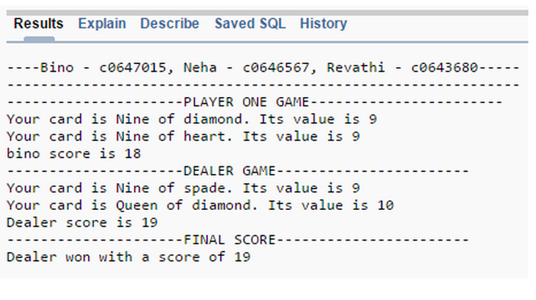

## **TWO PLAYER SIMULATION**

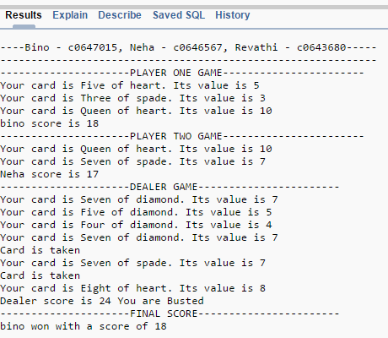

## **Three Player Simulation**

