**LAB-2 Submission:-**

**Name:-Neha Anil Shimpi**

**Student Id:-1001827779**

**Sites referred:-**

/*https://stackoverflow.com/questions/9413656/how-to-use-timer-class-to-call-a-method-do-something-reset-timer-repeat*/

**System Environment:**

Operating System: Windows

Environment Required: Java Virtual Machine

Language: Java

**Instructions for running program:**

1. Download the Eclipse and have JVM installed in the machine.
2. We need to first put all the files of zip under one directory (E.g. : C:\Client_Server).Sample.txt is the file client will send to server.
3. Run Server_Side_Code.java first. This is how it will look:-

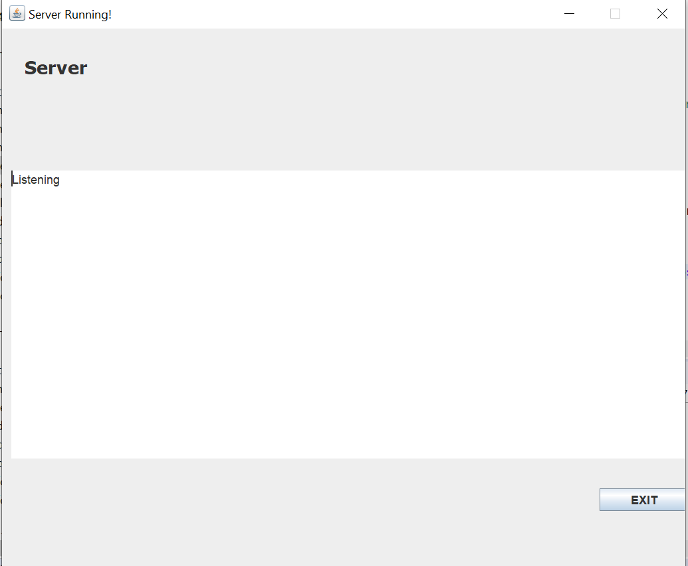

1. Now, run the Client.java.--> Register the name of client(Type in the text-box)🡪Click on ‘OK’.

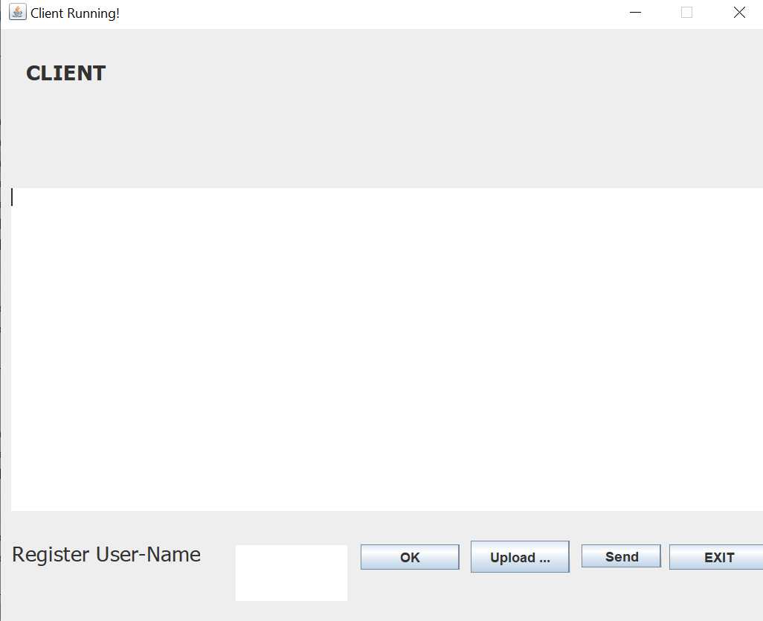

1. Now, click on upload button. Choose the text file provided(sample.txt) and click on ‘Send’ button. You will see the output in on the screen.
2. Open multiple clients and check the output. Click on exit button if you want to exit the server or client.
3. Now, add a word and click on “Send Message”. You can add multiple word. This will add thw words to queue.
4. Server will poll the queue every 60 seconds. Thus, after every 60seconds contents of queue will be sent to server and this will appear on Client GUI.

**Limitations:-** Just after the queue content is written write the username back to the text input area.

**Zip Contents:**

1. Client_Handler.java
2. Client.java
3. Server_Side_Code.java
4. Server_Side_GUI.java
5. Client_Side_GUI.java
6. sample.txt
7. lexicon.txt
8. WriteUp.docx