**LAB-3 Submission:-**

**Name:-Neha Anil Shimpi**

**Student Id:-1001827779**

**Sites referred:-** /*https://www.ejbtutorial.com/distributed-systems/using-sockets-to-create-a-group-chat-system-with-a-graphical-interface*/

**System Environment:**

Operating System: Windows

Environment Required: Java Virtual Machine

Language: Java

**Instructions for running program:**

1. Download the Eclipse and have JVM installed in the machine.
2. We need to first put all the files of zip under one directory (E.g. : C:\Client_Server). Sample.txt is the file client will send to server.
3. Run Server_Side_Code.java first. This is how it will look:-

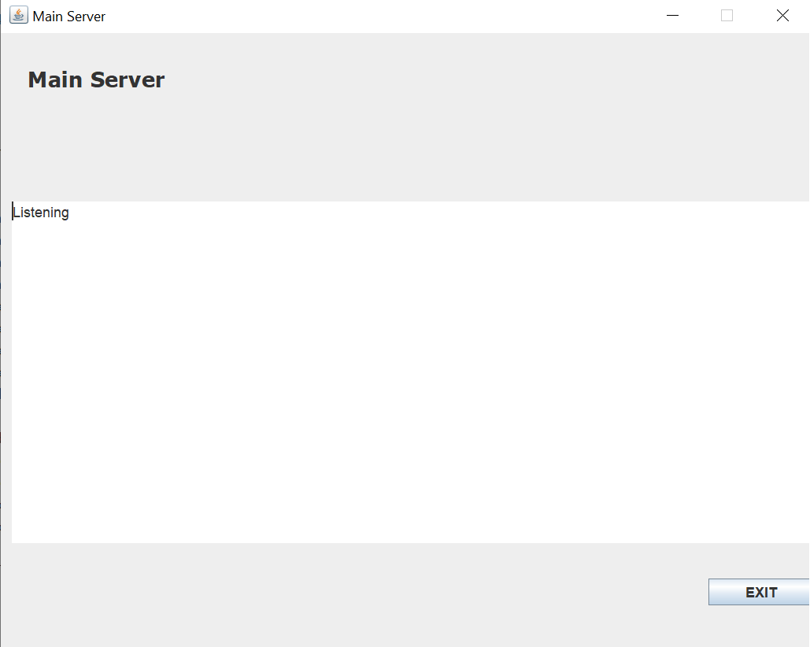

1. Start the BackUp server Server_Side_Code2.java. It will look like this:-

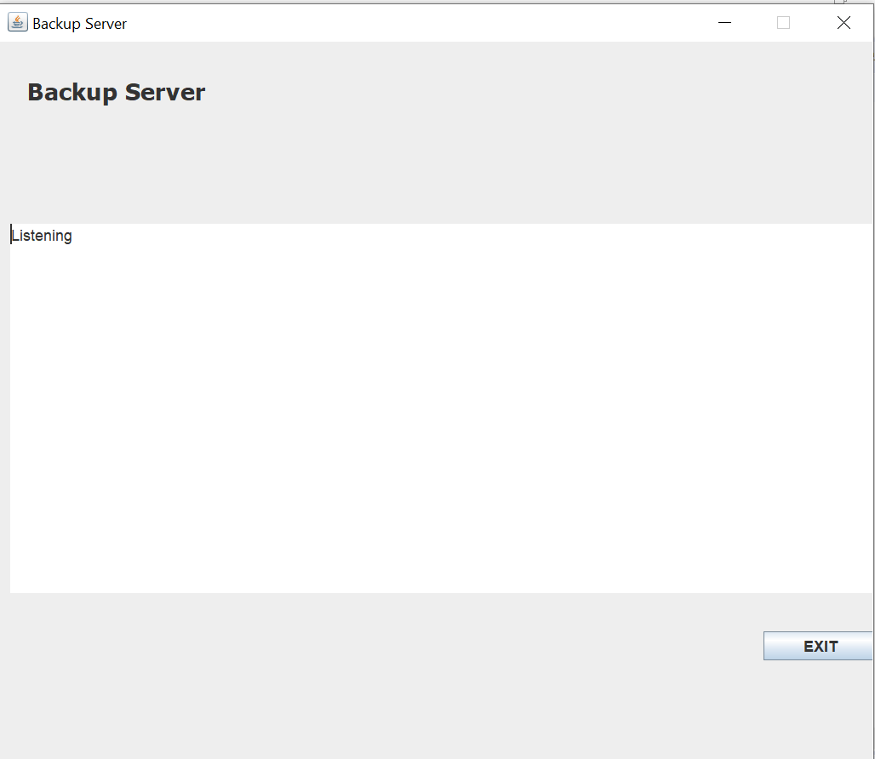

1. Now, run the Client.java.--> Register the name of client(Type in the text-box)🡪Click on ‘OK’.

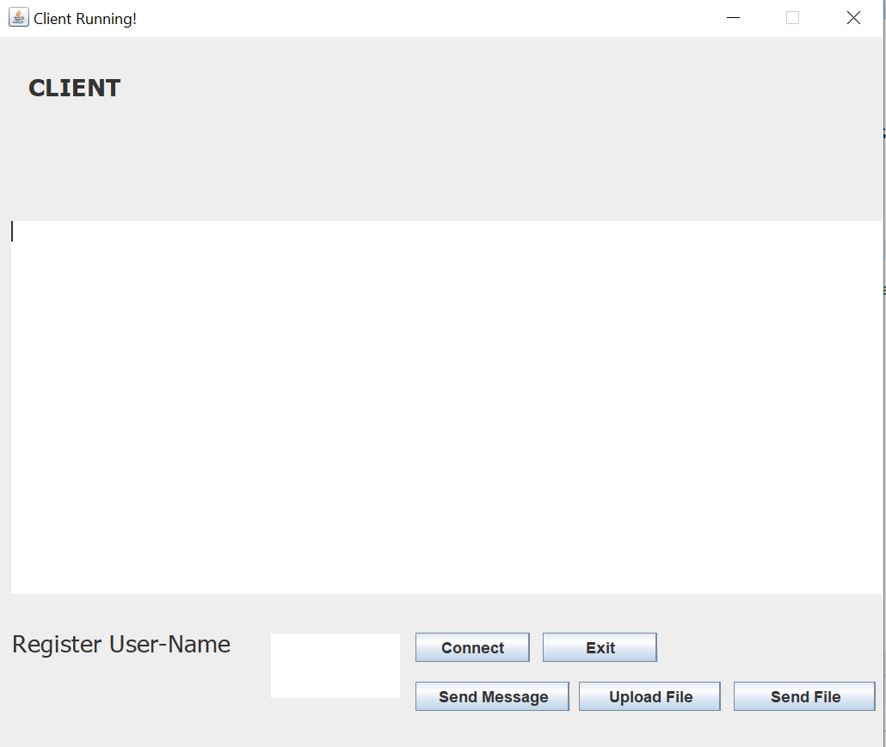

1. Now, click on upload button. Choose the text file provided(sample.txt) and click on ‘Send’ button. You will see output in output file.
2. Open multiple clients and check the output. Click on exit button if you want to exit the server or client.
3. Now, add a word and click on “Send Message”. You can add multiple word. This will add the words to queue.
4. Server will poll the queue every 60 seconds. Thus, after every 60seconds contents of queue will be sent to server and this will appear on Client GUI.
5. Now, close the main server. Client will immediately connect to backup server. Carry on the same

Process of uploading the file and adding words to lexicon. Normal operations with back up server will work.

**Limitations:-** Just after the queue content is written write the username back to the text input area.

**Zip Contents:**

1. Client_Handler2.java
2. Client.java
3. Server_Side_Code.java
4. Server_Side_Code2.java
5. Client_Handler.java
6. Server_Side_GUI.java
7. Server_Side_GUI2.java
8. Client_Side_GUI.java
9. sample.txt
10. lexicon.txt
11. utils->Constants.java
12. WriteUp.docx