**Question 1**

Screenshot of Report View

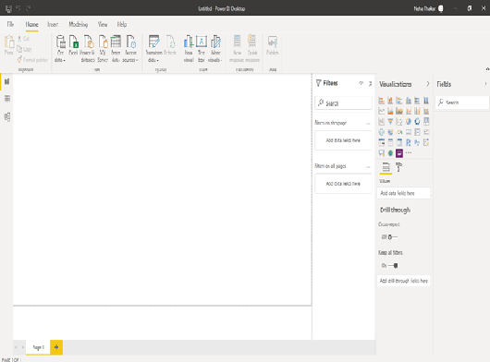

**Question 2**

Different Views of Sales by Geography

* Report View

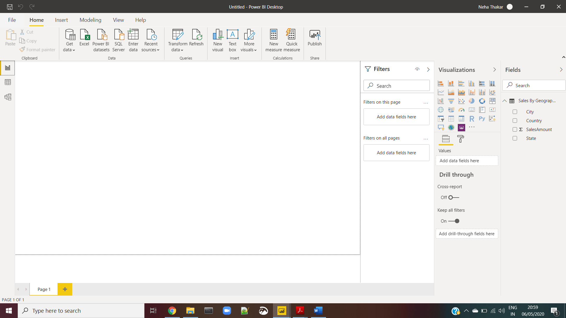

* Data View

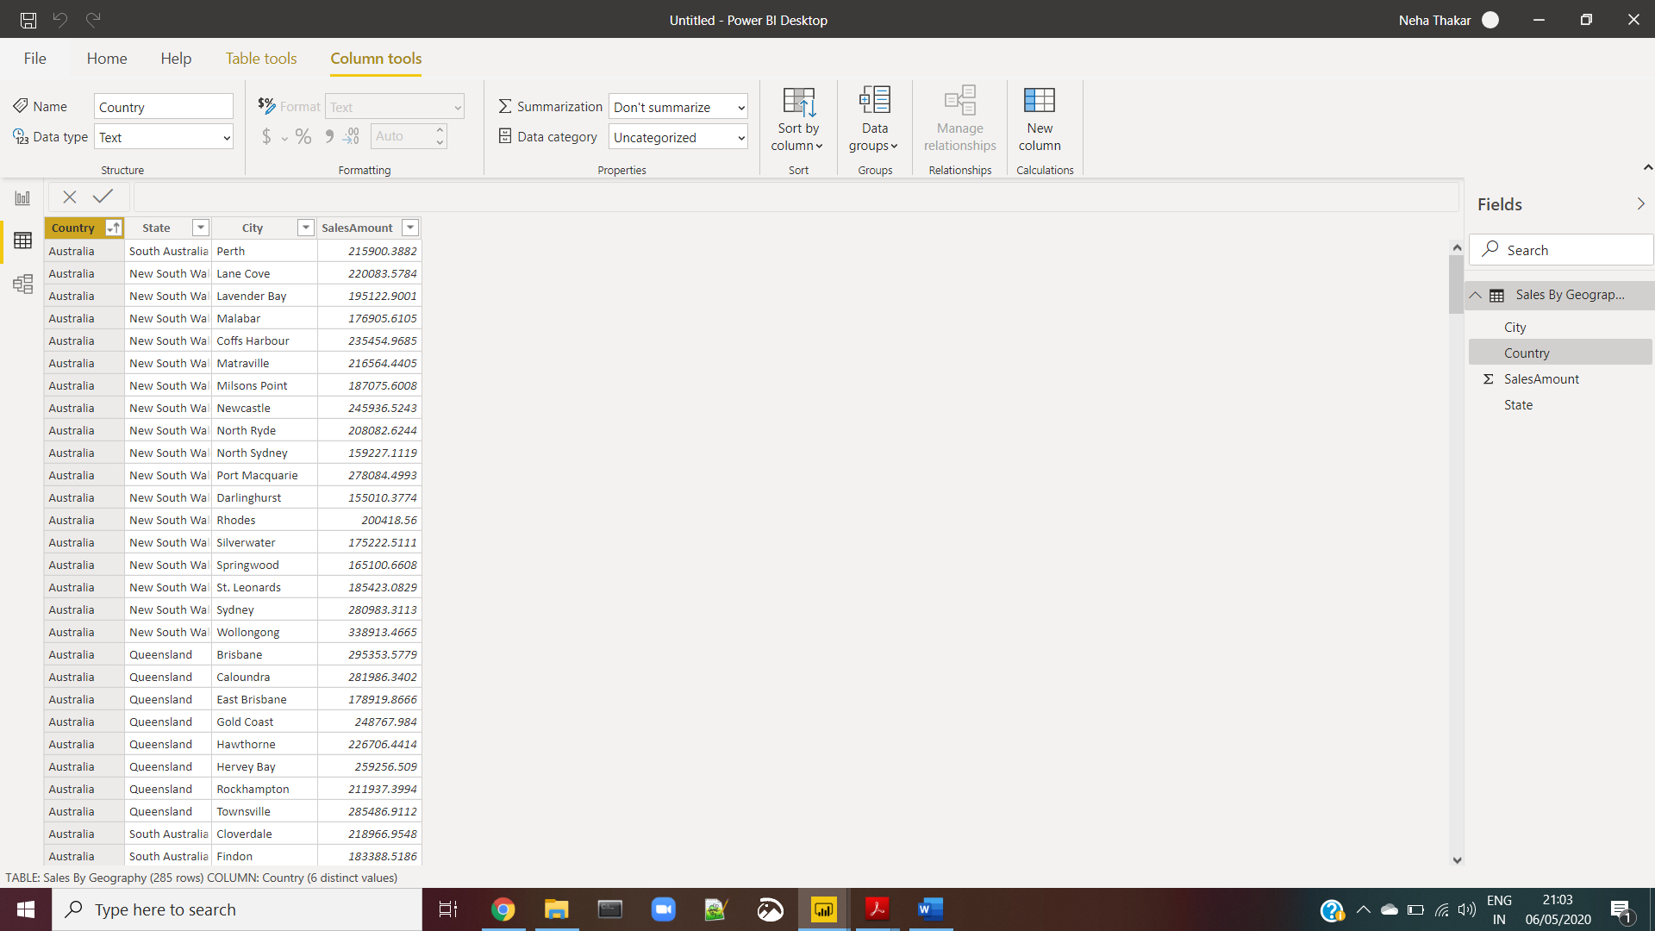

* Model View

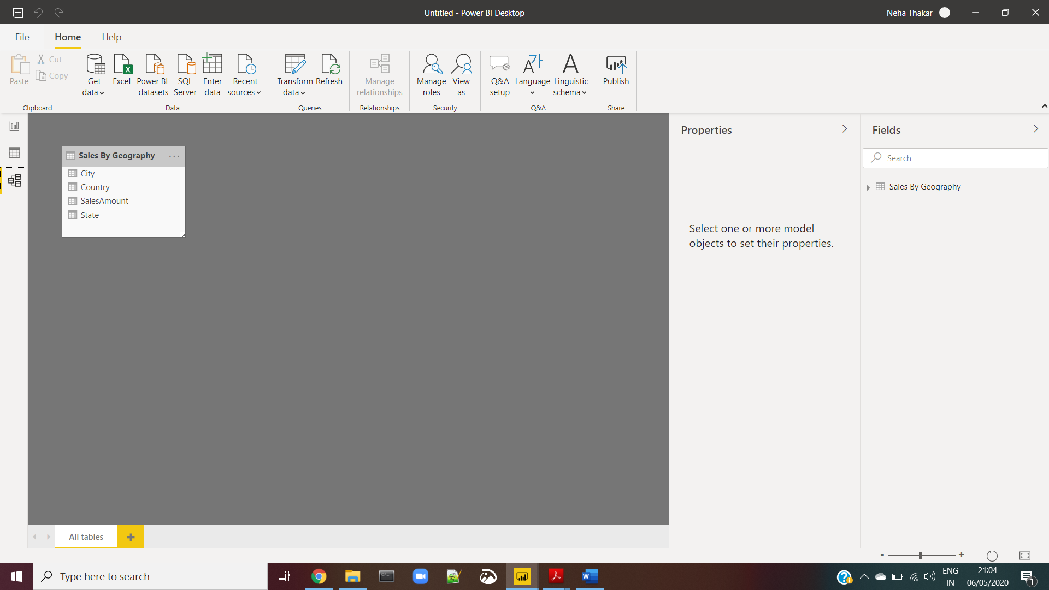

* Power Query Editor

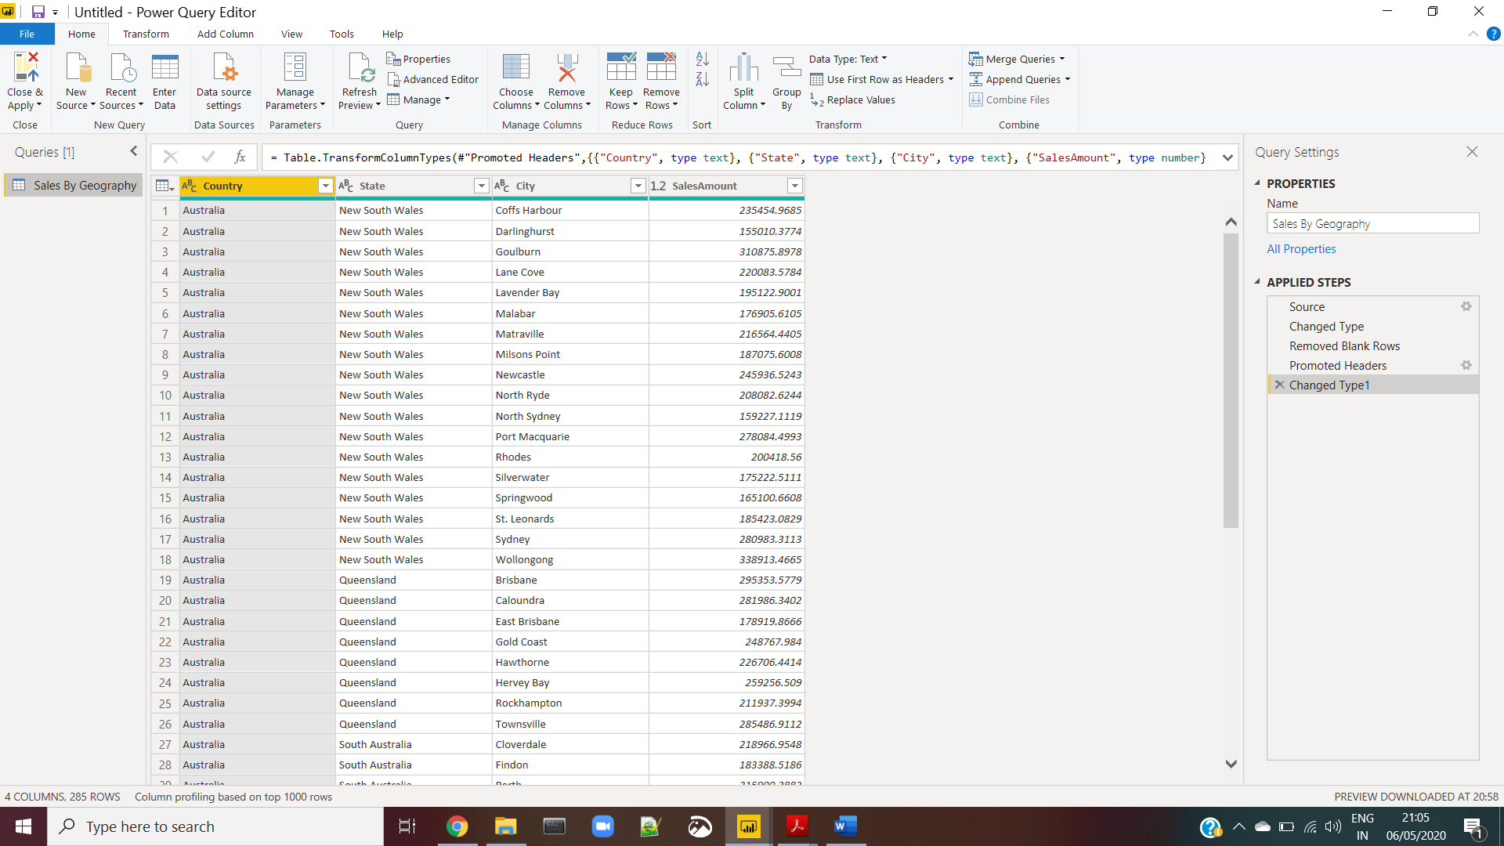

* Advance Editor

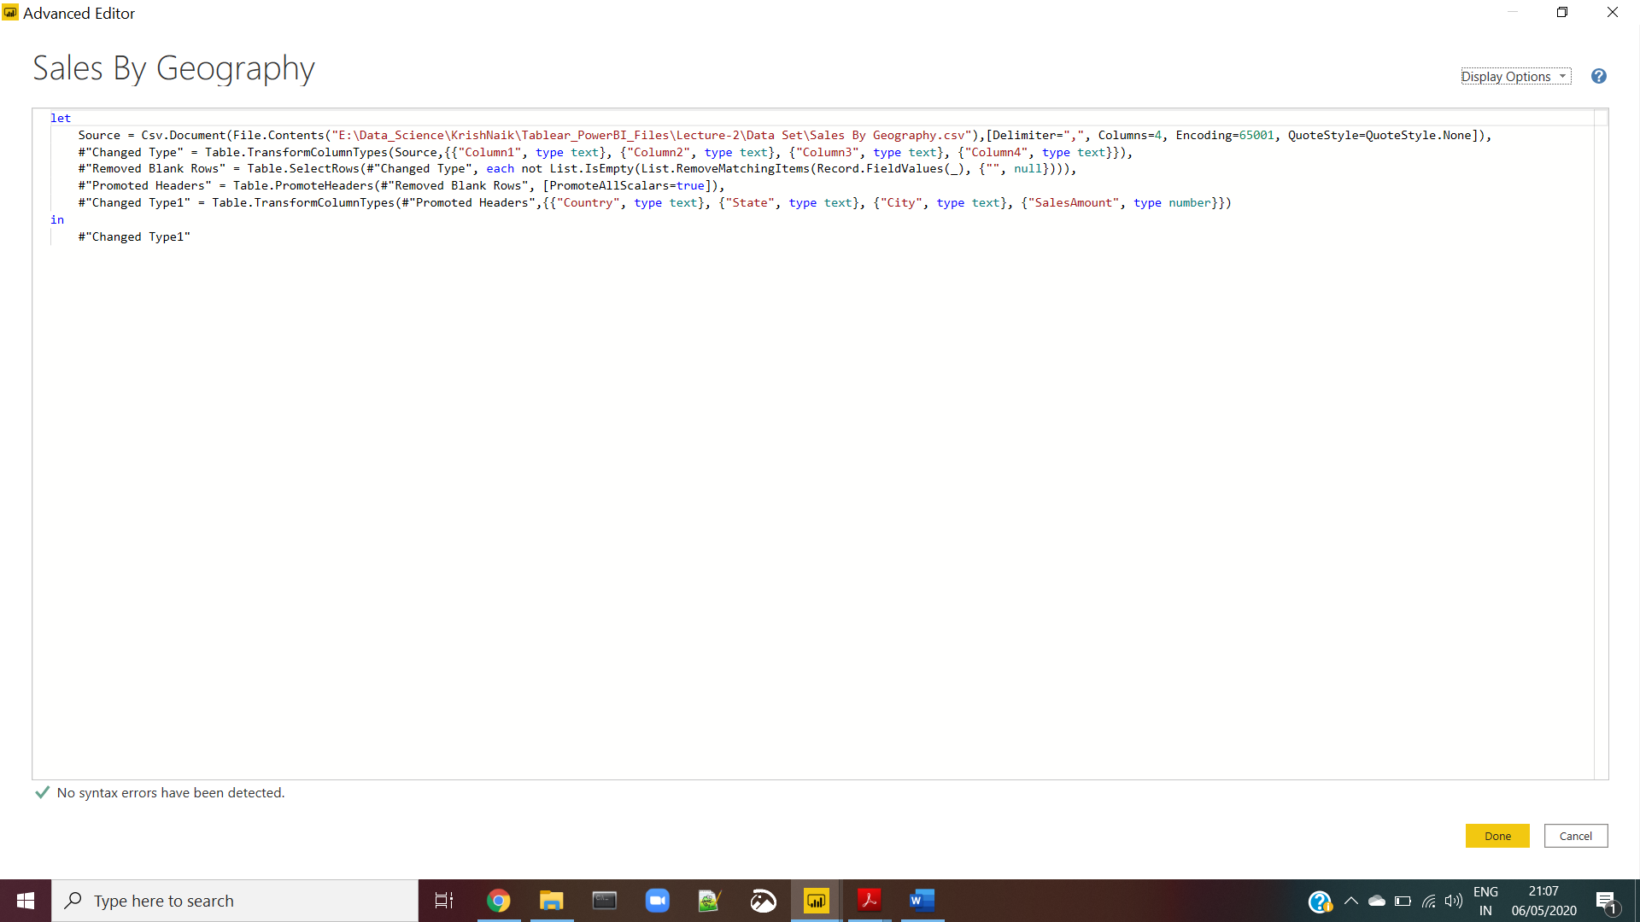

**Question** **3**

Price Details

Power BI Desktop 🡪 Free to any single user

Power BI Pro 🡪 $9.99/User/month

Power BI Premium 🡪 starts at $4995/month