**Output :**

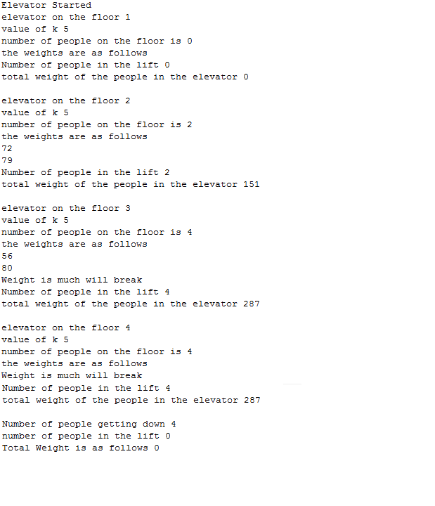

#There are random values in the code so the test cases will be the output of the console

The number of people is > 0

The weight assigned is greater than 0

The weight in the lift is always < 300

The elevator is an individual thread.

At each floor some person will get down.

At each floor some person will get into the lift each person will have some weight.

The thread will be synchronized on object.

The weights will be subtracted when people will exit the elevator.