NAME: Neha Vithob Nayak

USN: 2SD22CS129

SUBJECT: Database Management System

BRANCH: CSE

SEM: 5th

COLLEGE: SDM College of Engineering and Technology Dharwad.

**Q1. Consider the schema:**

EMPLOYEE (EmpID#, Empname, DOB, State, City, Street)

WORKS (EmpID#, CompanyName, Salary)

LOCATION (CompanyName#, City#)

MANAGES (ManagerEMPID#, EmpID#)

**CREATE STATEMENTS:**

1. **EMPLOYEE Table**

CREATE TABLE EMPLOYEE (

EmpID INT PRIMARY KEY,

Empname VARCHAR(100) NOT NULL,

DOB DATE NOT NULL,

State VARCHAR(50),

City VARCHAR(50),

Street VARCHAR(100)

);

1. **WORKS Table**

CREATE TABLE WORKS (

EmpID INT PRIMARY KEY,

CompanyName VARCHAR(100) NOT NULL,

Salary DECIMAL(10, 2),

FOREIGN KEY (EmpID) REFERENCES EMPLOYEE(EmpID)

);

1. **LOCATION Table**

CREATE TABLE LOCATION (

CompanyName VARCHAR(100) PRIMARY KEY,

City VARCHAR(50) NOT NULL

);

1. **MANAGES Table**

CREATE TABLE MANAGES (

ManagerEMPID INT NOT NULL,

EmpID INT PRIMARY KEY,

FOREIGN KEY (ManagerEMPID) REFERENCES EMPLOYEE(EmpID),

FOREIGN KEY (EmpID) REFERENCES EMPLOYEE(EmpID)

);

**DISPLAY EACH TABLE:**

1. **EMPLOYEE Table**

SELECT * FROM EMPLOYEE;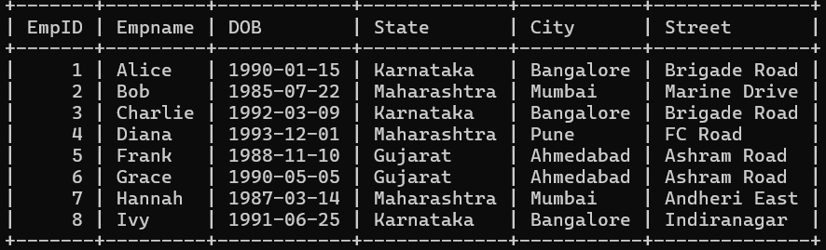

1. **WORKS Table**

SELECT * FROM WORKS;

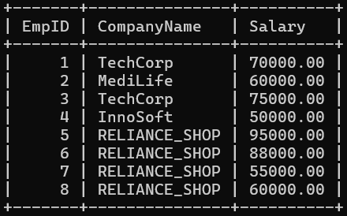

1. **LOCATION Table**

SELECT * FROM LOCATION;

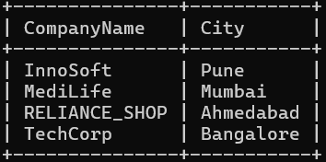

1. **MANAGES Table**

SELECT * FROM MANAGES;

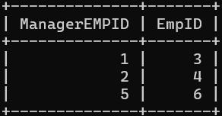

**Write the SQL statements.**

1. **Find the names of all the employees who have born on Monday and live in the same city as company for which they work.**

SELECT E.Empname

FROM EMPLOYEE E

JOIN WORKS W ON E.EmpID = W.EmpID

JOIN LOCATION L ON W.CompanyName = L.CompanyName

WHERE TO_CHAR(E.DOB, 'Day') = 'Monday'

AND E.City = L.City;

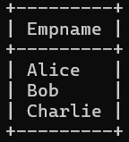

1. **Find the names of all the employees who live in the same city and on same street as their manager.**

SELECT E.Empname

FROM EMPLOYEE E

JOIN MANAGES M ON E.EmpID = M.EmpID

JOIN EMPLOYEE MGR ON M.ManagerEMPID = MGR.EmpID

WHERE E.City = MGR.City

AND E.Street = MGR.Street;

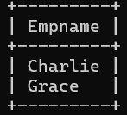

1. **Find the details of all employees who are the top THREE salary taker in RELIANCE_SHOP**

SELECT EmpID, Empname, Salary

FROM (

SELECT E.EmpID, E.Empname, W.Salary

FROM EMPLOYEE E

JOIN WORKS W ON E.EmpID = W.EmpID

WHERE W.CompanyName = 'RELIANCE_SHOP'

ORDER BY W.Salary DESC

)

WHERE ROWNUM <= 3;

