DOCKER

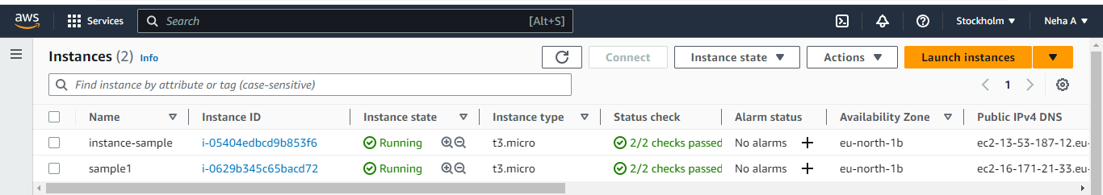

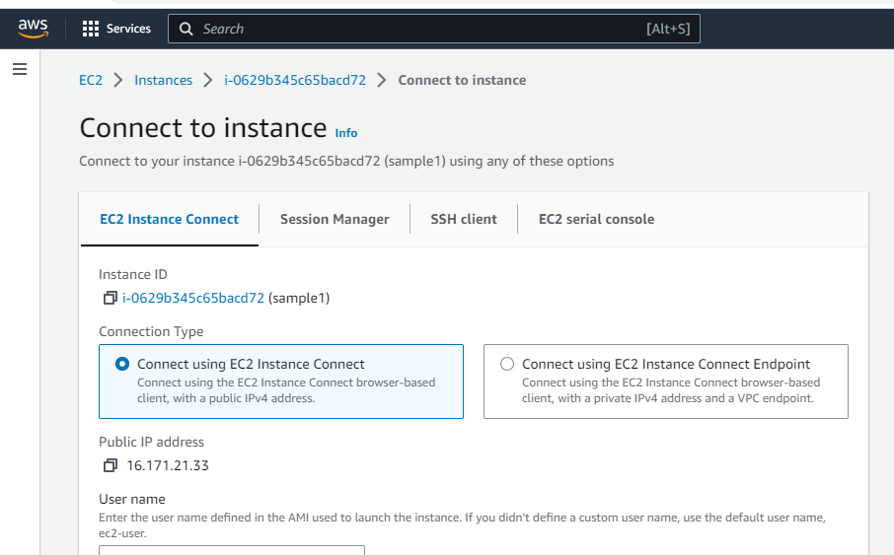

pwd-To print working directory



sudo su – To change in root user



yum update –y – To update all packages

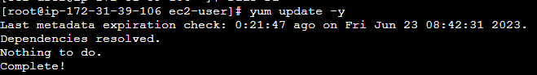

which docker - To find in which directory the docker is downloaded.

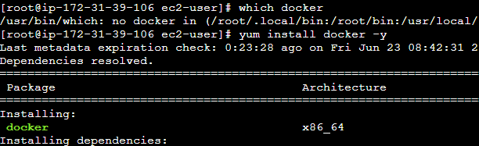



docker –version -To find the version of the docker



docker info -To get the information about the docker

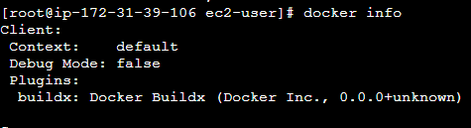

service docker status - To check the current status of the docker

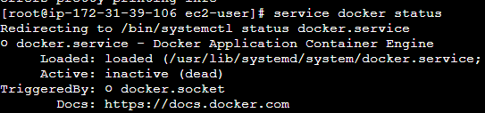

service docker start - To start the docker



service docker status - To check the current status of the docker

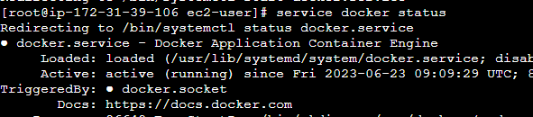

docker images - To check if there is any images in docker



docker ps - To check the running process



docker ps –a –To check all the running process



docker pull ubuntu –Pull images of Ubuntu from the docker hub

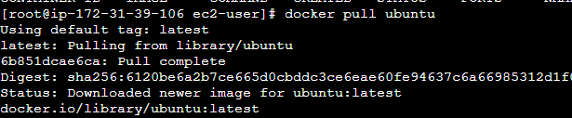

docker run –it ubuntu /bin/bash -To create a container for ubuntu



docker run –it - - name neha ubuntu / bin/bash – To create a container with a name



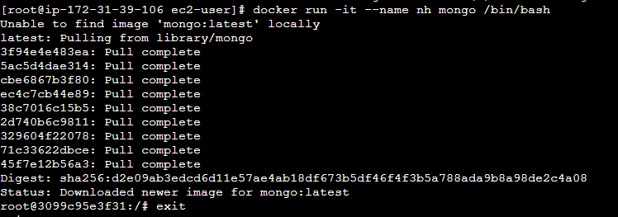

docker start neha – To start the container



docker attach neha –To attach the container



cat > file.txt – Creating a file

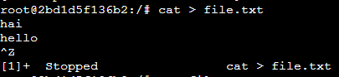

cat file.txt –To show the file



ls – To list all the files



apt-get update – used to update the package index files on the system, which contain information about available packages and their versions.

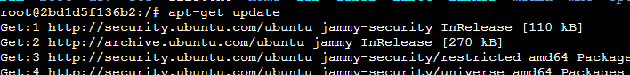

apt –get install apache –y -To install apache

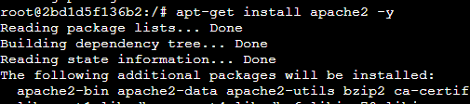

which apache2

