**KVM**

$sudo su

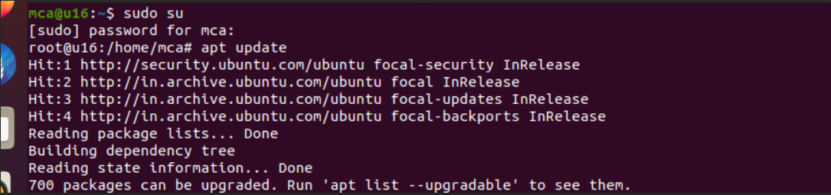

$egrep -c ‘(vmx|svm)’ /proc/cpuinfo

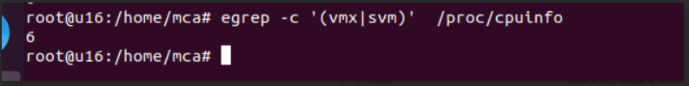

$sudo apt install qemu-kvm libvirt-daemon-system libvirt-clients bridge-utils

$apt install virt-manager

$virt-manager

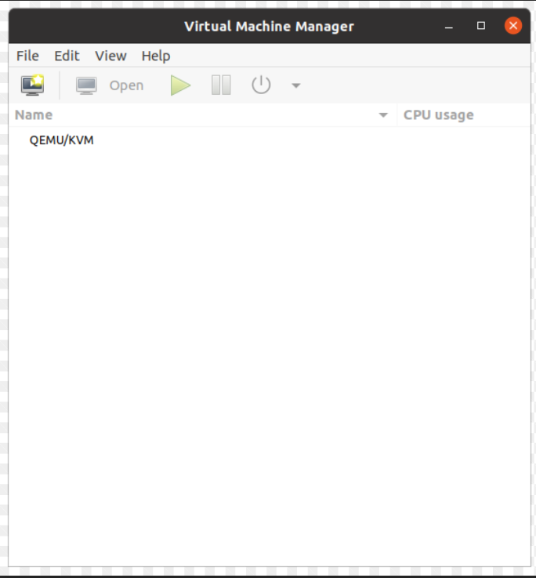

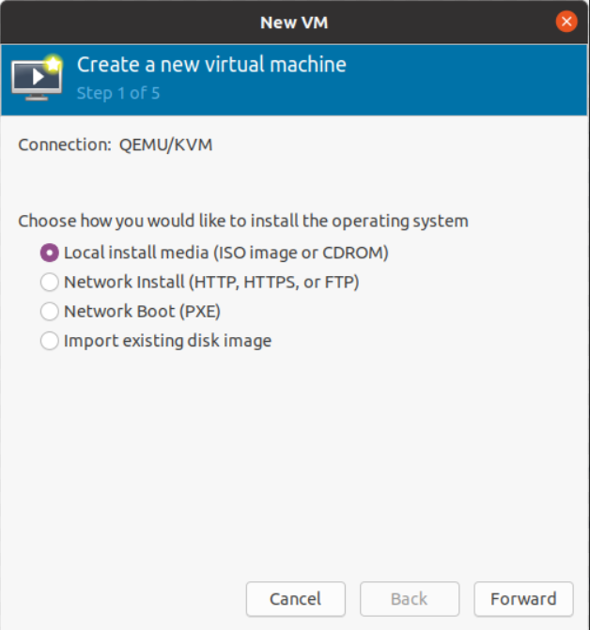

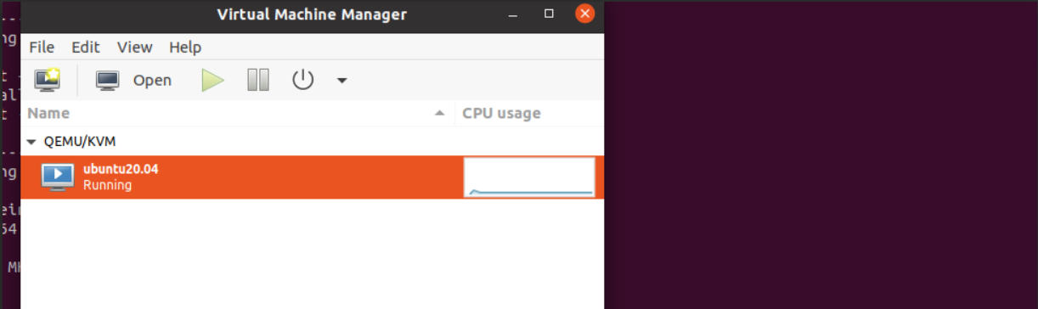

$sudo virsh -all

$sudo start ubuntu20.04

$sudo resume ubuntu20.04

$sudo suspend ubuntu20.04

$sudo stop ubuntu20.04

$sudo destroy ubuntu20.04

