**EXPERIMENT NO 3: Date:06/03/2023**

**AIM :**

Familiarization of linux command.

**C02 :**

Perform system administration task.

**Procedure :**

1. pwd – print the working directory

$ pwd

**Output :**

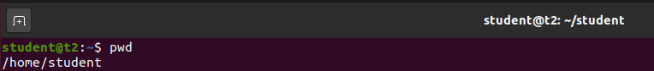

1. ls – To list the directory

$ ls

**Output :**



2.1. ls -R – It shows sub directories file

$ ls -R

**Output :**

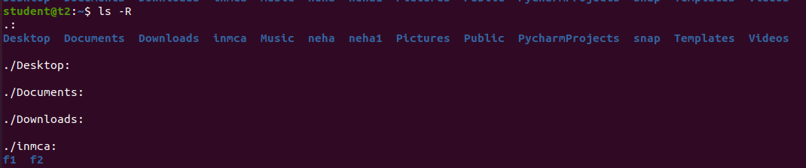

2.2. ls -l -Long listing the contents

$ ls -l

**Output :**

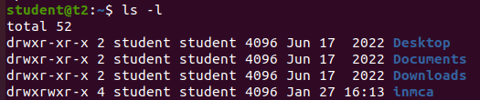

2.3. ls -a -List hidden files

$ ls -a

**Output :**

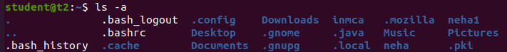

2.4. ls -al -List the files and directory with detailed information with detailed information with permission, owner, file size etc.

$ ls -al

**Output :**

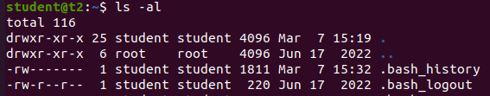

2.5. ls -t - List the files sorted in the order of last modified.

$ ls -t

**Output :**



2.6. ls -r - To reverse the natural sorting order.

$ ls -r

**Output :**



1. history -To review the command that have been previously executed for certain period of time.

$ history

**Output :**

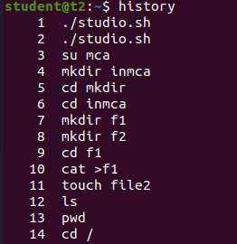

1. man – we can learn and understand about different command write from the shell using man command

$ man ls

**Output :**

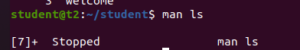

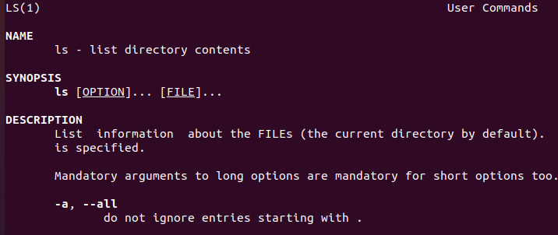

1. mkdir – To create a new directory.

$ mkdir names

$ cd names

**Output :**



1. rmdir – To remove the directory.

$ rmdir names

**Output :**

1. touch – To create files

$ touch names

**Output :**



1. cat – To add contets to that file

$ cat > names

**Output :**

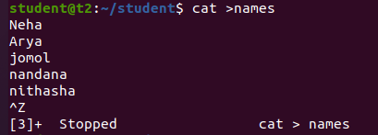

8.1. cat [filename]- to view contents in that file

$cat names

**Output :**

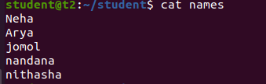

8.2. cat >>[filename]- To append to that file

$cat >>names

**Output :**

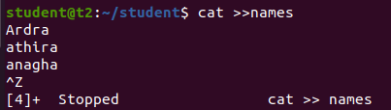

8.3. cat -n [filename]- Used to display the content with line number.

$ cat -n names

**Output :**

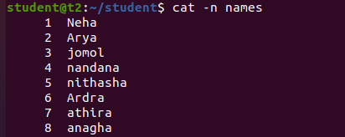

8.4. cat -b [filename]- Blank space will not have the line number

$ cat -b names

**Output :**

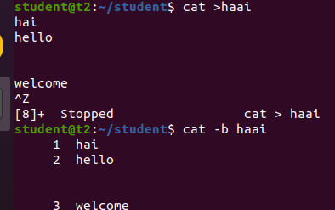

8.5. cat [filename] | tr a-z A-Z >[filename] – To capitalize the content in the file.

$cat names | tr a-z A-Z > outputs

$cat outputs

**Output :**

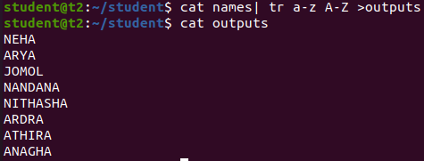

**Result:**

The program was executed and the result was successfully obtained. Thus CO2 was obtained.