1. CREATE TABLE consumer (

consumer_no number,

consumer_name varchar2(20) NOT NULL,

email_id varchar2(35),

units_consumed number,

CONSTRAINT pk_consumer PRIMARY KEY (consumer_no)

);

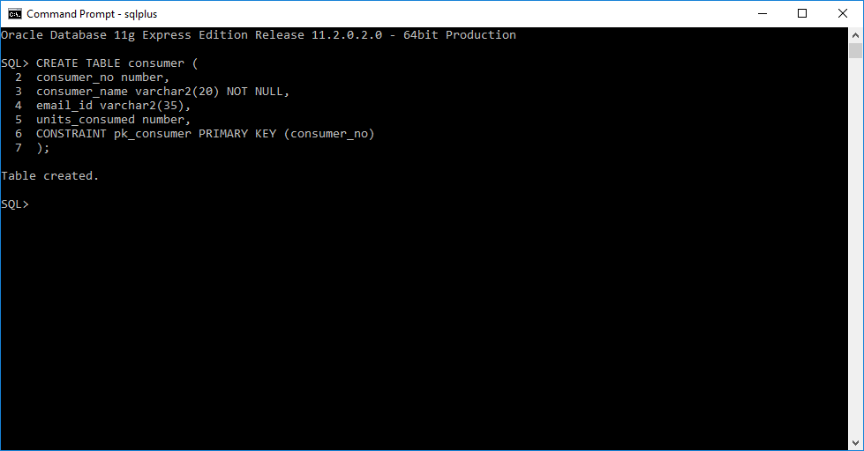

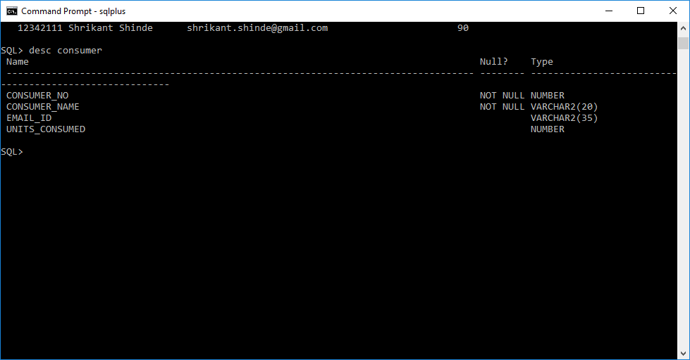

Insert rows

INSERT INTO CONSUMER VALUES(12322110,'Seema Joshi', 'seema.joshi@gmail.com',250);

INSERT INTO CONSUMER VALUES(17531111,'Amey Joshi', 'amey.j@gmail.com',345);

INSERT INTO CONSUMER VALUES(17533411,'Pravin T', 'pravin.t@gmail.com',457);

INSERT INTO CONSUMER VALUES(12432121,'Manoj Kulkarni', 'manoj.k@gmail.com',780);

INSERT INTO CONSUMER VALUES(12342111,'Shrikant Shinde', 'shrikant.shinde@gmail.com',90);

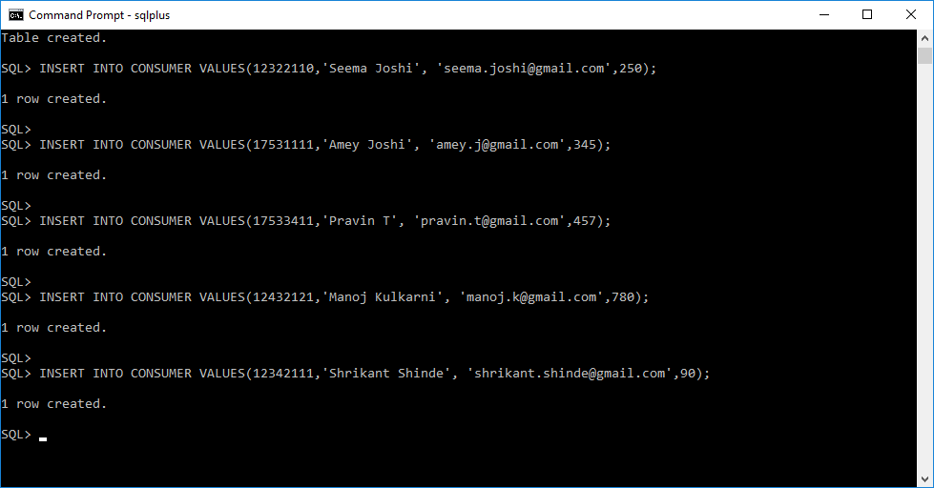

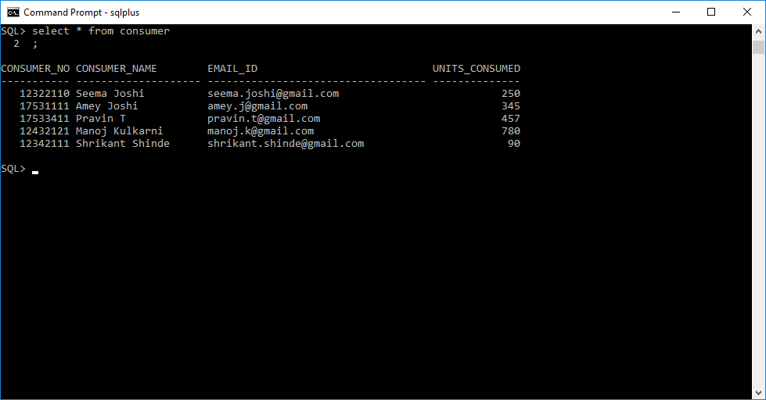

Create electricity bill table

CREATE TABLE electricity_bill (

bill_no number,

consumer_no number,

bill_amount number,

bill_paid_date date,

CONSTRAINT pk_electricity_bill PRIMARY KEY (bill_no),

CONSTRAINT fk_consumer_bill FOREIGN KEY (consumer_no) REFERENCES consumer(consumer_no)

);

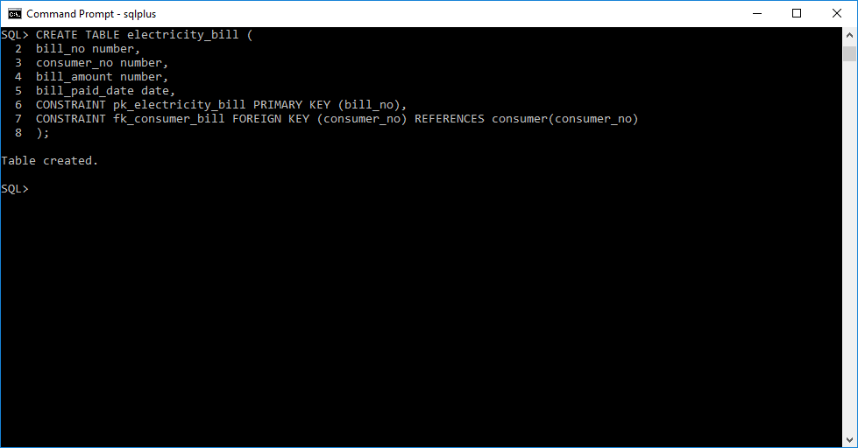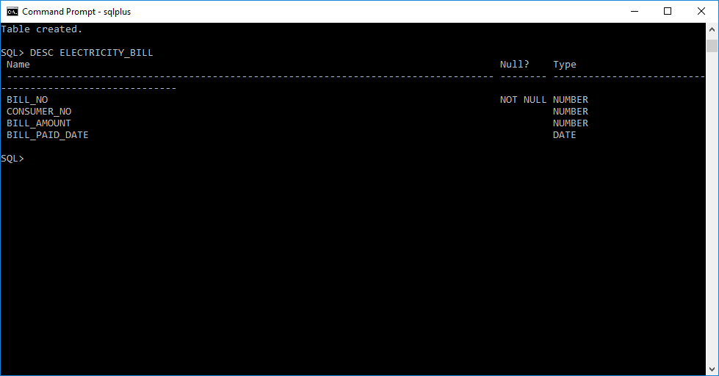

Insert DATA in electricity bill

INSERT INTO electricity_bill VALUES(101, 12342111, 300, '10-JAN-2010');

INSERT INTO electricity_bill VALUES(102, 17531111, 650, '10-NOV-2005');

INSERT INTO electricity_bill VALUES(103, 17533411, 870, '19-DEC-2011');

INSERT INTO electricity_bill VALUES(104, 12322110, 530, '23-JUN-2006');

INSERT INTO electricity_bill VALUES(105, 12432121, 1790, '05-FEB-2004');

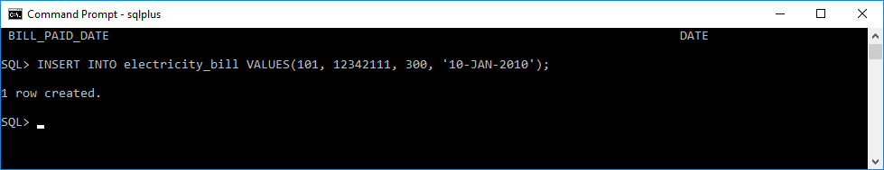

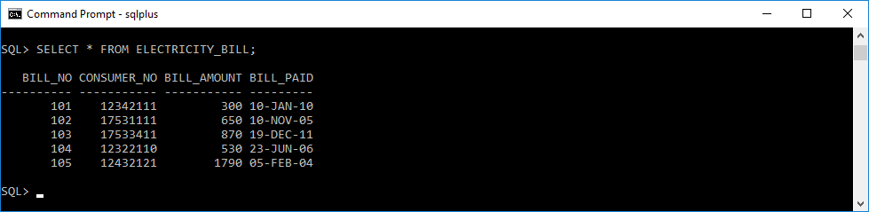

PART 2 QUARY

1. SELECT consumer_no as "Consumer NO", consumer_name as "Consumer Name" FROM consumer where units_consumed>300;

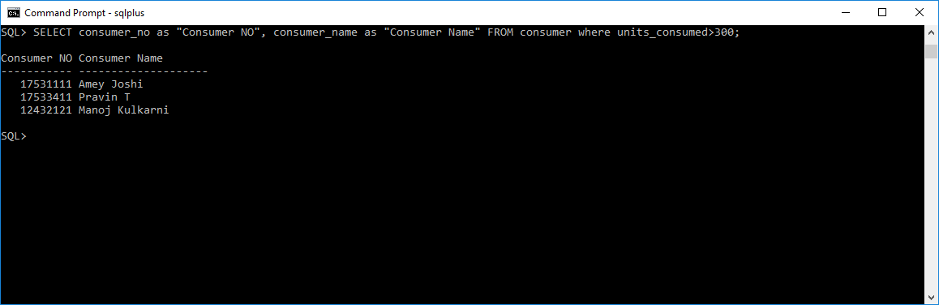

2. SELECT MAX(bill_amount) as "Highest Bill Amount Paid" from electricity_bill;

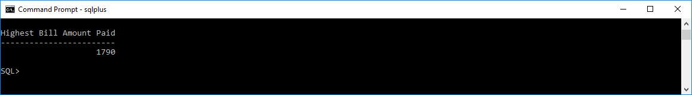

5. SELECT c.consumer_no as "Consumer NO",

consumer_name as "Consumer Name",

email_id as "Email Id",

bill_no as "Bill No",

units_consumed as "Units Consumed",

bill_amount as "Bill Amount",

bill_paid_date as "Bill Paid Date"

FROM consumer c, electricity_bill e

where c.consumer_no = e.consumer_no AND

consumer_name = 'Seema Joshi';