Table creation – (Account_Master)

create table account_master(

2 account_no number,

3 accountHolder_name varchar2(30),

4 accountholder_Address varchar(50),

5 constraint pk_acc_no primary key(account_no));

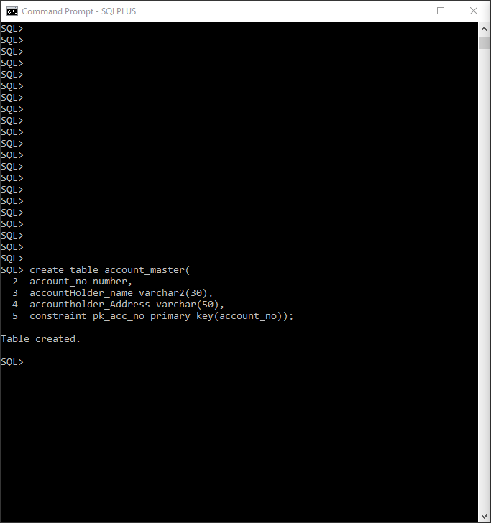

Data Insertion

1.

insert into Account_Master values(&account_no,'&accountHolder_name','&accountholder_address');

Enter value for account_no: 10001

Enter value for accountholder_name: Rajesh Sharma

Enter value for accountholder_address: Mumbai

old 1: insert into Account_Master values(&account_no,'&accountHolder_name','&accountholder_address')

new 1: insert into Account_Master values(10001,'Rajesh Sharma','Mumbai')2.

2.

/

Enter value for account_no: 10002

Enter value for accountholder_name: Aniket Vishwas

Enter value for accountholder_address: Delhi

old 1: insert into Account_Master values(&account_no,'&accountHolder_name','&accountholder_address')

new 1: insert into Account_Master values(10002,'Aniket Vishwas','Delhi')

3.

/

Enter value for account_no: 10003

Enter value for accountholder_name: Abhishek Kumar

Enter value for accountholder_address: Pune

old 1: insert into Account_Master values(&account_no,'&accountHolder_name','&accountholder_address')

new 1: insert into Account_Master values(10003,'Abhishek Kumar','Pune')

4.

/

Enter value for account_no: 10004

Enter value for accountholder_name: Shivani Shah

Enter value for accountholder_address: Gandhinagar

old 1: insert into Account_Master values(&account_no,'&accountHolder_name','&accountholder_address')

new 1: insert into Account_Master values(10004,'Shivani Shah','Gandhinagar')

5.

/

SQL> /

Enter value for account_no: 10005

Enter value for accountholder_name: Anjali Mishra

Enter value for accountholder_address: Mumbai

old 1: insert into Account_Master values(&account_no,'&accountHolder_name','&accountholder_address')

new 1: insert into Account_Master values(10005,'Anjali Mishra','Mumbai')

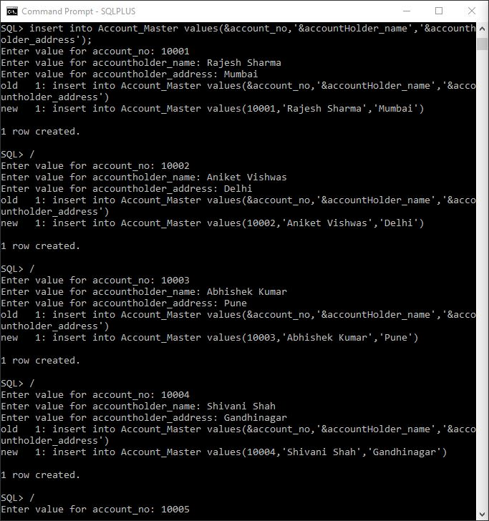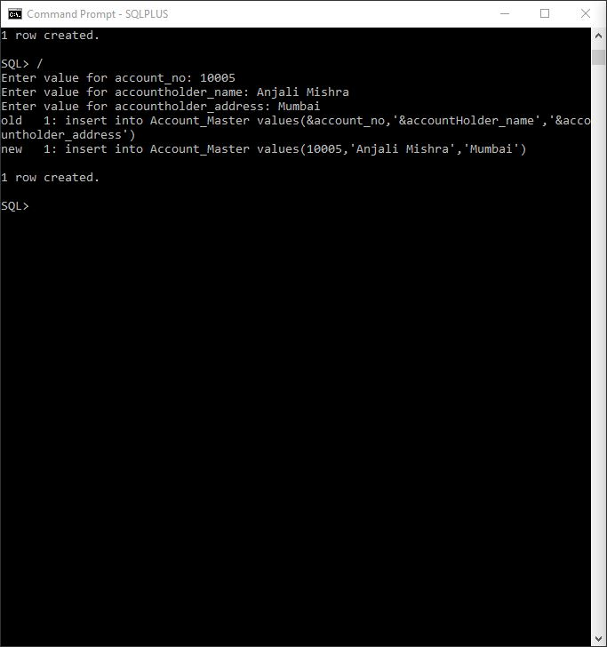

Table Creation (Transactions)

SQL> create table Transactions(

2 Transaction_ID number,

3 Transaction_Date date,

4 Transaction_Type Varchar2(15),

5 Account_No Number,

6 Amount number,

7 constraint pk_tran_id primary key(transaction_id),

8 constraint fk_acc_no foreign key(account_no) references account_master(account_no),

9 constraint chk_tran_type check(transaction_type = 'withdraw' or transaction_type = 'deposit'));

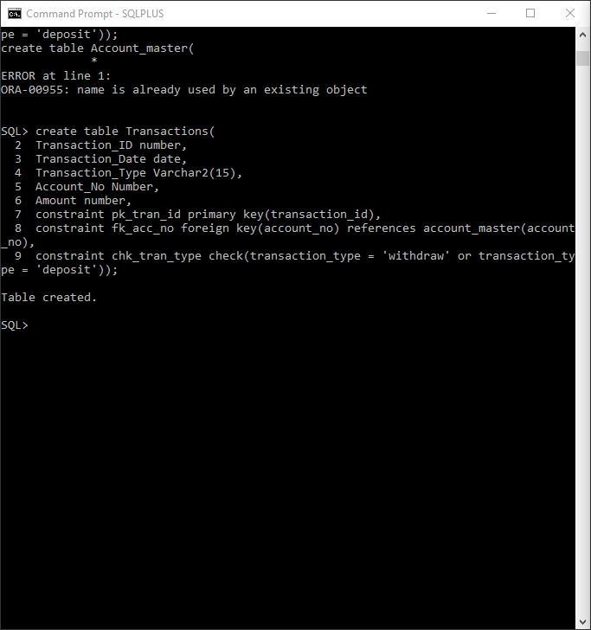

Data Insertion

1.

insert into transactions values(&transaction_id,'&Transaction_Date','&Transaction_Type','&Account_No','&Amount');

Enter value for transaction_id: 111

Enter value for transaction_date: 22-aug-2014

Enter value for transaction_type: withdraw

Enter value for account_no: 10001

Enter value for amount: 5000

old 1: insert into transactions values(&transaction_id,'&Transaction_Date','&Transaction_Type','&Account_No','&Amount')

new 1: insert into transactions values(111,'22-aug-2014','withdraw','10001','5000')

2.

/

Enter value for transaction_id: 112

Enter value for transaction_date: 23-sep-2014

Enter value for transaction_type: deposit

Enter value for account_no: 10004

Enter value for amount: 20000

old 1: insert into transactions values(&transaction_id,'&Transaction_Date','&Transaction_Type','&Account_No','&Amount')

new 1: insert into transactions values(112,'23-sep-2014','deposit','10004','20000')

3.

/

Enter value for transaction_id: 113

Enter value for transaction_date: 15-feb-2015

Enter value for transaction_type: withdraw

Enter value for account_no: 10002

Enter value for amount: 6000

old 1: insert into transactions values(&transaction_id,'&Transaction_Date','&Transaction_Type','&Account_No','&Amount')

new 1: insert into transactions values(113,'15-feb-2015','withdraw','10002','6000')

4.

/

Enter value for transaction_id: 114

Enter value for transaction_date: 18-jun-2015

Enter value for transaction_type: withdraw

Enter value for account_no: 10002

Enter value for amount: 3000

old 1: insert into transactions values(&transaction_id,'&Transaction_Date','&Transaction_Type','&Account_No','&Amount')

new 1: insert into transactions values(114,'18-jun-2015','withdraw','10002','3000')

5.

/

Enter value for transaction_id: 115

Enter value for transaction_date: 2-jan-2016

Enter value for transaction_type: deposit

Enter value for account_no: 10003

Enter value for amount: 5000

old 1: insert into transactions values(&transaction_id,'&Transaction_Date','&Transaction_Type','&Account_No','&Amount')

new 1: insert into transactions values(115,'2-jan-2016','deposit','10003','5000')

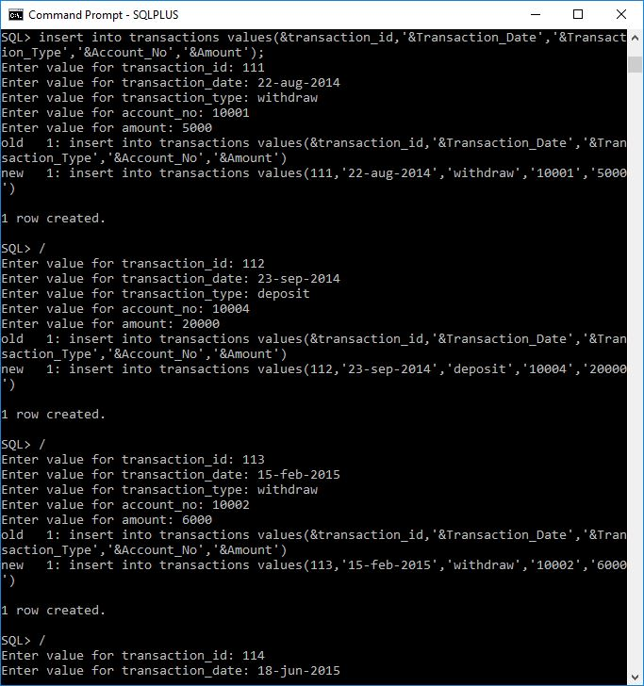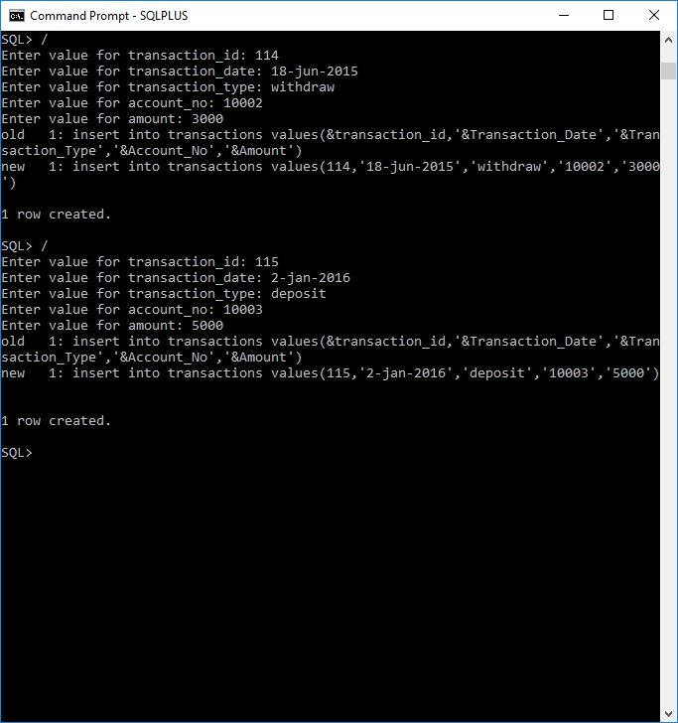

Answer of question 2

1.

select Account_no as "Account Number", Transaction_Date as "Transaction Date" from Transactions where Transaction_type = 'deposit';

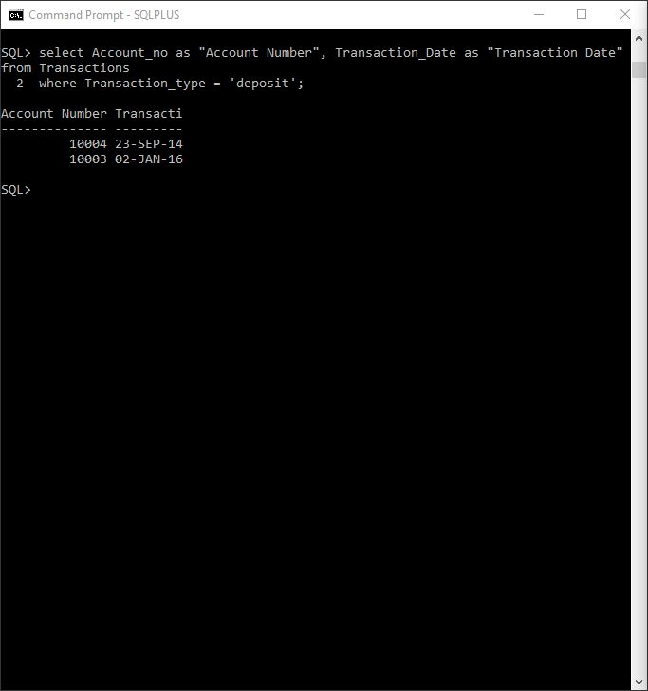

2. select count(Transaction_ID) as "No of Transaction", Account_No as "Account Number" from Transactions group by Account_No;

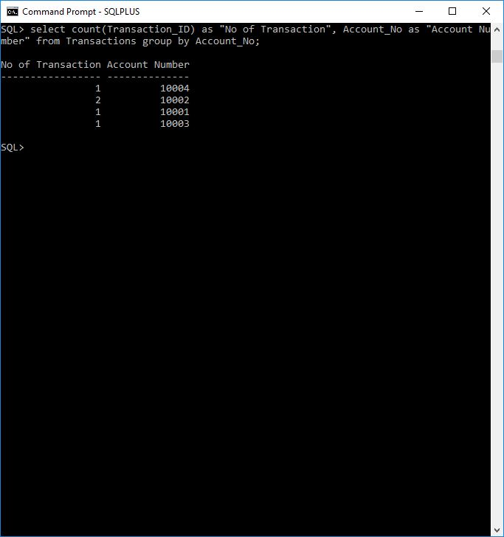

3.

Select t.Transaction_ID as "Transaction ID",

t.Transaction_Date as "Transaction Date",

t.Transaction_Type as "Transaction Type",

a.AccountHolder_Name as "Account Holder Name",

t.amount as "Amount"

from Transactions t, Account_master a;

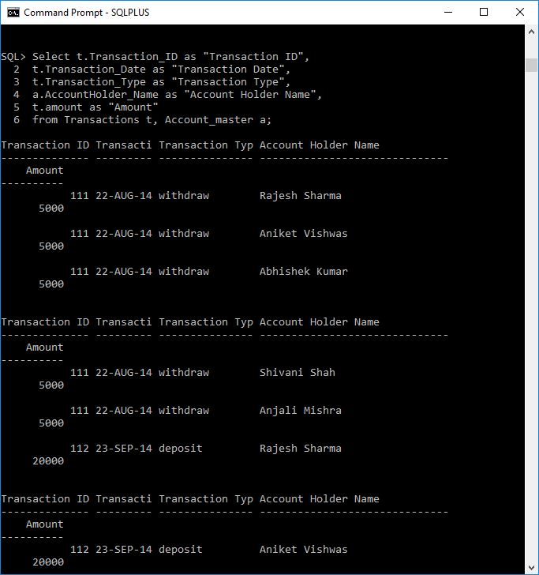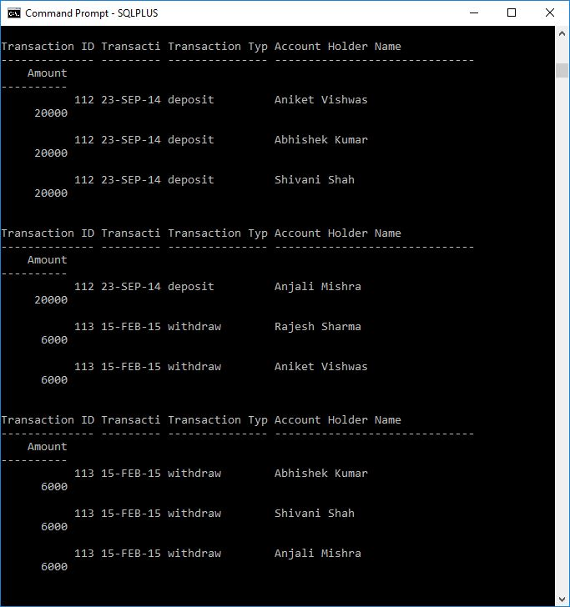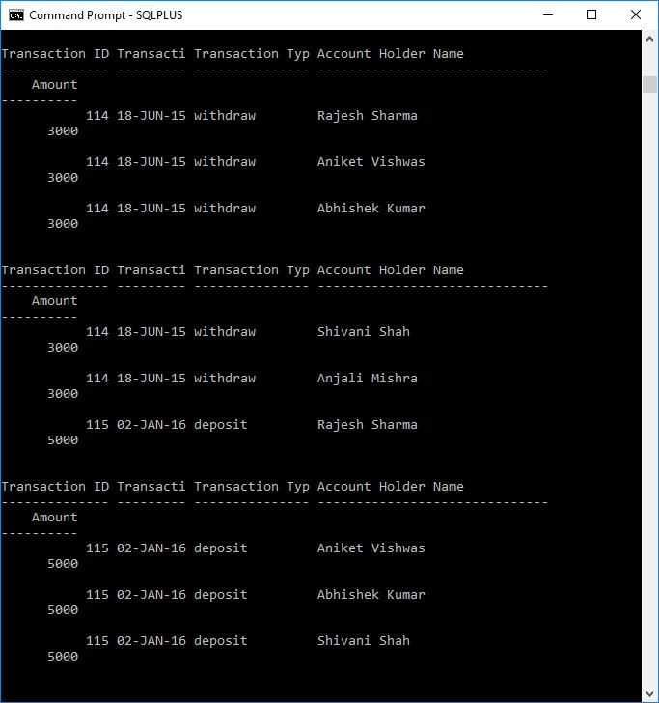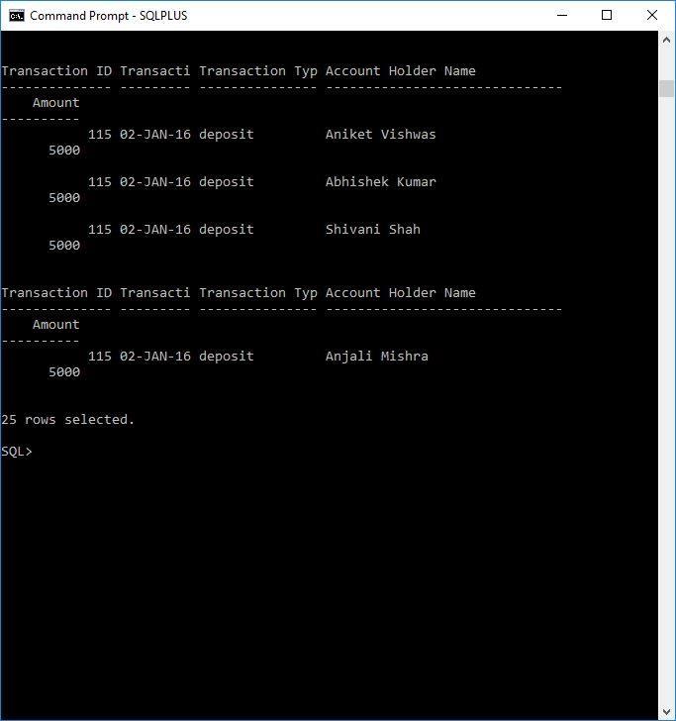

4.

select Amount from transactions where amount between 3000 and 8000;

