Question 1:-Create Database

Answer 1:-

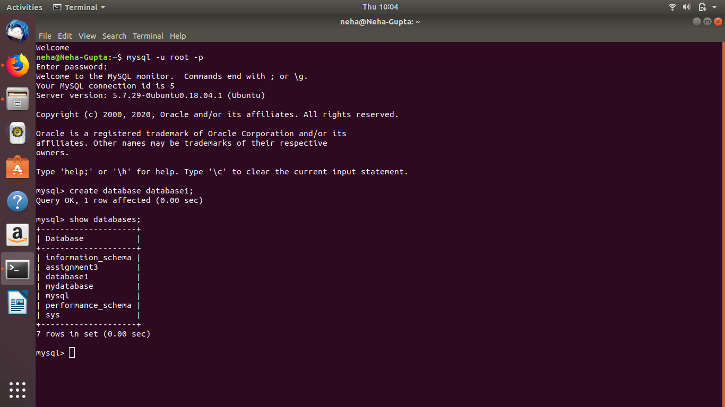

Question 2:-Design Schema

Answer 2:-

Question 3:-Create tables

Answer 3:-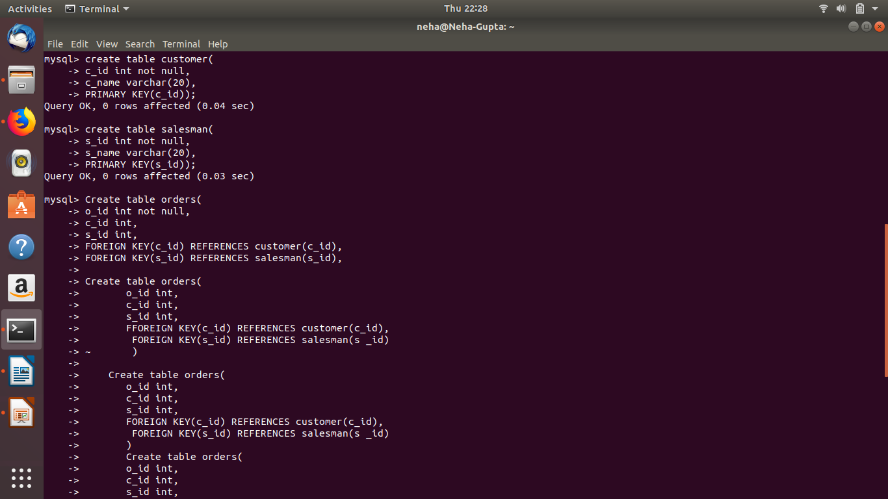

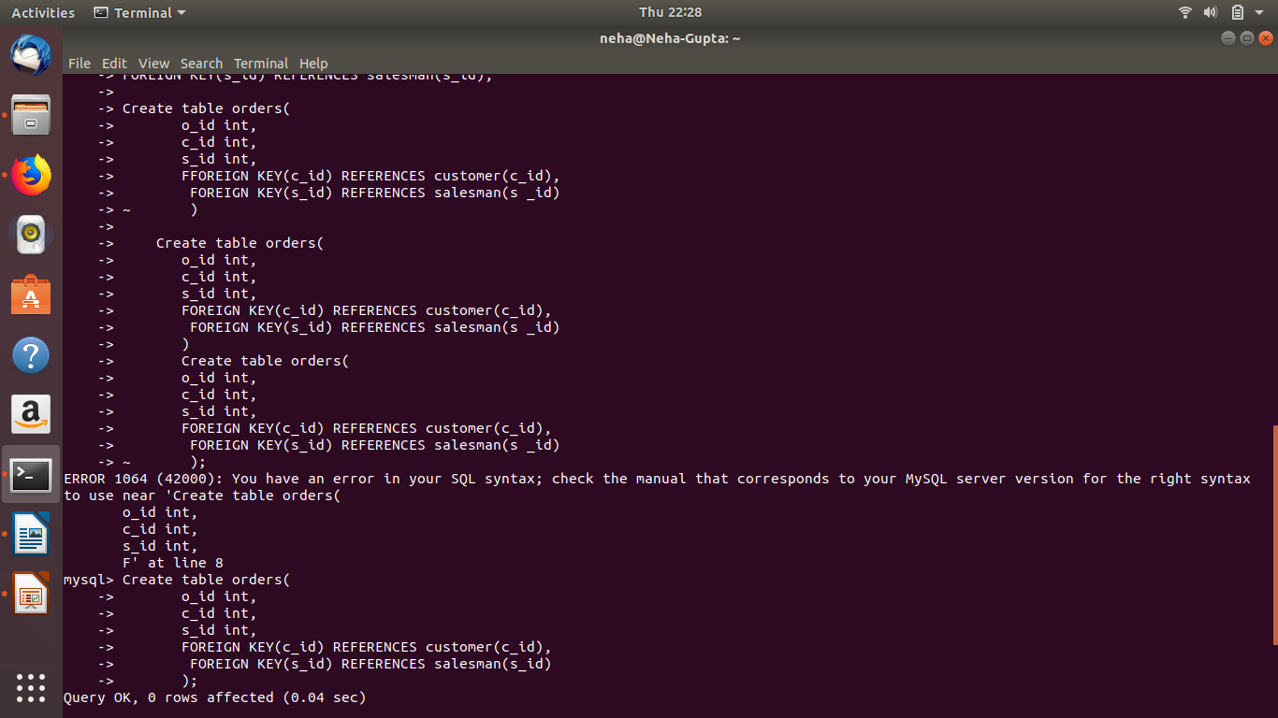

Question 4:-Insert sample data

Answer 4:-

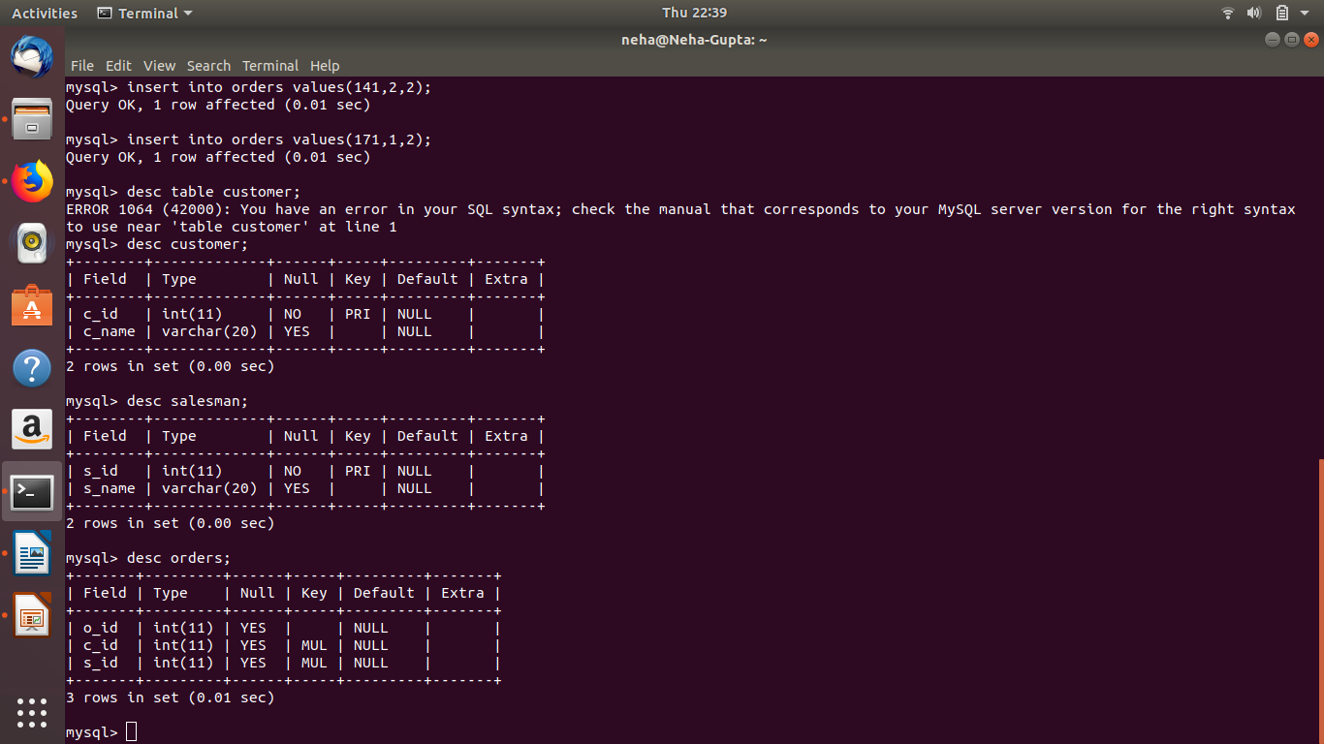

Question 5:-Find the sales person have multiple orders.

Answer 5:-

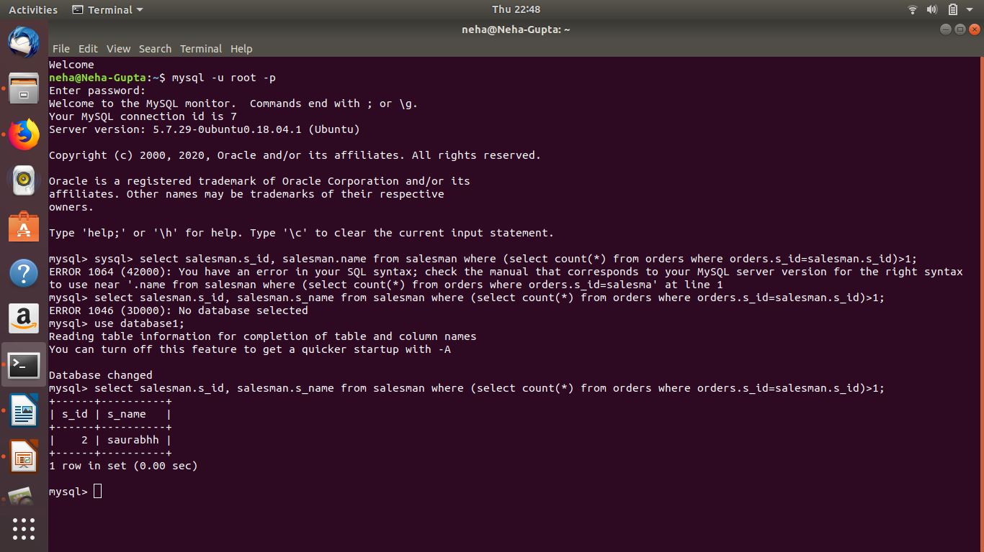

Question 6:-Find the all sales person details along with order details

Answer 6:-

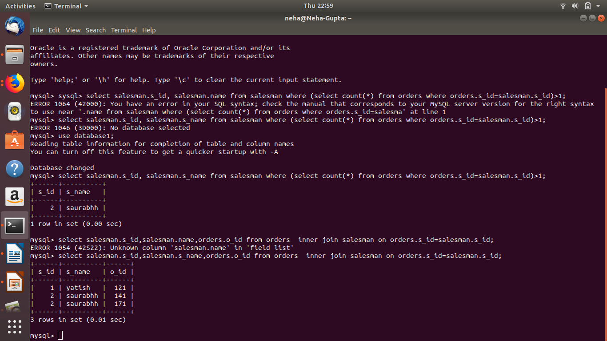

Question 7:-Create index

Answer 7:-

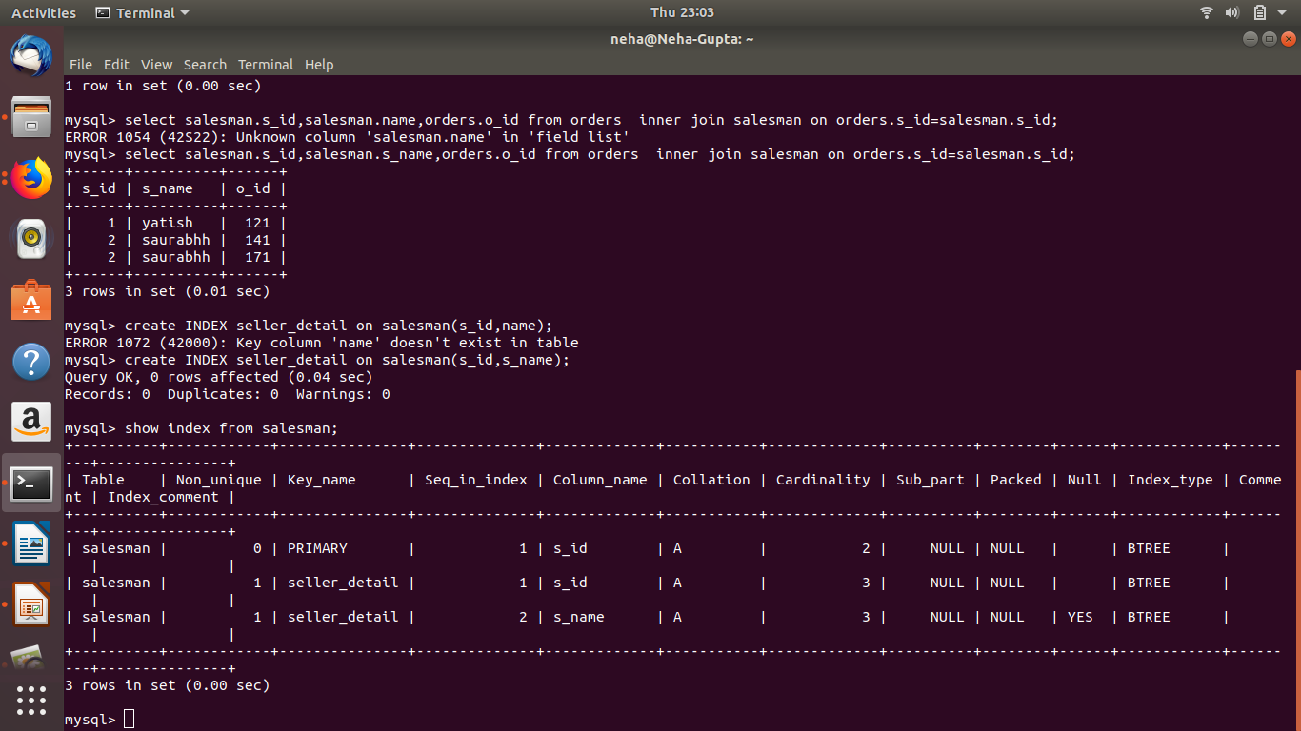

Question 8:-How to show index on a table

Answer 8:-



Question 9:-Find the order number, sale person name, along with the customer to whom that order belongs to

Answer 9:-

