1. Add a gradle dependency and its related repository url.

Ans:- The gradle dependency and its repository url is injected in build.gradle.

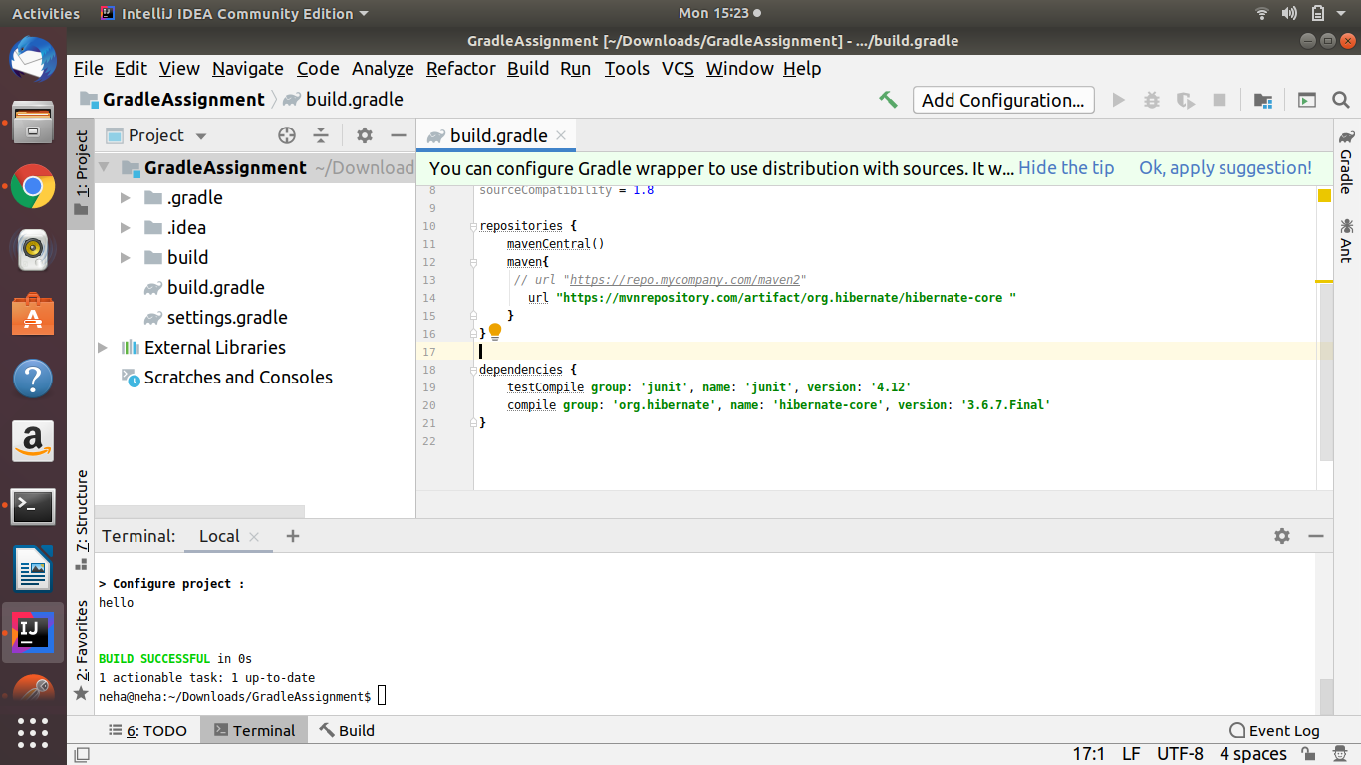

1. Using java plugin, make changes in the manifest to make the jar executable. Using java -jar JAR_NAME, the output should be printed as "Hello World"

Ans:- Java Plugin is injected in build.gradle.

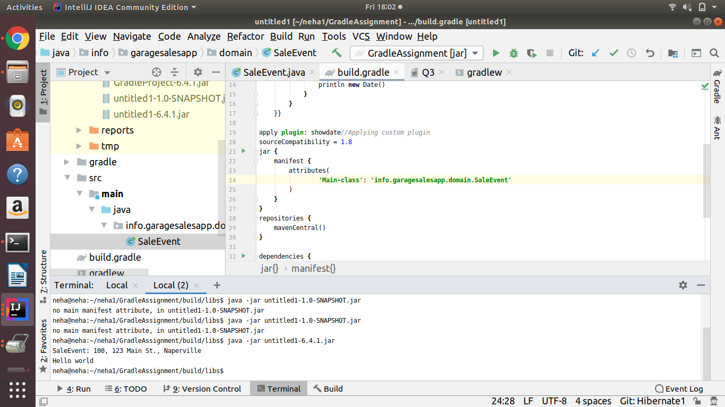

1. Differentiate between the different dependency scopes: compile, runtime, testCompile, testRuntime using different dependencies being defined in your build.gradle.

Ans:- Compile − The dependencies required to compile the production source of the project.

Runtime − The dependencies required by the production classes at runtime.

By default, also includes the compile time dependencies.

Test Compile − The dependencies required to compile the test source of the project.

By default, it includes compiled production classes and the compile time dependencies.

Test Runtime − The dependencies required to run the tests. By default, it includes runtime and test compile dependencies.

1. Create a custom plugin which contains a custom task which prints the current date-time. Using that plugin in your project, execute that task after the jar task executes.

Ans:-The plugin has been created in build.gradle.

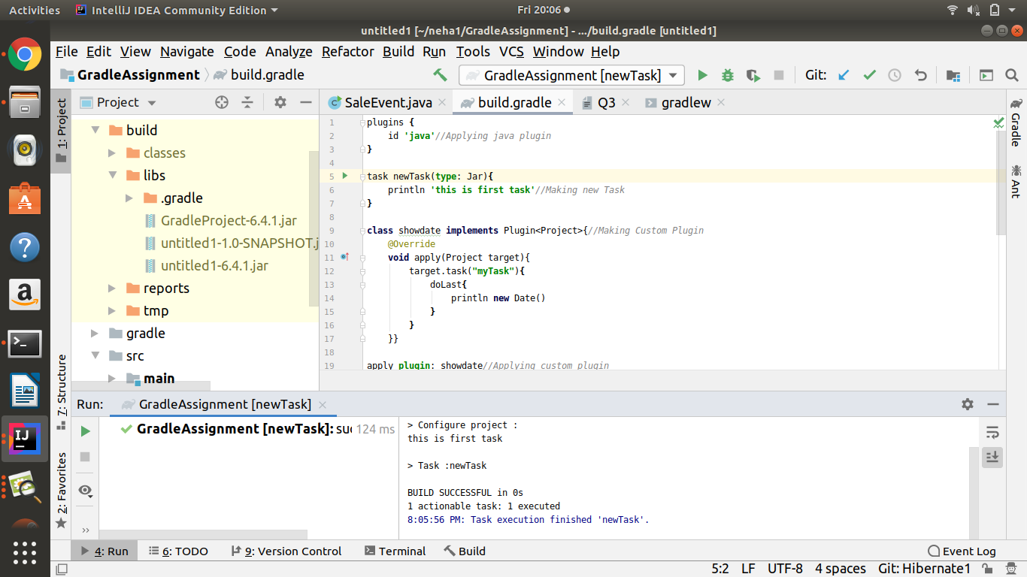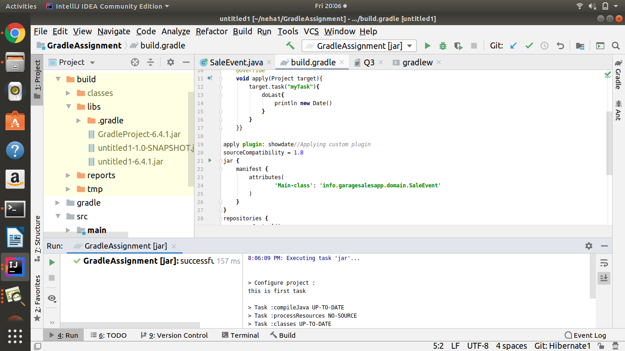

1. Instead of using default source set, use src/main/javaCode1, src/main/javaCode2 to be taken as code source. Make sure that the JAR created contains files from both the directories and not from src/main/java.

Sir this is showing some error not working on this project

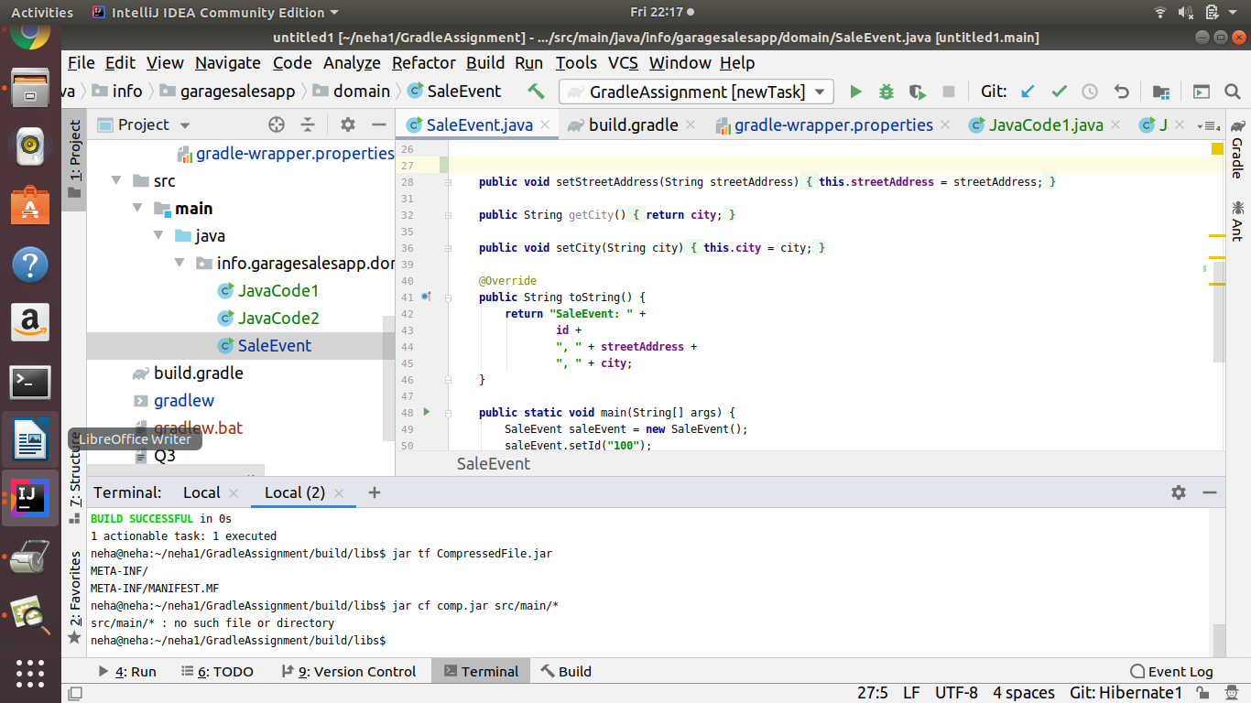

1. Override the Gradle Wrapper task to install a different version of gradle. Make sure that the task written in Q4 also executes with it.

Ans:-Gradle Wrapper is overridden in build.gradle

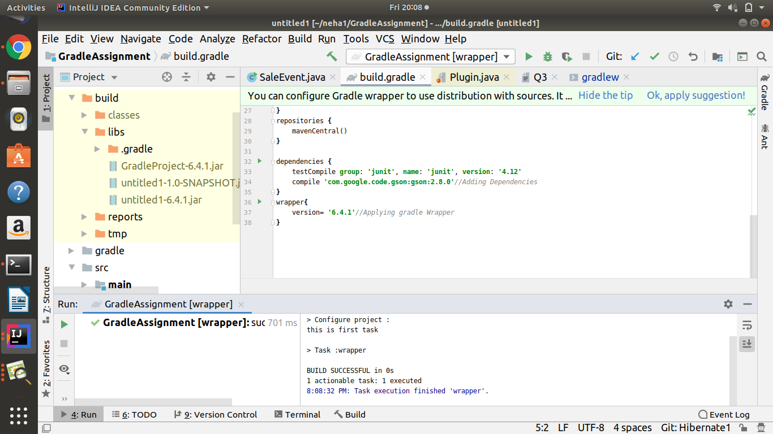

1. Run the gradle profile command and attach the resulting file.

Ans:-

