Data Analysis Task Report
Python Developer Internship

1. Objective
This task analyzes a student score dataset using the pandas library. The goal is to explore the data, compute summary statistics, rank students by performance, and visualize class-wide and individual results.

2. Dataset
student_data.csv contains scores for 20 students across 5 subjects: Math, Science, English, Computer Science, and Social Studies. The dataset has no missing values.

3. Methodology
Using pandas, the dataset was loaded into a DataFrame. Descriptive statistics (mean, standard deviation, min, max) were computed per subject with describe(). A new Average_Score column was derived per student using mean(axis=1), and students were ranked in descending order of that average. Results were visualized with matplotlib and exported as average_scores.png.

4. Subject-Wise Summary Statistics
Subject | Average | Std Dev | Min | Max
Math | 72.25 | 15.38 | 47 | 97
Science | 72.60 | 14.86 | 46 | 95
English | 70.95 | 18.97 | 46 | 99
Computer Science | 72.40 | 18.83 | 46 | 98
Social Studies | 72.05 | 14.31 | 52 | 97

5. Key Findings
• Top performer: Simran Kaur, with an average score of 85.2.
• Science had the highest class average (72.60); English had the lowest (70.95).
• English and Computer Science showed the widest spread in scores (highest standard deviation), indicating more variation in student performance.
• Overall class performance across subjects is fairly balanced, with all subject averages falling between 71 and 73.

6. Visualization
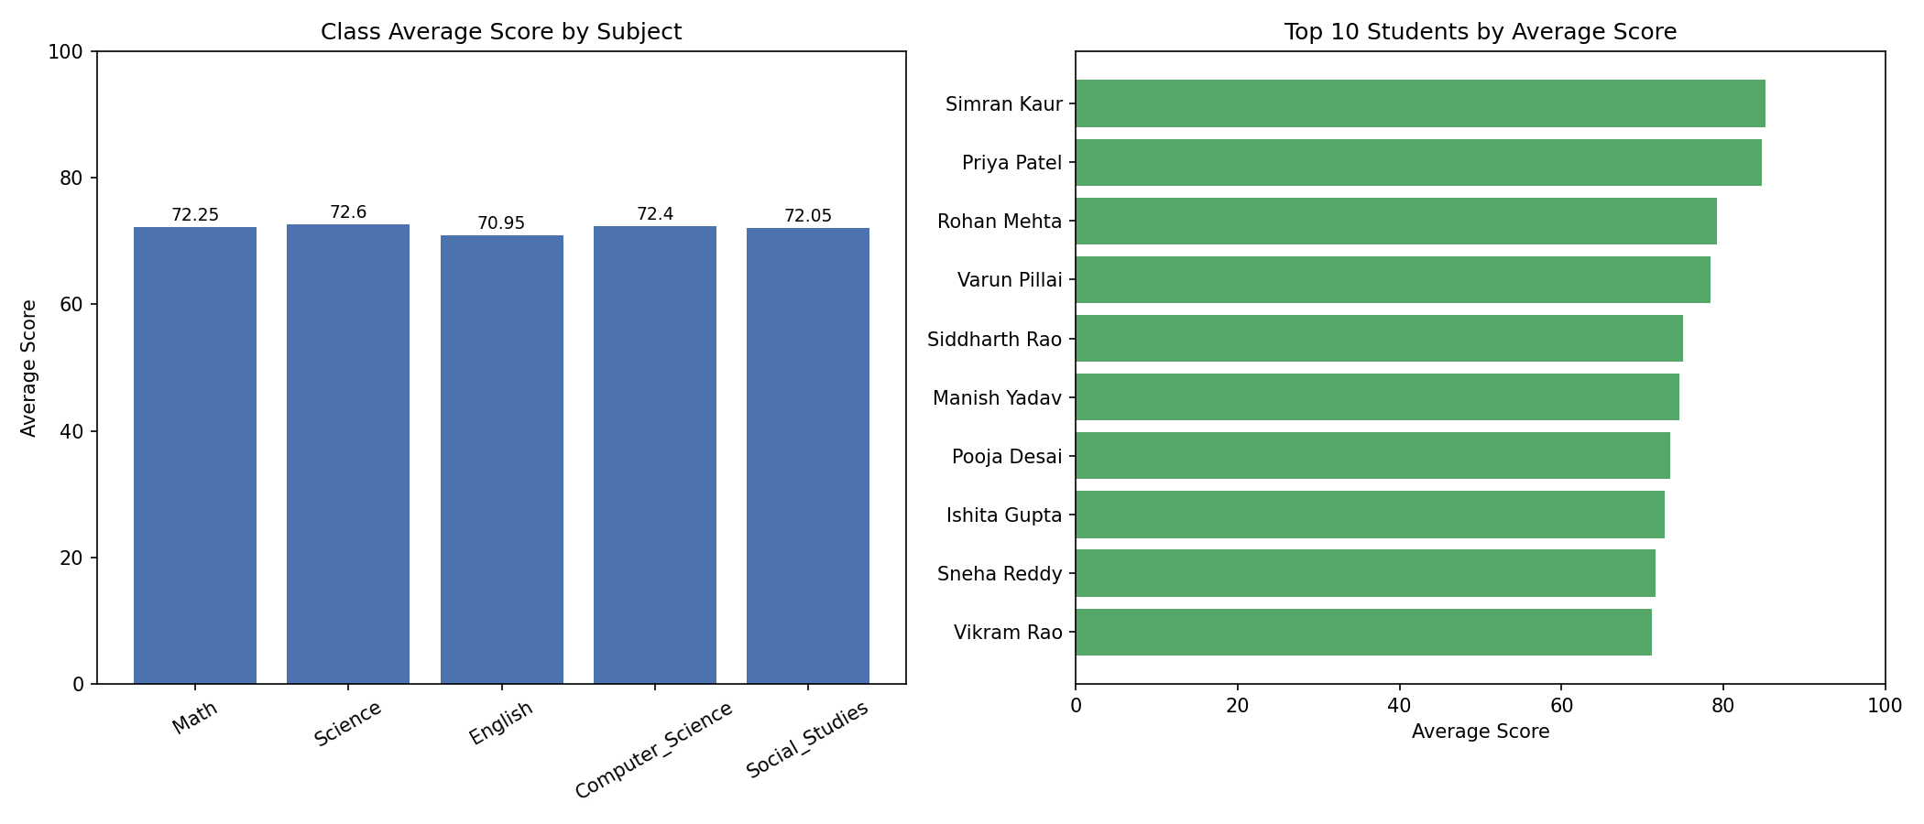

7. Conclusion
This task demonstrates core data analysis skills using pandas and matplotlib: loading and validating tabular data, computing summary statistics, deriving new metrics, ranking records, and communicating results visually — the fundamental workflow behind most real-world data analysis tasks.

