***Geographical Spread of Cultivated Area Across States***

Submitted by

Neha Jaiswal Registration No. : 12312259

Section : KM007

Course Code : INT217

Under the Guidance of

Maneet Kaur

UID: 15709

Discipline of CSE/IT

Lovely School of Computer Science and Engineering Lovely Professional University, Phagwara

CERTIFICATE

This is to certify that Neha Jaiswal bearing Registration No. 12312259 has completed the INT217 project titled, **“Geographical Spread of Cultivated Area Across States”** under my guidance and supervision. To the best of my knowledge, the present work is the result of his/her original development, effort, and study.

Maneet Kaur

Professor

School of Computer Science and Engineering

Lovely Professional University Phagwara, Punjab.

Date: 10-04-2025

DECLARATION

I, Neha Jaiswal, student of BTech under CSE/IT Discipline at Lovely Professional University, Punjab, hereby declare that all the information furnished in this project report titled **“Geographic Spread of Cultivated Area Across States”** is based on my own intensive work and is genuine.

Date: 10-04-2025

Registration No.: 12312259 Name of the student: Neha Jaiswal

ACKNOWLEDGEMENT

I would like to express my sincere gratitude to my faculty and department for their constant guidance and encouragement throughout the successful completion of this minor project titled **“Geographical Spread of Cultivated Area Across States.”**

I also extend my heartfelt thanks to Lovely Professional University for providing the necessary resources, infrastructure, and learning environment that enabled me to carry out this project effectively.

Neha Jaiswal

B.Tech CSE

Contents

1. Introduction 7
2. Source of Dataset 8
3. Sample Dataset 9

. 9

1. Dataset Preprocessing 10
2. Dashboard 11
3. Analysis on dataset 13

Objective 1: Top 5 States with High Production 13

* 1. General Description: 13
  2. Specific Requirements: 13
  3. Analysis Results 13
  4. Visualization 13

. 14

Objective 2: Year-Wise Trend of Total Agriculture Production 15

1. General Description: 15
2. Specific Requirements: 15
3. Analysis Results 15
4. Visualization 15

Objective 3: Crop-Wise % Share of Total Cultivated Area 17

1. General Description: 17
2. Specific Requirements: 17
3. Analysis Results 17
4. Visualization 17

Objective 4: Top 5 Crops by Average Yields 19

1. General Description: 19
2. Specific Requirements: 19
3. Analysis Results 19
4. Visualization 19

Objective 5: State Contribution to National Production 21

1. General Description: 21
2. Specific Requirements: 21
3. Analysis Results 21
4. Visualization 21

Objective 6: Production Efficiency of Crops 23

1. General Description: 23
2. Specific Requirements: 23
3. Analysis Results 23
4. Visualization 23

Objective 6: Area and Production Over Time 24

1. General Description: 24
2. Specific Requirements: 24
3. Analysis Results 24
4. Visualization 24
5. Conclusion 25
6. Future Scope 26
7. Linkedln 28
8. References 29

## Introduction

Agriculture is the support system of the Indian economy, playing an important role in livelihood, food availability, and regional development. Geographical variation of cultivated areas by states is essential to be understood for intelligent land use planning, policy making, and sustainable agriculture. For reasons of size and variability, agricultural data typically become difficult to analyze and meaningfully interpret in the absence of proper visualization and analytical tools.

Here in this research work, a sophisticated Excel-based dashboard titled "Geographical Spread of Cultivated Area Across States" has been prepared to analyze and display cultivated area trends state-wise, year-wise, and season-wise across India. The primary motive of developing this dashboard is to convert gigantic datasets into graphical and interactive plots to facilitate greater analysis and wise decision-making. The dashboard enables users to:

* + Track cultivated area trends across multiple years and states.
  + Compare seasonal variations in land use across different regions.
  + Identify top states by total cultivated land.
  + Analyze average cultivation intensity and patterns.
  + Focus on regional hotspots with high or low agricultural land coverage.

Interactive slicers and filters enable interaction with the data on different axes like seasons, years, and crops, making the insights highly customizable. PivotTables, PivotCharts, and slicers in Excel have been used to create a dynamic and informative user experience.

This project demonstrates the power of Excel as a robust tool for the visualization of agricultural statistics, emphasizing the importance of geographic intelligence in agricultural analytics. It facilitates more data-driven, more informed decisions and opens the door to future enhancements in land use forecasting, resource allocation, and policy evaluation.

## Source of Dataset

The data utilized in this study have been accessed from the official open data portal of the Government of India — data.gov.in. The portal offers openly available data from various sectors such as agriculture, health, education, and economy and thus supports open research and evidence-based policy-making.

For the current study, the dataset titled "**District-wise, Season-wise Crop Production Statistics**" was selected because it has extensive documentation of the cultivated area across different Indian states and seasons. The dataset has significant attributes such as state, district, crop, season, year, area under cultivation (in hectares), and production values. Therefore, it is an appropriate dataset to study the spatial pattern as well as the temporal trend of land under cultivation in India.

³ **Dataset Link:** <https://ndap.niti.gov.in/dataset/6162>

Key features of the dataset:

* **Attributes:** State, District, Crop, Year, Area (in hectares), Production (in tonnes)
* **Coverage:** Multi-year data across major agricultural states of India
* **Format:** CSV
* **Purpose: T**o enable analysis of cultivated land distribution, seasonal land use, and geographic cultivation patterns.

The dataset was downloaded in CSV format and prepared using Microsoft Excel. Data cleaning and formatting were done to enable accurate analysis and the creation of an interactive dashboard focused on cultivated area distribution across Indian states.

## Sample Dataset

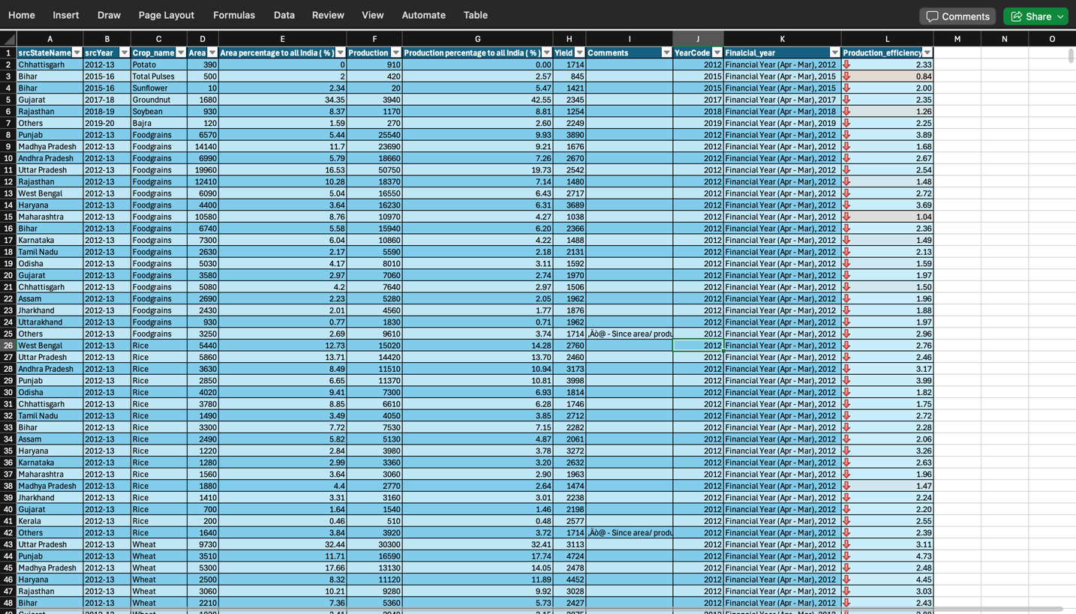

## Dataset Preprocessing

Before any analysis or visualizations were done, the dataset went through strict preprocessing to obtain accuracy, consistency, and usability of the data. Preprocessing is a very important process of transforming raw agricultural data into a structured form for good dashboard building and interpretation.

Steps Taken for Preprocessing:

1. Data Cleaning:
   * Removed rows that were empty or contained null values.
   * Standard naming conventions for states to avoid duplication.
   * Corrected the inconsistencies and spelling mistakes in state and district names.
2. Handling Missing Values:
   * Excluded rows with missing area values to maintain accuracy in cultivated area analysis.
   * Verified that each column had complete and interpretable entries.
3. Data Type Conversion:
   * Converted the 'Area' column to appropriate numeric types (float/int).
   * Ensured textual fields such as State, Season, and Year were properly formatted.
4. Derived Column Creation:
   * Filtered only necessary fields like State, Year, Season, and Area for focused analysis.
   * Aggregated total cultivated area per state and per season using PivotTables.
5. Data Formatting for Excel:
   * Saved the final sorted and cleaned dataset in .xlsx format.
   * Created the PivotTables and Pivot Charts on separate sheets for clear view of the analysis.
   * Added interactive slicers for State, Year and crop names to enhance user control for the dashboard.

This structured preprocessing made the dataset dashboard-ready and ensured reliable, clear visual insights into how cultivated land is spread across India’s geographic regions.

# Dashboard

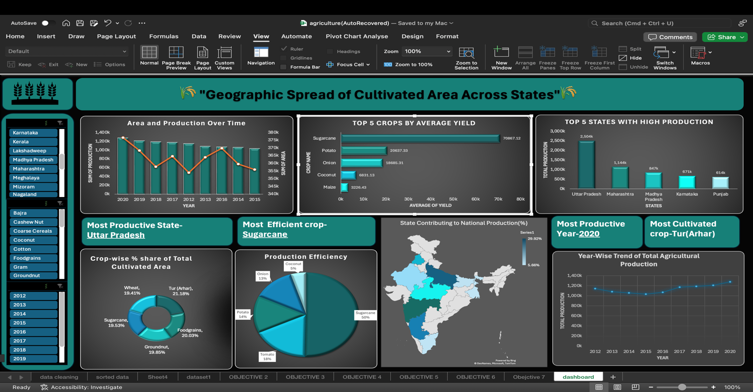

Interactive Crop Production Dashboard

The dashboard developed in this project presents key insights on the distribution of cultivated land across Indian states using intuitive visualizations. It highlights critical dimensions of agricultural land use through the following features:

* + **State-wise Cultivated Area:** Bar charts display how much land each state dedicates to agriculture.
  + **Year-wise Trends:** Line graphs reveal how the total cultivated area has changed over the years
  + **Top Cultivating States:** Visuals rank the top 5 or 10 states based on total cultivated area
  + **Regional Focus:** Charts show variations in cultivated area across geographical zones.
  + **Dynamic Slicers:** Filters allow users to interactively view data by state, year, and season.

This dashboard was designed using Microsoft Excel’s PivotTables, PivotCharts, and slicers, making it dynamic and easy to navigate. It enables users to explore geographic patterns and trends in cultivated area with precision and interactivity.

## Analysis on dataset

##### Objective 1: Top 5 States with High Production

###### General Description:

This goal selects the top 5 farm production states in India that have the largest total farm production. Targeting these states allows one to identify regional leaders in farm production and comprehend geographic concentration of food production.

###### Specific Requirements:

Use a PivotTable to sum production by state and sort in descending order. Copy the top 5 entries and graph them as a column chart. Add slicers for crop and year to allow interactive comparative filtering.

###### Analysis Results:

###### The results show that states like Uttar Pradesh, Madhya Pradesh, and Punjab consistently feature among the leading contributors to total agricultural production. These states are blessed with a favorable climate, sufficient arable land, and high levels of cultivation intensity.

###### Visualization:

A column graph entitled "Top 5 States with Highest Agricultural Production" was plotted.Crop and year slicers allow for dynamic examination of various combinations by which users can monitor production rank changes within time intervals.

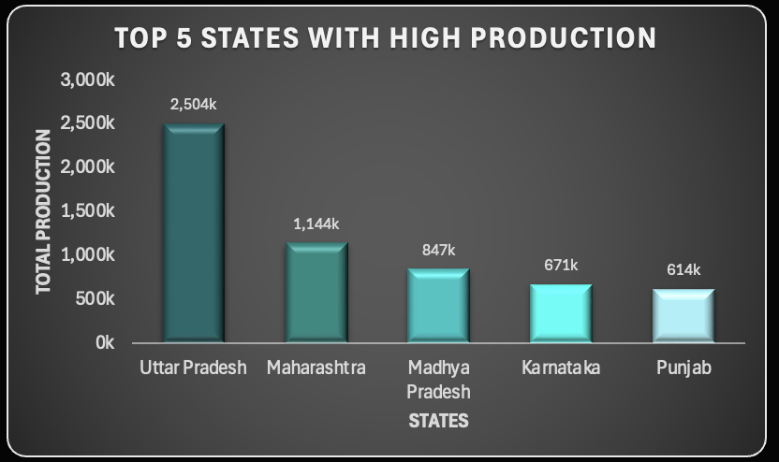

#### Objective 2: Year-Wise Trend of Total Agricultural Production

###### General Description:

This goal tries to examine the way in which the overall agricultural production in India has changed over the years. Year-to-year examination offers useful insights regarding the overall growth, decline, or stability in production, and assists in assessing the impact of climatic factors, farm reforms, and technological innovations on the level of production.

###### Specific Requirements:

Calculate the total production of crops by aggregate year using a PivotTable. Plot the trend using a line chart to depict the trend over time.

Add slicers for filtering by state and crop in order to support comparative analysis. Use proper chart formatting in terms of appropriate titles, axes, and gridlines for better readability

###### Analysis Results:

The trend varied from year to year, with some peaks at some times indicating good farm production. Years 2012 and 2016 indicated high production, while others indicated a decrease possibly because of environmental reasons or cost constraints. Recent data can indicate lower figures because of incomplete coverage

###### Visualization:

A line graph with the title "Total Agricultural Production by Year" was created.

Interactive features in the form of crop and state slicers were incorporated. This visualization assists users in monitoring the improvement of production performance over time and various crop conditions.

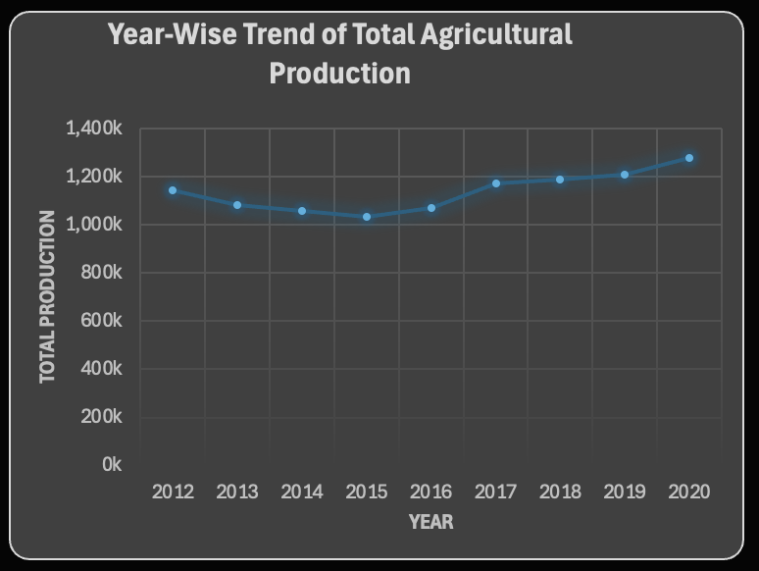

#### Objective 3: Crop-wise % Share of Total Cultivated Area

###### General Description:

This goal considers the share of the total cropped area under different crops. Crop-wise land allocation analysis allows evaluation of agricultural priorities, preference, and use of resources by region and seasons. It is required for improving land management and designing crop diversification strategies.

###### Specific Requirements:

* + Using a PivotTable to calculate total cultivated area for each type of crop.
  + Derive each crop’s percentage share of the total area of the country.
  + Display the results using a pie chart.
  + Applying slicers for filtering by state, year, and crop name to make the dashboard interactive and responsive for the user.

###### Analysis Results:

The study indicated that staple crops like rice and wheat held the greatest share of cultivable land in different states. Horticultural or specialized crops, on the other hand, took up a lesser share but were dominant in some states. This classification is an effective approach to evaluating land use by crop type and helps in planning for sustainable agriculture.

###### Visualization:

A pie chart titled "Crop-wise % Share of Total Cultivated Area" was drawn.

State, year, and season slicers were added to allow interactive filtering. The visualization updates in real-time according to the filters applied, hence giving a general overview of land distribution at the crop level.

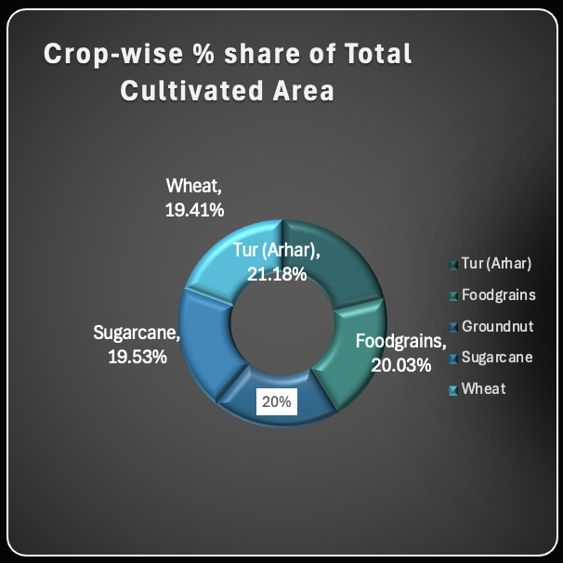

#### Objective 4: Top 5 Crops by Average Yield

###### General Description:

This objective entails listing the top 5 highest average yield crops by computing the production per unit area under cultivation. An analysis of average yield provides satisfactory information regarding the efficiency of crops, indicating the crops that are more productive in relation to the amount of land they use. This is beneficial for promoting high-yielding crops and optimizing agricultural production.

###### Specific Requirements:

###### • Use a calculated column to calculate yield using the formula: Production ÷ Area.

• Make a PivotTable summarizing average yield across all crops by state.

• Show and rank the top 5 crops in a horizontal bar chart.

• Add slicers to filter by year and state to provide more interactivity to the visualization.

###### Analysis Results:

The findings indicated that crops such as sugarcane, bananas, and maize uniformly had high average yields in various states. These are conventionally linked with high-input farming methods and improved access to irrigation. In contrast, coarse grains were lower in average yields, which are typically representative of farming under marginal soil conditions.

###### Visualization:

A bar graph with the title "**Top 5 Crops by Average Yield**" was created.

State and year interactive slicers allow users to filter results based on a variety of criteria. The graphical tool facilitates stakeholders in easily identifying the most appropriate crops for prevailing conditions immediately.

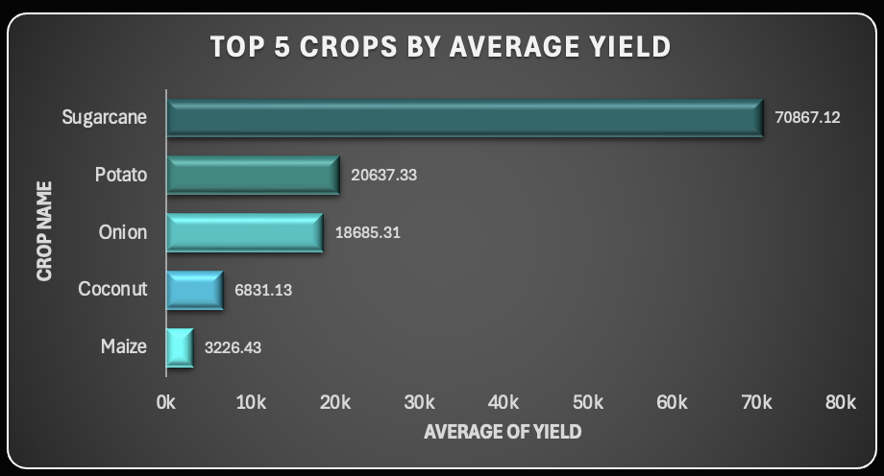

#### Objective 5: State Contribution to National Production

###### General Description:

This objective is about measuring the degree to which each state contributes to the total agricultural production in the national context. Understanding these contributions makes it easier to identify high-performing states, makes policy targeting easier, and highlights regional disparities in agricultural production.

###### Specific Requirements:

• Make a PivotTable to sum up total production by state.

• Calculate each state's share as a percentage of the total national figure.

• Use a clustered column chart to comparatively show the contributions.

• Add year and crop slicers to enable examination of trends over time and product types.

###### Analysis Results:

The research established that those states including Uttar Pradesh, Madhya Pradesh, and Maharashtra account for a high percentage of the country's agricultural production. Other states, particularly those from the northeastern or dry regions, contribute relatively low percentages. These results help in the determination of states with high agricultural potential and those requiring investment or support.

A cluster column chart and a map chart titled "State-wise Contribution to National Production" were prepared.

Year and crop slicers enable filtering and examination of trends in real time. The chart is able to distinguish clearly between high and low contributing states with consistent color coding for legibility.

###### Visualization:

A clustered column chart and a map chart titled **“State-wise Contribution to National Production”** was created.  
Slicers for year and crop allow users to filter and explore trends dynamically. The chart clearly distinguishes between high and low contributing states using consistent color formatting for clarity.

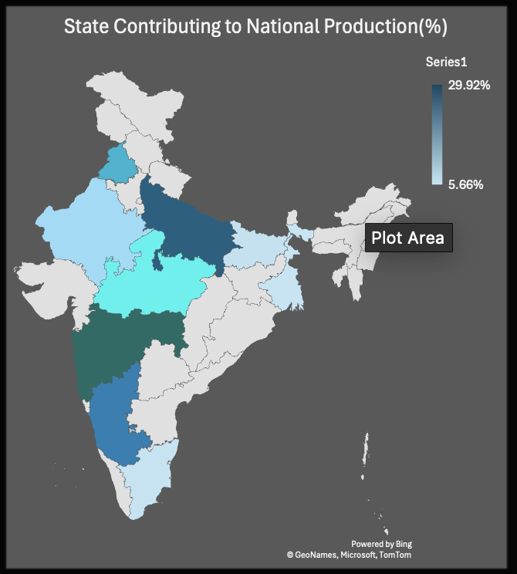

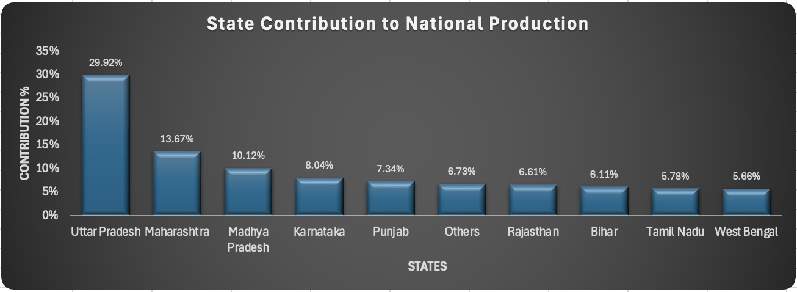

##### Objective 6: Production Efficiency of Crops

###### General Description:

The aim of this study is to evaluate the productivity efficiency of various crops in terms of yield per hectare. Instead of comparing mere levels of production, this study emphasizes the effectiveness of land use across various crops, thereby informing the decisions on best crop choice and resource allocation.

###### Specific Requirements:

• Compute yield by using the formula: Production ÷ Area per crop.

• Create a PivotTable by crop to show average yield values.

• Use a horizontal bar chart to compare crop efficiencies.

• Include slicers for state and year to enable dynamic filtering and contextual analysis.

###### Analysis Results:

The result showed that crop types like sugarcane, banana, and maize were significantly efficient in their production, compared to cereals and pulses in terms of output rates. Such differences reflect the influence of weather, crop type, and the quality of input on efficiency and thus inform enhanced land use planning.

###### Visualization:

A horizontal bar chart with the name "Crop-wise Production Efficiency (Yield per Hectare)" was prepared.

State and year filters were added in order to enable effective filtering. The visualization also supports comparison of the efficiency with which various crops are able to convert land into production.

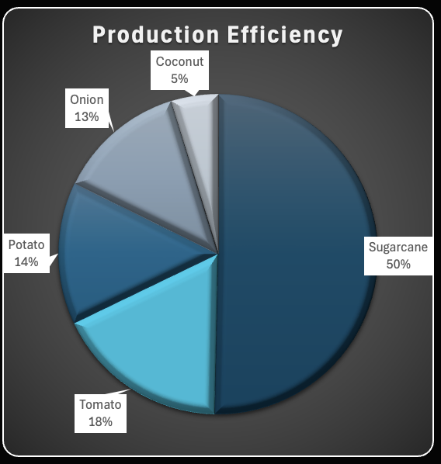

##### Objective 7: Area and Production Over Time

###### General Description:

This objective attempts to examine how cultivated and overall crop production have changed over the years. Putting these two indicators side by side, users are able to assess whether increases in production are a result of enhanced cultivation or improved efficiency, and how external forces may have influenced farm trends.

###### Specific Requirements:

a. Develop two PivotTables to sum Area and Production year-wise separately.

b. Plot both measures on a dual-axis line chart to compare.

c. Add crop and state slicers to enable complete filtering.

d. Ensure chart formatting clearly distinguishes between the two lines and enhances readability.

###### Analysis Results:

The analysis showed that while the area planted did have stability over different years, production was more variable—responding to changes in levels of efficiency. In certain states, higher production was achieved with a non-significant rise in area, showing improvement in farm practices or favorable climatic conditions.

###### Visualization:

A composite graph entitled "**Cultivated Area vs. Production Over Time**" was plotted.

State and crop slicers were employed to facilitate interactive analysis. The graph is used to display the interaction between area and output and facilitate the identification of trends in land use and productivity.

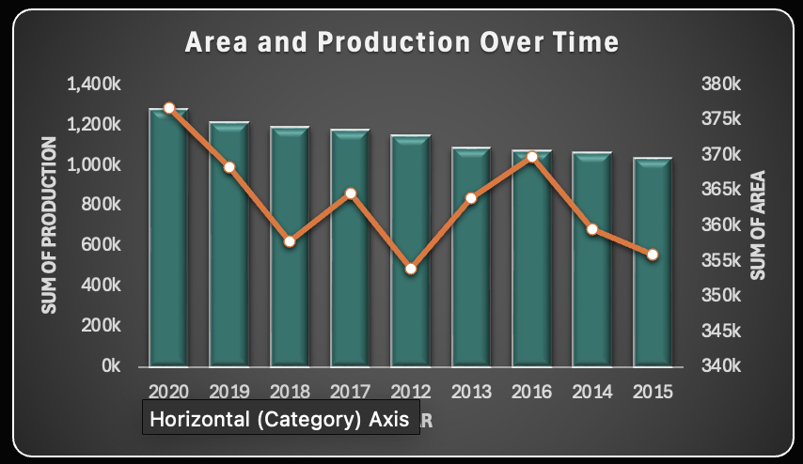

## Conclusion

The "Geographic Spread of Cultivated Area Across States" project sought to make interpretations of large-scale agricultural data easier by presenting concise, visual representations of the spatial extent of cultivated land across India. Through the utilization of Microsoft Excel functions like Pivot Tables, Charts, and Slicers, the project was able to transform complicated data into an interactive, user-friendly dashboard.

• This dashboard allows users to compare and analyze cultivated area data in different dimensions like state, year, season, and crop. Some of the important functionalities are:

• Visualizing contribution of each state to overall cultivated area to identify top agricultural regions.

• Trend analysis year-wise for cultivated land to observe growth or reduction over a period of time.

• Filtration of data by season (Kharif, Rabi, Zaid) to determine seasonal patterns of land use.

• Comparing crop average yield and efficiency measures, informing land allocation decisions.

• Identifying the leading crops by area or yield, informing cultivation planning decisions.

• Investigating the correlation between area and production, providing insights into farm productivity.

Consistent formatting, color schemes, and interactive slicers improve both the dashboard's visual appeal and usability, enabling users to make informed decisions from trusted, real-time insights.

This project demonstrates the promise of Excel dashboards in agricultural data science for intelligent resource management and regional planning. The approach is flexible and can be further extended to incorporate live data sources, sophisticated analytics, or geographic mapping capabilities in future revisions.

## Future Scope

The latest version of the "Geographic Spread of Cultivated Area Across States" dashboard provides useful information on cultivated land distribution, seasonal use, state-wise trends, and crop-wise area distribution. There is immense scope to further improve the dashboard for enhanced usability, depth, and impact:

**Real-Time Data Integration**  
Merging live agricultural data sets through APIs or web scraping might allow the dashboard to present the latest cultivation data, in place of static historical perspectives with real-time information.

**Automated Refresh Mechanism**

Making the process of updating data automatic will keep the dashboard current and precise without human intervention, particularly critical when dealing with rapidly changing data sets.

**Interactive Geo-Mapping**

Adding geographic maps to display state-wise or district-wise area under cultivation can enhance spatial orientation and improve the visual appeal and understandability of the dashboard.

**Advanced Filters and Drill-Down Analysis**

Adding multi-level filtering would enable users to delve into certain crop types, regional, or time-based comparisons to analyze in a more detailed and contextual manner.

**Predictive Analysis**

Integration with predictive models via Python or R can predict future cultivation trends from past land use and environmental patterns.

**Web-Based Dashboard Version**

Shifting the dashboard from Excel to tools such as Power BI, Tableau, or Python Dash can enhance it to become more accessible, interactive, and sharable over the web with more advanced features.

**Mobile Compatibility**

Having a responsive version of the dashboard would enable mobile users to be able to easily access and read cultivated area trends and insights remotely.

**User Documentation and Help Guide**

Including help tabs or tooltips in-built will enhance the intuitiveness of the dashboard, particularly for new users, so they can learn to work with slicers and interpret visualization.

By incorporating these features, the dashboard has the potential to become a complete agricultural analysis platform that caters to farmers, planners, researchers, and policymakers.

### Linkedln:

<https://www.linkedin.com/feed/update/urn:li:activity:7316774581300523008/>

### References

1. Government of India, Ministry of Agriculture and Farmers Welfare, , [Online]. Available: <https://www.data.gov.in/catalog/district-wise-season-wise-crop-production-statistics-0> [Accessed: Apr. 2025].
2. Microsoft, *"Create a PivotTable to analyze worksheet data"*, Microsoft Support. [Online]. Available: <https://support.microsoft.com/en-us/excel> [Accessed: Apr. 2025