Scala Word count

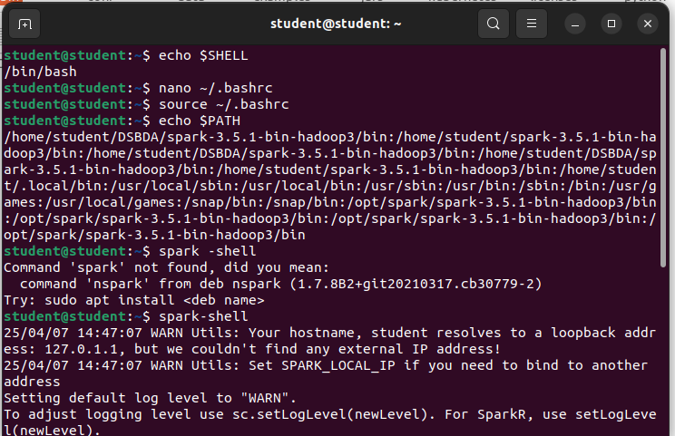

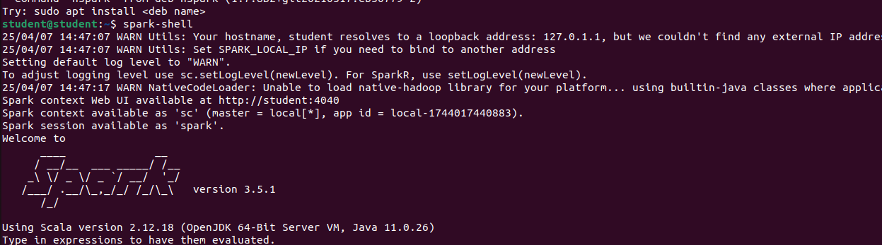

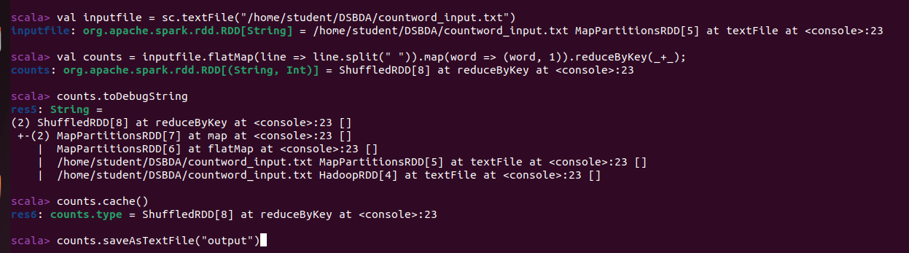

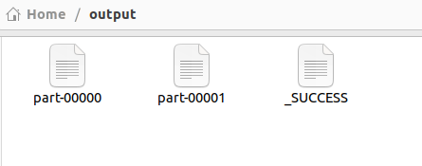

//Method 2

wordcount1.scala

val inputfile = sc.textFile("/home/student/DSBDA/countword_input.txt")
val counts = inputfile.flatMap(line => line.split(" ")).map(word => (word, 1)).reduceByKey(_+_);
counts.toDebugString
counts.cache()
counts.saveAsTextFile("output")

